Analysis of HB CE cohort

Niklaus Meier

November 14, 2023

## Warning: Removed 210 rows containing missing values (`geom_line()`).

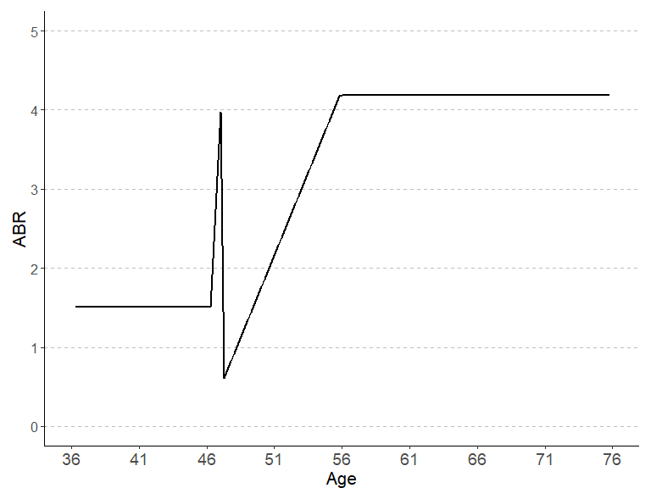

## Warning: Removed 210 rows containing missing values (`geom_line()`).

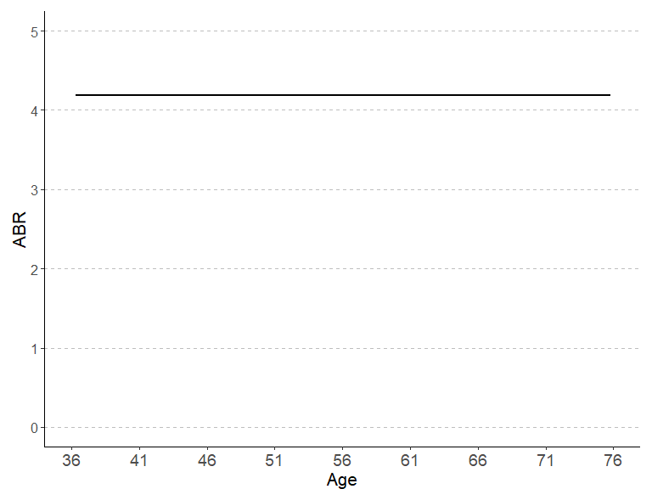

## Warning: Removed 70 rows containing missing values (`geom_line()`).  
## Removed 70 rows containing missing values (`geom_line()`).

## Warning: Removed 207 rows containing missing values (`geom_line()`).

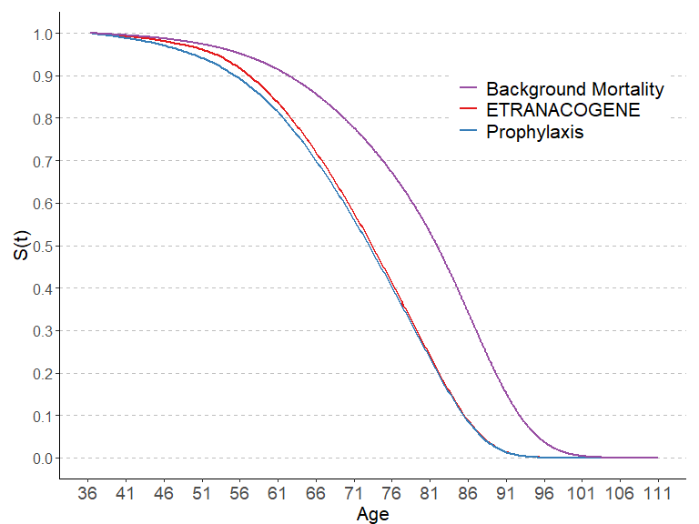

## Warning: Removed 70 rows containing missing values (`geom_line()`).

## Warning: Removed 70 rows containing missing values (`geom_line()`).

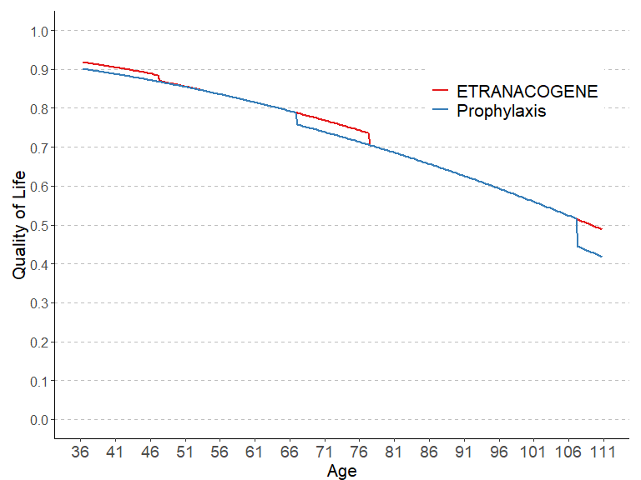

kbl(cycle_length_comp_LYs, format = "simple", caption = "Comparison Life Years")

Comparison Life Years

|  | ETRANACOGENE | PROPHYLAXIS |
| --- | --- | --- |
| 12 months | 21.91437 | 21.54836 |
| 3 months | 21.57047 | 21.22726 |
| 1 month | 21.51748 | 21.17500 |
| 1 week | 21.48530 | 21.14216 |

# We see a relevant reduction in the number of LYs based on shorter cycle lengths,  
# though the difference between one month and one week is very small  
  
kbl(cycle_length_comp_costs, format = "simple", caption = "Comparison Costs")

Comparison Costs

|  | ETRANACOGENE | PROPHYLAXIS |
| --- | --- | --- |
| 12 months | 5629957 | 7108287 |
| 3 months | 5559866 | 7003264 |
| 1 month | 5586220 | 6986025 |
| 1 week | 5592474 | 6975326 |

# For viral gene therapy and prophylaxis:   
# We see a relevant reduction in the costs based on shorter cycle lengths,  
# though the difference between one month and one week is very small  
  
kbl(cycle_length_INMB, format = "simple", caption = "Comparison Incremental Net Monetary Benefit")

Comparison Incremental Net Monetary Benefit

|  | ETRANACOGENE vs. PROPHYLAXIS |
| --- | --- |
| 12 months | 1504734 |
| 3 months | 1468628 |
| 1 month | 1424925 |
| 1 week | 1407957 |

# We see a relevant reduction in the INMB based on shorter cycle lengths,  
# though the difference between one month and one week is very small

# System information

Sys.info()

sysname release version nodename machine login user effective_user   
 "Windows" "10 x64" "build 19045" "M04486" "x86-64" "min1" "min1" "min1"

sessionInfo(package = NULL)

R version 4.3.1 (2023-06-16 ucrt) Platform: x86_64-w64-mingw32/x64 (64-bit) Running under: Windows 10 x64 (build 19045)

Matrix products: default

locale: [1] LC_COLLATE=German_Switzerland.utf8 LC_CTYPE=German_Switzerland.utf8 LC_MONETARY=German_Switzerland.utf8 LC_NUMERIC=C LC_TIME=German_Switzerland.utf8

time zone: Europe/Zurich tzcode source: internal

attached base packages: [1] stats graphics grDevices utils datasets methods base

other attached packages: [1] rmarkdown_2.23 ggrepel_0.9.3 plyr_1.8.8 ggpubr_0.6.0 truncnorm_1.0-9 lookup_1.0 data.table_1.14.8 pander_0.6.5 RColorBrewer_1.1-3 ggplot2_3.4.2  
[11] kableExtra_1.3.4

loaded via a namespace (and not attached): [1] utf8_1.2.3 generics_0.1.3 tidyr_1.3.0 rstatix_0.7.2 xml2_1.3.5 stringi_1.7.12 digest_0.6.33 magrittr_2.0.3 evaluate_0.21 grid_4.3.1 fastmap_1.1.1  
[12] backports_1.4.1 httr_1.4.6 rvest_1.0.3 purrr_1.0.1 fansi_1.0.4 viridisLite_0.4.2 scales_1.2.1 abind_1.4-5 cli_3.6.1 crayon_1.5.2 rlang_1.1.1  
[23] cowplot_1.1.1 munsell_0.5.0 withr_2.5.0 yaml_2.3.7 tools_4.3.1 ggsignif_0.6.4 dplyr_1.1.2 colorspace_2.1-0 webshot_0.5.5 broom_1.0.5 vctrs_0.6.3  
[34] R6_2.5.1 lifecycle_1.0.3 stringr_1.5.0 car_3.1-2 pkgconfig_2.0.3 pillar_1.9.0 gtable_0.3.3 glue_1.6.2 Rcpp_1.0.11 systemfonts_1.0.4 highr_0.10  
[45] xfun_0.39 tibble_3.2.1 tidyselect_1.2.0 rstudioapi_0.15.0 knitr_1.43 farver_2.1.1 htmltools_0.5.5 labeling_0.4.2 carData_3.0-5 svglite_2.1.2 compiler_4.3.1