Analysis of HB CE deterministic model

Niklaus Meier

November 14, 2023

## [1] "These plots show the convergence of various outcomes as more patients are added to generate the running mean."

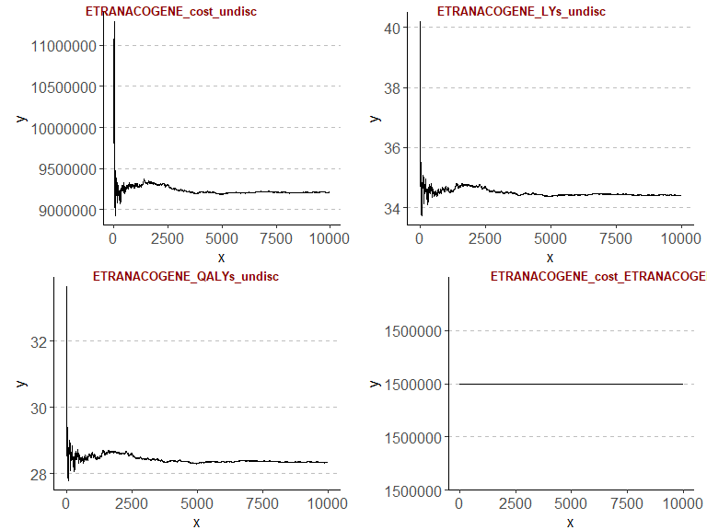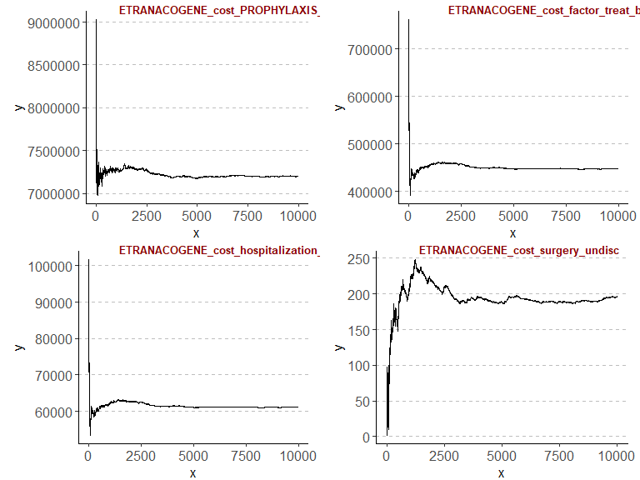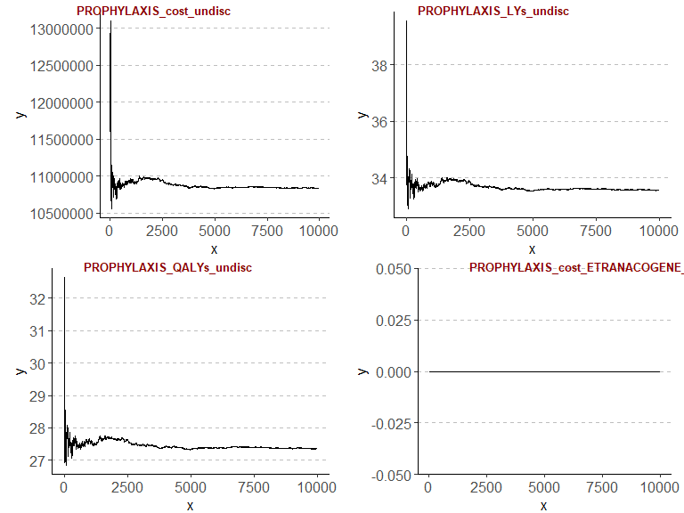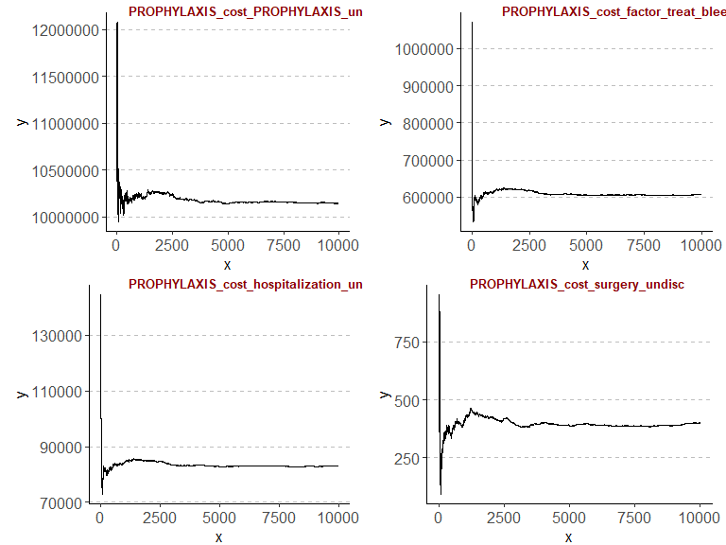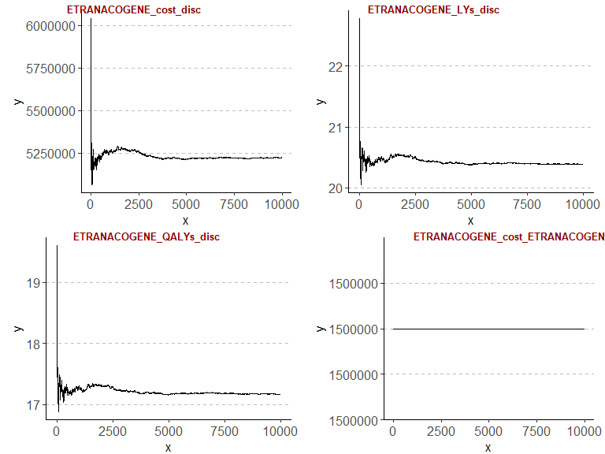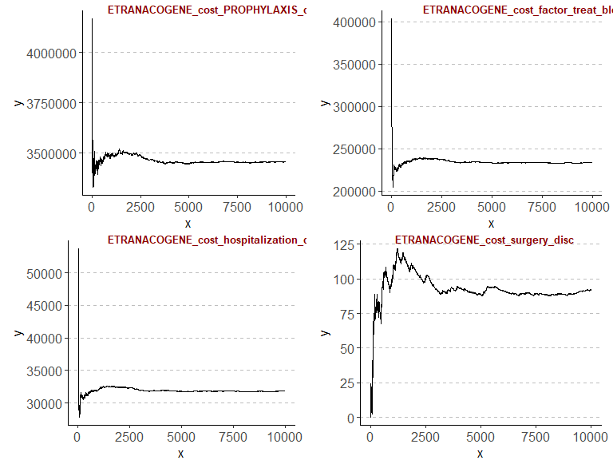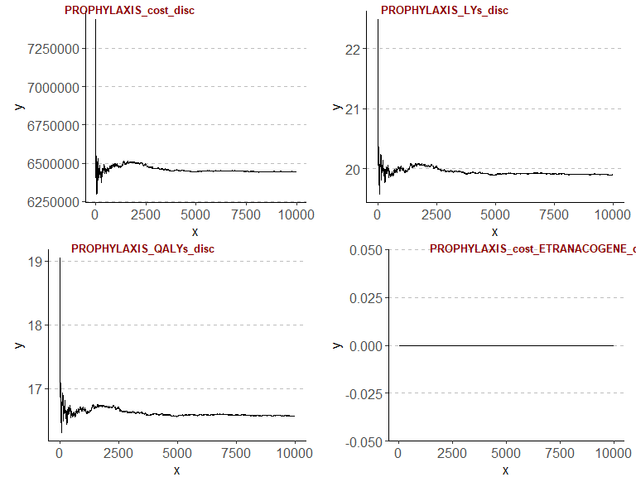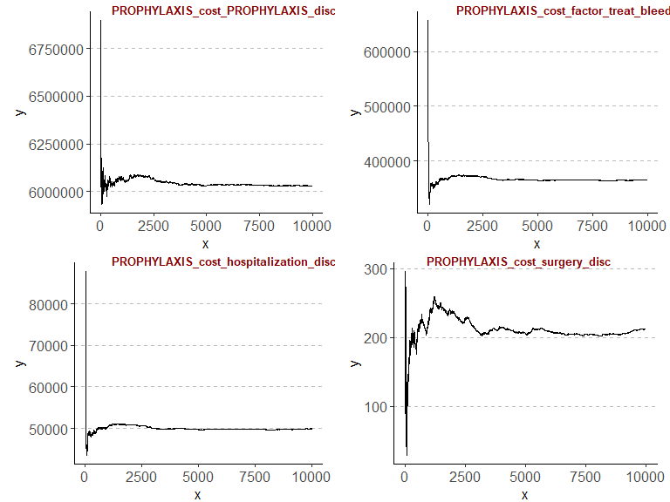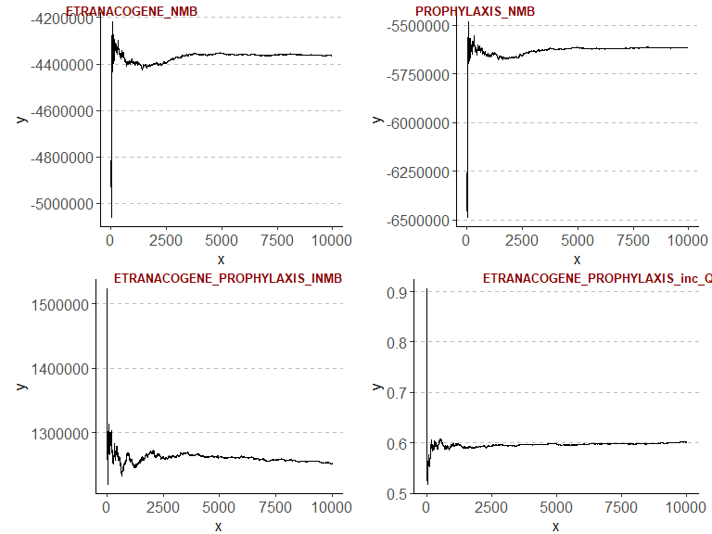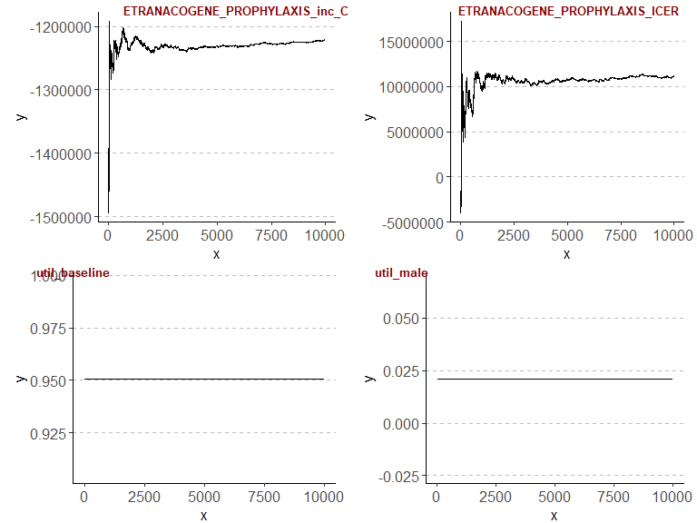

Diagnostics of convergence of running incremental outcomes over all patients in simulation

| ETRA vs. PROPH inc. QALYs | ETRA vs. PROPH inc. Costs | ETRA vs. PROPH inc. NMB |
| --- | --- | --- |
| 0 | 0 | 0 |
| 0 | 0 | 0 |
| 0 | 0 | 0 |
| 0 | 0 | 0 |
| 0 | 0 | 0 |
| 0 | 0 | 0 |
| 0 | 0 | 0 |
| 0 | 0 | 0 |
| 0 | 0 | 0 |
| 0 | 0 | 0 |

## [1] "We used intervals of 1000 patients, and checked whether the running mean of the incremental outcomes change by more than 1%."

## [1] "A 0 means that we have reached a stable value, i.e. we have achieved convergence and have a sufficient sample size, using this interval and this percentage change as a measure of sufficient stability."

Comparison undiscounted outcomes between ETRANACOGENE and Prophylaxis

| Treatment | LYs | QALYs | Costs | NMB | ICER |
| --- | --- | --- | --- | --- | --- |
| ETRANACOGENE | 34.40 | 28.34 | 9211920 | 0 | 0 |
| Prophylaxis | 33.56 | 27.36 | 10838802 | 0 | 0 |
| Increment | 0.84 | 0.98 | -1626882 | 0 | 0 |

Comparison discounted outcomes between ETRANACOGENE and Prophylaxis

| Treatment | LYs | QALYs | Costs | NMB | ICER |
| --- | --- | --- | --- | --- | --- |
| ETRANACOGENE | 20.39 | 17.17 | 5223105 | -4364641 | 0 |
| Prophylaxis | 19.90 | 16.57 | 6444970 | -5616597 | 0 |
| Increment | 0.49 | 0.60 | -1221865 | 1251956 | -2030303 |

Undiscounted costs broken down by category

| Treatment | ETRANACOGENE | FIX Prophylaxis | FIX for treatment of bleeds | Hospitalization | Surgery | Total |
| --- | --- | --- | --- | --- | --- | --- |
| ETRANACOGENE | 1500000 | 7202197 | 448284.3 | 61242.11 | 196.19 | 9211920 |
| FIX Prophylaxis | 0 | 10148127 | 607092.5 | 83181.57 | 400.44 | 10838802 |

Discounted costs broken down by category

| Treatment | ETRANACOGENE | FIX Prophylaxis | FIX for treatment of bleeds | Hospitalization | Surgery | Total |
| --- | --- | --- | --- | --- | --- | --- |
| ETRANACOGENE | 1500000 | 3457338 | 233834.7 | 31840.27 | 92.39 | 5223105 |
| FIX Prophylaxis | 0 | 6029393 | 365433.5 | 49931.47 | 212.61 | 6444970 |

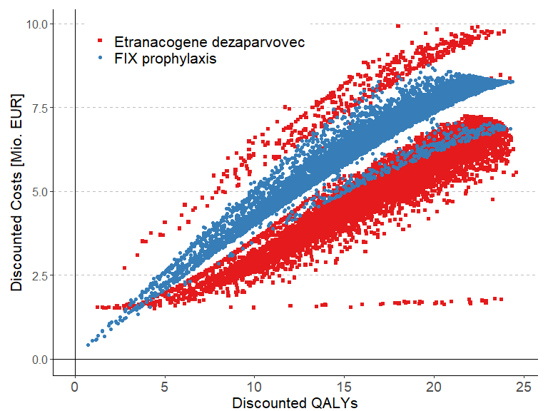

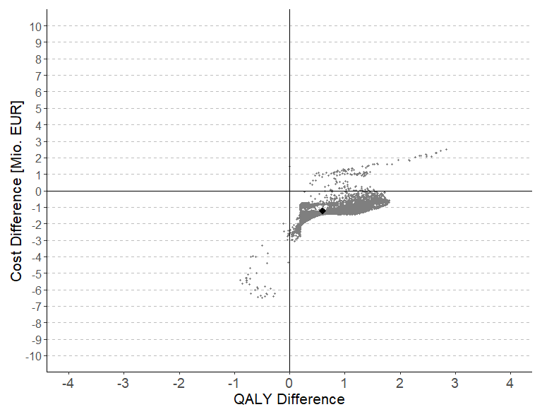

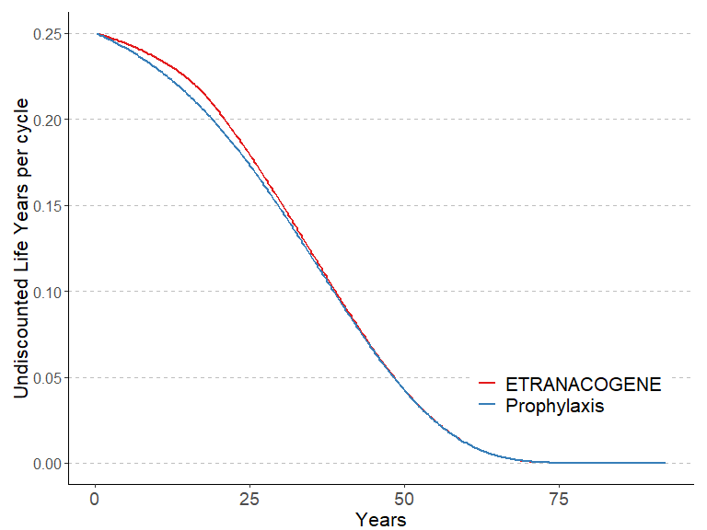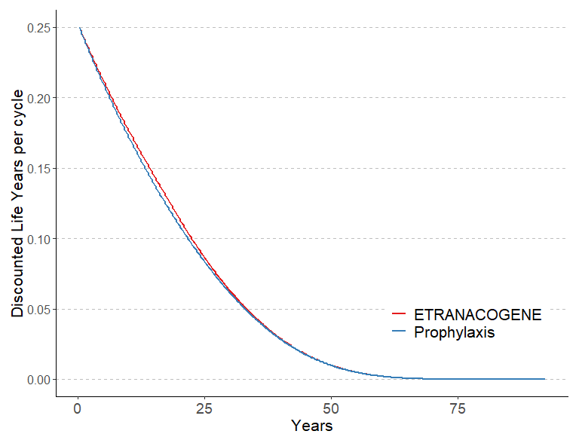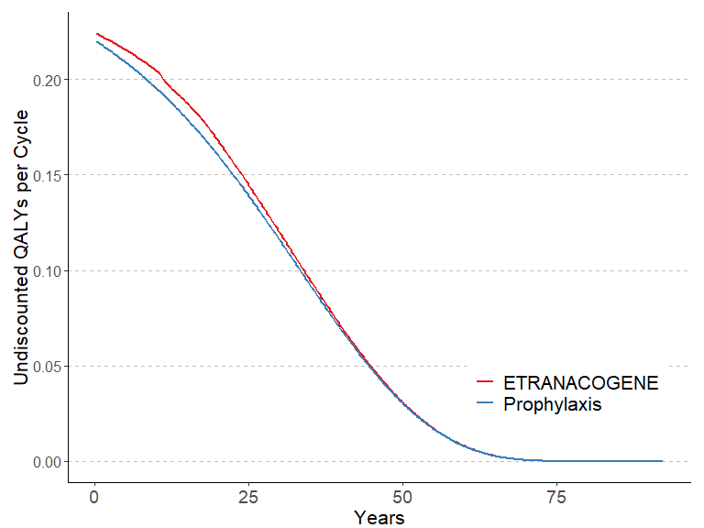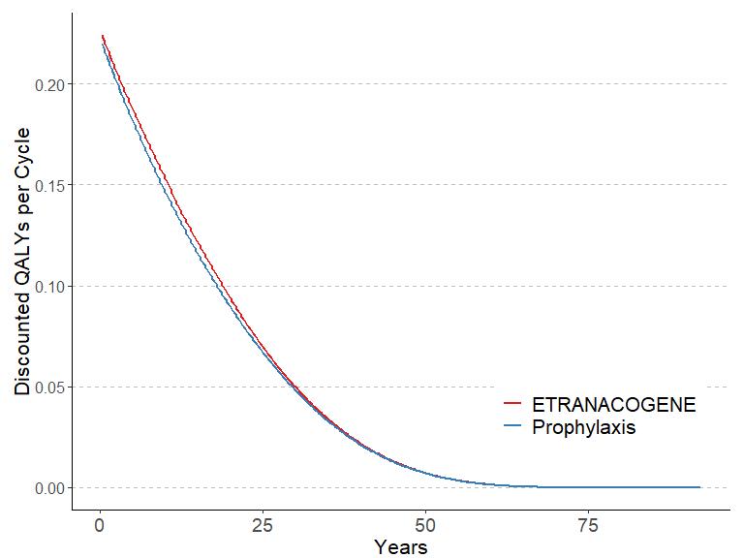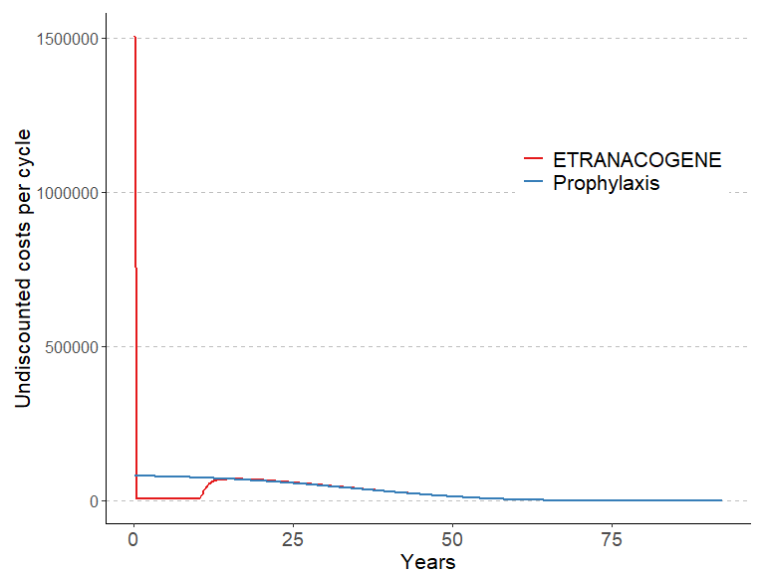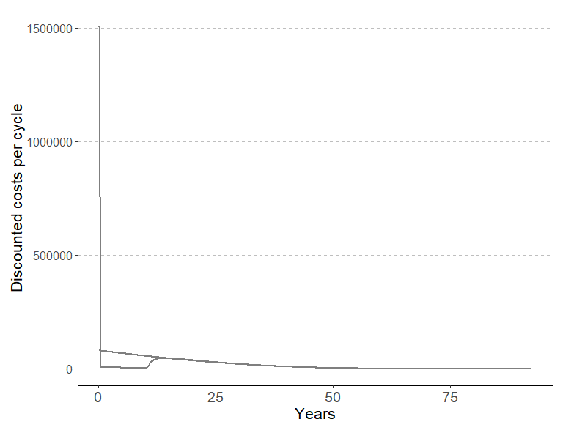

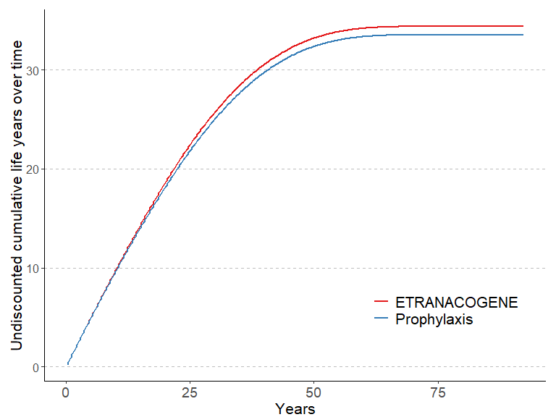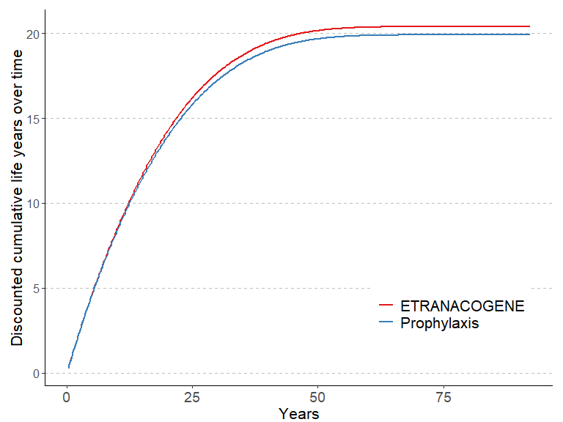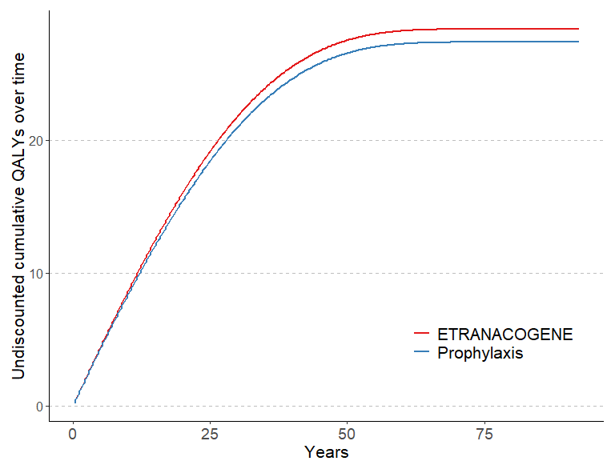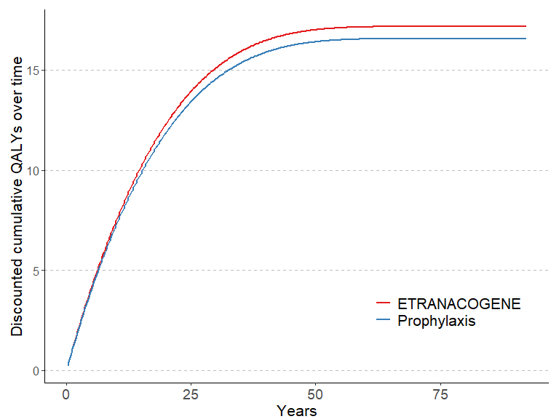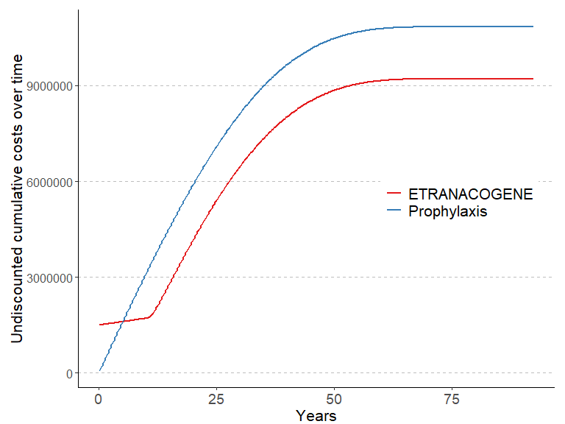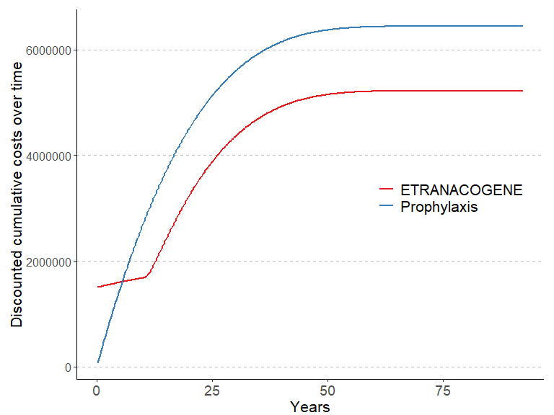

# System information

Sys.info()

sysname release version nodename machine login user effective_user   
 "Windows" "10 x64" "build 19045" "M04486" "x86-64" "min1" "min1" "min1"

sessionInfo(package = NULL)

R version 4.3.1 (2023-06-16 ucrt) Platform: x86_64-w64-mingw32/x64 (64-bit) Running under: Windows 10 x64 (build 19045)

Matrix products: default

locale: [1] LC_COLLATE=German_Switzerland.utf8 LC_CTYPE=German_Switzerland.utf8 LC_MONETARY=German_Switzerland.utf8 LC_NUMERIC=C LC_TIME=German_Switzerland.utf8

time zone: Europe/Zurich tzcode source: internal

attached base packages: [1] stats graphics grDevices utils datasets methods base

other attached packages: [1] rmarkdown_2.23 ggrepel_0.9.3 plyr_1.8.8 ggpubr_0.6.0 truncnorm_1.0-9 lookup_1.0 data.table_1.14.8 pander_0.6.5 RColorBrewer_1.1-3 ggplot2_3.4.2  
[11] kableExtra_1.3.4

loaded via a namespace (and not attached): [1] utf8_1.2.3 generics_0.1.3 tidyr_1.3.0 rstatix_0.7.2 xml2_1.3.5 stringi_1.7.12 digest_0.6.33 magrittr_2.0.3 evaluate_0.21 grid_4.3.1 fastmap_1.1.1  
[12] backports_1.4.1 httr_1.4.6 rvest_1.0.3 purrr_1.0.1 fansi_1.0.4 viridisLite_0.4.2 scales_1.2.1 abind_1.4-5 cli_3.6.1 crayon_1.5.2 rlang_1.1.1  
[23] cowplot_1.1.1 munsell_0.5.0 withr_2.5.0 yaml_2.3.7 tools_4.3.1 ggsignif_0.6.4 dplyr_1.1.2 colorspace_2.1-0 webshot_0.5.5 broom_1.0.5 vctrs_0.6.3  
[34] R6_2.5.1 lifecycle_1.0.3 stringr_1.5.0 car_3.1-2 pkgconfig_2.0.3 pillar_1.9.0 gtable_0.3.3 glue_1.6.2 Rcpp_1.0.11 systemfonts_1.0.4 highr_0.10  
[45] xfun_0.39 tibble_3.2.1 tidyselect_1.2.0 rstudioapi_0.15.0 knitr_1.43 farver_2.1.1 htmltools_0.5.5 labeling_0.4.2 carData_3.0-5 svglite_2.1.2 compiler_4.3.1