Analysis of HB CE probabilistic model

Niklaus Meier

Juli 28, 2023

##   
##   
## | Treatment | LYs | QALYs | Costs | NMB | ICER |  
## |:------------:|:-----:|:------:|:--------:|:--------:|:--------:|  
## | ETRANACOGENE | 20.29 | 17.08 | 4912711 | -4058541 | 0 |  
## | Prophylaxis | 19.87 | 16.51 | 6427660 | -5601952 | 0 |  
## | Increment | 0.424 | 0.5693 | -1514948 | 1543412 | -2661244 |  
##   
## Table: Comparison discounted outcomes between ETRANACOGENE and Prophylaxis

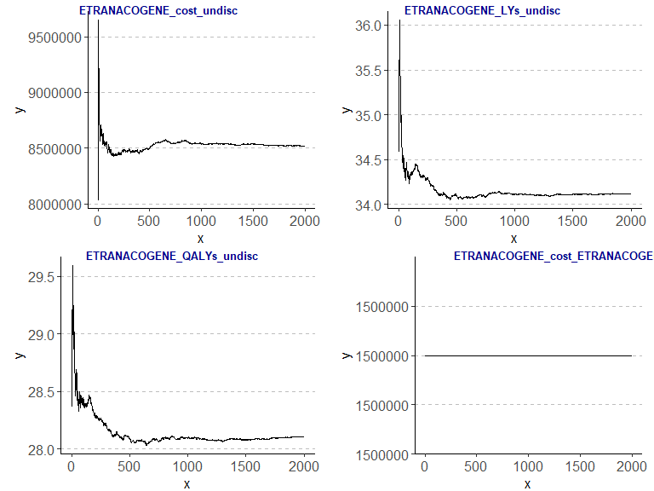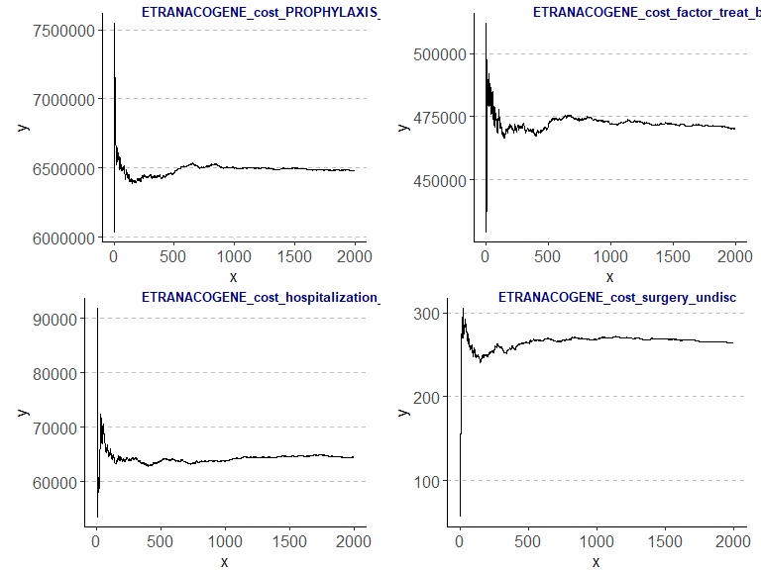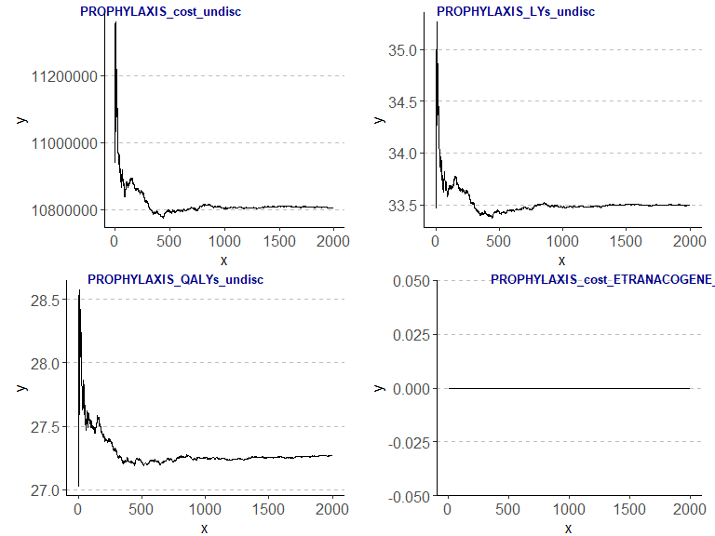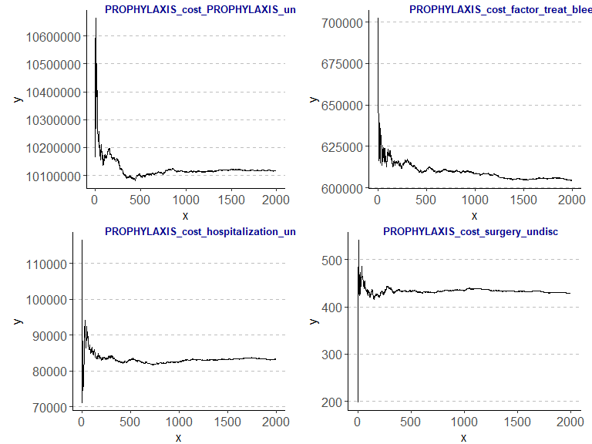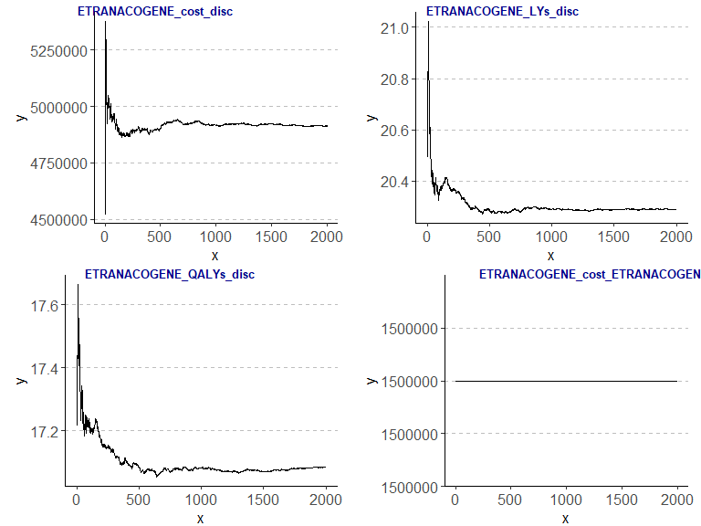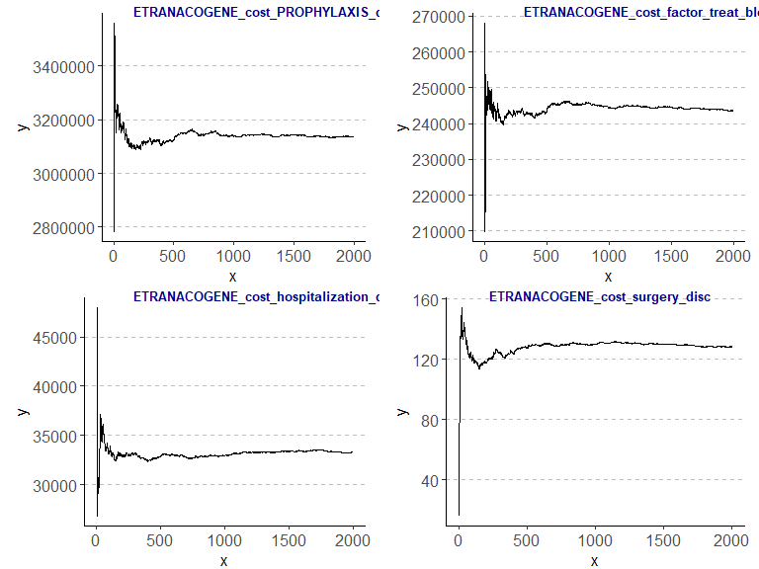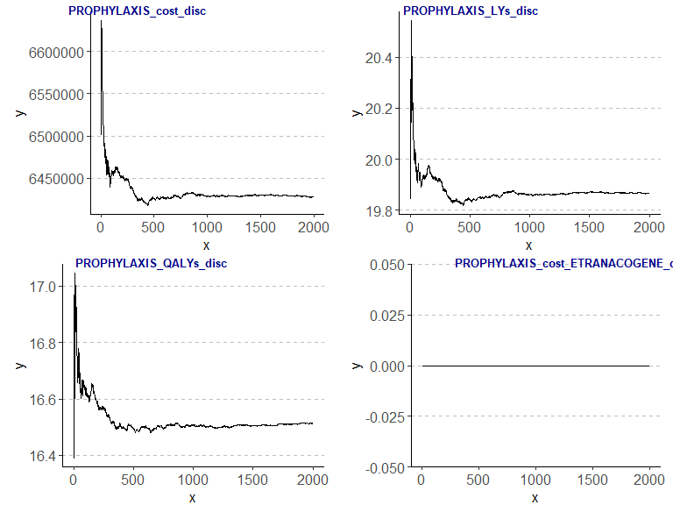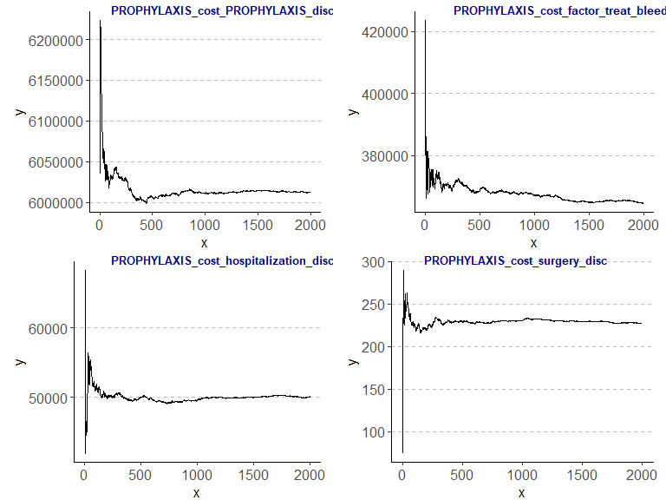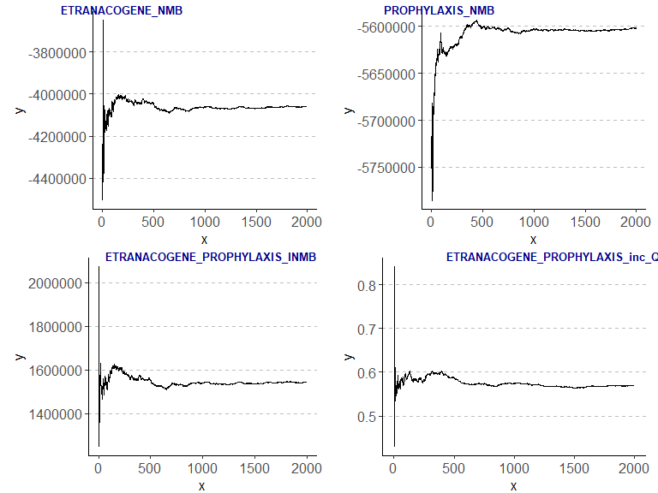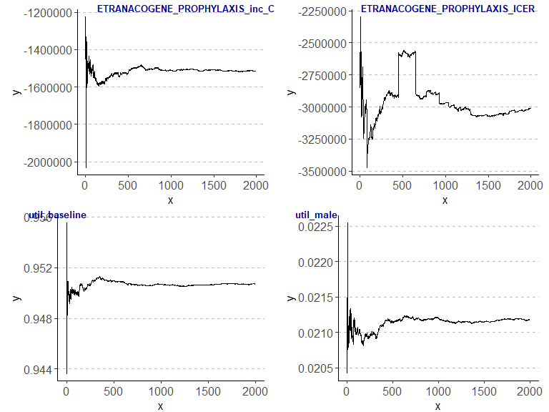

##   
##   
## | ETRA vs. PROPH inc. QALYs | ETRA vs. PROPH inc. Costs |  
## |:-------------------------:|:-------------------------:|  
## | 0 | 0 |  
## | 1 | 1 |  
## | 0 | 1 |  
## | 1 | 1 |  
## | 1 | 1 |  
## | 0 | 1 |  
## | 0 | 0 |  
## | 1 | 0 |  
## | 1 | 1 |  
## | 1 | 1 |  
## | 1 | 0 |  
## | 0 | 0 |  
## | 1 | 1 |  
## | 0 | 0 |  
## | 0 | 0 |  
## | 1 | 1 |  
## | 0 | 1 |  
## | 1 | 1 |  
## | 1 | 1 |  
## | 1 | 0 |  
## | 1 | 0 |  
## | 1 | 1 |  
## | 0 | 0 |  
## | 0 | 0 |  
## | 0 | 0 |  
## | 0 | 0 |  
## | 0 | 0 |  
## | 0 | 0 |  
## | 0 | 0 |  
## | 0 | 0 |  
## | 0 | 1 |  
## | 0 | 0 |  
## | 0 | 0 |  
## | 0 | 0 |  
## | 0 | 0 |  
## | 0 | 0 |  
## | 0 | 0 |  
## | 0 | 0 |  
## | 0 | 0 |  
## | 0 | 0 |  
## | 0 | 0 |  
## | 0 | 0 |  
## | 0 | 0 |  
## | 0 | 0 |  
## | 0 | 0 |  
## | 1 | 1 |  
## | 0 | 0 |  
## | 0 | 0 |  
## | 1 | 0 |  
## | 0 | 0 |  
## | 0 | 0 |  
## | 0 | 0 |  
## | 1 | 0 |  
## | 0 | 0 |  
## | 0 | 0 |  
## | 0 | 0 |  
## | 0 | 0 |  
## | 0 | 0 |  
## | 0 | 0 |  
## | 0 | 0 |  
## | 0 | 0 |  
## | 0 | 0 |  
## | 0 | 0 |  
## | 0 | 0 |  
## | 0 | 0 |  
## | 0 | 0 |  
## | 0 | 0 |  
## | 0 | 0 |  
## | 0 | 0 |  
## | 0 | 0 |  
## | 0 | 0 |  
## | 0 | 0 |  
## | 0 | 0 |  
## | 0 | 0 |  
## | 0 | 0 |  
## | 0 | 0 |  
## | 0 | 0 |  
## | 0 | 0 |  
## | 0 | 0 |  
## | 0 | 0 |  
## | 0 | 0 |  
## | 0 | 0 |  
## | 0 | 0 |  
## | 0 | 0 |  
## | 0 | 0 |  
## | 0 | 0 |  
## | 0 | 0 |  
## | 0 | 0 |  
## | 0 | 0 |  
## | 0 | 0 |  
## | 0 | 0 |  
## | 0 | 0 |  
## | 0 | 0 |  
## | 0 | 0 |  
## | 0 | 0 |  
## | 0 | 0 |  
## | 0 | 0 |  
## | 0 | 0 |  
## | 0 | 0 |  
## | 0 | 0 |  
## | 0 | 0 |  
## | 0 | 0 |  
## | 0 | 0 |  
## | 0 | 0 |  
## | 0 | 0 |  
## | 0 | 0 |  
## | 0 | 0 |  
## | 0 | 0 |  
## | 0 | 0 |  
## | 0 | 0 |  
## | 0 | 0 |  
## | 0 | 0 |  
## | 0 | 0 |  
## | 0 | 0 |  
## | 0 | 0 |  
## | 0 | 0 |  
## | 0 | 0 |  
## | 0 | 0 |  
## | 0 | 0 |  
## | 0 | 0 |  
## | 0 | 0 |  
## | 0 | 0 |  
## | 0 | 0 |  
## | 0 | 0 |  
## | 0 | 0 |  
## | 0 | 0 |  
## | 0 | 0 |  
## | 0 | 0 |  
## | 0 | 0 |  
## | 0 | 0 |  
## | 0 | 0 |  
## | 0 | 0 |  
## | 0 | 0 |  
## | 0 | 0 |  
## | 0 | 0 |  
## | 0 | 0 |  
## | 0 | 0 |  
## | 0 | 0 |  
## | 0 | 0 |  
## | 0 | 0 |  
## | 0 | 0 |  
## | 0 | 0 |  
## | 0 | 0 |  
## | 0 | 0 |  
## | 0 | 0 |  
## | 0 | 0 |  
## | 0 | 0 |  
## | 0 | 0 |  
## | 0 | 0 |  
## | 0 | 0 |  
## | 0 | 0 |  
## | 0 | 0 |  
## | 0 | 0 |  
## | 0 | 0 |  
## | 0 | 0 |  
## | 0 | 0 |  
## | 0 | 0 |  
## | 0 | 0 |  
## | 0 | 0 |  
## | 0 | 0 |  
## | 0 | 0 |  
## | 0 | 0 |  
## | 0 | 0 |  
## | 0 | 0 |  
## | 0 | 0 |  
## | 0 | 0 |  
## | 0 | 0 |  
## | 0 | 0 |  
## | 0 | 0 |  
## | 0 | 0 |  
## | 0 | 0 |  
## | 0 | 0 |  
## | 0 | 0 |  
## | 0 | 0 |  
## | 0 | 0 |  
## | 0 | 0 |  
## | 0 | 0 |  
## | 0 | 0 |  
## | 0 | 0 |  
## | 0 | 0 |  
## | 0 | 0 |  
## | 0 | 0 |  
## | 0 | 0 |  
## | 0 | 0 |  
## | 0 | 0 |  
## | 0 | 0 |  
## | 0 | 0 |  
## | 0 | 0 |  
## | 0 | 0 |  
## | 0 | 0 |  
## | 0 | 0 |  
## | 0 | 0 |  
## | 0 | 0 |  
## | 0 | 0 |  
## | 0 | 0 |  
## | 0 | 0 |  
## | 0 | 0 |  
## | 0 | 0 |  
## | 0 | 0 |  
## | 0 | 0 |  
## | 0 | 0 |  
## | 0 | 0 |  
## | 0 | 0 |  
## | 0 | 0 |  
## | 0 | 0 |  
## | 0 | 0 |  
## | 0 | 0 |  
## | 0 | 0 |  
## | 0 | 0 |  
## | 0 | 0 |  
## | 0 | 0 |  
## | 0 | 0 |  
## | 0 | 0 |  
## | 0 | 0 |  
## | 0 | 0 |  
## | 0 | 0 |  
## | 0 | 0 |  
## | 0 | 0 |  
## | 0 | 0 |  
## | 0 | 0 |  
## | 0 | 0 |  
## | 0 | 0 |  
## | 0 | 0 |  
## | 0 | 0 |  
## | 0 | 0 |  
## | 0 | 0 |  
## | 0 | 0 |  
## | 0 | 0 |  
## | 0 | 0 |  
## | 0 | 0 |  
## | 0 | 0 |  
## | 0 | 0 |  
## | 0 | 0 |  
## | 0 | 0 |  
## | 0 | 0 |  
## | 0 | 0 |  
## | 0 | 0 |  
## | 0 | 0 |  
## | 0 | 0 |  
## | 0 | 0 |  
## | 0 | 0 |  
## | 0 | 0 |  
## | 0 | 0 |  
## | 0 | 0 |  
## | 0 | 0 |  
## | 0 | 0 |  
## | 0 | 0 |  
## | 0 | 0 |  
## | 0 | 0 |  
## | 0 | 0 |  
## | 0 | 0 |  
## | 0 | 0 |  
## | 0 | 0 |  
## | 0 | 0 |  
## | 0 | 0 |  
## | 0 | 0 |  
## | 0 | 0 |  
## | 0 | 0 |  
## | 0 | 0 |  
## | 0 | 0 |  
## | 0 | 0 |  
## | 0 | 0 |  
## | 0 | 0 |  
## | 0 | 0 |  
## | 0 | 0 |  
## | 0 | 0 |  
## | 0 | 0 |  
## | 0 | 0 |  
## | 0 | 0 |  
## | 0 | 0 |  
## | 0 | 0 |  
## | 0 | 0 |  
## | 0 | 0 |  
## | 0 | 0 |  
## | 0 | 0 |  
## | 0 | 0 |  
## | 0 | 0 |  
## | 0 | 0 |  
## | 0 | 0 |  
## | 0 | 0 |  
## | 0 | 0 |  
## | 0 | 0 |  
## | 0 | 0 |  
## | 0 | 0 |  
## | 0 | 0 |  
## | 0 | 0 |  
## | 0 | 0 |  
## | 0 | 0 |  
## | 0 | 0 |  
## | 0 | 0 |  
## | 0 | 0 |  
## | 0 | 0 |  
## | 0 | 0 |  
## | 0 | 0 |  
## | 0 | 0 |  
## | 0 | 0 |  
## | 0 | 0 |  
## | 0 | 0 |  
## | 0 | 0 |  
## | 0 | 0 |  
## | 0 | 0 |  
## | 0 | 0 |  
## | 0 | 0 |  
## | 0 | 0 |  
## | 0 | 0 |  
## | 0 | 0 |  
## | 0 | 0 |  
## | 0 | 0 |  
## | 0 | 0 |  
## | 0 | 0 |  
## | 0 | 0 |  
## | 0 | 0 |  
## | 0 | 0 |  
## | 0 | 0 |  
## | 0 | 0 |  
## | 0 | 0 |  
## | 0 | 0 |  
## | 0 | 0 |  
## | 0 | 0 |  
## | 0 | 0 |  
## | 0 | 0 |  
## | 0 | 0 |  
## | 0 | 0 |  
## | 0 | 0 |  
## | 0 | 0 |  
## | 0 | 0 |  
## | 0 | 0 |  
## | 0 | 0 |  
## | 0 | 0 |  
## | 0 | 0 |  
## | 0 | 0 |  
## | 0 | 0 |  
## | 0 | 0 |  
## | 0 | 0 |  
## | 0 | 0 |  
## | 0 | 0 |  
## | 0 | 0 |  
## | 0 | 0 |  
## | 0 | 0 |  
## | 0 | 0 |  
## | 0 | 0 |  
## | 0 | 0 |  
## | 0 | 0 |  
## | 0 | 0 |  
## | 0 | 0 |  
## | 0 | 0 |  
## | 0 | 0 |  
## | 0 | 0 |  
## | 0 | 0 |  
## | 0 | 0 |  
## | 0 | 0 |  
## | 0 | 0 |  
## | 0 | 0 |  
## | 0 | 0 |  
## | 0 | 0 |  
## | 0 | 0 |  
## | 0 | 0 |  
## | 0 | 0 |  
## | 0 | 0 |  
## | 0 | 0 |  
## | 0 | 0 |  
## | 0 | 0 |  
## | 0 | 0 |  
## | 0 | 0 |  
## | 0 | 0 |  
## | 0 | 0 |  
## | 0 | 0 |  
## | 0 | 0 |  
## | 0 | 0 |  
## | 0 | 0 |  
## | 0 | 0 |  
## | 0 | 0 |  
## | 0 | 0 |  
## | 0 | 0 |  
## | 0 | 0 |  
## | 0 | 0 |  
## | 0 | 0 |  
## | 0 | 0 |  
## | 0 | 0 |  
## | 0 | 0 |  
## | 0 | 0 |  
## | 0 | 0 |  
## | 0 | 0 |  
## | 0 | 0 |  
## | 0 | 0 |  
## | 0 | 0 |  
## | 0 | 0 |  
## | 0 | 0 |  
## | 0 | 0 |  
## | 0 | 0 |  
## | 0 | 0 |  
## | 0 | 0 |  
## | 0 | 0 |  
## | 0 | 0 |  
## | 0 | 0 |  
## | 0 | 0 |  
## | 0 | 0 |  
## | 0 | 0 |  
## | 0 | 0 |  
## | 0 | 0 |  
##   
## Table: Diagnostics of convergence of running incremental outcomes over all patients in simulation. (continued below)  
##   
##   
##   
## | ETRA vs. PROPH inc. NMB |  
## |:-----------------------:|  
## | 0 |  
## | 1 |  
## | 1 |  
## | 1 |  
## | 1 |  
## | 1 |  
## | 0 |  
## | 0 |  
## | 1 |  
## | 1 |  
## | 0 |  
## | 0 |  
## | 1 |  
## | 0 |  
## | 0 |  
## | 1 |  
## | 1 |  
## | 1 |  
## | 1 |  
## | 0 |  
## | 0 |  
## | 1 |  
## | 0 |  
## | 0 |  
## | 0 |  
## | 0 |  
## | 0 |  
## | 0 |  
## | 0 |  
## | 0 |  
## | 1 |  
## | 0 |  
## | 0 |  
## | 0 |  
## | 0 |  
## | 0 |  
## | 0 |  
## | 0 |  
## | 0 |  
## | 0 |  
## | 0 |  
## | 0 |  
## | 0 |  
## | 0 |  
## | 0 |  
## | 1 |  
## | 0 |  
## | 0 |  
## | 0 |  
## | 0 |  
## | 0 |  
## | 0 |  
## | 0 |  
## | 0 |  
## | 0 |  
## | 0 |  
## | 0 |  
## | 0 |  
## | 0 |  
## | 0 |  
## | 0 |  
## | 0 |  
## | 0 |  
## | 0 |  
## | 0 |  
## | 0 |  
## | 0 |  
## | 0 |  
## | 0 |  
## | 0 |  
## | 0 |  
## | 0 |  
## | 0 |  
## | 0 |  
## | 0 |  
## | 0 |  
## | 0 |  
## | 0 |  
## | 0 |  
## | 0 |  
## | 0 |  
## | 0 |  
## | 0 |  
## | 0 |  
## | 0 |  
## | 0 |  
## | 0 |  
## | 0 |  
## | 0 |  
## | 0 |  
## | 0 |  
## | 0 |  
## | 0 |  
## | 0 |  
## | 0 |  
## | 0 |  
## | 0 |  
## | 0 |  
## | 0 |  
## | 0 |  
## | 0 |  
## | 0 |  
## | 0 |  
## | 0 |  
## | 0 |  
## | 0 |  
## | 0 |  
## | 0 |  
## | 0 |  
## | 0 |  
## | 0 |  
## | 0 |  
## | 0 |  
## | 0 |  
## | 0 |  
## | 0 |  
## | 0 |  
## | 0 |  
## | 0 |  
## | 0 |  
## | 0 |  
## | 0 |  
## | 0 |  
## | 0 |  
## | 0 |  
## | 0 |  
## | 0 |  
## | 0 |  
## | 0 |  
## | 0 |  
## | 0 |  
## | 0 |  
## | 0 |  
## | 0 |  
## | 0 |  
## | 0 |  
## | 0 |  
## | 0 |  
## | 0 |  
## | 0 |  
## | 0 |  
## | 0 |  
## | 0 |  
## | 0 |  
## | 0 |  
## | 0 |  
## | 0 |  
## | 0 |  
## | 0 |  
## | 0 |  
## | 0 |  
## | 0 |  
## | 0 |  
## | 0 |  
## | 0 |  
## | 0 |  
## | 0 |  
## | 0 |  
## | 0 |  
## | 0 |  
## | 0 |  
## | 0 |  
## | 0 |  
## | 0 |  
## | 0 |  
## | 0 |  
## | 0 |  
## | 0 |  
## | 0 |  
## | 0 |  
## | 0 |  
## | 0 |  
## | 0 |  
## | 0 |  
## | 0 |  
## | 0 |  
## | 0 |  
## | 0 |  
## | 0 |  
## | 0 |  
## | 0 |  
## | 0 |  
## | 0 |  
## | 0 |  
## | 0 |  
## | 0 |  
## | 0 |  
## | 0 |  
## | 0 |  
## | 0 |  
## | 0 |  
## | 0 |  
## | 0 |  
## | 0 |  
## | 0 |  
## | 0 |  
## | 0 |  
## | 0 |  
## | 0 |  
## | 0 |  
## | 0 |  
## | 0 |  
## | 0 |  
## | 0 |  
## | 0 |  
## | 0 |  
## | 0 |  
## | 0 |  
## | 0 |  
## | 0 |  
## | 0 |  
## | 0 |  
## | 0 |  
## | 0 |  
## | 0 |  
## | 0 |  
## | 0 |  
## | 0 |  
## | 0 |  
## | 0 |  
## | 0 |  
## | 0 |  
## | 0 |  
## | 0 |  
## | 0 |  
## | 0 |  
## | 0 |  
## | 0 |  
## | 0 |  
## | 0 |  
## | 0 |  
## | 0 |  
## | 0 |  
## | 0 |  
## | 0 |  
## | 0 |  
## | 0 |  
## | 0 |  
## | 0 |  
## | 0 |  
## | 0 |  
## | 0 |  
## | 0 |  
## | 0 |  
## | 0 |  
## | 0 |  
## | 0 |  
## | 0 |  
## | 0 |  
## | 0 |  
## | 0 |  
## | 0 |  
## | 0 |  
## | 0 |  
## | 0 |  
## | 0 |  
## | 0 |  
## | 0 |  
## | 0 |  
## | 0 |  
## | 0 |  
## | 0 |  
## | 0 |  
## | 0 |  
## | 0 |  
## | 0 |  
## | 0 |  
## | 0 |  
## | 0 |  
## | 0 |  
## | 0 |  
## | 0 |  
## | 0 |  
## | 0 |  
## | 0 |  
## | 0 |  
## | 0 |  
## | 0 |  
## | 0 |  
## | 0 |  
## | 0 |  
## | 0 |  
## | 0 |  
## | 0 |  
## | 0 |  
## | 0 |  
## | 0 |  
## | 0 |  
## | 0 |  
## | 0 |  
## | 0 |  
## | 0 |  
## | 0 |  
## | 0 |  
## | 0 |  
## | 0 |  
## | 0 |  
## | 0 |  
## | 0 |  
## | 0 |  
## | 0 |  
## | 0 |  
## | 0 |  
## | 0 |  
## | 0 |  
## | 0 |  
## | 0 |  
## | 0 |  
## | 0 |  
## | 0 |  
## | 0 |  
## | 0 |  
## | 0 |  
## | 0 |  
## | 0 |  
## | 0 |  
## | 0 |  
## | 0 |  
## | 0 |  
## | 0 |  
## | 0 |  
## | 0 |  
## | 0 |  
## | 0 |  
## | 0 |  
## | 0 |  
## | 0 |  
## | 0 |  
## | 0 |  
## | 0 |  
## | 0 |  
## | 0 |  
## | 0 |  
## | 0 |  
## | 0 |  
## | 0 |  
## | 0 |  
## | 0 |  
## | 0 |  
## | 0 |  
## | 0 |  
## | 0 |  
## | 0 |  
## | 0 |  
## | 0 |  
## | 0 |  
## | 0 |  
## | 0 |  
## | 0 |  
## | 0 |  
## | 0 |  
## | 0 |  
## | 0 |  
## | 0 |  
## | 0 |  
## | 0 |  
## | 0 |  
## | 0 |  
## | 0 |  
## | 0 |  
## | 0 |  
## | 0 |  
## | 0 |  
## | 0 |  
## | 0 |  
## | 0 |  
## | 0 |  
## | 0 |  
## | 0 |  
## | 0 |  
## | 0 |  
## | 0 |  
## | 0 |  
## | 0 |  
## | 0 |  
## | 0 |  
## | 0 |  
## | 0 |  
## | 0 |  
## | 0 |  
## | 0 |  
## | 0 |  
## | 0 |  
## | 0 |  
## | 0 |  
## | 0 |  
## | 0 |  
## | 0 |  
## | 0 |  
## | 0 |  
## | 0 |  
## | 0 |  
## | 0 |  
## | 0 |  
## | 0 |  
## | 0 |  
## | 0 |  
## | 0 |  
## | 0 |  
## | 0 |

## [1] "We used intervals of 1000 patients, and checked whether the running mean of the incremental outcomes change by more than 1%."

## [1] "A 0 means that we have reached a stable value, i.e. we have achieved convergence and have a sufficient sample size, using this interval and this percentage change as a measure of sufficient stability."

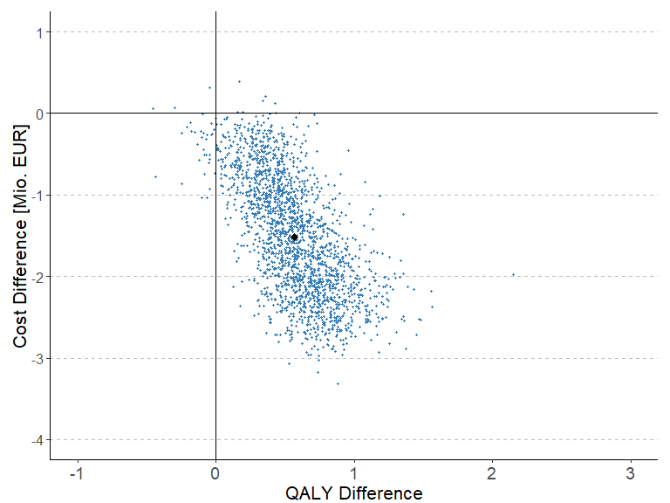

# System information

Sys.info()

sysname release version nodename machine login user   
 "Windows" "10 x64" "build 19044" "M04486" "x86-64" "min1" "min1"

effective_user “min1”

sessionInfo(package = NULL)

R version 4.3.1 (2023-06-16 ucrt) Platform: x86_64-w64-mingw32/x64 (64-bit) Running under: Windows 10 x64 (build 19044)

Matrix products: default

locale: [1] LC_COLLATE=German_Switzerland.utf8 LC_CTYPE=German_Switzerland.utf8 LC_MONETARY=German_Switzerland.utf8 [4] LC_NUMERIC=C LC_TIME=German_Switzerland.utf8

time zone: Europe/Zurich tzcode source: internal

attached base packages: [1] stats graphics grDevices utils datasets methods base

other attached packages: [1] rmarkdown_2.23 captioner_2.2.3 ggrepel_0.9.3 plyr_1.8.8 ggpubr_0.6.0  
[6] truncnorm_1.0-9 lookup_1.0 data.table_1.14.8 pander_0.6.5 RColorBrewer_1.1-3 [11] ggplot2_3.4.2

loaded via a namespace (and not attached): [1] utf8_1.2.3 generics_0.1.3 tidyr_1.3.0 rstatix_0.7.2 digest_0.6.33 magrittr_2.0.3  
[7] evaluate_0.21 grid_4.3.1 fastmap_1.1.1 backports_1.4.1 purrr_1.0.1 fansi_1.0.4  
[13] scales_1.2.1 abind_1.4-5 cli_3.6.1 rlang_1.1.1 crayon_1.5.2 cowplot_1.1.1  
[19] munsell_0.5.0 withr_2.5.0 yaml_2.3.7 tools_4.3.1 ggsignif_0.6.4 dplyr_1.1.2  
[25] colorspace_2.1-0 broom_1.0.5 vctrs_0.6.3 R6_2.5.1 lifecycle_1.0.3 car_3.1-2  
[31] pkgconfig_2.0.3 pillar_1.9.0 gtable_0.3.3 glue_1.6.2 Rcpp_1.0.11 highr_0.10  
[37] xfun_0.39 tibble_3.2.1 tidyselect_1.2.0 rstudioapi_0.15.0 knitr_1.43 farver_2.1.1  
[43] htmltools_0.5.5 carData_3.0-5 labeling_0.4.2 compiler_4.3.1