Analysis of HB CE model scenarios

Niklaus Meier

August 02, 2023

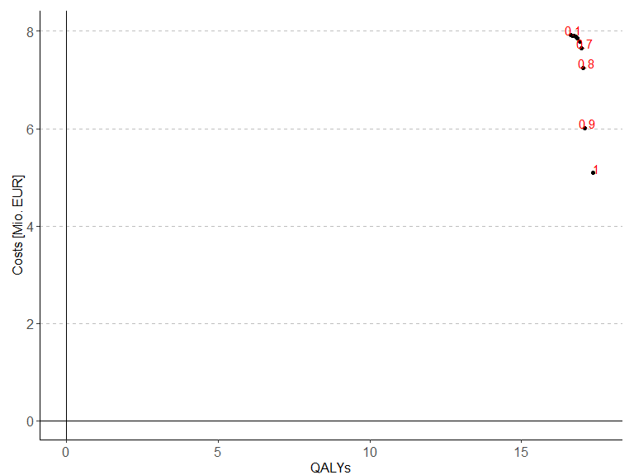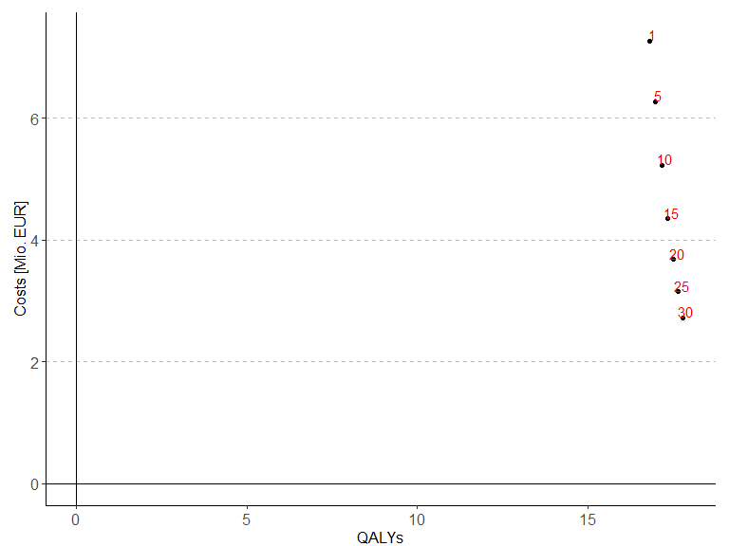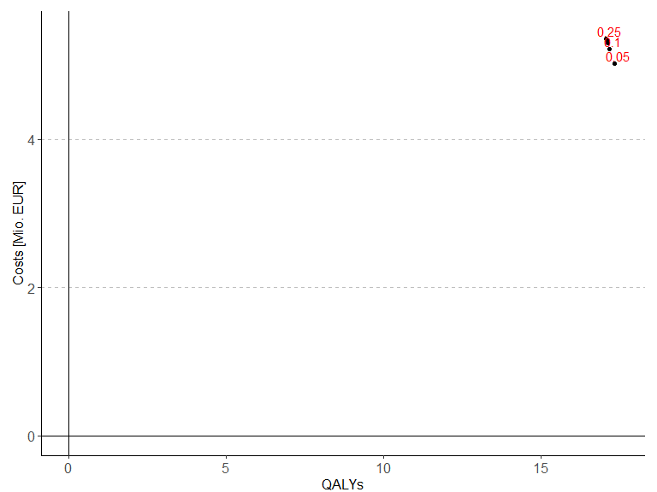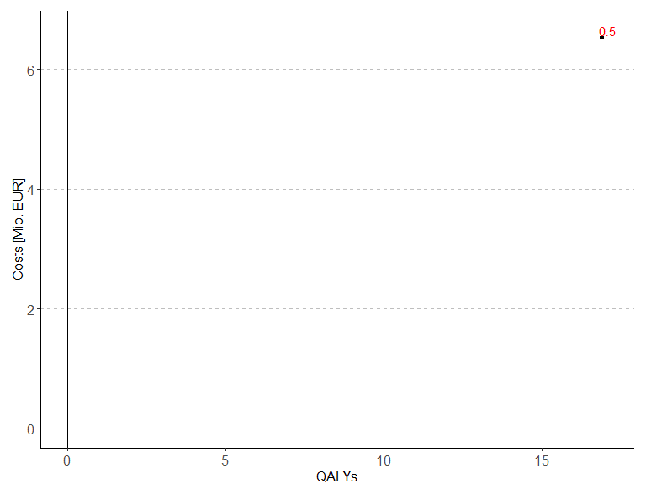

## Warning: Removed 8 rows containing missing values (`geom_point()`).

## Warning: Removed 8 rows containing missing values (`geom_text_repel()`).

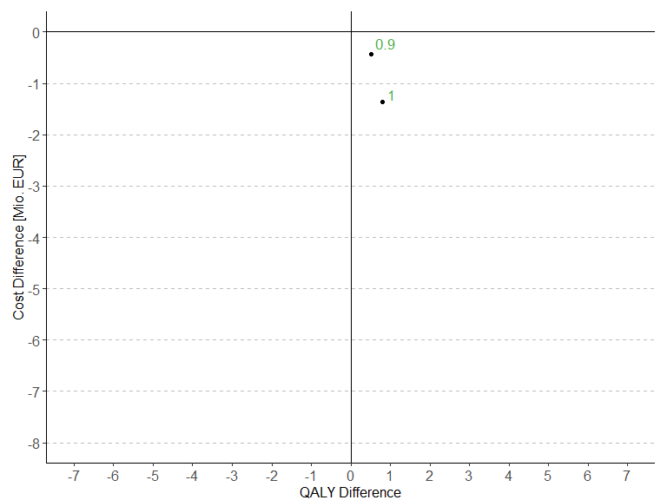

## Warning: Removed 1 rows containing missing values (`geom_point()`).

## Warning: Removed 1 rows containing missing values (`geom_text_repel()`).

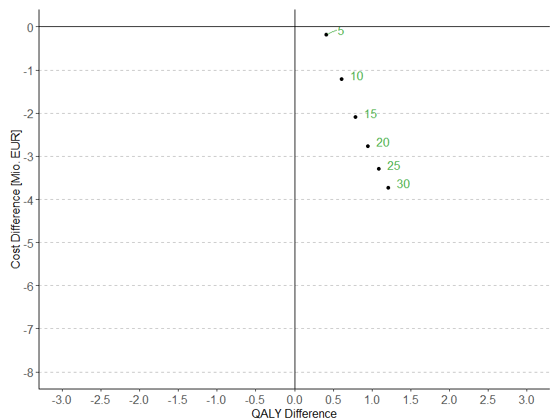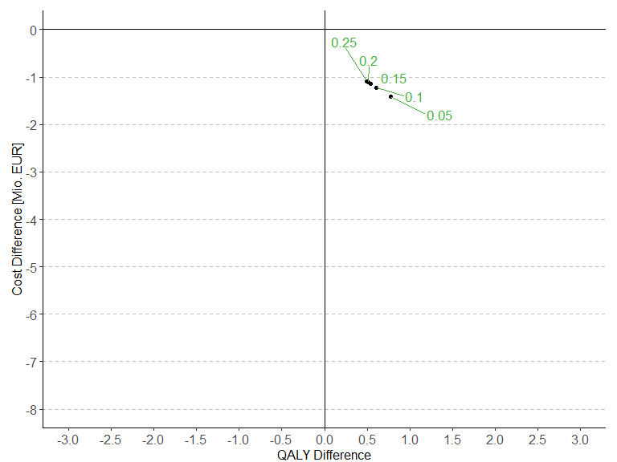

## Warning: Removed 1 rows containing missing values (`geom_point()`).  
## Removed 1 rows containing missing values (`geom_text_repel()`).

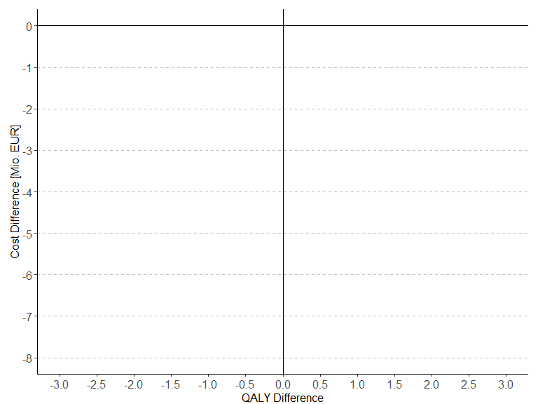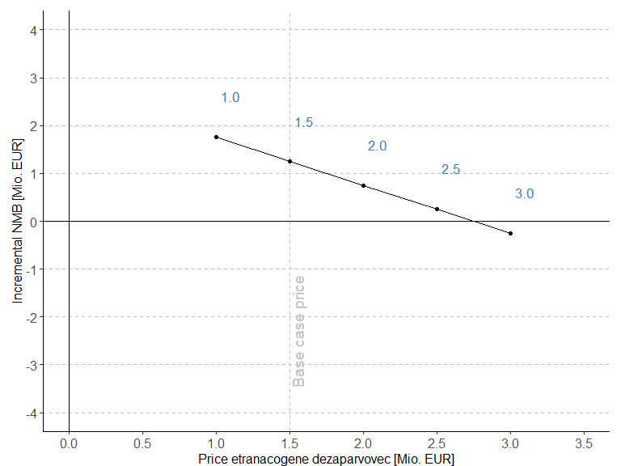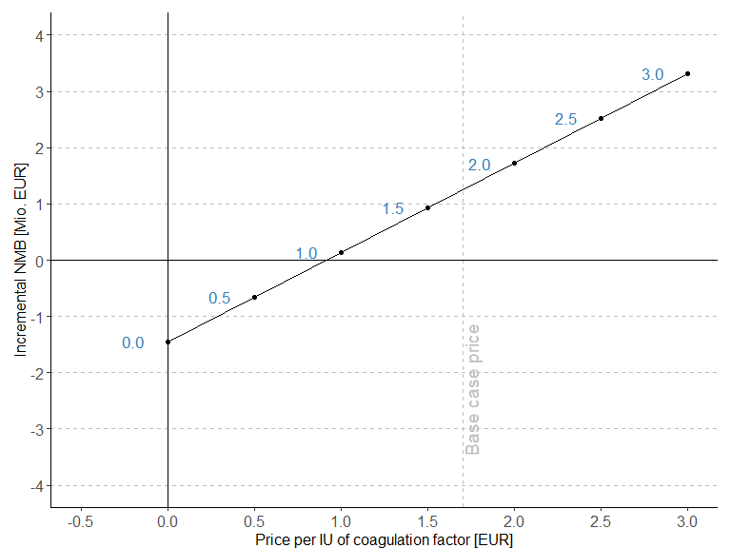

##   
##   
## | Treatment | Baseline QALYs | Baseline total costs | Baseline INMB |  
## |:------------:|:--------------:|:--------------------:|:-------------:|  
## | ETRANACOGENE | 17.17 | 5230829 | 0 |  
## | Prophylaxis | 16.57 | 6444970 | 1244236 |  
##   
## Table: Comparison 1 day vs 7 day bleed disutility (continued below)  
##   
##   
##   
## | Scenario QALYs | Scenario total costs | Scenario INMB |  
## |:--------------:|:--------------------:|:-------------:|  
## | 17 | 5231738 | 0 |  
## | 16.3 | 6444970 | 1248125 |

##   
##   
## | Treatment | Baseline QALYs | Baseline total costs |  
## |:------------:|:--------------:|:--------------------:|  
## | ETRANACOGENE | 17.17 | 5230829 |  
## | Prophylaxis | 16.57 | 6444970 |  
##   
## Table: Comparison base case vs 5x costs per day ICU (continued below)  
##   
##   
##   
## | Baseline costs hosp per bleed | Baseline INMB | Scenario QALYs |  
## |:-----------------------------:|:-------------:|:--------------:|  
## | 31850 | 0 | 17.17 |  
## | 49931 | 1244236 | 16.57 |  
##   
## Table: Table continues below  
##   
##   
##   
## | Scenario total costs | Scenario costs hosp per bleed | Scenario INMB |  
## |:--------------------:|:-----------------------------:|:-------------:|  
## | 5338674 | 129577 | 0 |  
## | 6597443 | 202404 | 1288789 |

##   
##   
## | Treatment | Baseline QALYs | Baseline total costs |  
## |:------------:|:--------------:|:--------------------:|  
## | ETRANACOGENE | 17.17 | 5230829 |  
## | Prophylaxis | 16.57 | 6444970 |  
##   
## Table: Comparison base case no treatment switching for Etranacogene Dezaparvovec (continued below)  
##   
##   
##   
## | Baseline costs FIX prophylaxis | Baseline INMB | Scenario QALYs |  
## |:------------------------------:|:-------------:|:--------------:|  
## | 3464972 | 0 | 14.46 |  
## | 6029393 | 1244236 | 16.57 |  
##   
## Table: Table continues below  
##   
##   
##   
## | Scenario total costs | Scenario costs FIX prophylaxis | Scenario INMB |  
## |:--------------------:|:------------------------------:|:-------------:|  
## | 2631249 | 223688 | 0 |  
## | 6444970 | 6029393 | 3708556 |

##   
##   
## | Treatment | Baseline QALYs | Baseline total costs |  
## |:------------:|:--------------:|:--------------------:|  
## | ETRANACOGENE | 17.17 | 5230829 |  
## | Prophylaxis | 16.57 | 6444970 |  
##   
## Table: Comparison base case no vial sharing (continued below)  
##   
##   
##   
## | Baseline costs FIX prophylaxis | Baseline INMB | Scenario QALYs |  
## |:------------------------------:|:-------------:|:--------------:|  
## | 3464972 | 0 | 17.17 |  
## | 6029393 | 1244236 | 16.57 |  
##   
## Table: Table continues below  
##   
##   
##   
## | Scenario total costs | Scenario costs FIX prophylaxis | Scenario INMB |  
## |:--------------------:|:------------------------------:|:-------------:|  
## | 5495005 | 3702124 | 0 |  
## | 6902192 | 6444797 | 1437308 |

##   
##   
## | Treatment | Baseline QALYs | Baseline total costs | Baseline INMB |  
## |:------------:|:--------------:|:--------------------:|:-------------:|  
## | ETRANACOGENE | 17.17 | 5230829 | 0 |  
## | Prophylaxis | 16.57 | 6444970 | 1244236 |  
##   
## Table: Comparison base case no vial sharing (continued below)  
##   
##   
##   
## | Scenario QALYs | Scenario total costs | Scenario INMB |  
## |:--------------:|:--------------------:|:-------------:|  
## | 23.53 | 7057050 | 0 |  
## | 23.2 | 8283696 | 1242885 |  
##   
## Table: Table continues below  
##   
##   
##   
## | Baseline costs FIX prophylaxis | Scenario costs FIX prophylaxis |  
## |:------------------------------:|:------------------------------:|  
## | 3464972 | 5174725 |  
## | 6029393 | 7743125 |

##   
##   
## | Treatment | Baseline QALYs | Baseline total costs | Baseline INMB |  
## |:------------:|:--------------:|:--------------------:|:-------------:|  
## | ETRANACOGENE | 17.17 | 5230829 | 0 |  
## | Prophylaxis | 16.57 | 6444970 | 1244236 |  
##   
## Table: Comparison base case no vial sharing (continued below)  
##   
##   
##   
## | Scenario QALYs | Scenario total costs | Scenario INMB |  
## |:--------------:|:--------------------:|:-------------:|  
## | 10.2 | 3069173 | 0 |  
## | 9.138 | 3881889 | 865960 |  
##   
## Table: Table continues below  
##   
##   
##   
## | Baseline costs FIX prophylaxis | Scenario costs FIX prophylaxis |  
## |:------------------------------:|:------------------------------:|  
## | 3464972 | 1437999 |  
## | 6029393 | 3637681 |

##   
##   
## | Treatment | Baseline QALYs | Baseline total costs | Baseline INMB |  
## |:------------:|:--------------:|:--------------------:|:-------------:|  
## | ETRANACOGENE | 17.17 | 5230829 | 0 |  
## | Prophylaxis | 16.57 | 6444970 | 1244236 |  
##   
## Table: Comparison base case vs. German utilities (continued below)  
##   
##   
##   
## | Scenario QALYs | Scenario total costs | Scenario INMB |  
## |:--------------:|:--------------------:|:-------------:|  
## | 17.76 | 5199922 | 0 |  
## | 17.12 | 6444970 | 1276944 |

##   
##   
## | Scenario | Incremental QALYs |  
## |:-----------------------------------:|:-----------------:|  
## | Base case | 0.6019 |  
## | Scenario 1: 7 day bleed disutility | 0.6979 |  
## | Scenario 2: 5x costs per day in ICU | 0.6004 |  
## | Scenario 3: No treatment switching | -2.103 |  
## | Scenario 4: No vial sharing | 0.6024 |  
## | Scenario 5: Cost-minimization | 0.6019 |  
## | Scenario 6: Age 18 | 0.3248 |  
## | Scenario 7: Age 60 | 1.065 |  
## | Scenario 8: German utilities | 0.6379 |  
##   
## Table: Comparison base case no vial sharing (continued below)  
##   
##   
##   
## | Incremental Costs [EUR] | INMB [EUR] |  
## |:-----------------------:|:----------:|  
## | -1214141 | 1244236 |  
## | -1213232 | 1248125 |  
## | -1258769 | 1288789 |  
## | -3813721 | 3708556 |  
## | -1407187 | 1437308 |  
## | -1214141 | 1214141 |  
## | -1226645 | 1242885 |  
## | -812716 | 865960 |  
## | -1245048 | 1276944 |

# System information

Sys.info()

sysname release version nodename machine login user effective_user   
 "Windows" "10 x64" "build 19045" "M04486" "x86-64" "min1" "min1" "min1"

sessionInfo(package = NULL)

R version 4.3.1 (2023-06-16 ucrt) Platform: x86_64-w64-mingw32/x64 (64-bit) Running under: Windows 10 x64 (build 19045)

Matrix products: default

locale: [1] LC_COLLATE=German_Switzerland.utf8 LC_CTYPE=German_Switzerland.utf8 LC_MONETARY=German_Switzerland.utf8 LC_NUMERIC=C LC_TIME=German_Switzerland.utf8

time zone: Europe/Zurich tzcode source: internal

attached base packages: [1] stats graphics grDevices utils datasets methods base

other attached packages: [1] rmarkdown_2.23 captioner_2.2.3 ggrepel_0.9.3 plyr_1.8.8 ggpubr_0.6.0 truncnorm_1.0-9 lookup_1.0 data.table_1.14.8 pander_0.6.5 RColorBrewer_1.1-3 [11] ggplot2_3.4.2

loaded via a namespace (and not attached): [1] utf8_1.2.3 generics_0.1.3 tidyr_1.3.0 rstatix_0.7.2 digest_0.6.33 magrittr_2.0.3 evaluate_0.21 grid_4.3.1 fastmap_1.1.1 backports_1.4.1  
[11] purrr_1.0.1 fansi_1.0.4 scales_1.2.1 abind_1.4-5 cli_3.6.1 rlang_1.1.1 munsell_0.5.0 withr_2.5.0 yaml_2.3.7 tools_4.3.1  
[21] ggsignif_0.6.4 dplyr_1.1.2 colorspace_2.1-0 broom_1.0.5 vctrs_0.6.3 R6_2.5.1 lifecycle_1.0.3 car_3.1-2 pkgconfig_2.0.3 pillar_1.9.0  
[31] gtable_0.3.3 glue_1.6.2 Rcpp_1.0.11 xfun_0.39 tibble_3.2.1 tidyselect_1.2.0 highr_0.10 rstudioapi_0.15.0 knitr_1.43 farver_2.1.1  
[41] htmltools_0.5.5 carData_3.0-5 labeling_0.4.2 compiler_4.3.1