Analysis of HB CE model scenarios

Niklaus Meier

November 14, 2023

## [1] "Outcomes depending on ED relative bleed reduction parameter"

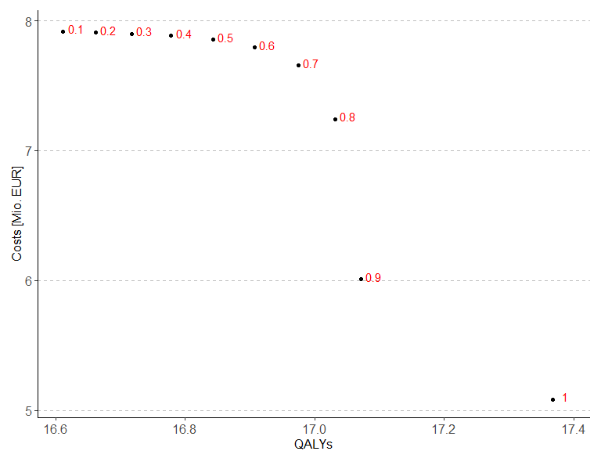

## [1] "Outcomes depending on ED maximum bleed reduction period parameter"

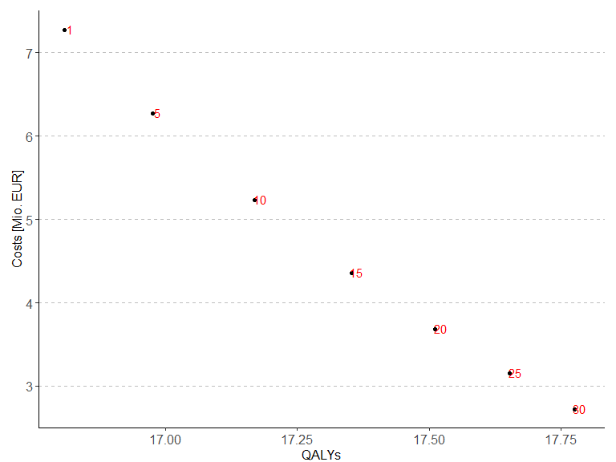

## [1] "Outcomes depending on ED bleed rate increase per year parameter"

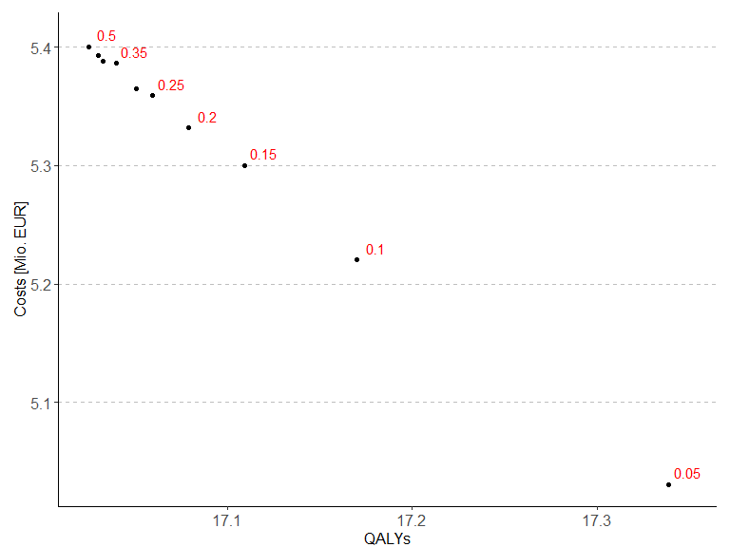

## [1] "Outcomes depending on ED success probability parameter"

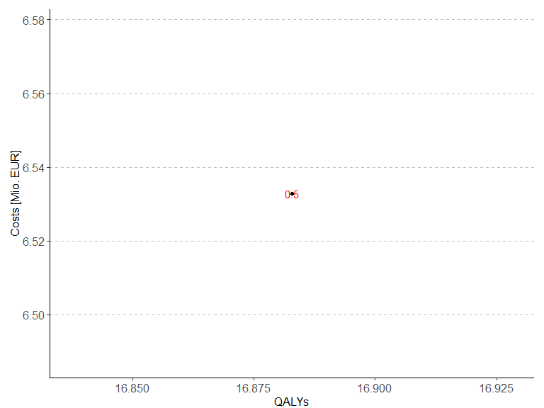

## [1] "Incremental Outcomes depending on ED relative bleed reduction parameter"

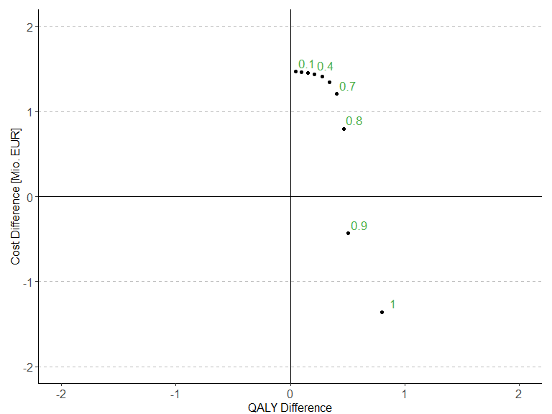

## [1] "Incremental Outcomes depending on ED maximum bleed reduction period parameter"

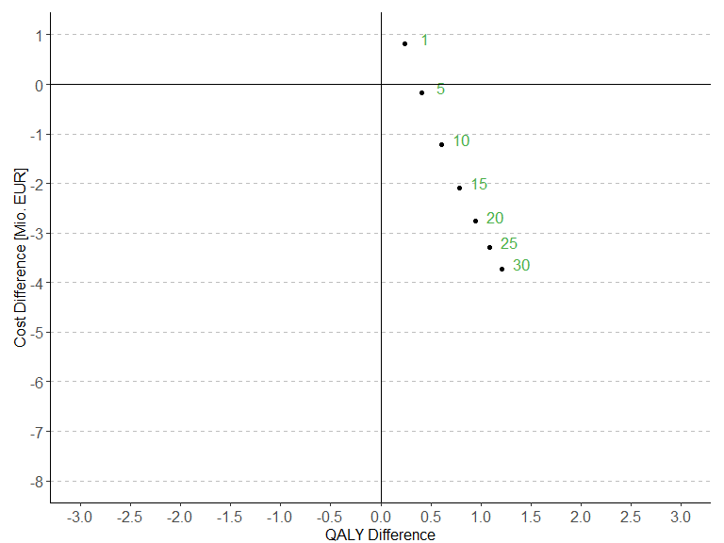

## [1] "Incremental Outcomes depending on ED bleed rate increase per year parameter"

## Warning: Removed 1 rows containing missing values (`geom_text()`).

## Warning: Removed 1 rows containing missing values (`geom_hline()`).

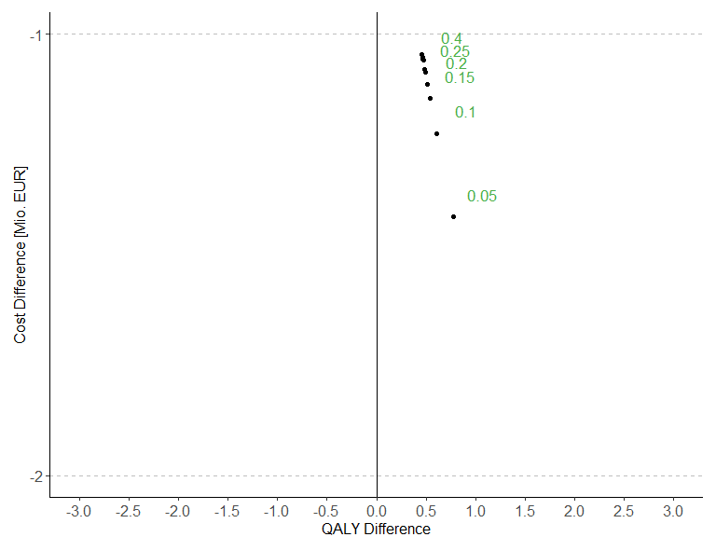

## [1] "Incremental Outcomes depending on ED success probability parameter"

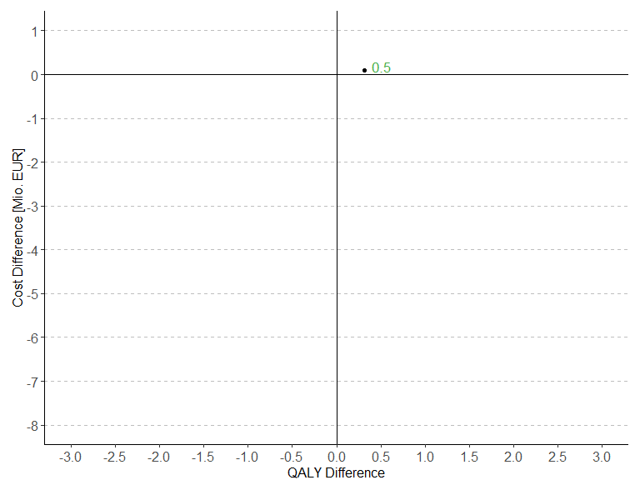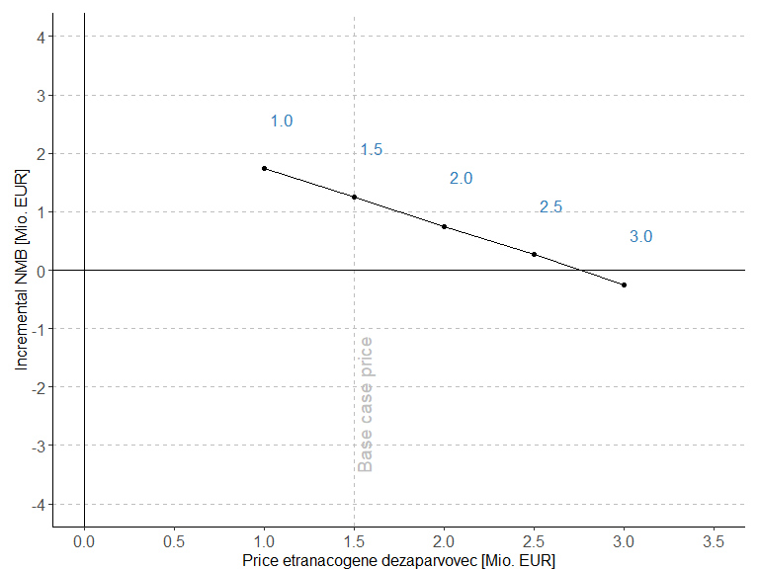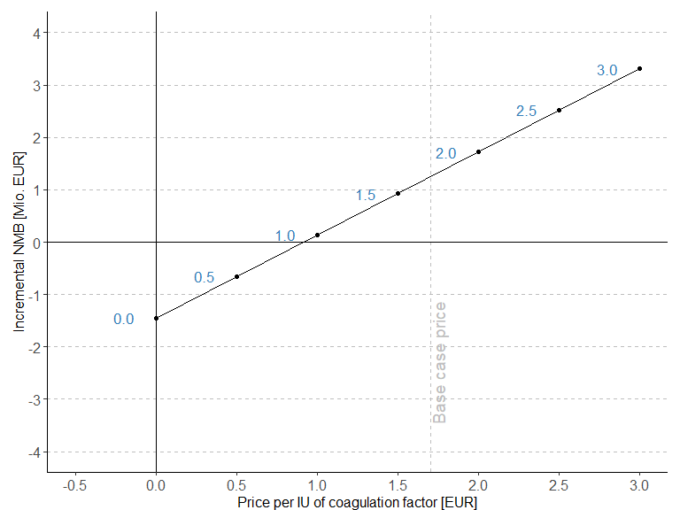

Comparison 1 day vs 7 day bleed disutility

| Treatment | Baseline QALYs | Baseline total costs | Baseline INMB | Scenario QALYs | Scenario total costs | Scenario INMB |
| --- | --- | --- | --- | --- | --- | --- |
| ETRANACOGENE | 17.17 | 5220575 | 0 | 17.0 | 5224648 | 0 |
| Prophylaxis | 16.57 | 6444970 | 1254554 | 16.3 | 6444970 | 1255201 |

Comparison base case vs 5x costs per day ICU

| Treatment | Baseline QALYs | Baseline total costs | Baseline costs hosp per bleed | Baseline INMB | Scenario QALYs | Scenario total costs | Scenario costs hosp per bleed | Scenario INMB |
| --- | --- | --- | --- | --- | --- | --- | --- | --- |
| ETRANACOGENE | 17.17 | 5220575 | 31796.11 | 0 | 17.17 | 5312955 | 129121.3 | 0 |
| Prophylaxis | 16.57 | 6444970 | 49931.47 | 1254554 | 16.57 | 6597443 | 202404.0 | 1314729 |

Comparison base case no treatment switching for Etranacogene Dezaparvovec

| Treatment | Baseline QALYs | Baseline total costs | Baseline costs FIX prophylaxis | Baseline INMB | Scenario QALYs | Scenario total costs | Scenario costs FIX prophylaxis | Scenario INMB |
| --- | --- | --- | --- | --- | --- | --- | --- | --- |
| ETRANACOGENE | 17.17 | 5220575 | 3455152 | 0 | 14.46 | 2624003 | 216478 | 0 |
| Prophylaxis | 16.57 | 6444970 | 6029393 | 1254554 | 16.57 | 6444970 | 6029393 | 3715685 |

Comparison base case no vial sharing

| Treatment | Baseline QALYs | Baseline total costs | Baseline costs FIX prophylaxis | Baseline INMB | Scenario QALYs | Scenario total costs | Scenario costs FIX prophylaxis | Scenario INMB |
| --- | --- | --- | --- | --- | --- | --- | --- | --- |
| ETRANACOGENE | 17.17 | 5220575 | 3455152 | 0 | 17.17 | 5493291 | 3700401 | 0 |
| Prophylaxis | 16.57 | 6444970 | 6029393 | 1254554 | 16.57 | 6902192 | 6444797 | 1438997 |

Comparison base case no vial sharing

| Treatment | Baseline QALYs | Baseline total costs | Baseline INMB | Scenario QALYs | Scenario total costs | Scenario INMB | Baseline costs FIX prophylaxis | Scenario costs FIX prophylaxis |
| --- | --- | --- | --- | --- | --- | --- | --- | --- |
| ETRANACOGENE | 17.17 | 5220575 | 0 | 23.53 | 7069510 | 0 | 3455152 | 5186701 |
| Prophylaxis | 16.57 | 6444970 | 1254554 | 23.20 | 8283696 | 1230380 | 6029393 | 7743125 |

Comparison base case no vial sharing

| Treatment | Baseline QALYs | Baseline total costs | Baseline INMB | Scenario QALYs | Scenario total costs | Scenario INMB | Baseline costs FIX prophylaxis | Scenario costs FIX prophylaxis |
| --- | --- | --- | --- | --- | --- | --- | --- | --- |
| ETRANACOGENE | 17.17 | 5220575 | 0 | 10.20 | 3083022 | 0.0 | 3455152 | 1451060 |
| Prophylaxis | 16.57 | 6444970 | 1254554 | 9.14 | 3881889 | 851759.9 | 6029393 | 3637681 |

Comparison base case vs. German utilities

| Treatment | Baseline QALYs | Baseline total costs | Baseline INMB | Scenario QALYs | Scenario total costs | Scenario INMB |
| --- | --- | --- | --- | --- | --- | --- |
| ETRANACOGENE | 17.17 | 5220575 | 0 | 17.75 | 5224628 | 0 |
| Prophylaxis | 16.57 | 6444970 | 1254554 | 17.12 | 6444970 | 1251900 |

Comparison Table all scenarios

| Scenario | Incremental QALYs | Incremental Costs [EUR] | INMB [EUR] |
| --- | --- | --- | --- |
| Base case | 0.60 | -1224395.0 | 1254553.5 |
| Scenario 1: 7 day bleed disutility | 0.70 | -1220322.6 | 1255200.8 |
| Scenario 2: 5x costs per day in ICU | 0.60 | -1284488.1 | 1314728.6 |
| Scenario 3: No treatment switching | -2.11 | -3820967.3 | 3715684.5 |
| Scenario 4: No vial sharing | 0.60 | -1408901.3 | 1438996.7 |
| Scenario 5: Cost-minimization | 0.60 | -1224395.0 | 1224395.0 |
| Scenario 6: Age 18 | 0.32 | -1214186.1 | 1230379.6 |
| Scenario 7: Age 60 | 1.06 | -798866.8 | 851759.9 |
| Scenario 8: German utilities | 0.63 | -1220342.5 | 1251899.7 |
| Scenario 9: Duration of maximum bleed reduction 20 years | 0.94 | -2763515.2 | 2810683.7 |
| Scenario 10: Duration of maximum bleed reduction 30 years | 1.21 | -3721009.5 | 3781355.7 |
| Scenario 11: Bleed rate increase 20% per year | 0.49 | -1085733.5 | 1110341.2 |
| Scenario 12: Bleed rate increase 30% per year | 0.47 | -1058803.8 | 1082413.8 |

# System information

Sys.info()

sysname release version nodename machine login user effective_user   
 "Windows" "10 x64" "build 19045" "M04486" "x86-64" "min1" "min1" "min1"

sessionInfo(package = NULL)

R version 4.3.1 (2023-06-16 ucrt) Platform: x86_64-w64-mingw32/x64 (64-bit) Running under: Windows 10 x64 (build 19045)

Matrix products: default

locale: [1] LC_COLLATE=German_Switzerland.utf8 LC_CTYPE=German_Switzerland.utf8 LC_MONETARY=German_Switzerland.utf8 LC_NUMERIC=C LC_TIME=German_Switzerland.utf8

time zone: Europe/Zurich tzcode source: internal

attached base packages: [1] stats graphics grDevices utils datasets methods base

other attached packages: [1] kableExtra_1.3.4 rmarkdown_2.23 ggrepel_0.9.3 plyr_1.8.8 ggpubr_0.6.0 truncnorm_1.0-9 lookup_1.0 data.table_1.14.8 pander_0.6.5 RColorBrewer_1.1-3 [11] ggplot2_3.4.2

loaded via a namespace (and not attached): [1] utf8_1.2.3 generics_0.1.3 tidyr_1.3.0 rstatix_0.7.2 xml2_1.3.5 stringi_1.7.12 digest_0.6.33 magrittr_2.0.3 evaluate_0.21 grid_4.3.1 fastmap_1.1.1  
[12] backports_1.4.1 httr_1.4.6 rvest_1.0.3 purrr_1.0.1 fansi_1.0.4 viridisLite_0.4.2 scales_1.2.1 abind_1.4-5 cli_3.6.1 rlang_1.1.1 munsell_0.5.0  
[23] withr_2.5.0 yaml_2.3.7 tools_4.3.1 ggsignif_0.6.4 dplyr_1.1.2 colorspace_2.1-0 webshot_0.5.5 broom_1.0.5 vctrs_0.6.3 R6_2.5.1 lifecycle_1.0.3  
[34] stringr_1.5.0 car_3.1-2 pkgconfig_2.0.3 pillar_1.9.0 gtable_0.3.3 glue_1.6.2 Rcpp_1.0.11 systemfonts_1.0.4 highr_0.10 xfun_0.39 tibble_3.2.1  
[45] tidyselect_1.2.0 rstudioapi_0.15.0 knitr_1.43 farver_2.1.1 htmltools_0.5.5 labeling_0.4.2 svglite_2.1.2 carData_3.0-5 compiler_4.3.1