Analysis of HB CE univariate sensitivity analysis

Niklaus Meier

Juli 29, 2023

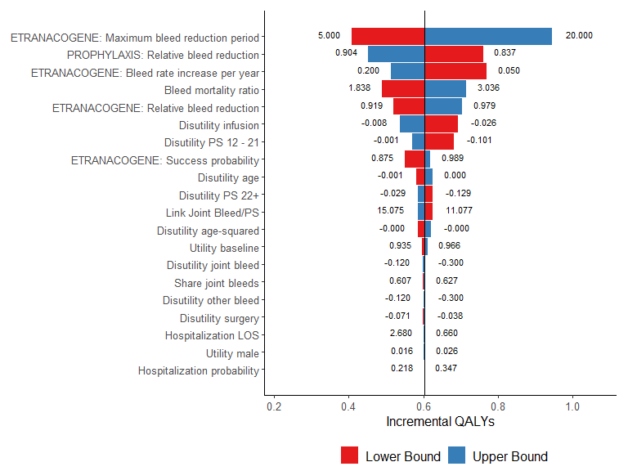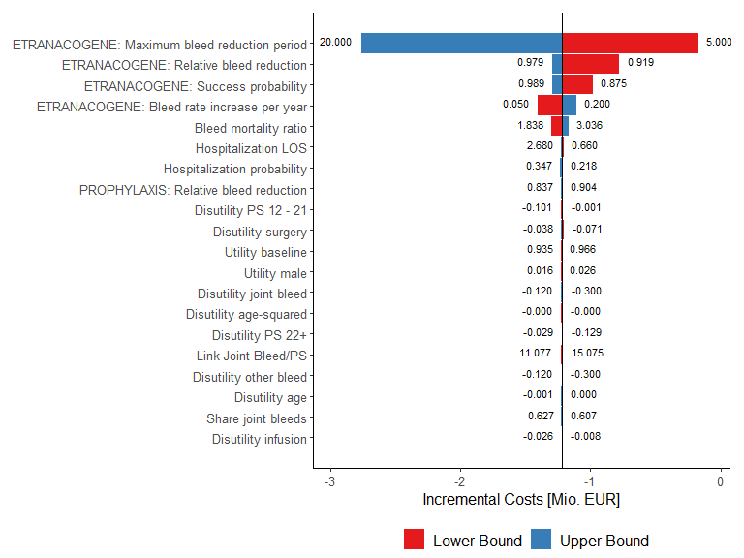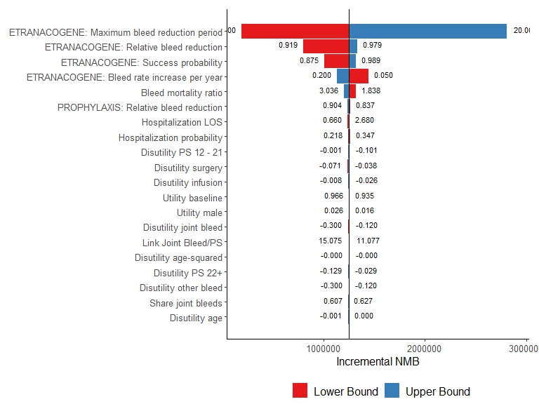

# System information

Sys.info()

sysname release version nodename machine login   
 "Windows" "10 x64" "build 19044" "M04486" "x86-64" "min1"   
 user effective_user   
 "min1" "min1"

sessionInfo(package = NULL)

R version 4.3.1 (2023-06-16 ucrt) Platform: x86_64-w64-mingw32/x64 (64-bit) Running under: Windows 10 x64 (build 19044)

Matrix products: default

locale: [1] LC_COLLATE=German_Switzerland.utf8 LC_CTYPE=German_Switzerland.utf8  
[3] LC_MONETARY=German_Switzerland.utf8 LC_NUMERIC=C  
[5] LC_TIME=German_Switzerland.utf8

time zone: Europe/Zurich tzcode source: internal

attached base packages: [1] stats graphics grDevices utils datasets methods base

other attached packages: [1] rmarkdown_2.23 captioner_2.2.3 ggrepel_0.9.3 plyr_1.8.8  
[5] ggpubr_0.6.0 truncnorm_1.0-9 lookup_1.0 data.table_1.14.8 [9] pander_0.6.5 RColorBrewer_1.1-3 ggplot2_3.4.2

loaded via a namespace (and not attached): [1] gtable_0.3.3 highr_0.10 dplyr_1.1.2 compiler_4.3.1 ggsignif_0.6.4  
[6] tidyselect_1.2.0 Rcpp_1.0.11 tidyr_1.3.0 scales_1.2.1 yaml_2.3.7  
[11] fastmap_1.1.1 R6_2.5.1 labeling_0.4.2 generics_0.1.3 knitr_1.43  
[16] backports_1.4.1 tibble_3.2.1 car_3.1-2 munsell_0.5.0 pillar_1.9.0  
[21] rlang_1.1.1 utf8_1.2.3 broom_1.0.5 xfun_0.39 cli_3.6.1  
[26] withr_2.5.0 magrittr_2.0.3 digest_0.6.33 grid_4.3.1 rstudioapi_0.15.0 [31] lifecycle_1.0.3 vctrs_0.6.3 rstatix_0.7.2 evaluate_0.21 glue_1.6.2  
[36] farver_2.1.1 abind_1.4-5 carData_3.0-5 fansi_1.0.4 colorspace_2.1-0 [41] purrr_1.0.1 tools_4.3.1 pkgconfig_2.0.3 htmltools_0.5.5