Analysis of HB CE univariate sensitivity analysis

Niklaus Meier

November 08, 2023

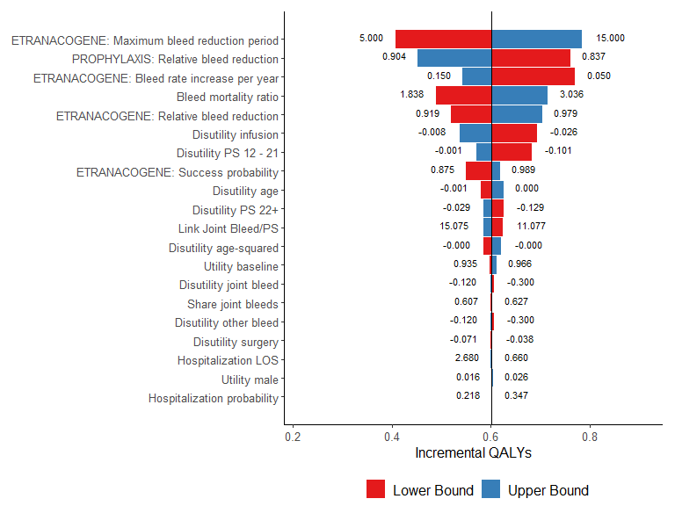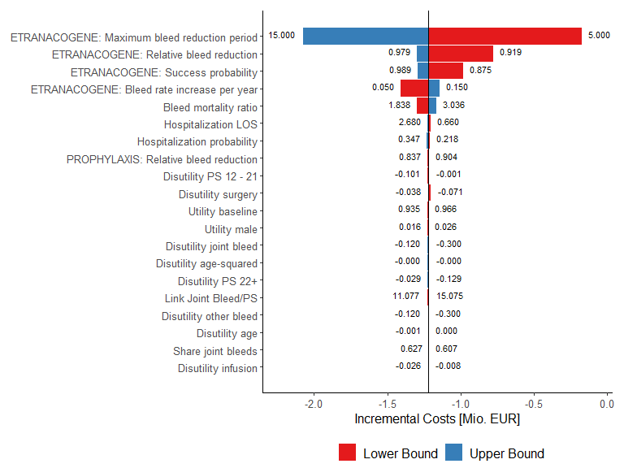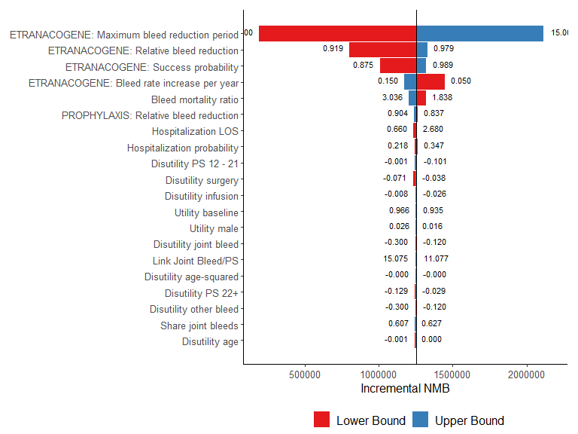

##   
## ----------------------------------------------------------  
## parameter lower Bound upper Bound   
## ------------------------------ ------------- -------------  
## Hospitalization probability 0.2175 0.3475   
##   
## Hospitalization LOS 0.6596 2.68   
##   
## Utility baseline 0.9355 0.9661   
##   
## Utility male 0.01597 0.02642   
##   
## Disutility age -0.0009841 0.0004761   
##   
## Disutility age-squared -0.00004093 -0.00002534   
##   
## Disutility PS 12 - 21 -0.1006 -0.001434   
##   
## Disutility PS 22+ -0.1291 -0.02884   
##   
## Disutility joint bleed -0.2999 -0.1201   
##   
## Disutility other bleed -0.2999 -0.1201   
##   
## Disutility infusion -0.02613 -0.007762   
##   
## Disutility surgery -0.07144 -0.03766   
##   
## Share joint bleeds 0.6066 0.6273   
##   
## Bleed mortality ratio 1.838 3.036   
##   
## Link Joint Bleed/PS 11.08 15.07   
##   
## ETRANACOGENE: Relative bleed 0.9189 0.9794   
## reduction   
##   
## ETRANACOGENE: Maximum bleed 5 15   
## reduction period   
##   
## ETRANACOGENE: Bleed rate 0.05 0.15   
## increase per year   
##   
## ETRANACOGENE: Success 0.8747 0.9886   
## probability   
##   
## PROPHYLAXIS: Relative bleed 0.8366 0.9043   
## reduction   
## ----------------------------------------------------------  
##   
## Table: Lower and Upper Bound of parameter values

# System information

Sys.info()

sysname release version nodename machine login user effective_user   
 "Windows" "10 x64" "build 19045" "M04486" "x86-64" "min1" "min1" "min1"

sessionInfo(package = NULL)

R version 4.3.1 (2023-06-16 ucrt) Platform: x86_64-w64-mingw32/x64 (64-bit) Running under: Windows 10 x64 (build 19045)

Matrix products: default

locale: [1] LC_COLLATE=German_Switzerland.utf8 LC_CTYPE=German_Switzerland.utf8 LC_MONETARY=German_Switzerland.utf8 LC_NUMERIC=C  
[5] LC_TIME=German_Switzerland.utf8

time zone: Europe/Zurich tzcode source: internal

attached base packages: [1] stats graphics grDevices utils datasets methods base

other attached packages: [1] rmarkdown_2.23 ggrepel_0.9.3 plyr_1.8.8 ggpubr_0.6.0 truncnorm_1.0-9 lookup_1.0 data.table_1.14.8 [8] pander_0.6.5 RColorBrewer_1.1-3 ggplot2_3.4.2

loaded via a namespace (and not attached): [1] gtable_0.3.3 highr_0.10 dplyr_1.1.2 compiler_4.3.1 ggsignif_0.6.4 tidyselect_1.2.0 Rcpp_1.0.11  
[8] tidyr_1.3.0 scales_1.2.1 yaml_2.3.7 fastmap_1.1.1 R6_2.5.1 labeling_0.4.2 generics_0.1.3  
[15] knitr_1.43 backports_1.4.1 tibble_3.2.1 car_3.1-2 munsell_0.5.0 pillar_1.9.0 rlang_1.1.1  
[22] utf8_1.2.3 broom_1.0.5 xfun_0.39 cli_3.6.1 withr_2.5.0 magrittr_2.0.3 digest_0.6.33  
[29] grid_4.3.1 rstudioapi_0.15.0 lifecycle_1.0.3 vctrs_0.6.3 rstatix_0.7.2 evaluate_0.21 glue_1.6.2  
[36] farver_2.1.1 abind_1.4-5 carData_3.0-5 fansi_1.0.4 colorspace_2.1-0 purrr_1.0.1 tools_4.3.1  
[43] pkgconfig_2.0.3 htmltools_0.5.5