PROJECT WHITE DUST

By Nikodem Drabik

Cyber-Security

Contents

Initial Ideas 2

Main Menu: 2

Possible Target Users: 2

Elderly: 2

Tech inept: 2

Children: 2

Password: 2

Vulnerabilities: 3

Example: 3

Issues to overcome: 3

Central Website Hub: 4

Websites: 4

Layout: 5

# Initial Ideas

## Main Menu:

Have a main hub that leads to all the features of my desired product and other things like so.

Idea:

Have a similar functionality to a browser such as google with being able to boot it up instead of Google and make it simpler.

## Possible Target Users:

### Elderly:

The first target users will be the elderly as they struggle to keep safe on the internet and are one of the main victims of online scams. This website is intended to minimise the risk by “holding their hand” while they explore the internet.

### Tech inept:

This website will also help people who struggle with the internet as a while. This can be caused by age, disabilities, or lack of willingness to learn the internet. This means that they need a “dumbed” down UI to be able to access all they need in a very quick and easy way that is not to closeted but has everything they need. This website hopefully will be the perfect solution for these people as it will have everything to kick start their journey on the internet every time, they turn on their device.

### Children:

This may be the solution also for parents with young children allow them to use the device. This can be achieved by having the base website however the parent or guardian may be able to remove some of the functions and create a child specific interface that allows children to navigate the internet much safer than if they were to do it without an assistant website like the one, I may create.

## Password:

Create a password generator that allows users to input a few pieces of information that are meaningful to them. The password algorithm will use this data to create a password that not only will have a high level of security but will also be easy to remember for the user which may allow them to not use a password manager but instead memorize it. I think this may be a more secure way of keeping a password.

### Vulnerabilities:

There are many vulnerabilities that I foresee for this item. The act of saving the password to a website and things like such. The reason for this if the user is attacked with a malicious virus that has a built-in cookie grabber and this may and is most likely to lead to a lot of passwords being leaked. However, the need to no longer store the passwords on websites will mean no vulnerability as such.

### Example:

Tested by PasswordMonster.com

The generated Password -> PlyMouth-2023_UniVersiTy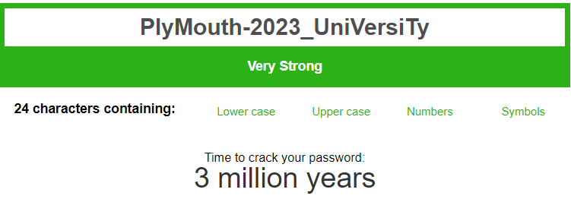

As you can see the strength is greatly increased.

I will work out how to calculate the syllables of words and capitalise each syllable to increase security and each space will have a different special character. For example

### Issues to overcome:

There are several issues I will need to overcome to make this system to work. The greatest one is to work out how to separate the word into syllables. There are two options I can see.

1. Manually separate the word into syllables by the user.
2. Have a library or a operation that is able to get the word and then separate it.

This will be an issue as the English language is notorious for its complicated spelling and weird rules and making a program which is able to manage it all will be hard. So far, I have tried to find a simple formula that is able to calculate how many syllables there are. However, for example I am unable to use vowels as a marker as for example Dog and Cat are both 1 syllable yet a vowel is in the middle. During my short research the best way to calculate the words syllables’ is to clap however a program is unable to do so. As a result, I will need to have a deep dive on the English language.

1. Brute force attack with human or ai assistance that is aware that the word is split by syllables and as a result all it needs to do is to find the correct word combination. However hopefully due to the large number of words as well as the addition of special characters this will increase the difficulty.

## Central Website Hub:

Create an area with a secure connection to many websites used by people. The reason for this is that there are many persons trying to create a sort of “man in the middle” attack by purchasing website URLs such as gooogle, gogle, facebok. These are 1 letter of the main website name and are designed as a type of phishing attack. These create a high level of vulnerabilities for many users and their internet security. The idea for this is that it should eliminate or as a bare minimum decrease the amount times this happens when my website is used.

### Websites:

Google

Facebook

eBay

Amazon

Weather app of their choice.

User Email Service:

User will be able to choose between PL and UK email providers as they use both.

Choice of 5:

ASDA

TESCO

WAITROSE

MORISSONS

SAINSBURY

Others to be added.

## Layout:

While doing research for HTML and website designs, I came across many articles which debate on the best layout for a website. The two most popular ones are the F scan and the Z scan. They are both very similar in the amount of data they cover when scanning a website with your eyes. This is an important aspect of a website as you want to maximise the amount of space you have and knowing where the customer looks when using it is important when deciding how to lay out the website.

Following these theories will allow me to create an eye pleasing and easy to read website.

### First Prototype.

This is my initial prototype of my website as displayed when designing the webpage I looked at the research I performed regarding webpage design. I decided to utilise the F scan pattern to ensure my website is well designed.

The most utilised areas of my website are in the “golden” area where the peoples eyes tend to track towards. This will make the website have a much greater ease of use and as a result lead to a better experience.

#### Improvements:

My prototype looks not aesthetically pleasing to the eye. I will need to create some colour scheme for it to improve the overall look of the website. This will also in my opinion improve the user experience as I do not like using website which look very minimalistic.

Secondly, I do not like the layout of the website icons on the right. At this current point I do not have a way of improving them however with time and research I believe I can put them in a more visually appealing location.

After doing this first website designed, I felt something was wrong with the way it was laid out. After looking at other websites and analysing their layout I found out the reason for that feeling. The reason it seems wrong is that websites often have all their information laid out in the centre early reaching the sides and as a result they have white space around the sides. As a result of this my next design I will utilise this new information to make it more uniform looking.

## Backend Code.

I will be using HTML as the base code for my layout it has many functionalities that I need to make this work. It allows me to create links to the desired websites that will have my user redirected to them. Furthermore, I will also use JavaScript to create the code for my password maker. This should be easier to implement than C++ code into HTML therefore making the code much easier to maintain in the future.