Project White Spectra COMP 1004

# Project Vision:

During this project I intend to create a website that enhances user safety and experience on the internet. The reason behind this is that many people who access the internet do not know how to keep safe and secure. My project aims to help these people keep as safe as they can.

I will do this by having my website be their main “hub” making the online experience streamline and more secure by making sure they access the websites safely and have the tools they need to browse the web safely. The UI will aimed to simulate a mobile device.

My users are all the people who are tech illiterate however my focus is on the aging population who struggle with this the most due to the inability to adapt to change.

A second aim is to simplify the web by providing everything they need in a day-to-day scenario in this main hub. This will reduce the amount of time they are vulnerable which can lead to being exploited by malicious individuals.

Thirdly a password creator aims to help with a secure password as it can be their greatest weakness. By having my generator take memorable user data and using it to create a password this will allow them to remember it much easier compared to the secure auto generated password while also having the added benefit of better security compared to a password, they are likely to use.

Lastly, I will store a Memorable piece of data for the user that hints at the password they created for that website so when they forget the password or lose it, they are able to return to the page and retrieve their hint as a last resort.

I also aim to have a few quality-of-life API’s like a Search engine, weather forecast and others I may be requested to include.

# Product Backlog

**Required:**

An index HTML page

JSON output to a flat file

JSON input from a flat file

A single page application showing some form of interactivity.

**CRITICAL:**

Password Generator

Link to Websites

A Password encryption method

Memorable password hint (read,write)

**BENEFICIAL:**

Website Links are Icons

Additional Password Encryption Levels

Navigation Menu

**EXTRA:**

Readable Font for elders

E-Safety Section

Search Engine API (google?)

Easy to navigate UI

Weather API

JS encoded

Green has been fully implemented.

Yellow means its partially achieved.

Red it has not been achieved nor attempted to implement.

# Background

The idea behind this project came from my grandmother. This is because she struggles to do anything on the internet without assistance. No matter how many times I show her the same process she can’t memorise it. As a result, I have put short cuts to webpages on her home screen like app Icons.

I thought that my grandmother must not be the only person who has this issue. Therefore, I thought about implementing such idea into a much broader idea by having a website be that homepage. This allows others to use the website without the need for manually adding links to websites.

Lastly the idea for the Password creator came from seeing my parents’ password security and watching many videos on YouTube about how many people have vulnerable passwords that are quite widely used like “1111”. This led to the idea of me creating a system that takes data and makes it more secure for the user. Hence, I did some research to see what kind of password systems are easy to remember. I finally decided on a system that the encrypted password uses data that relates to the user.

Furthermore, I opted for not creating a password management system instead a hint-based system due to my understanding that most of the older population does not trust the internet with any bit of sensitive information meaning they would not use that feature. Due to this I decided to not directly store that sensitive information but assist my user in remembering what it is.

# Software Development Life Cycle

This is very important aspect for a cyber security product as new threats and technologies are developed daily that can help or hinder the security of a person on the internet and keeping on top is very important. Therefore, I decided to follow an agile model as its best suited to this type of workflow as I see that I will amend multiple aspects of the website front end and especially the backend to improve the security when I learn new things. Also, through continuous improvement and getting many things done quickly and then just revisiting them allows me the programmer to keep a fresh mind and if something is partially finished it goes out to the customer as an alpha feature and the feedback is used to update it.

Furthermore, I will be undertaking the task in sprints having small manageable workloads. However, I see certain aspects of this project taking longer than others because I am learning new programming languages, skills, technologies and have not much prior knowledge of how to perform tasks efficiently using the agile method.

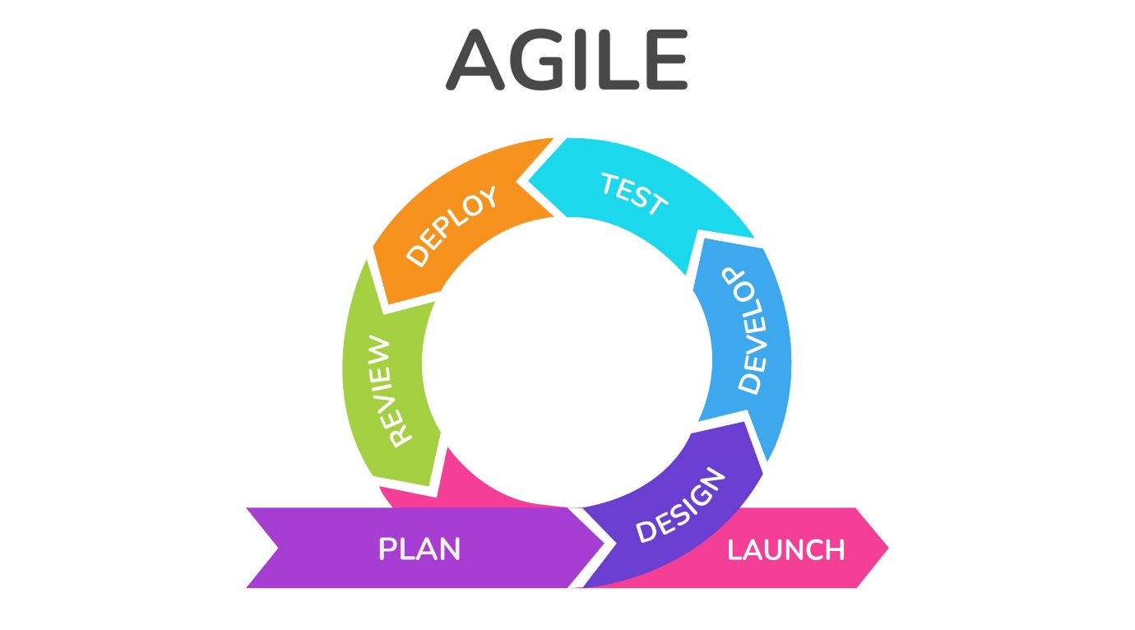

From: https://www.krasamo.com/agile-development-process/

# Sprints

## Sprint 1 – November (1 Week)

In this sprint I dedicated my time to creating an outline of my idea and things I need to achieve to have a working SPA. I came up with multiple ideas that I would like to implement and did research on how they work and how to implement them. Ideas like Google Search API which did not end up being implemented.

## Sprint 2 – November (1 week)

Began visualising the idea using Wireframe software of a mock website. Did research on how to make a visually appealing website for the user by what the human instinct is for scanning pages, and adapting my design to an F format to ensure most important data is on the left as stated in the VWO research about eye tracking on a website.

Issue- Important data not located on the left

Final Design- F pattern utilised.

## Sprint 3 - Christmas Break (3 Weeks)

This sprint I laid out the foundation for my HTML website. I began designing the main site’s basic functionality. Navigation bar was stuck in one place and was not smooth when moving to designated webpage (could not find solution left for later date). Got inputs to parse from HTML to JS.

## Sprint 4 - February (1 weeks)

Website UI navigation bar now works as intended. Scrolls to wanted part of webpage and is always visible. Re-Designed to take up most of the space on the left for better user appeal.

## Sprint 5 – March (2 Week)

Built upon HTML data parsed through to JS for sting manipulation and learned how to get the generated password returned. Able to use it in future to save the data to a Database or file.

Second week I made a second scrambling method and created and a selection menu to let the user pick different scrambling methods.

This led to me re-writing the HTML and re-design the website to make it more visually appealing and easier to use by changing the colours and by changing text layouts and font size.

## Sprint 6 - March/April (2 Weeks)

Began using Firebase as a Database as I could not work out how to save JSON data in a flat file. The Realtime DB allows me to input data from my SPA and read form the Database directly to the HTLM website.

Began working on a way to Update user data with further intent to also have a way to delete.

Once again re-designed the UI.

For future still need to find how to delete “ in top left.

# UI

## Navigation Menu

The menu is on the left of the website always visible to the user. When an option is hovered, it changes colour and when clicked the screen moves to that location allowing the user to easily navigate.

## Websites/E-Saftey

User Friendly and intuitive Design. I followed a mobile phone home screen design that is split into sections regarding the topic. This was the best option for my target user as they do not have much experience with computers, so I decided to resemble a mobile phone as closely as possible.

Also added a useful websites section to help users with basic day to day needs via TinyWOW and Haveyoubeenpwned to let the user see what data has been leaked of theirs allowing them to act for example by changing the password to help them be safe online.

## Password Creator

User has 2 choices Basic and Extreme with a brief description of what each option does and how it benefits the user. Depending on the choice the user’s data will go through the scrambling method of their choice and it will return the password in a box.

## Memorable Identifier Creator (MIC) & Retriever (MIR)

This Section Requires the user to input their Unique ID so that the data is stored to their profile. The user can then make a Memorable hint and save to the Database by entering the Website name and the Hint. Then when user has data stored in the DB they can retrieve it by entering the Website name and the data will pop up in a box.

# Password Creator

This system is designed for my user to input data that they deem relevant to them, and my code will simply modify it to make it more secure. The user must input 12 characters into the field. This is done as the greater the number of characters the more secure it is and it grow exponentially. Most websites have a min of 8 however to futureproof I have gone with 12 as not only it increases the security the more characters a password is. Currently I have two scramble methods: Basic & Extreme.

Basic is just implementing Snake_Case to the user’s information.

Extreme not only implements Snake_Case but also substitutes letters for symbols and numbers to increase security. The code uses my own type of Cypher Text encryption by swapping letter for symbol or number. This does not benefit the passwords strength as much after using Snake_Case but every little helps as highlighted by Dan Wheeler’s report and program about password strength and cracking time even though it was written in 2012[zxvbn]

# Memorable Identifier Creator (MIC)/ Retriever (MIR)

## Explanation

The MIC is for the user to write a hint that reflects the password like a unique word used at a bank to verify the user is who they are. I decided that this is the better option for the time being instead of storing the user password as speaking to multiple people from my target market that they prefer to write down their passwords in a notebook and store that due to distrust of the internet, hence after talking to them I thought about creating MIC in case they forget to have a way to maybe re-remember some lost passwords via hints they gave themselves.

The MIC system uses Firebase as a DB to store the data that is like a JSON format with object names for the data saved. The user is required to have a Unique Username and Unique Identifier. These two data sets are used to create a user section in the database and then the website name is used that has the users hint for that website. This allows me to create a method to search for each user’s data.

Bellow is an example of how this data is stored.

## Issues

An Issue I have which means this system is not ready for public use is that the data is not secure sufficiently as people can access the data quite easily if they know somebody’s Unique ID. On the other hand, this is very similar to passwords and usernames currently, however I do not feel that it is secure for current distribution. In the future I would like to create a system that sends a request to the server for this data and sends it to the users email that has been verified for a type of 2fa to increase the security of the program.

# Sequence Diagram

This diagram is used to illustrate how the code interacts with user inputs. For example, how the js user’s data is pulled from the webpage to the js and combined to one output.

The MIR follows a similar process to MIC However is has a few additional steps due to need for data from the server and being sent back to the Webpage

# Site Map

Here I have outlined the base concept of how the website operates. It shows what sections I have and what each section does, for the user or behind the scenes. The colour scheme on the left refers to each boxes function.

# AI Threat

Ai is now being used for password cracking because of its fast-learning capabilities and pattern recognition, it’s more of a threat than ever to password integrity. During the project AI training has become more effective leading to smarter AI which can crack passwords more efficiently and the longevity of my solution may be at threat. With companies like AMD releasing consumer technology to train AI, which can land in the hands of cyber criminals, meaning more people are able to access this technology.

# Legal

An issue with Data Storage is that I do not have any TOS or T&Cs for me storing my user’s data. If I were to follow through with the plan and make this globally available, I would need to fulfil the requirements and follow all the laws of GDPR 2018 and Data protection Act 2018. For example, a law from The GDPR is art 17, I currently do not have a way to fully wipe a person’s details or even delete them as a result they cannot be “forgotten”.

# Wireframing

## Initial Idea

This was the first putting ideas on paper I had withing one of the first sprints. I put down all the ideas I had on a page and how it would function. I opted not to use scroll picker for picking what website to use but icons like on the right.

## Design 2

### Main page:

Here I created a main part of the website in HTML with what the buttons may look like and the side navigation Bar.

This was a great change from the first prototype as I disliked the layout of it.

### Password Creator

This was the initial layout of the Password Creator section.

# User Stories

I want to access any website I use day to day.

As user I want to be able to be safe on the internet

I want to have Facebook/messenger

I don’t trust the internet to keep my password safe.

I can enter my personal data and get a better password.

Above is a user story diagram to show the process of my user using my website

|  |  |
| --- | --- |
| Name | page9image63141328Retrieve Hint |
| Short Description | User want to retrieve a hint |
| page9image35689536Precondition | Hint is in the Database |
| Post Condition | Hint Visually Presented |
| Error Situations | User mistyped input/no data exists |
| System state in the event of an error | "Failed to Find Data" |
| page9image36638272Actors | page9image36642304User |
| page9image36649984Triggers | page9image36530880User want to retrieve hint |
| Standard Process | 1. User enters Unique ID   2. User Enters website name  3. presses Enter  4. JS calls DB with the data  5. Data returned to JS  5. HTML is altered to represent data |
| page9image36442432  Alternative Process | page9image36535296 User creates Hint |

|  |  |
| --- | --- |
| Name | page9image63141328Save Hint |
| Short Description | User want to Save a hint |
| page9image35689536Precondition | Password Generated |
| Post Condition | Hint stored in Database |
| Error Situations | User enters generated password |
| System state in the event of an error | "The hint cannot be the same as your new generated password" |
| page9image36638272Actors | page9image36642304User |
| page9image36649984Triggers | page9image36530880User want to save hint |
| Standard Process | 1. User enters Unique ID 2. User Enters website name 3. User enters Hint   4. presses Enter  5. JS formats data to JSON style  6. Data sent to JS |
| page9image36442432Alternative Process | page9image36535296 n/a |

# UML Diagram

This diagram represents the workings of my Password system. It shows what functions get called as well as where data gets sent and received. The process begins at the Button class.

The UML diagram of Website icon is there to show what data is used to make the HTML hyperlink work and how it is activated due to the lack of explanation in other part of the report.

# Reflection

## Overview

Overall, I have reached many of the goals I set out the website is functioning with many of the features having issues polished out. I was able to get a bare bones website with basic UI working with a week after following many video tutorials. Overall, I learnt many new skills for future projects I may undertake.

An issue I stumbled upon when doing the report, I did not have any evidence of the program as it was being developed for example a log of issues, I had was very minimal and consisted of only 2 images. For future I would have a document dedicated to issues I have encountered and their fix.

Due to my lack of organisation, I was not able to make time for any of the API systems in the Extra section for users ease of use. However, this means they can be future projects I can undertake to better understand web development and how API’s work.

A big mistake I have done, I was unaware of a word count and created a much too in-depth analysis of the project and project vision this resulted in me losing a minimum of 2 weeks’ worth of time in report making and issue analysing. However, this did allow me to fully understand what I intended to reach and led to a much easier workflow.

The future of this project seems bright if I continue working on it. However, it’s likely that I will use this project for a mock testing ground for different cyber attacks to learn about how to keep websites safe such as SQL inject and or gain access to a Database through other means like Brute Force. This is because I feel there are many vulnerabilities in this website’s security.

## Issues

The Password system creates a password that is secure however it is not as secure as auto generated passwords like: aFjk3464HuOape54I9F56ds32. I find that this can be an issue with the longevity of my system. However, this can be reformed by performing future updates to the code when new methods are available and possibly creating a new memorable password algorithm for the user.

I was unable to work out how to perform updates to the db. Due to time constraints due to me spending too much time trying to work out the issue I halted the idea for a future update.

Through the project I struggled with the HTML to JS and vice versa aspects of the website. Where I needed to have the two files communicate and exchange data and the data to be manipulated and returned to HTML. I spent a few days with no progress. In the end I was able to finally have most of my JS in a separate file instead of having it in the script section making it easier to maintain.

# References

*Art. 17 GDPR – right to erasure ('right to be forgotten’)* (2017) *General Data Protection Regulation (GDPR)*. Available at: https://gdpr-info.eu/art-17-gdpr/ (Accessed: 09 April 2024).

Wheeler, D. (2012) *Zxcvbn: Realistic password strength estimation*, *Dropbox*. Available at: https://dropbox.tech/security/zxcvbn-realistic-password-strength-estimation (Accessed: 10 April 2024).

Zehra, N. (2023) *Learn how eye tracking helps with website optimization: VWO*, *Blog*. Available at: https://vwo.com/blog/eye-tracking-website-optimization/ (Accessed: 10 April 2024).

# GITHUB

<https://github.com/Niko-PL/Nikodem-Drabik-1004-Project>

# Firebase Database Link