**Střední průmyslová škola elektrotechnická Ječná**

**Informační technologie**

Ječná 30, Praha 2

**TNT Sweep**

Logic game

**Nikola Poláchová**

Informační technologie

2024

Table of Contents

Goal 2

Software 2

Description 2

Rules 3

Design 3

Class ButtonWorks 5

Class Menu 5

Class SelectDiff 6

Class SelectFlag 6

Class Instructions 6

Class Hint 6

Class Solver 6

Manual 6

Sources 6

Code 7

Inspiration 7

Images 7

Audio 8

Conclusion 9

List of pictures

1. Title of the game TNT Sweep 4
2. Window Difficulty selection 4
3. Starting board 5
4. After first move 5
5. Marked TNTs 5
6. Dig up TNT 5

# Goal

Window game TNT Sweep should be logical and fun. It should include unusual elements from some popular games. Should include:

* Main menu, menu bar
* Rules of the game, how to play, instructions
* Difficulty levels
* Hints for a little price
* Automatic solver
* Option of changing flag design

# Software

Game is made in IntelliJ IDEA with SDK 22.

# Description

## Rules

TNT Sweep (Minesweeper) is a game, where mines are hidden somewhere in the shown field.  
Every move you make, you have to write a location and if you want to mark it with a flag or show the number.  
Simply by writing 2 1 s (2 row, column 1, show place - you think there's no mine),  
or 2 1 f (2 row, column 1, mark place - you place a flag where you think the mine is).  
First we write rows then columns.   
If there's a number on a cell, it shows how many mines are around the number. For example:

0 1 2  
 0 X X X  
 1 X 1 X  
 2 X X X

In this field there are 8 hidden boxes, where could be a mine.  
 If there's a -. It means there are no mines around.

0 1 2  
 0 X X X  
 1 X 1 -  
 2 - - -

In this case, we can tell that box 10 is definitely safe. Because of - next to it.  
 We mark mines with 🚩 and if you click on a mine, it explodes 💥.

These are the rules of classical Minesweeper. But in this game, there are a few differences. Here, you do not mark mines with flags but with flowers. However, let’s call it flags. And we could say we do not mark mines but TNT bombs.

Regarding hints, if you need a hint, you can get one but for something in return. It would be too easy. So, when you want a hint, you can use a hint button. The cell without a TNT will change into obsidian. Which means more work, because you have to press ten times to break the obsidian.

The goal in this game is to find all the mines (TNTs) and not to trigger one.  
 Enjoy! 😊

## Design

Design is mainly inspired by Minecraft. Changes made from this game are:

* Cells in this game are not grey or one specific color, they look like grass blocks from above.
* Flags are not images of flags. They are displayed here as flowers from Minecraft. Player can choose which kind of flowers he will use.
* Mines are in form of TNT bombs.
* If player needs a hint, the system will mark the cell by making a block of dirt with grass a block of obsidian.

Main menu is eye catching and simple. Main screen has big title, three buttons and background image. This image changes every ten seconds. There are ten pictures that switch, these pictures are most of the time AI made or searchable online. The title is designed in LibreOffice Impress.



Title of the game TNT Sweep

Right before a user starts playing, a new window will pop up. This window is called Difficulty selection. Here, user will choose, how many mines and how big he wants the playing board to be.

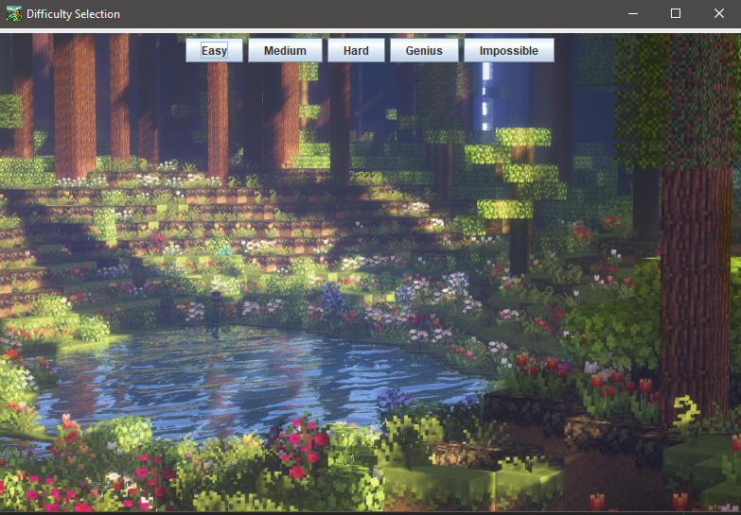 2. Window Difficulty selection

Playing board looks like empty meadow, until you place some flags/flowers. Player can choose from different kinds of flowers. There are nine kinds of Minecraft flowers. Each cell is an individual image of pixel grass. When you uncover grass, dirt or TNT will show. If no TNTs are around only dirt will appear. In case of occurrence a TNT number will appear on dirt block.

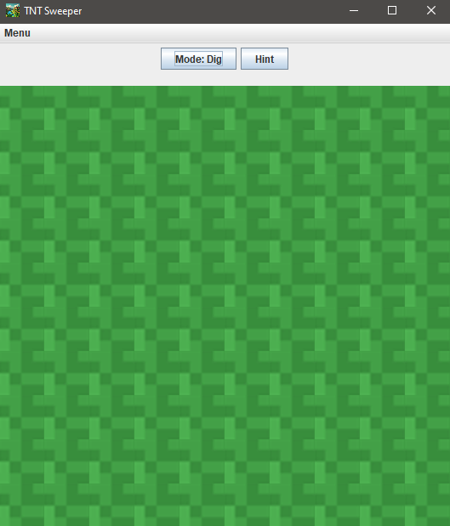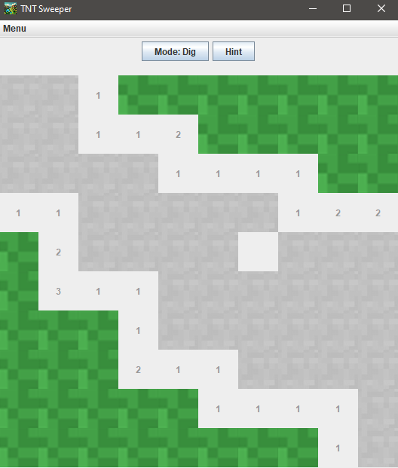 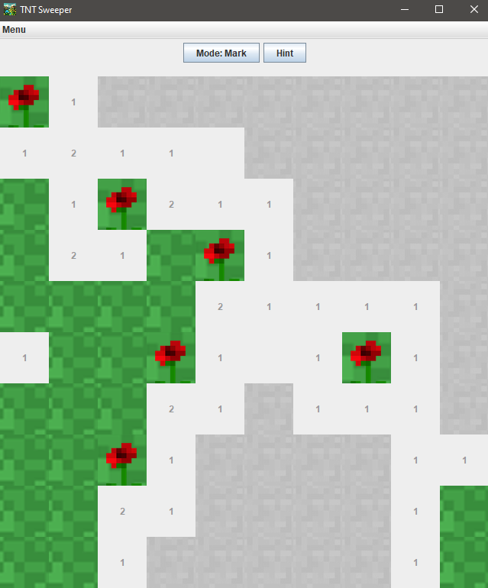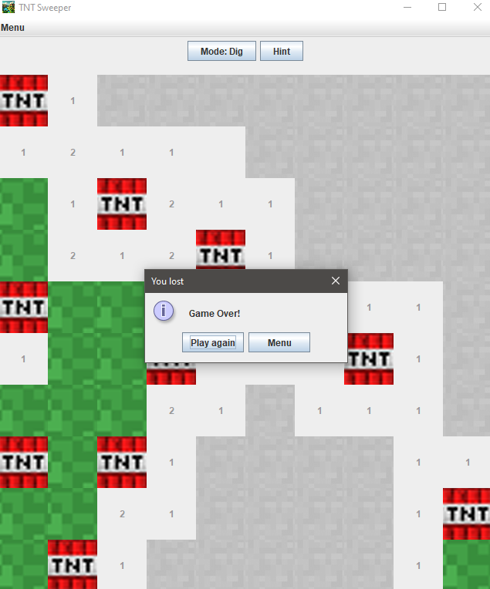

3. Starting board 4. After first move 5. Marked TNTs 6. Dig up TNT

Mechanics

Class Visual

This class is the main class, where most of the game logic takes place. It has a lot of supporting variables. The class contains:

Variables:

* JButton [][] buttons – a location of a button
* Boolean [][] mines - a location of a mine, that is true
* Boolean flagMode – decides whether the player is digging cell or marking a mine
* Int foundMines – number of mines that has been marked
* Boolean lost – if player looses, it equals true
* Boolean won – if player wins, it equals true
* Difficulty difficulty – enum class with difficulties
* Hint hint – class Hint, that gives hints

Methods:

* Constructor – contains all design of the game board
* MakeButtons - builds a field of buttons
* PlaceMine – places mines on board (under buttons)
* RevealM – uncovers all mines if player looses
* Count – calculates number of mines around one cell
* RevealEmpty – reveals all cells that have no mines around them
* WinCheck – checks if the player won
* Win – displays an option window with message of winning and options to choose from, specifically Play again or Menu

## Class ButtonWorks

This class is responsible for all functionality of playing board and its buttons. Mainly sets new icons to the buttons. Issues of hint class are processed here.

## Class Menu

Creates Main menu window. This class has a feature of changing its background every five seconds.

## Class SelectDiff

Creates window after clicking button Play, that is located in Main menu. This window consists of five buttons of difficulty and picture background of MainMenu5.png file. Choice is handled by ActionListener with lambda.

## Class SelectFlag

This class holds addresses of all flag images and makes a window of these images with their labels.

## Class Instructions

This class also has an individual window. This class is run, when a button How to play from Main menu is pressed. Loads a text from file Intro.eng and inserts it in the window as JTextArea.

## Class Hint

Gives a hint by marking one cell on playing board.

## Class Solver

This class should solve a whole board by itself.

# Manual

The first thing a player sees is a Main menu. Simple layout can ensure easy access to every function available. Highest placed button Play leads to window with difficulty selection. There are five difficulty levels. Easy, Medium, Hard, Genius and Impossible. They differ in amount of cell and mines contained on game board.

* Easy level – 10x10 field, 10 mines
* Medium level – 13x13 field, 30 mines
* Hard level – 16x16 field, 40 mines
* Genius – 21x21 field, 99 mines
* Impossible – 10x10 field, 100 mines

After that, a playing board is presented to the user with a bright green field. Just by clicking player digs. Button records which mode is used. It is either dig mode or mark mode. There is also a button hint. This button marks one block as safe by displaying it as obsidian block. When all mines and cells are cleared the player wins. But when the player uncovers a TNT, it explodes and all mines are shown. That is, where the game ends.

In Main menu, button How to play is present for a reason of instructions. If written text is incomprehensible, user can find a button I still don’t understand in menu bar. This button leads to webpage further explaining game Minesweeper.

# Sources

## Code

The code that did not work after several attempts, I had to search more. But class Solver is mostly not mine code.

/*

public void solve(){  
 while(!visual.lostGame() && !visual.wonGame()){  
 for (int i = 0; i < rows; i++) {  
 for (int j = 0; j < columns; j++) {  
 if(buttons[i][j].getText().equals("") && !did[i][j]){  
 int closeMines = countCloseM(i, j);  
 int closeFlags = countCloseF(i, j);  
 int closeHidden = countHidden(i, j);  
 if(closeMines == closeFlags){  
 revealMines(i, j);  
 }else if(closeMines == closeHidden + closeFlags){  
 revealF(i, j);  
 }  
 }  
 }  
 }  
 }  
}

*/

## Inspiration

* <https://www.youtube.com/watch?v=5VrMVSDjeso>
* <https://www.youtube.com/watch?v=r_u_C1VEKFA&list=PLN_MXAIQJL6IANMIPNoO4dsTKx5qgjE4h&index=3>
* <https://www.youtube.com/watch?v=DvqURR_XN5U>

## Images

* MainMenu1.jpg - <https://mrwallpaper.com/wallpapers/download-minecraft-wallpaper-97xm1w3j69a4wmzb-2.html>
* MainMenu2.jpg - <http://minecraft.nikee.net/index.php?stranka=tapety&page=4>
* MainMenu3.jpg - <https://wallpapers.com/wallpapers/minecraft-aesthetic-fresh-flower-garden-2y5nkpuqtpb73iao.html>
* MainMenu4.png - <https://www.pxfuel.com/en/desktop-wallpaper-gghqb>
* MainMenu5.png - <https://tensor.art/images/701914647059739813?post_id=701914647055545516>
* MainMenu6.jpg - <https://pngtree.com/freebackground/minecraft-island-with-trees-under-a-sky_2773506.html>
* MainMenu7.jpg - <https://en.softonic.com/articles/how-to-install-and-play-the-minecraft-release-candidate>
* MainMenu8.png - <https://dribbble.com/shots/13973799-Cute-Cow-Enjoys-Awesome-Minecart-Rail-System-in-Realmcraft-Free>
* MainMenu9.jpg - <https://www.pinterest.com/pin/minecraft-aesthetic--906630968704647035/>
* MainMenu10.png - <https://soundcloud.com/kidmuzicbeats/minecraft-subwoofer-lullaby>
* MainMenu11.jpg - <https://mrwallpaper.com/wallpapers/beautiful-minecraft-flower-garden-sh8biddh7iv27rn4.html>
* Dirt.jpg - <https://minecraft.fandom.com/cs/wiki/Zku%C5%A1ebn%C3%AD_verze>
* Grass.png - <http://www.pixilart.com/twoside22/albums/8x8-minecraft-99434>
* Obsidian.jpg - <https://www.pinterest.com/pin/obsidian-in-minecraft-a-stunning-block-for-your-creations--252975704061939105/>
* Sign.png - <https://wiki.traincarts.net/p/TrainCarts/Signs/Waiter>
* TNT.png - <https://mineblocks.com/1/wiki/?title=TNT>
* Allium.png - <https://minecraft-knowhow.fandom.com/wiki/Allium>
* Blue_Orchid.png - <https://www.curseforge.com/members/tyra314>
* Cyan_Flower.png - <https://minecraftbedrock-archive.fandom.com/wiki/Cyan_Flower>
* Dandelion.png - <https://earthmc.fandom.com/wiki/Dandelionism>
* Lilac.png - <https://minecraftbedrock-archive.fandom.com/wiki/Lilac>
* Orange_Tulip.png - <https://tiermaker.com/create/all-wandering-trader-trades-120-1294947>
* Peony_aka_Paeonia.png - <https://minecraftuniverse.fandom.com/wiki/Peony>
* Poppy.png - <https://www.google.com/url?sa=i&url=https%3A%2F%2Fminecraftbedrock-archive.fandom.com%2Fwiki%2FPoppy&psig=AOvVaw25hX0lNOzKkAWltgBVtX8J&ust=1717274124712000&source=images&cd=vfe&opi=89978449&ved=0CBIQjRxqFwoTCNipoeneuIYDFQAAAAAdAAAAABAj>
* Rose_Bush.png - <https://cz-tekkit-ftb.fandom.com/wiki/Flowers>

## Audio

There are audio files from this website - <https://tuna.voicemod.net/memes> - :

* Wii Theme.wav
* TNT_explosion.wav
* Dirt.wav

# Conclusion

I began early for a reason. But I still managed to fail at finishing early. Firstly, I decided to understand the whole principle of game Minesweeper. Then, I drew on paper how I imagined it could look. The goal seemed too unrealistic. I regret a decision coding console version of this game, it went right into bin afterwards. But it helped at least a little. I always come across interesting resources, where there is some specialty, I just have to add. Normally, I add some feature and it breaks down the whole code. But I can say I tried.

I think the visual part and design is okay. Except, the field of the game, dirt does not appear as it should. However, the functionality is a little behind. I am sorry for not coming up with a functional way to make flags options work. I hope to make more versions with this theme and more functions. For example, an ocean version with ocean weed or animals.