OTAA Join request

OTAA Join request processed SUCCESS

Middleware_twoway.py log:
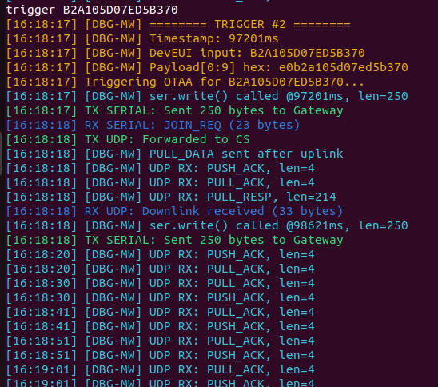

Transponder log:
