**Assignment 2**

**Zhichao He z5282955**

Question 1:

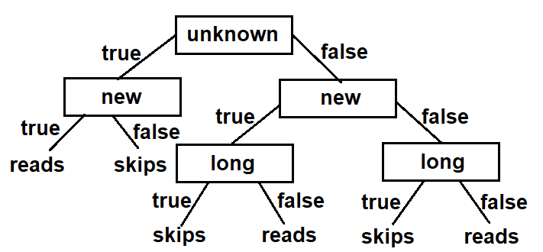

They are different. The function with the maximum information gain split looks like this.

if long(e): return skips

else if new(e): return reads

else if unknown(e): return skips

else: return reads **(function 1)**

The function from the new decision tree is like

if unknown(e): if new(e): return reads

else: return skips

else: if new(e): if long(e): return skips

else: return reads

else: if long(e): return skips

else: return reads **(function 2)**

Structurally, they are different functions. And one function cannot be transformed to the other. Additionally, there’s a counter example e19 from Figure 7.1 which is *<unknown, new, long, work, User_action>*

If we use this to test both functions, the function 1 gives the output User_action = **skips** while function 2 gives **reads**. Thus, they are completely different.

b)

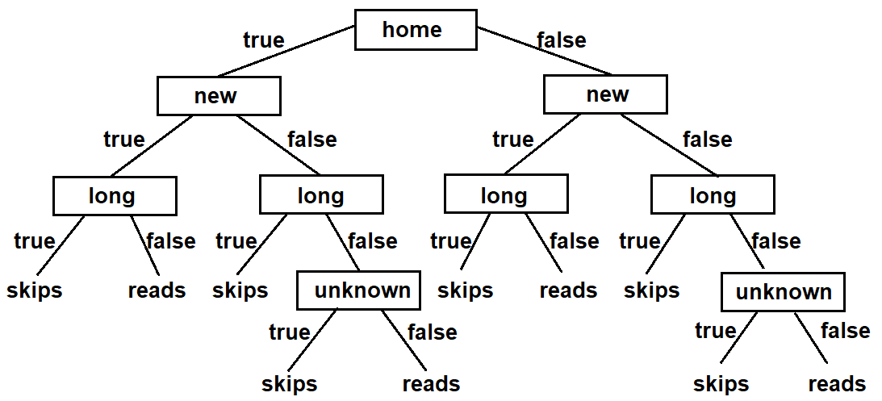

This tree represents the following function 3 which is substantially the same as function 1.

if home(e): if new(e): if long(e): return skips

else: return reads

else: if long(e): return skips

else: if unknown(e): return skips

else: return reads

else: if new(e): if long(e): return skips

else: return reads

else: if long(e): return skips

else: if unknown(e): return skips

else: return false **(function 3)**

Though the structure of the 2 functions look different, they are identical substantially. As we can transform one function to the other. In the new decision tree, we can see that whatever values $home(e)$ and $new(e)$ are, if $long(e)$ is true, the result is **skips**. This corresponds to 1st line of function 1. Similarly, whatever value $home(e)$ is, if $long(e)$ is false and $new(e)$ is true, the result is **reads.** Corresponding to 2nd line of function 1. Whatever value $home(e)$ is, if $long(e)$ is false and $new(e)$ is false and $unknown(e)$ is true, the result is **skips**. Corresponding to 3rd line of function 1. Finally, whatever value $home(e)$ is, if $long(e)$, $new(e)$ and $unknown(e)$ are all false, the result is **reads**. Corresponding to 4th line of function 1. Thus, they are the same function.

1. A

Question 2: