**Assignment 2**

**Zhichao He z5282955**

Question 1:

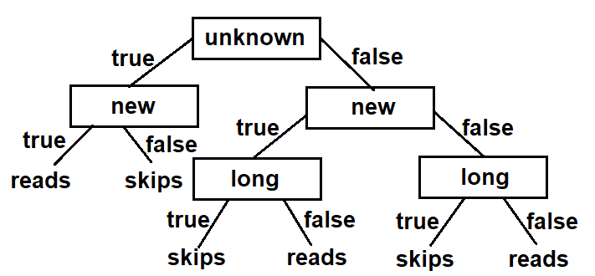

They are different. The function with the maximum information gain split looks like this.

if long(e): return skips

else if new(e): return reads

else if unknown(e): return skips

else: return reads **(function 1)**

The function from the new decision tree is like

if unknown(e): if new(e): return reads

else: return skips

else: if new(e): if long(e): return skips

else: return reads

else: if long(e): return skips

else: return reads **(function 2)**

Structurally, they are different functions. And one function cannot be transformed to the other. Additionally, there’s a counter example e19 from Figure 7.1 which is *<unknown, new, long, work, User_action?>*

If we use this to test both functions, the function 1 gives the output User_action = **skips** while function 2 gives **reads**. Thus, they are completely different.

b)

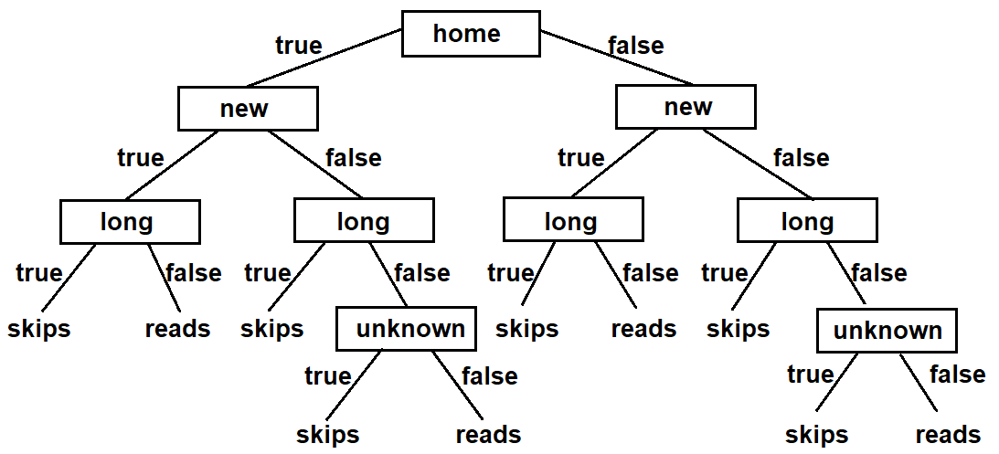

This tree represents the following function 3 which is substantially the same as function 1.

if home(e): if new(e): if long(e): return skips

else: return reads

else: if long(e): return skips

else: if unknown(e): return skips

else: return reads

else: if new(e): if long(e): return skips

else: return reads

else: if long(e): return skips

else: if unknown(e): return skips

else: return false **(function 3)**

Though the structure of the 2 functions look different, they are substantially identical. As we can transform one function to the other. In the new decision tree, we can see that whatever values $home(e)$ and $new(e)$ are, if $long(e)$ is true, the result is **skips**. This corresponds to 1st line of function 1. Similarly, whatever value $home(e)$ is, if $long(e)$ is false and $new(e)$ is true, the result is **reads.** Corresponding to 2nd line of function 1. Whatever value $home(e)$ is, if $long(e)$ is false and $new(e)$ is false and $unknown(e)$ is true, the result is **skips**. Corresponding to 3rd line of function 1. Finally, whatever value $home(e)$ is, if $long(e)$, $new(e)$ and $unknown(e)$ are all false, the result is **reads**. Corresponding to 4th line of function 1. Thus, they are the same function.

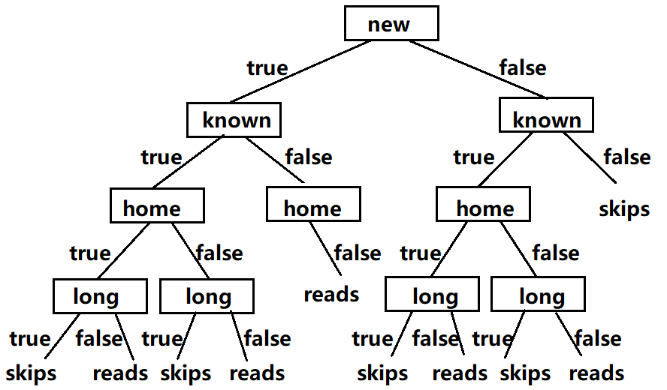

This tree is generated if the order of features is [*Thread, Author, Where, Length*]. This tree correctly classifies the training examples as each example can obtain the correct User_action using this tree. And the tree represents different functions from those 2 in a) and b)

Considering a test case <*unknown, new, home, long, User_action?*>,

the tree in a) gives **reads**, the tree in b) gives **skips**, but the tree in c) doesn’t define this scenario because there is no such kind of data to generate the tree. Thus, although the new tree correctly classifies the training data, the function represented is different from the preceding ones.

Question 2:

I used Weka to create the decision tree. As Weka only accepts .arff format files, I combined adult.data and adult.test to make a complete data file and add labels @relation, @attribute and @data to make it a correct .arff file.

Then I used J48 algorithm to build a few decision trees. I changed some parameters and compare the results in the table.

|  |  |  |  |  |  |  |  |
| --- | --- | --- | --- | --- | --- | --- | --- |
| Algorithm | J48 | | | | | | |
| ConfiFactor | - | 0.75 | 0.50 | 0.25 | 0.1 | 0.25 | 0.25 |
| MinNumObj | 2 | 2 | 2 | 2 | 2 | 3 | 4 |
| Model time | 2.68s | 73.68s | 3.16s | 5.1s | 3.3s | 2.72s | 2.35s |
| Test time | 0.07s | 0.03s | 0.02s | 0.1s | 0.01s | 0.02s | 0.02s |
| # leaves | 9129 | 8025 | 2386 | 696 | 205 | 503 | 401 |
| Tree size | 10657 | 9365 | 2946 | 911 | 275 | 651 | 530 |
| Accuracy | 84.1% | 84.1% | 85.3% | 85.9% | 85.5% | 85.8% | 85.7% |

ConfidenceFactor is the confidence factor for pruning (smaller values incur more pruning). The tree become smaller as this parameter decreases, but the accuracy isn’t affected much.

MinNumObj is the minimum number of instances per leaf. The tree become smaller as this parameter increases but doesn’t affect the accuracy much.

Considering the accuracy and efficiency, the optimal choice of parameters is the shaded one which has relatively high accuracy and the shortest test time. The decision tree of it is below.

capital-gain <= 6849

| matital-status = Married-civ-spouse

| | capital-loss <= 1844

| | | education-num <= 11

| | | | capital-gain <= 5060

| | | | | age <= 29: <=50K (1999.0/241.0)

| | | | | age > 29

| | | | | | hours-per-week <= 34: <=50K (1243.0/155.0)

| | | | | | hours-per-week > 34

| | | | | | | education-num <= 9: <=50K (6969.0/1820.0)

| | | | | | | education-num > 9

| | | | | | | | capital-loss <= 1510

| | | | | | | | | occupation = Tech-support

| | | | | | | | | | capital-gain <= 3103: >50K (169.69/71.36)

| | | | | | | | | | capital-gain > 3103: <=50K (12.05/2.0)

| | | | | | | | | occupation = Craft-repair

| | | | | | | | | | workclass = Private

| | | | | | | | | | | fnlwgt <= 152968

| | | | | | | | | | | | age <= 49

| | | | | | | | | | | | | capital-gain <= 1506: <=50K (170.22/48.51)

| | | | | | | | | | | | | capital-gain > 1506

| | | | | | | | | | | | | | capital-gain <= 3273: >50K (4.0)

| | | | | | | | | | | | | | capital-gain > 3273: <=50K (7.0/2.0)

| | | | | | | | | | | | age > 49

| | | | | | | | | | | | | hours-per-week <= 51

| | | | | | | | | | | | | | age <= 59: >50K (42.37/14.2)

| | | | | | | | | | | | | | age > 59: <=50K (12.37/2.51)

| | | | | | | | | | | | | hours-per-week > 51: <=50K (6.17/0.17)

| | | | | | | | | | | fnlwgt > 152968

| | | | | | | | | | | | hours-per-week <= 47

| | | | | | | | | | | | | education = Bachelors: <=50K (0.0)

| | | | | | | | | | | | | education = Some-college: <=50K (208.45/89.54)

| | | | | | | | | | | | | education = 11th: <=50K (0.0)

| | | | | | | | | | | | | education = HS-grad: <=50K (0.0)

| | | | | | | | | | | | | education = Prof-school: <=50K (0.0)

| | | | | | | | | | | | | education = Assoc-acdm: <=50K (0.0)

| | | | | | | | | | | | | education = Assoc-voc

| | | | | | | | | | | | | | fnlwgt <= 192344: <=50K (24.17/6.17)

| | | | | | | | | | | | | | fnlwgt > 192344: >50K (41.17/14.17)

| | | | | | | | | | | | | education = 9th: <=50K (0.0)

| | | | | | | | | | | | | education = 7th-8th: <=50K (0.0)

| | | | | | | | | | | | | education = 12th: <=50K (0.0)

| | | | | | | | | | | | | education = Masters: <=50K (0.0)

| | | | | | | | | | | | | education = 1st-4th: <=50K (0.0)

| | | | | | | | | | | | | education = 10th: <=50K (0.0)

| | | | | | | | | | | | | education = Doctorate: <=50K (0.0)

| | | | | | | | | | | | | education = 5th-6th: <=50K (0.0)

| | | | | | | | | | | | | education = Preschool: <=50K (0.0)

| | | | | | | | | | | | hours-per-week > 47

| | | | | | | | | | | | | education = Bachelors: >50K (0.0)

| | | | | | | | | | | | | education = Some-college: >50K (69.88/25.2)

| | | | | | | | | | | | | education = 11th: >50K (0.0)

| | | | | | | | | | | | | education = HS-grad: >50K (0.0)

| | | | | | | | | | | | | education = Prof-school: >50K (0.0)

| | | | | | | | | | | | | education = Assoc-acdm: >50K (0.0)

| | | | | | | | | | | | | education = Assoc-voc: <=50K (20.68/7.68)

| | | | | | | | | | | | | education = 9th: >50K (0.0)

| | | | | | | | | | | | | education = 7th-8th: >50K (0.0)

| | | | | | | | | | | | | education = 12th: >50K (0.0)

| | | | | | | | | | | | | education = Masters: >50K (0.0)

| | | | | | | | | | | | | education = 1st-4th: >50K (0.0)

| | | | | | | | | | | | | education = 10th: >50K (0.0)

| | | | | | | | | | | | | education = Doctorate: >50K (0.0)

| | | | | | | | | | | | | education = 5th-6th: >50K (0.0)

| | | | | | | | | | | | | education = Preschool: >50K (0.0)

| | | | | | | | | | workclass = Self-emp-not-inc: <=50K (102.1/23.75)

| | | | | | | | | | workclass = Self-emp-inc

| | | | | | | | | | | hours-per-week <= 59

| | | | | | | | | | | | hours-per-week <= 42: <=50K (11.37/3.1)

| | | | | | | | | | | | hours-per-week > 42: >50K (7.14/1.07)

| | | | | | | | | | | hours-per-week > 59: <=50K (9.05/1.03)

| | | | | | | | | | workclass = Federal-gov: <=50K (22.46/8.16)

| | | | | | | | | | workclass = Local-gov

| | | | | | | | | | | fnlwgt <= 188709: <=50K (10.34/0.12)

| | | | | | | | | | | fnlwgt > 188709: >50K (19.27/8.17)

| | | | | | | | | | workclass = State-gov: <=50K (11.23/5.08)

| | | | | | | | | | workclass = Without-pay: <=50K (0.0)

| | | | | | | | | | workclass = Never-worked: <=50K (0.0)

| | | | | | | | | occupation = Other-service: <=50K (144.99/32.06)

| | | | | | | | | occupation = Sales

| | | | | | | | | | workclass = Private

| | | | | | | | | | | fnlwgt <= 89259: <=50K (67.76/17.19)

| | | | | | | | | | | fnlwgt > 89259

| | | | | | | | | | | | age <= 40: <=50K (119.89/49.47)

| | | | | | | | | | | | age > 40: >50K (147.25/56.46)

| | | | | | | | | | workclass = Self-emp-not-inc

| | | | | | | | | | | fnlwgt <= 345734: <=50K (60.29/17.42)

| | | | | | | | | | | fnlwgt > 345734: >50K (7.1/0.02)

| | | | | | | | | | workclass = Self-emp-inc

| | | | | | | | | | | hours-per-week <= 42

| | | | | | | | | | | | hours-per-week <= 39: >50K (4.1/1.05)

| | | | | | | | | | | | hours-per-week > 39: <=50K (11.69/2.16)

| | | | | | | | | | | hours-per-week > 42: >50K (42.41/12.2)

| | | | | | | | | | workclass = Federal-gov: <=50K (0.0)

| | | | | | | | | | workclass = Local-gov: <=50K (1.02/0.01)

| | | | | | | | | | workclass = State-gov: <=50K (2.04/1.01)

| | | | | | | | | | workclass = Without-pay: <=50K (0.0)

| | | | | | | | | | workclass = Never-worked: <=50K (0.0)

| | | | | | | | | occupation = Exec-managerial

| | | | | | | | | | workclass = Private: >50K (346.13/132.59)

| | | | | | | | | | workclass = Self-emp-not-inc: <=50K (68.41/21.5)

| | | | | | | | | | workclass = Self-emp-inc: >50K (91.89/32.22)

| | | | | | | | | | workclass = Federal-gov: >50K (25.53/6.34)

| | | | | | | | | | workclass = Local-gov: >50K (40.84/19.54)

| | | | | | | | | | workclass = State-gov

| | | | | | | | | | | age <= 45: <=50K (12.17/3.04)

| | | | | | | | | | | age > 45: >50K (11.32/3.19)

| | | | | | | | | | workclass = Without-pay: >50K (0.0)

| | | | | | | | | | workclass = Never-worked: >50K (0.0)

| | | | | | | | | occupation = Prof-specialty: >50K (258.32/113.43)

| | | | | | | | | occupation = Handlers-cleaners: <=50K (92.91/18.68)

| | | | | | | | | occupation = Machine-op-inspct: <=50K (197.06/64.45)

| | | | | | | | | occupation = Adm-clerical

| | | | | | | | | | workclass = Private: <=50K (201.14/80.48)

| | | | | | | | | | workclass = Self-emp-not-inc: >50K (4.08/1.05)

| | | | | | | | | | workclass = Self-emp-inc: >50K (1.02/0.01)

| | | | | | | | | | workclass = Federal-gov: >50K (55.14/18.73)

| | | | | | | | | | workclass = Local-gov

| | | | | | | | | | | sex = Female: <=50K (15.11/5.04)

| | | | | | | | | | | sex = Male: >50K (9.39/3.26)

| | | | | | | | | | workclass = State-gov: <=50K (14.29/5.1)

| | | | | | | | | | workclass = Without-pay: <=50K (0.0)

| | | | | | | | | | workclass = Never-worked: <=50K (0.0)

| | | | | | | | | occupation = Farming-fishing: <=50K (146.01/30.07)

| | | | | | | | | occupation = Transport-moving: <=50K (201.14/75.48)

| | | | | | | | | occupation = Priv-house-serv: <=50K (0.0)

| | | | | | | | | occupation = Protective-serv

| | | | | | | | | | race = White

| | | | | | | | | | | workclass = Private: <=50K (19.39/2.13)

| | | | | | | | | | | workclass = Self-emp-not-inc: >50K (1.02/0.01)

| | | | | | | | | | | workclass = Self-emp-inc: >50K (1.02/0.01)

| | | | | | | | | | | workclass = Federal-gov

| | | | | | | | | | | | age <= 46: <=50K (2.03/0.01)

| | | | | | | | | | | | age > 46: >50K (2.06/0.03)

| | | | | | | | | | | workclass = Local-gov

| | | | | | | | | | | | education = Bachelors: >50K (0.0)

| | | | | | | | | | | | education = Some-college

| | | | | | | | | | | | | age <= 53

| | | | | | | | | | | | | | age <= 38: <=50K (32.35/13.03)

| | | | | | | | | | | | | | age > 38

| | | | | | | | | | | | | | | fnlwgt <= 121253: <=50K (8.09/2.03)

| | | | | | | | | | | | | | | fnlwgt > 121253: >50K (28.21/4.15)

| | | | | | | | | | | | | age > 53: <=50K (5.77/0.27)

| | | | | | | | | | | | education = 11th: >50K (0.0)

| | | | | | | | | | | | education = HS-grad: >50K (0.0)

| | | | | | | | | | | | education = Prof-school: >50K (0.0)

| | | | | | | | | | | | education = Assoc-acdm: >50K (0.0)

| | | | | | | | | | | | education = Assoc-voc

| | | | | | | | | | | | | fnlwgt <= 112772: <=50K (2.12/0.06)

| | | | | | | | | | | | | fnlwgt > 112772: >50K (15.29/2.12)

| | | | | | | | | | | | education = 9th: >50K (0.0)

| | | | | | | | | | | | education = 7th-8th: >50K (0.0)

| | | | | | | | | | | | education = 12th: >50K (0.0)

| | | | | | | | | | | | education = Masters: >50K (0.0)

| | | | | | | | | | | | education = 1st-4th: >50K (0.0)

| | | | | | | | | | | | education = 10th: >50K (0.0)

| | | | | | | | | | | | education = Doctorate: >50K (0.0)

| | | | | | | | | | | | education = 5th-6th: >50K (0.0)

| | | | | | | | | | | | education = Preschool: >50K (0.0)

| | | | | | | | | | | workclass = State-gov

| | | | | | | | | | | | age <= 41: <=50K (9.13/0.03)

| | | | | | | | | | | | age > 41: >50K (15.35/6.22)

| | | | | | | | | | | workclass = Without-pay: <=50K (0.0)

| | | | | | | | | | | workclass = Never-worked: <=50K (0.0)

| | | | | | | | | | race = Asian-Pac-Islander: <=50K (2.18/0.14)

| | | | | | | | | | race = Amer-Indian-Eskimo: <=50K (1.05)

| | | | | | | | | | race = Other: >50K (2.05/0.05)

| | | | | | | | | | race = Black

| | | | | | | | | | | fnlwgt <= 154897: <=50K (3.14/0.05)

| | | | | | | | | | | fnlwgt > 154897: >50K (11.09/3.05)

| | | | | | | | | occupation = Armed-Forces: >50K (1.02/0.01)

| | | | | | | | capital-loss > 1510: <=50K (43.0/1.0)

| | | | capital-gain > 5060

| | | | | capital-gain <= 6612: >50K (111.0)

| | | | | capital-gain > 6612: <=50K (5.0)

| | | education-num > 11

| | | | hours-per-week <= 30

| | | | | sex = Female

| | | | | | race = White: >50K (145.0/54.0)

| | | | | | race = Asian-Pac-Islander: <=50K (6.0/3.0)

| | | | | | race = Amer-Indian-Eskimo: <=50K (1.0)

| | | | | | race = Other: <=50K (1.0)

| | | | | | race = Black: <=50K (6.0/1.0)

| | | | | sex = Male: <=50K (386.0/111.0)

| | | | hours-per-week > 30

| | | | | age <= 33

| | | | | | age <= 25: <=50K (121.0/28.0)

| | | | | | age > 25

| | | | | | | education-num <= 12: <=50K (129.0/40.0)

| | | | | | | education-num > 12

| | | | | | | | relationship = Wife: >50K (120.0/36.0)

| | | | | | | | relationship = Own-child: <=50K (2.0)

| | | | | | | | relationship = Husband

| | | | | | | | | age <= 28: <=50K (166.0/75.0)

| | | | | | | | | age > 28: >50K (542.0/229.0)

| | | | | | | | relationship = Not-in-family: >50K (0.0)

| | | | | | | | relationship = Other-relative: <=50K (10.0/4.0)

| | | | | | | | relationship = Unmarried: >50K (0.0)

| | | | | age > 33

| | | | | | occupation = Tech-support: >50K (128.28/38.19)

| | | | | | occupation = Craft-repair

| | | | | | | education = Bachelors: >50K (142.11/66.16)

| | | | | | | education = Some-college: >50K (0.0)

| | | | | | | education = 11th: >50K (0.0)

| | | | | | | education = HS-grad: >50K (0.0)

| | | | | | | education = Prof-school: <=50K (5.39/2.22)

| | | | | | | education = Assoc-acdm

| | | | | | | | age <= 37: <=50K (15.06/3.0)

| | | | | | | | age > 37

| | | | | | | | | fnlwgt <= 153052: <=50K (18.11/5.06)

| | | | | | | | | fnlwgt > 153052: >50K (26.06/5.06)

| | | | | | | education = Assoc-voc: >50K (0.0)

| | | | | | | education = 9th: >50K (0.0)

| | | | | | | education = 7th-8th: >50K (0.0)

| | | | | | | education = 12th: >50K (0.0)

| | | | | | | education = Masters: >50K (20.11/8.5)

| | | | | | | education = 1st-4th: >50K (0.0)

| | | | | | | education = 10th: >50K (0.0)

| | | | | | | education = Doctorate: <=50K (1.22/0.11)

| | | | | | | education = 5th-6th: >50K (0.0)

| | | | | | | education = Preschool: >50K (0.0)

| | | | | | occupation = Other-service: <=50K (57.01/10.49)

| | | | | | occupation = Sales: >50K (541.61/188.0)

| | | | | | occupation = Exec-managerial: >50K (1180.96/289.91)

| | | | | | occupation = Prof-specialty: >50K (1446.68/373.37)

| | | | | | occupation = Handlers-cleaners: <=50K (31.56/10.27)

| | | | | | occupation = Machine-op-inspct: <=50K (51.92/22.44)

| | | | | | occupation = Adm-clerical: >50K (240.26/98.22)

| | | | | | occupation = Farming-fishing

| | | | | | | workclass = Private: <=50K (20.36/6.17)

| | | | | | | workclass = Self-emp-not-inc: <=50K (41.74/10.36)

| | | | | | | workclass = Self-emp-inc: >50K (6.11/0.06)

| | | | | | | workclass = Federal-gov: <=50K (2.04/1.02)

| | | | | | | workclass = Local-gov: <=50K (0.0)

| | | | | | | workclass = State-gov: >50K (1.02/0.01)

| | | | | | | workclass = Without-pay: <=50K (1.02/0.01)

| | | | | | | workclass = Never-worked: <=50K (0.0)

| | | | | | occupation = Transport-moving: <=50K (54.98/20.47)

| | | | | | occupation = Priv-house-serv: <=50K (2.04/0.02)

| | | | | | occupation = Protective-serv

| | | | | | | age <= 42

| | | | | | | | capital-gain <= 1506: <=50K (30.15/11.06)

| | | | | | | | capital-gain > 1506: >50K (2.02/0.02)

| | | | | | | age > 42: >50K (44.19/7.59)

| | | | | | occupation = Armed-Forces: >50K (1.02/0.01)

| | capital-loss > 1844

| | | capital-loss <= 1980: >50K (857.0/18.0)

| | | capital-loss > 1980

| | | | capital-loss <= 2163: <=50K (104.0)

| | | | capital-loss > 2163

| | | | | capital-loss <= 2415

| | | | | | capital-loss <= 2377

| | | | | | | age <= 64: <=50K (38.0/4.0)

| | | | | | | age > 64: >50K (30.0/3.0)

| | | | | | capital-loss > 2377: >50K (82.0)

| | | | | capital-loss > 2415: <=50K (14.0)

| matital-status = Divorced: <=50K (6454.0/498.0)

| matital-status = Never-married

| | capital-loss <= 2206: <=50K (15843.0/495.0)

| | capital-loss > 2206

| | | capital-loss <= 2377: <=50K (38.0/9.0)

| | | capital-loss > 2377: >50K (27.0/1.0)

| matital-status = Separated: <=50K (1505.0/76.0)

| matital-status = Widowed

| | capital-loss <= 2205: <=50K (1460.0/82.0)

| | capital-loss > 2205

| | | race = White: >50K (23.0/9.0)

| | | race = Asian-Pac-Islander: >50K (0.0)

| | | race = Amer-Indian-Eskimo: >50K (0.0)

| | | race = Other: >50K (0.0)

| | | race = Black: <=50K (2.0)

| matital-status = Married-spouse-absent: <=50K (613.0/44.0)

| matital-status = Married-AF-spouse: <=50K (35.0/12.0)

capital-gain > 6849: >50K (2055.0/28.0)

Then I used REPTree algorithm to build a few other decision trees. I changed some parameters and compare the results in the table.

|  |  |  |  |  |  |  |  |
| --- | --- | --- | --- | --- | --- | --- | --- |
| Algorithm | REPTree | | | | | | |
| MaxDepth | noLimit | 7 | 4 | 2 | 4 | 4 | 4 |
| MinNum | 2 | 2 | 2 | 2 | 3 | 2 | 2 |
| numFolds | 3 | 3 | 3 | 3 | 3 | 4 | 5 |
| Model time | 0.83s | 0.7s | 0.37s | 0.35s | 0.77s | 0.46s | 0.64s |
| Test time | 0.02s | 0.02s | 0.01s | 0.02s | 0.01s | 0.01s | 0.01s |
| Tree size | 2041 | 1094 | 238 | 45 | 200 | 217 | 209 |
| Accuracy | 84.9% | 85.1% | 84.3% | 82.7% | 84.3% | 84.5% | 84.4% |

MaxDepth is the max depth of the decision tree, as we limit the MaxDepth, the tree size will be decreased, and accuracy will be also decreased slightly.

MinNum is the minimum total weight of the instances in a leaf, as it increases, the tree size decreases. But the accuracy doesn’t change much.

numFolds determines the amount used for pruning. As it increases, the tree size decreases slightly. But the accuracy doesn’t change much.

Following is a decision tree with the minimum tree size in the table.

relationship = Wife

| education = Bachelors : >50K (298/90) [166/64]

| education = Some-college : <=50K (306/132) [162/69]

| education = 11th : <=50K (36/3) [8/1]

| education = HS-grad : <=50K (485/153) [239/84]

| education = Prof-school : >50K (25/4) [13/1]

| education = Assoc-acdm : >50K (78/36) [30/14]

| education = Assoc-voc : >50K (76/33) [42/20]

| education = 9th : <=50K (25/2) [10/1]

| education = 7th-8th : <=50K (22/1) [7/0]

| education = 12th : <=50K (14/3) [7/0]

| education = Masters : >50K (117/20) [63/12]

| education = 1st-4th : <=50K (1/0) [5/0]

| education = 10th : <=50K (27/1) [19/2]

| education = Doctorate : >50K (18/1) [8/2]

| education = 5th-6th : <=50K (17/4) [4/0]

| education = Preschool : <=50K (1/0) [2/0]

relationship = Own-child

| capital-gain < 4718.5 : <=50K (4991/46) [2541/29]

| capital-gain >= 4718.5 : >50K (24/5) [25/8]

relationship = Husband

| education = Bachelors : >50K (2375/758) [1261/416]

| education = Some-college : <=50K (2486/1128) [1172/480]

| education = 11th : <=50K (322/44) [157/24]

| education = HS-grad : <=50K (4297/1328) [2091/677]

| education = Prof-school : >50K (362/53) [196/33]

| education = Assoc-acdm : >50K (380/194) [201/93]

| education = Assoc-voc : <=50K (576/250) [307/137]

| education = 9th : <=50K (186/17) [119/11]

| education = 7th-8th : <=50K (337/39) [166/17]

| education = 12th : <=50K (114/26) [52/11]

| education = Masters : >50K (876/212) [463/113]

| education = 1st-4th : <=50K (74/6) [37/2]

| education = 10th : <=50K (303/48) [168/27]

| education = Doctorate : >50K (256/44) [121/23]

| education = 5th-6th : <=50K (164/17) [74/5]

| education = Preschool : <=50K (10/0) [13/0]

relationship = Not-in-family

| capital-gain < 8296 : <=50K (8237/643) [4007/295]

| capital-gain >= 8296 : >50K (236/0) [103/1]

relationship = Other-relative : <=50K (1006/33) [500/19]

relationship = Unmarried

| capital-gain < 7139.5 : <=50K (3352/148) [1695/89]

| capital-gain >= 7139.5 : >50K (51/3) [27/3]

In conclusion, the best accuracy of predicting this dataset is 85.5%. Appropriate pruning and limitation of max tree depth will adjust the decision tree to a smaller size and the accuracy will remain much the same or improve.