Meaningful Values for Indicators

Ziel dieses Dokuments ist es Trading Strategien zu sammeln und aus ihnen abzuleiten, welche Werte interessant sind. Z.B. oszilliert der RSI zwischen 0 und 100, aber es macht keinen Sinn eine Strategie zu testen a la buy if RSI==34.5. Meaningful Values für den RSI wären 70 und 30, oder auch 80 und 20.

Momentum Indicators

MACD  
Buy if  
The MACD Histogram bar must have fallen 4 days in a row.  
The fourth latest bar must have been below zero.  
The current close of the ETF must be lower than the day before.

Sell if  
The exit is on the first day when the close is higher than the day before.

RSI  
Sell if RSI>80 oder RSI>70  
Buy if RSI<20 oder RSI<30

ADX

Rate of Change:

Stochastic

Relative Strength

Trend Indicators

Moving Average

EMA

Supertrend

Parabolic SAR

Aroon Oscillator

Volume Indicators

OBV On-balance indicator  
Signal line crossovers with moving average or ema  
Another strategy for using the On Balance Volume is to use divergencies. A divergence happens when the OBV indicator is rising when the price of an asset is falling. When that happens, it usually means there is an imbalance between an asset’s price and the overall volume.  
In other words, a bullish divergence forms when the OBV is rising while the stock is falling. However, in most cases, these divergences are usually hard to see.

Volume price trend indicator  
https://profitmart.in/knowledge-center/candlestick-patterns/what-is-a-volume-price-trend-indicator/  
divergence: e.g. price moves higher while VPT moves lower  
  
Signal Line Crossovers:A signal line, which is just a moving average of the indicator, can be applied and used to generate trading signals. For example, a trader may buy a stock when the VPT line crosses above its signal line and sell when the VPT line passes below its signal line.

money flow index  
<https://www.avatrade.com/education/technical-analysis-indicators-strategies/mfi-indicator-trading-strategies>  
Sell short if MFI>80  
Buy if MFI<20  
50 is also meaningful  
Buy if MFI goes upward and price goes downward  
Sell if MFI goes downward and price goes upward

chaikin money flow indicator  
https://de.tradingview.com/scripts/chaikinmoneyflow/  
buy if CMF>0 oder CMF crosses 0 upwards  
sell if CMF<0 oder CMF crosses 0 downwards

https://www.tradingsim.com/day-trading/chaikin-money-flow-indicator#Trading_with_the_Chaikin_Money_Flow_Indicator  
+- 0.05 or 0.2 to identify stronger trends

Divergence  
Divergence can show up in the indicator when the chaikin money flow indicator makes a higher high, while the price action makes a lower low. This implies that there is less selling pressure pushing the security lower, thus a bounce is in order.  
  
Es ist zu beachten, dass es zu schwachen Kreuzen kommen kann, die zu falschen Signalen führen. Der beste Weg, diese falschen Signale zu vermeiden, besteht darin, die bisherige Performance für das jeweilige analysierte Wertpapier zu untersuchen und daraufhin die Schwellenwerte entsprechend anzupassen. Beispielsweise kann ein technischer Analyst anstelle eines Nulllinienkreuzes zwei getrennte Linien wie .05 und -.05 verwenden.

accumulation/distribution  
<https://www.investopedia.com/terms/a/accumulationdistribution.asp>  
Divergence  
buy if A/D rises and stock price goes down   
sell if A/D falls and stock price goes up

je steiler er hoch/runtergeht, desto stärker der Trend  
  
buy if A/D of last 5 candles moved lower  
sell <->

ease of movement  
https://www.daytradetheworld.com/trading-blog/ease-of-movement-indicator/  
sell if EOM relatively high and buy if EOM relatively low  
buy if EOM relatively high and sell if EOM relatively low  
buy if EOM crosses 0 up and sell if EOM crosses 0 down

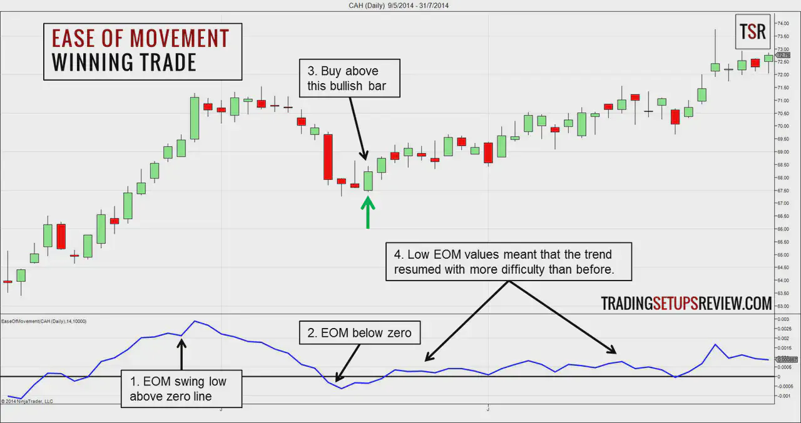

VWAP (volume-weighted average price)  
buy first closing price above vwap and vice versa  
vwap line as support/resistance level  
buy if break above vwap then pullback to vwap and vice versa  
exit area if price touches vwap from below  
stop loss slightly below vwap  
vwap channel with 2 std deviations: buy if breaks lower boundary and reenters the channel

Volatility Indicators

Bollinger Bands  
In a ranging market, trade the bounce: long if price touches lower band, and lower band = support line, and bullish divergence in RSI or stochastic  
Bollinger Band squeeze then buy/short in trend direction; stop loss beyond the other band  
buy if upward trend and pullback to lower/middle band and RSI/stochastic divergence  
if double bottom and the second bottom stays inside channel -> trend reversal

Keltner Channel  
buy if close below lower band  
buy if price below lower band and price rises towards lower band  
  
https://www.fxtradingrevolution.com/strategies/the-bb-momentum-keltner-channel-trading-strategy  
1. The upper and lower borders of the Bollinger Bands indicator should cross with the Keltner Channel borders, and then Keltner Channel should be inside the Bollinger Bands channel and move up.  
2. The signal candle should be above the midline of the Keltner Channel indicator.  
3. Momentum indicator should move up.  
  
Buy if:  
1 The price has penetrated and closed above the Upper channel or closed below the lower channel and started an uptrend or downtrend.  
2 Average Directional Index confirms the start of the trend by showing a reading above 25  
  
Sell if:  
1 The price has penetrated and closed above the lower channel and started a downtrend.  
2 price retraces to middle or higher band  
2 stochastic shows overbought

Donchian Channel  
https://www.netpicks.com/donchian-channel/  
Is the ADX above 25? Yes – continue No – stand aside  
Price above 100 SMA? Yes – longs – No – shorts  
Breakout in direction of 100 SMA? – Yes – trade signal No – stand aside  
  
Buy if donchian upper band makes higher high after lower lows  
and price above 200EMA  
  
buy if MACD.blue crosses red upwards at the same time as upper donchian band makes higher high  
  
If the stock rises above the middle band of the Donchian channels, then you can open a long position. On the contrary, if the stock is trading below the middle band of the Donchian channel, then a trader can open a short position.

ATR (Average True Range)  
overlay a moving average and use it as signal line. Wait for crosses  
  
gives a trend change signal