# Java Basics – Debugging

The goal of this lab is to practice **debugging techniques** in scenarios where a piece of code does not work correctly. Your task is to pinpoint the bug(s) and fix it (without rewriting the entire code).

## Set up your debugger in Eclipse

Your first task is to configure the **debugger** in Eclipse so that you are comfortable using it.

Set a breakpoint in your program:

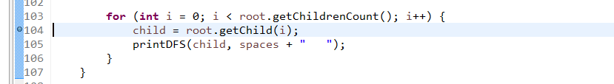

And start the debugger:

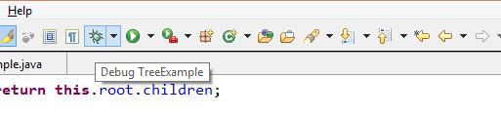

The debugging perspective should appear:

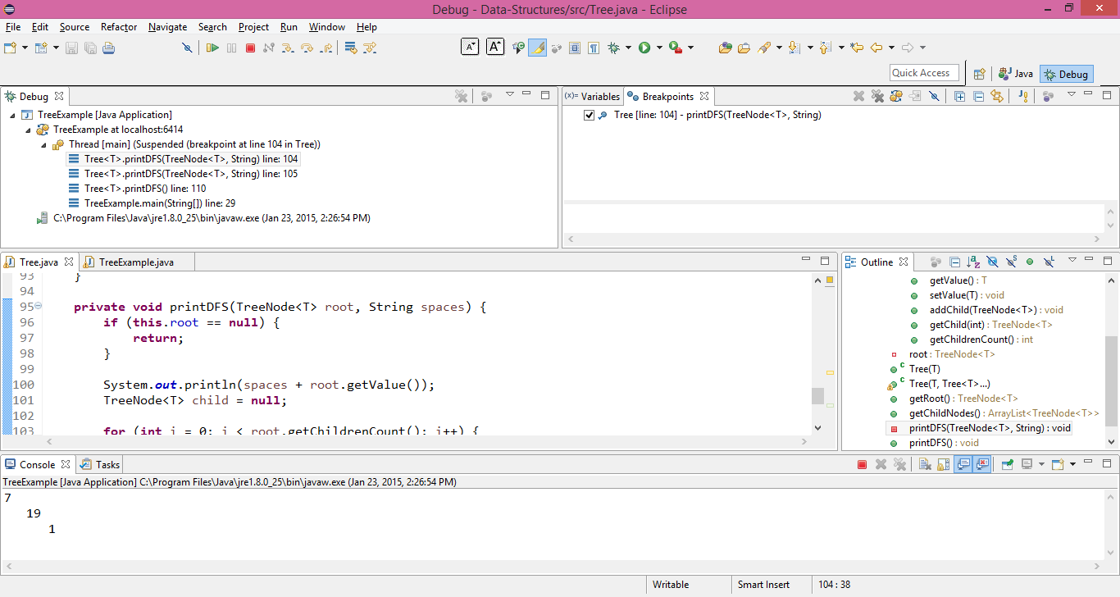

However, it's pretty messy. Modify it to your taste by moving the windows around. The following windows should be visible:

* **Variables** – shows all local variables and their value.
* **Debug** – shows the **call stack** (all the methods in the order they were called + line number).
* **Breakpoints** – displays all the breakpoints placed.
* **Console** – shows the output in the console.

The result should be something much more structured.

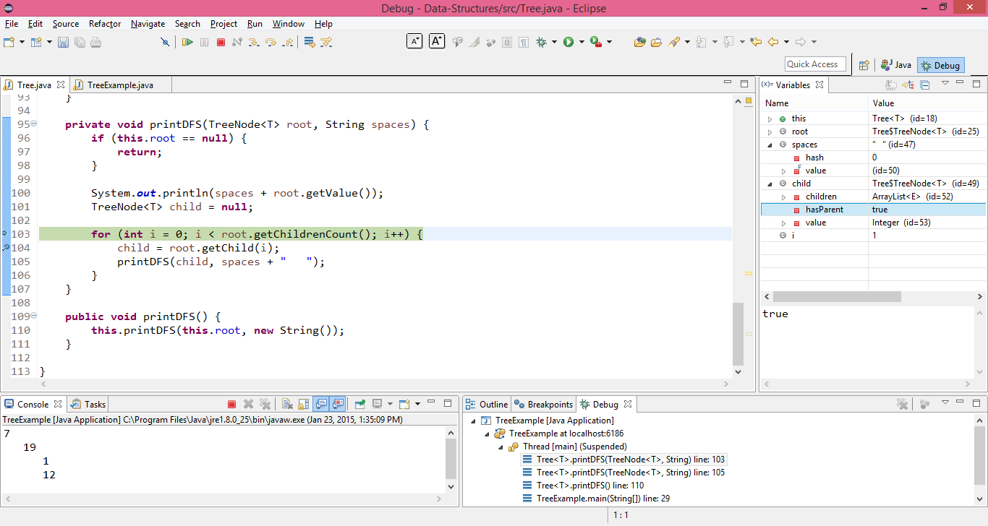

## Placing Breakpoints

Open the provided **AverageSum.java** program for practicing debugging.

* A **breakpoint** stops execution at a specific line of code. To add a breakpoint, click to left of a line number.



The next time the program is run in **debug mode**, it will stop execution when/if it reaches that line of code, allowing us to analyze the program variables.

* A **conditional breakpoint** stops execution only if a certain condition is met (e.g. **i == 3** in a loop). It is added by setting a normal breakpoint > **right click** > **Breakpoint Properties**.

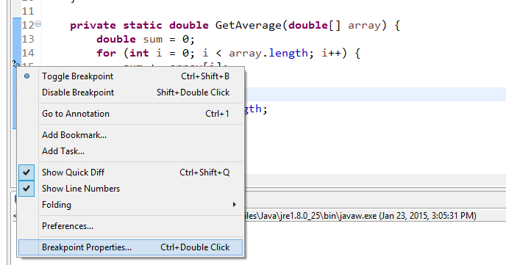

We then a condition (e.g. **i == 3**).

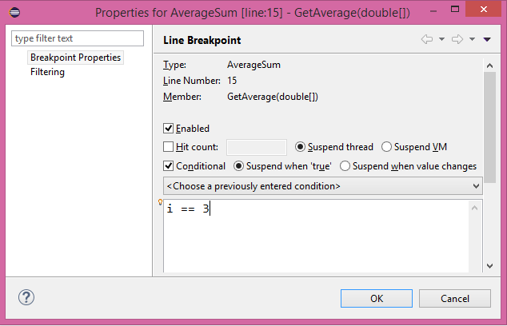

When we debug, the program will stop execution at the given line **only** when **i = 3**.

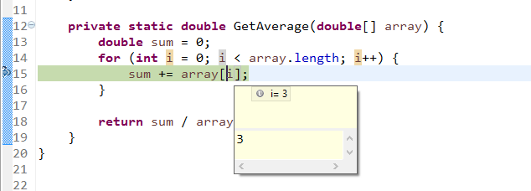

## Stepping through the code

When debugging, we can go line by line and analyze how our variables change as our program executes.

The **current line of execution** is shown by a blue arrow called the Current Instruction Pointer.

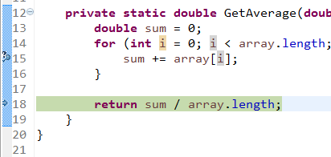

Stepping through our lines of code can be done using the following commands:

* **Step into (F5)** – executes the current line and enters the method
* **Step over (F6)** – executes the current line without entering the method
* **Step return (F7)** – exits the current method
* **Resume (F8)** – resumes program execution to the end (stops if it reaches another breakpoint)

Or by using the toolbar on the top:

