Alana Brunson
Joselyn Gil-Diaz
Nicolas Ruiz Rodriguez
January 27, 2020
Pac-Man: Game Analysis

INTRO
- Pac-Man is a maze arcade game developed by Namco in 1980. In game, the player must eat all white dots in the room to complete and proceed to the next level. The goal is to gain as many points as possible. Pac-Man's enemies are four ghosts who try to hunt him down, taking away a life every time they catch him until the game finally ends. They roam inside the maze rotating between chase and wander modes. In the beginning of each level, four larger dots appear in every corner. Once consumed by Pac-Man, ghosts will turn blue and become frightened, giving him a chance to fight back by eating them. Random fruits and items will also pop up time to time for bonus points. As for story, the game has no need to focus on one. No explanation is beneficial for continuous, repetitive gameplay.

World Construction
The world layout is a single-screen blue maze, built with no dead ends and left/right pathways centered on each side. Going through these pathways teleports Pac-Man to the other end, making it a good evade tactic. Before gameplay begins, three ghosts – Inky (blue), Pinky (pink), and Clyde (orange) – spawn inside the ghost house, or the box located in the center of the level. Blinky (red), however, starts off just outside the white door. Pac-Man spawns as a yellow circle a few tiles below in his idle position.

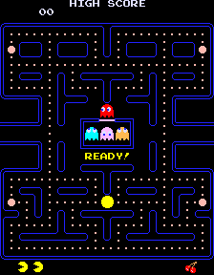
There are 240 dots spread throughout the level on every open tile, excluding those surrounding the ghost house and left/right pathways. The larger dots or "power pellets" appear in all four corners with flashing animations. This layout stays consistent after every death or level progression. The technical board is 3:4 or 224x288 with 28x36 tiles.

Progression Management
If the player consumes all dots and pellets, Pac-Man disappears and the maze flashes as a sign of a level win. It then resets with everyone back in their positions. The dots reappear and the next level begins. The original game was developed to be endless but technically only has 255 levels. This is because the 256th room is deemed unplayable, therefore labeling it its unofficial end. Several display errors and invisible blocks make it impossible to collect dots on the right side of the screen.

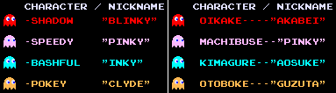

Enemy Behavior
Enemy Mechanics – Modes
- Chase
  - Will be assigned their target tiles
- Scatter
  - Each ghost has a fixed target tile outside of the map that causes them to run around in circles in their selective corners until alerted
- Frightened
  - No target tiles
  - Randomly decide which directions to turn

Path finding – Tile Targeting
- Blinky

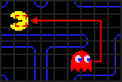
  - Begins chasing the tile Pac-Man is on
  - His speed is mathematically based on the number of dots remaining, making even scatter mode difficult

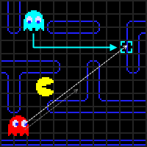
- Inky

  - Calculates target tile by combining the second tile in front of Pac-Man and Blinky's location.

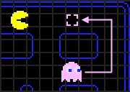
- Pinky

  - Chases 4 tiles in front of Pac-Man, meaning if the player turns around while she's on his tail, she will switch paths

- Clyde

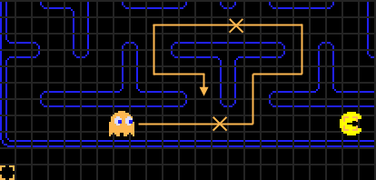
  - If he's further than 8 tiles from Pac-Man, Clyde will target his current tile
  - If he's inside this circle, he will change to scatter mode. This means his target tile switches to the lower left corner.

Attacks
- Cannot go in reverse even if Pac-Man is directly behind
- Can only happen in the split second their modes change
  - If they're in chase mode and a power pellet is eaten, then they will become frightened and run backwards

How Long Ghost Modes Change - Level 1
- Scatters board for 7 seconds, chases for 20
- Scatters board for 7 seconds, chases for 20
- Scatters board for 5 seconds, chases for 20
- Scatters board for 5 seconds, chases endlessly
- Changes difficulty at level 2 then 5

Player Controller
Pac-Man can be controlled with joysticks, handheld controllers, WASD buttons, or arrow keys depending on the device. The player's only options are to move up, down, left, or right. There are no special keys or combos used in game.

