High-Level Design (HLD) - Backend
ECommerce Product Management System

1. System Overview
The backend follows a microservices architecture with four independent services exposed via an API Gateway. It ensures scalability, separation of concerns, and secure role-based access using JWT.

2. Architecture
Frontend (Angular) communicates with backend services through Ocelot API Gateway, which routes requests to:
- Auth Service
- Catalog Service
- Product Workflow Service
- Admin/Reporting Service

3. API Gateway
Acts as a single entry point. Handles routing, authentication forwarding, and request aggregation.
Routes:
/gateway/auth/*
/gateway/catalog/*
/gateway/workflow/*
/gateway/admin/*

4. Authentication & Authorization
JWT-based authentication. Token issued by Auth Service and validated across services.
Role-based access using claims like Admin, ProductManager, ContentExecutive.

5. Microservices

5.1 Auth Service
Handles signup, login, JWT generation, and user roles.

5.2 Catalog Service
Manages product data, categories, media, and product CRUD operations.

5.3 Product Workflow Service
Manages pricing, inventory, approval workflows, and product lifecycle transitions.

5.4 Admin/Reporting Service
Handles dashboards, audit logs, reporting, and data exports.

REST API Summary (By Service + Gateway)
Postman and Swagger/OpenAPI should be used for endpoint testing and documentation.
Service | Method + Route | Purpose | Gateway Example
Identity/Auth | POST /api/auth/signup | Create user account | /gateway/auth/signup
Identity/Auth | POST /api/auth/login | Validate credentials and issue JWT | /gateway/auth/login
Catalog | GET /api/products | List/search products | /gateway/catalog/products
Catalog | GET /api/products/{id} | Fetch product detail | /gateway/catalog/products/{id}
Catalog | POST /api/products | Create a product | /gateway/catalog/products
Catalog | PUT /api/products/{id} | Update product metadata | /gateway/catalog/products/{id}
Product Workflow | PUT /api/workflow/products/{id}/pricing | Save or update pricing | /gateway/workflow/products/{id}/pricing
Product Workflow | PUT /api/workflow/products/{id}/inventory | Save stock data | /gateway/workflow/products/{id}/inventory
Product Workflow | POST /api/workflow/products/{id}/submit | Submit product for review | /gateway/workflow/products/{id}/submit
Product Workflow | PUT /api/workflow/products/{id}/status | Approve/reject/publish/archive | /gateway/workflow/products/{id}/status
Admin/Reporting | GET /api/reports/dashboard | Load dashboard KPIs | /gateway/admin/reports/dashboard
Admin/Reporting | GET /api/audit/products/{id} | Load product audit history | /gateway/admin/audit/products/{id}

6. Database Design
Each service has its own database using EF Core Code-First approach to ensure loose coupling.
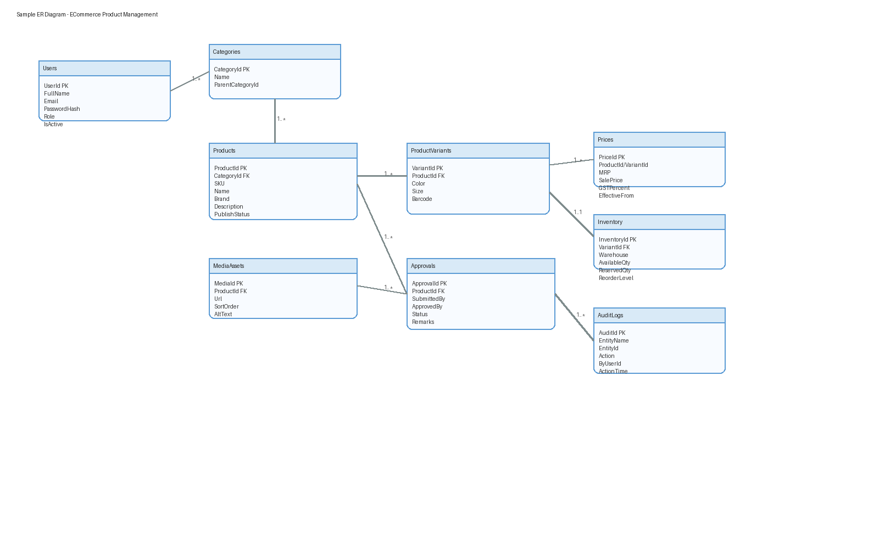

7. Inter-Service Communication
Currently uses REST APIs. Future enhancement includes event-driven architecture using RabbitMQ.

8. Product Lifecycle
Draft → Enrichment → Ready for Review → Approved → Published → Archived
Rejected state allows rework.

9. Design Patterns
API Gateway Pattern, Microservices Pattern, Repository Pattern, DTO Pattern, RBAC.

10. Security
JWT validation, role-based authorization, DTO validation, and isolated databases per service.

11. Scalability
Supports scaling of individual services. Future improvements include caching, messaging queues, and distributed logging.

12. Summary
The system uses a 4-service microservices architecture with an API Gateway and dedicated workflow service to manage product lifecycle independently from catalog data.

