**EV (electric vehicle) range analysis and calculation**

*The project is used as application documentation supplement to presents some of the users technical and problem solving skills.*

**Task:** The task is to analyze influential factors on the EV WLTP consumption and create approximation model for defining WLTP consumption for given parameters.

**Description:** In the first part of the project the main influential factors of EV WLTP consumption are determined and database that contains them is built. In second part database is used to create a model that predicts EV WLTP consumption based on influential factors. Consumption that is calculated in this project is **WLTP Combined consumption** so further only one **consumption** will be used interchangeably.

**First part – influential factors and database**

The WLTP stands for Worldwide Harmonized Light-Duty Test Procedure and it is a global vehicle testing system that predicts fuel economy, emissions, and electric vehicle range. WLTP fuel consumption figures are measured in miles per gallon (the distance you can travel in miles per gallon of fuel used). The tests take place at four different speed ranges:

Extra high: up to 81mph

High: up to 60mph

Medium: up to 47mph

Low: up to 35mph

These speeds are then averaged out to give a 'WLTP Combined' figure. First, influential factors on consumption needs to be determined from vehicle specifications. To get the data from reliable source [ADAC online catalog](https://www.adac.de/rund-ums-fahrzeug/autokatalog/marken-modelle/autosuche/?engineTypes=Elektro&pageNumber=1) of EVs is used as a reference.

**Creating database**

Database is created by scraping the data from catalog and saving it in one Excel file. To see the Python code on how this step is done click **here**.

**Cleaning and analyzing database**

Main factors that influence consumption are aerodynamic drag, rolling resistance and vehicles weight. To describe those influences from available vehicle specification these dataset attributes are used:

* **Width and height of vehicle (aerodynamic drag)** – when multiplied they will represent frontal area of the vehicle because that is the only value that changes in [equation](https://www.grc.nasa.gov/www/k-12/rocket/drageq.html)
* **Vehicles weight (rolling resistance is also included here because the most influential factor on the rolling resistance is weight)**

Dataset is then reduced to those factors and cleaned from duplicates and nonexistent values. To see the Python code on how this step is done click **here**.

Correlation between mentioned factors and consumption can be seen on the next diagrams.

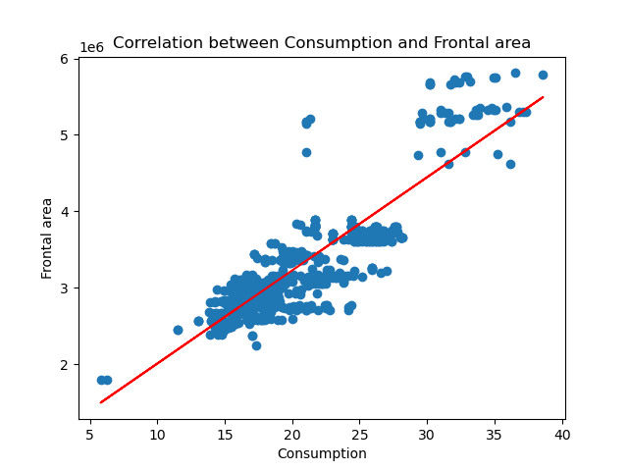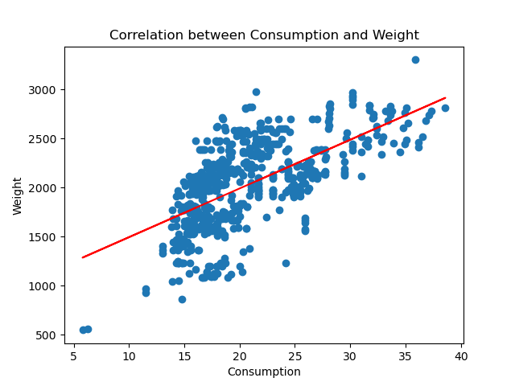

**Second part – building and testing the approximation model**

Approximation model will be created as small neural network.Network is built from one input normalization layer following 2 hidden layers with ReLu activation functions. To see the Python code on how this step is done click **here**.

**Loading and data inspection**

The data is loaded in the code and inspected once again before building a model. The top row suggests that the consumption is a function of all the other parameters. The other rows indicate they are functions of each other.

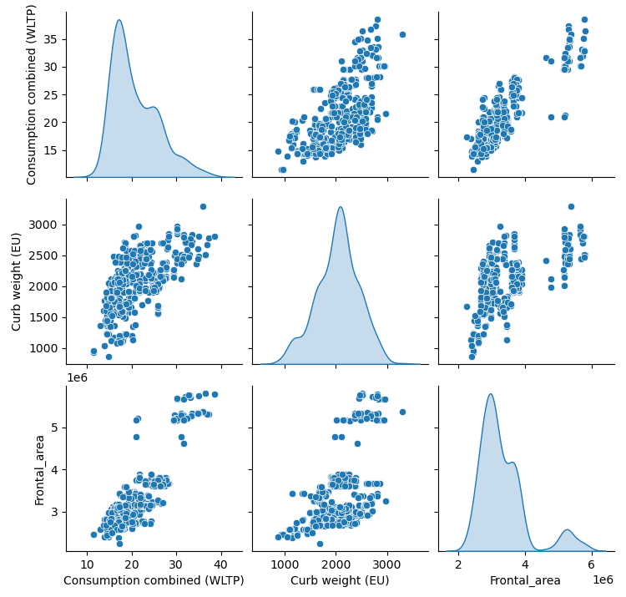

**Neural network**

The dataset is then divided into train and test dataset. After division neural network is created then trained and tested. For loss function mean absolute error is used and final value is around 1.8. Other parameters that show the accuracy of a model are listed here.

**Loss:**

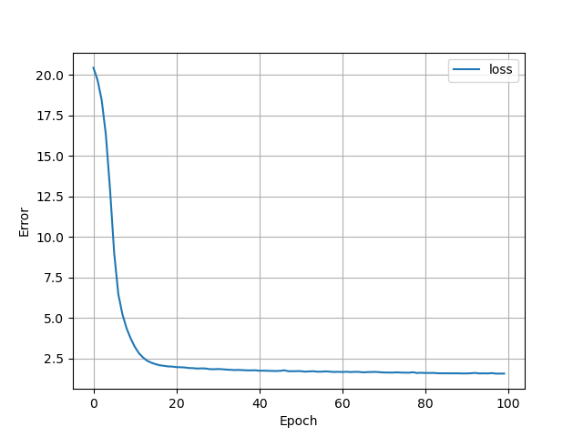

**True values versus prediction:**

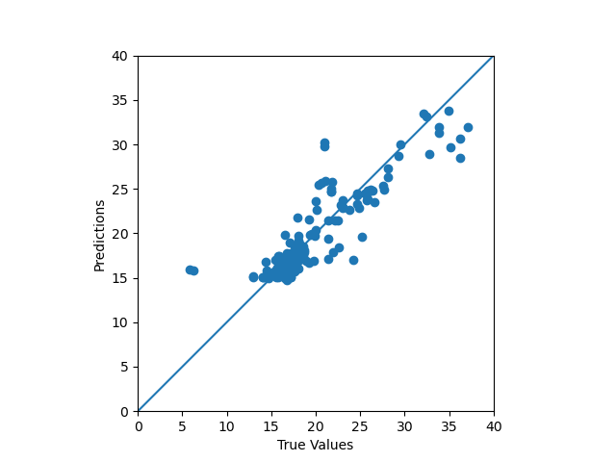

**Error distribution:**

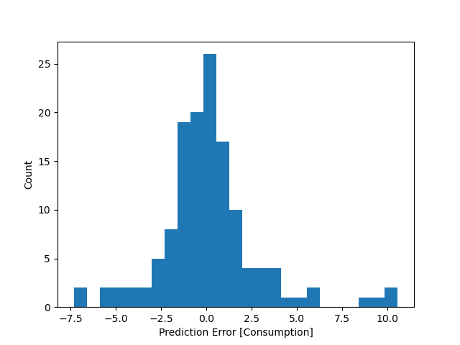

On the end it is concluded that model satisfies task requirements and it is saved so we can use it in a future.