Univerzita Pardubice

Fakulta elektrotechniky a informatiky

Semestrální práce z předmětu NNPIA

Bc. Nikola Jačková

Semestrální práce

2022

Obsah

Library Spring Application 3

API Reference 3

USERS 3

LIBRARY 4

BOOKS 4

GENRES 5

Database model 7

Authorization and authentication 7

Roles 7

# Library Spring Application

This project is part of the semester work from the subject NNPIA.

## API Reference

### USERS

#### Get all users

GET /api/v1/users

#### Get user according to username

GET /api/v1/users/${username}

| **Parameter** | **Type** | **Description** |
| --- | --- | --- |
| username | string | **Required**. Username of user to fetch |

#### Register new user

POST /api/v1/register

#### Authenticate user

POST /api/v1/authenticate

#### Update user

PUT /api/v1/users/${username}

| **Parameter** | **Type** | **Description** |
| --- | --- | --- |
| username | string | **Required**. Username of user to fetch |

#### Delete user

DELETE /api/v1/users/${username}

| **Parameter** | **Type** | **Description** |
| --- | --- | --- |
| username | string | **Required**. Username of user to fetch |

### LIBRARIES

#### Get all libraries

GET /api/v1/libraries

#### Get library according to id

GET /api/v1/libraries/${id}

| **Parameter** | **Type** | **Description** |
| --- | --- | --- |
| id | int | **Required**. Id of library to fetch |

#### Create library

POST /api/v1/libraries

#### Update library

PUT /api/v1/libraries/${id}

| **Parameter** | **Type** | **Description** |
| --- | --- | --- |
| id | int | **Required**. Id of library to fetch |

#### Delete library

DELETE /api/v1/libraries/${id}

| **Parameter** | **Type** | **Description** |
| --- | --- | --- |
| id | int | **Required**. Id of library to fetch |

### BOOKS

#### Get all books in library

GET /api/v1/libraries/${libraryId}/books

| **Parameter** | **Type** | **Description** |
| --- | --- | --- |
| libraryId | int | **Required**. Id of library to fetch |

#### Get book according to id

GET /api/v1/libraries/${libraryId}/books/${id}

| **Parameter** | **Type** | **Description** |
| --- | --- | --- |
| libraryId | int | **Required**. Id of library to fetch |
| id | int | **Required**. Id of book to fetch |

#### Create book in library

POST /api/v1/libraries/${libraryId}/books

| **Parameter** | **Type** | **Description** |
| --- | --- | --- |
| libraryId | int | **Required**. Id of library |

#### Update book

PUT /api/v1/libraries/${libraryId}/books/${id}

| **Parameter** | **Type** | **Description** |
| --- | --- | --- |
| libraryId | int | **Required**. Id of library |
| id | int | **Required**. Id of book to update |

#### Delete book

DELETE /api/v1/libraries/${libraryId}/books/${id}

| **Parameter** | **Type** | **Description** |
| --- | --- | --- |
| libraryId | int | **Required**. Id of library |
| id | int | **Required**. Id of book to delete |

### GENRES

#### Get all genres

GET /api/v1/genres

#### Get genre according to id

GET /api/v1/genres/${id}

| **Parameter** | **Type** | **Description** |
| --- | --- | --- |
| id | int | **Required**. Id of genre to fetch |

#### Create library

POST /api/v1/genres

#### Update library

PUT /api/v1/genres/${id}

| **Parameter** | **Type** | **Description** |
| --- | --- | --- |
| id | int | **Required**. Id of genre to fetch |

#### Delete library

DELETE /api/v1/genres/${id}

| **Parameter** | **Type** | **Description** |
| --- | --- | --- |
| id | int | **Required**. Id of genre to fetch |

## Database model

PostgreSQL was used as a database system.

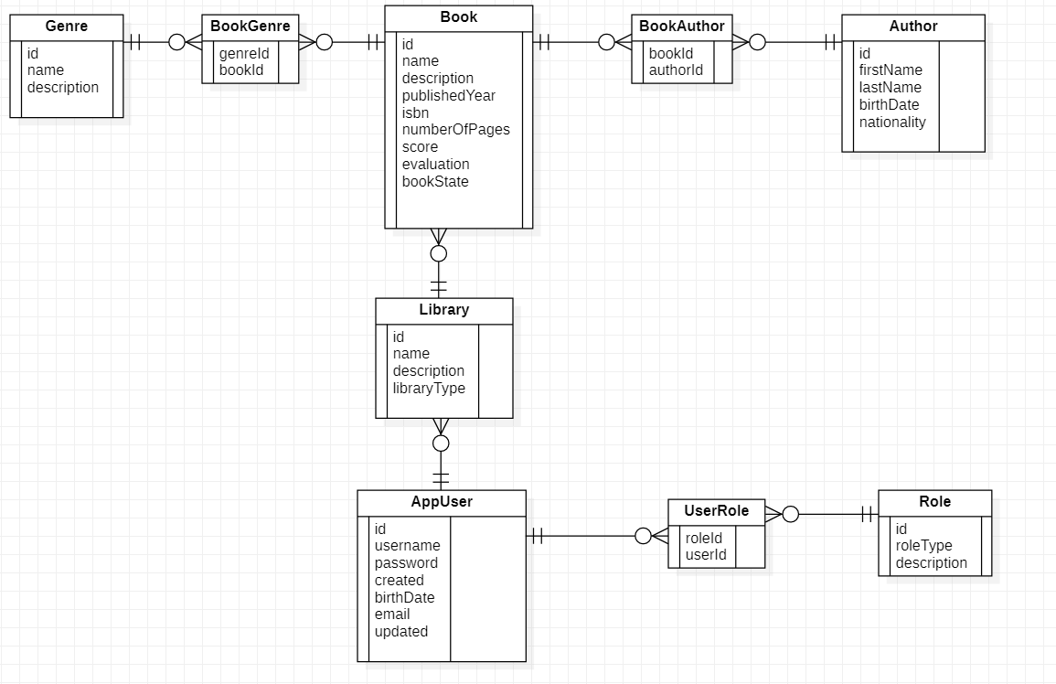

## Authorization and authentication

### Roles

|  |  |
| --- | --- |
| **Roles** | **Description** |
| ADMIN | Admin user. |
| USER | Standard user. |

Every registered user has at least one role. When the user is created, the USER role is assigned to him.

Every user with USER role can create, update or delete own libraries and books. He can also edit his profile.

Every user with ADMIN role can create or delete genres.

Password is encrypted with BCrypt.

# Library React Application

This project is part of the semester work from the subject NNPIA.

## GUI

### USERS

Login page – user can log in with his username and password.

Register page – user can register with unique username and email and password

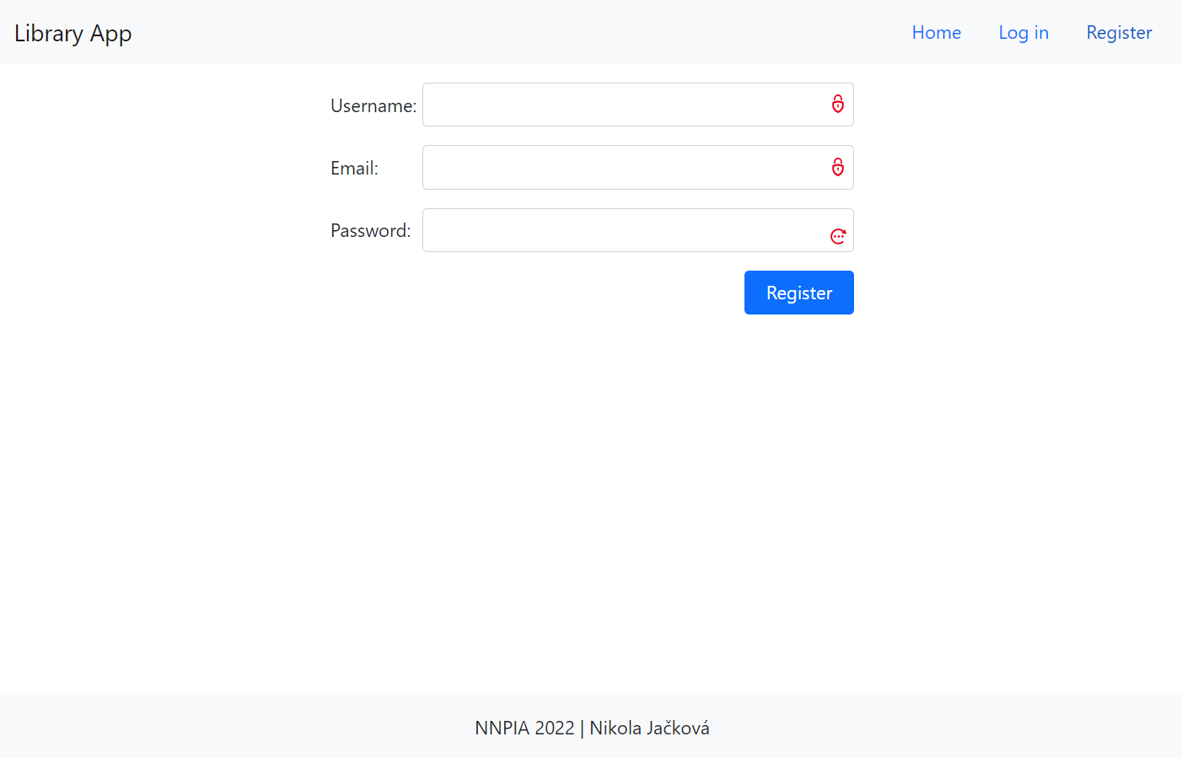

### LIBRARIES

Page with users libraries - user can add new library with upper form and can delete a library showed in table. The name of the library is link to detail page of library.

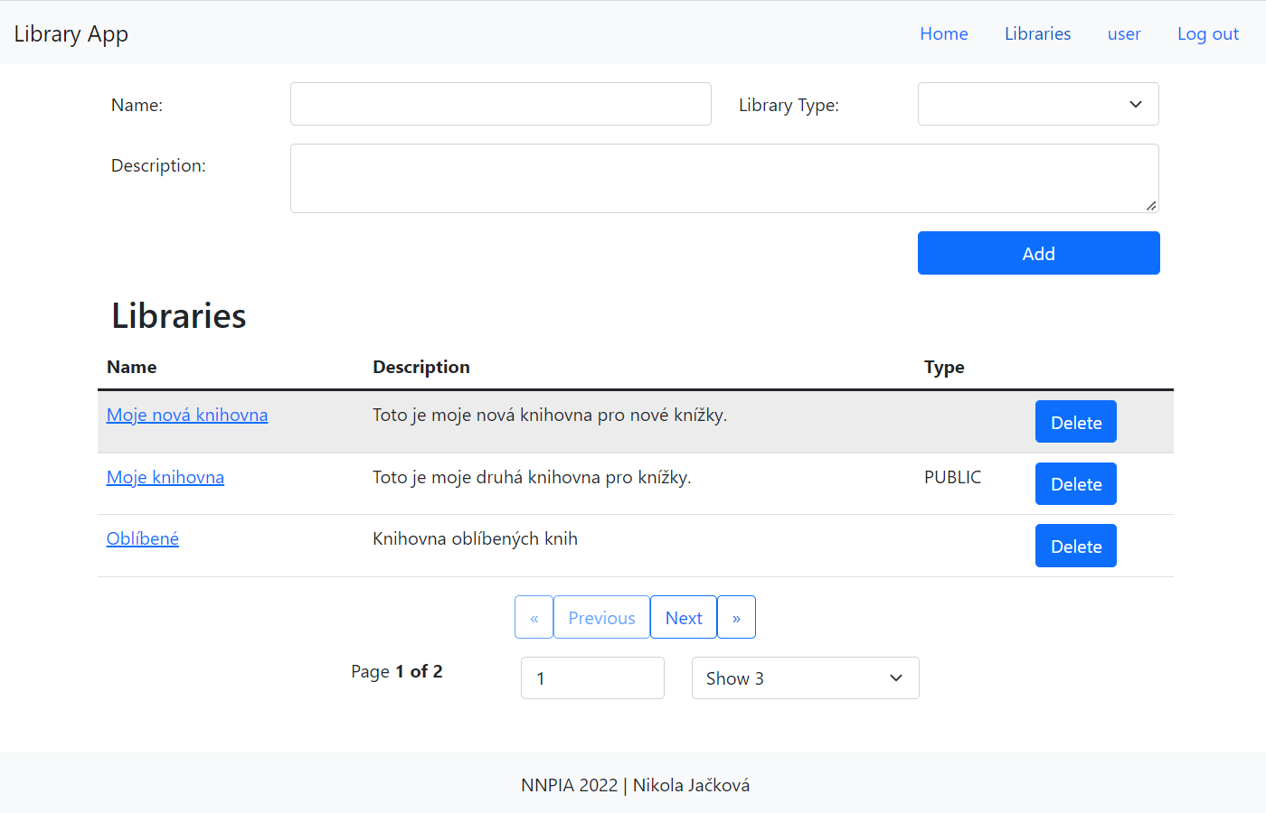

Detail page of library – user can edit attributes of library and add new book into library, he can also delete a book from this library. The name of the name is link to detail page of book.

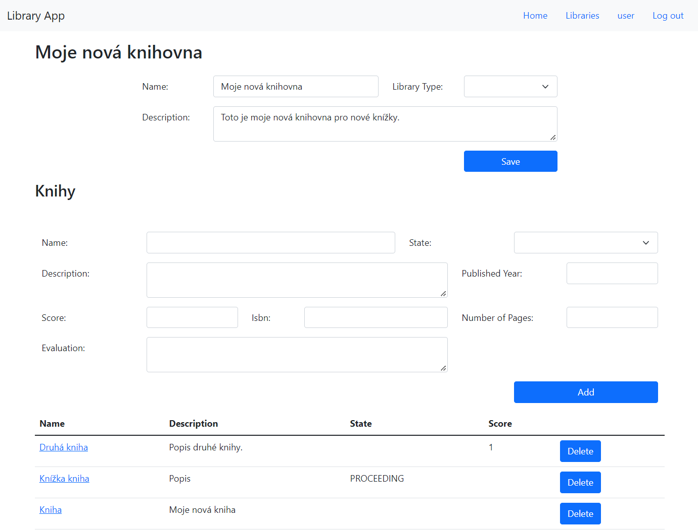

### BOOKS

Detail page of book – user can edit attributes of a book and can also set genres for this book; he can also copy this book to another library with button Copy.

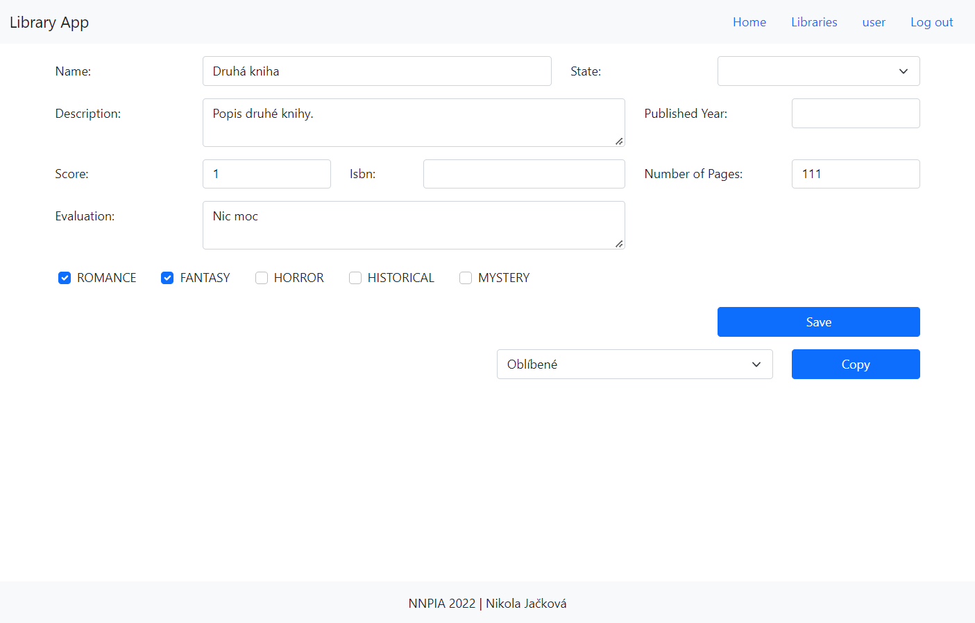

### GENRE

Genres page – admin can add and delete generes

