Univerzita Pardubice

Fakulta elektrotechniky a informatiky

Semestrální práce z předmětu NNPIA

Bc. Nikola Jačková

Semestrální práce

2022

Obsah

Library Spring Application 3

API Reference 3

USERS 3

LIBRARY 4

BOOKS 4

GENRES 5

Database model 7

Authorization and authentication 7

Roles 7

# Library Spring Application

This project is part of the semester work from the subject NNPIA.

## API Reference

### USERS

#### Get all users

GET /api/v1/users

#### Get user according to username

GET /api/v1/users/${username}

| **Parameter** | **Type** | **Description** |
| --- | --- | --- |
| username | string | **Required**. Username of user to fetch |

#### Register new user

POST /api/v1/register

#### Authenticate user

POST /api/v1/authenticate

#### Update user

PUT /api/v1/users/${username}

| **Parameter** | **Type** | **Description** |
| --- | --- | --- |
| username | string | **Required**. Username of user to fetch |

#### Delete user

DELETE /api/v1/users/${username}

| **Parameter** | **Type** | **Description** |
| --- | --- | --- |
| username | string | **Required**. Username of user to fetch |

### LIBRARY

#### Get all libraries

GET /api/v1/libraries

#### Get library according to id

GET /api/v1/libraries/${id}

| **Parameter** | **Type** | **Description** |
| --- | --- | --- |
| id | int | **Required**. Id of library to fetch |

#### Create library

POST /api/v1/libraries

#### Update library

PUT /api/v1/libraries/${id}

| **Parameter** | **Type** | **Description** |
| --- | --- | --- |
| id | int | **Required**. Id of library to fetch |

#### Delete library

DELETE /api/v1/libraries/${id}

| **Parameter** | **Type** | **Description** |
| --- | --- | --- |
| id | int | **Required**. Id of library to fetch |

### BOOKS

#### Get all books in library

GET /api/v1/libraries/${libraryId}/books

| **Parameter** | **Type** | **Description** |
| --- | --- | --- |
| libraryId | int | **Required**. Id of library to fetch |

#### Get book according to id

GET /api/v1/libraries/${libraryId}/books/${id}

| **Parameter** | **Type** | **Description** |
| --- | --- | --- |
| libraryId | int | **Required**. Id of library to fetch |
| id | int | **Required**. Id of book to fetch |

#### Create book in library

POST /api/v1/libraries/${libraryId}/books

| **Parameter** | **Type** | **Description** |
| --- | --- | --- |
| libraryId | int | **Required**. Id of library |

#### Update book

PUT /api/v1/libraries/${libraryId}/books/${id}

| **Parameter** | **Type** | **Description** |
| --- | --- | --- |
| libraryId | int | **Required**. Id of library |
| id | int | **Required**. Id of book to update |

#### Delete book

DELETE /api/v1/libraries/${libraryId}/books/${id}

| **Parameter** | **Type** | **Description** |
| --- | --- | --- |
| libraryId | int | **Required**. Id of library |
| id | int | **Required**. Id of book to delete |

### GENRES

#### Get all genres

GET /api/v1/genres

#### Get genre according to id

GET /api/v1/genres/${id}

| **Parameter** | **Type** | **Description** |
| --- | --- | --- |
| id | int | **Required**. Id of genre to fetch |

#### Create library

POST /api/v1/genres

#### Update library

PUT /api/v1/genres/${id}

| **Parameter** | **Type** | **Description** |
| --- | --- | --- |
| id | int | **Required**. Id of genre to fetch |

#### Delete library

DELETE /api/v1/genres/${id}

| **Parameter** | **Type** | **Description** |
| --- | --- | --- |
| id | int | **Required**. Id of genre to fetch |

## Database model

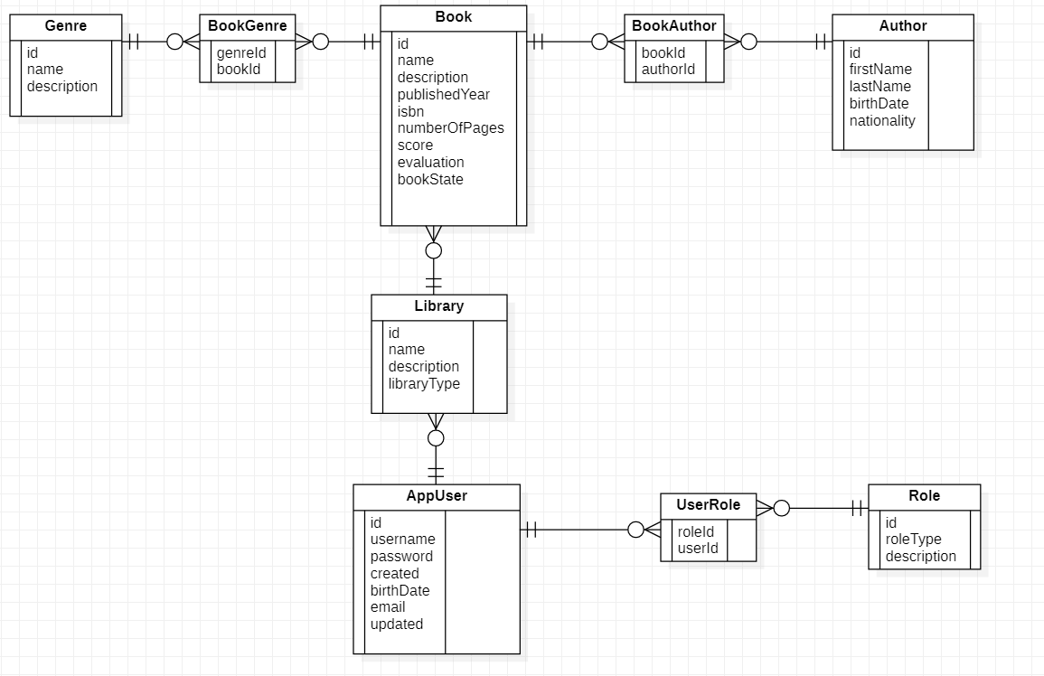

## Authorization and authentication

### Roles

|  |  |
| --- | --- |
| **Roles** | **Description** |
| ADMIN | Admin user. |
| USER | Standard user. |

Every registered user has at least one role. When the user is created, the USER role is assigned to him.

Every user with USER role can create, update or delete own libraries and books. He can also edit his profile.

Every user with ADMIN role can create or delete genres.