Getting Started with ENEXA
A step-by-step walkthrough for accepting ENEXA portfolio invitation, setting a password, and accessing the ENEXA platform for the first time.
BEFORE YOU BEGIN
⚙ | Access to ENEXA is invitation-based. Your administrator must send you an invitation before you can create an account. If you have not received an invitation email, please contact your system administrator.

Once your administrator has added you to the portfolio, the onboarding process consists of five steps:
- Step 1 Receive and open the invitation email
- Step 2 Navigate to the account update page
- Step 3 Set a new password
- Step 4 Confirm your account is updated and sign in
- Step 5 Receive platform role confirmation and access ENEXA modules

Step 1 Open the Invitation Email
When your administrator adds you to an ENEXA portfolio, you will receive an automated email from the platform. Check your inbox for an email with “Update Your Account” subject line.

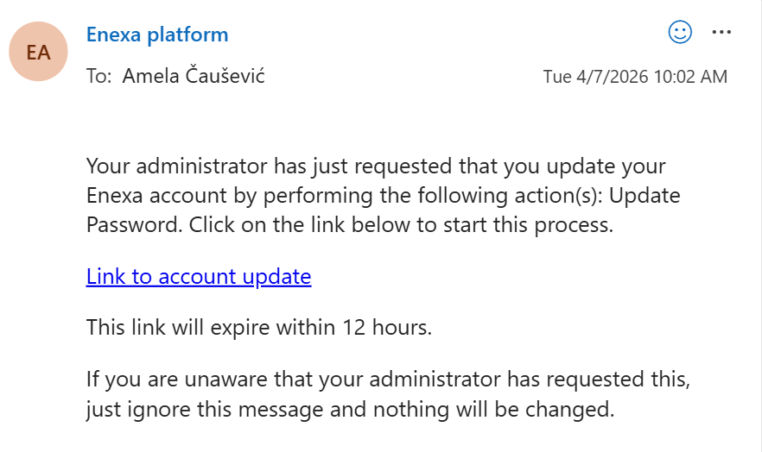
Figure 1: Invitation email from ENEXA Platform requesting a password update
The email contains a clickable link to begin the password setup process. The link is valid for 12 hours from the time the email was sent. Click Link to account update to proceed to the next step.

Step 2 Navigate to the Account Update Page
Clicking the link in the email opens the ENEXA platform in your browser and enables you to proceed to the account update page.
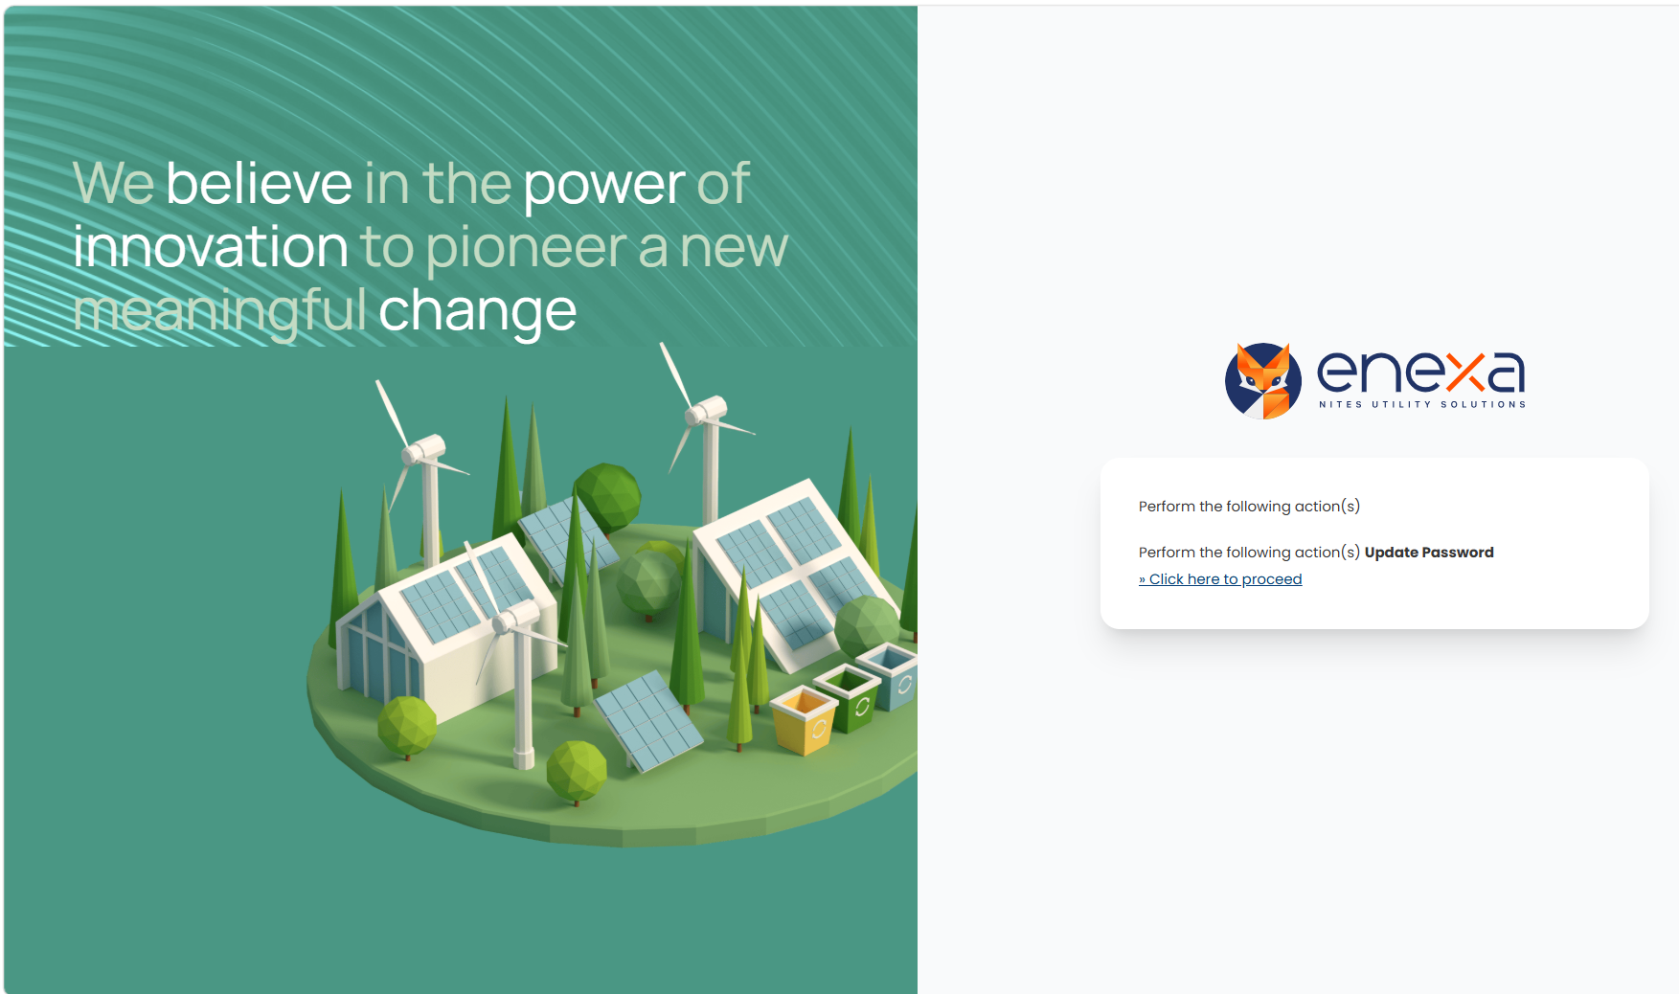
Figure 2: ENEXA account update landing page — click » Click here to proceed
Click » Click here to proceed in the right-hand card to open the password update form.

Step 3 Set a New Password
The Update password screen opens in your browser. Enter and confirm your new password to activate your ENEXA account.
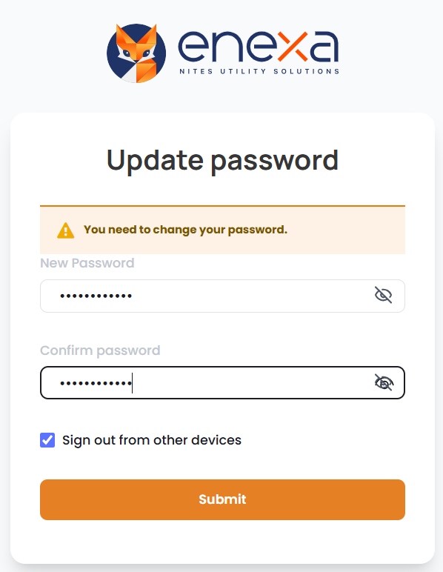
Figure 3: Update password form

Complete the form as follows:
- New Password enter a strong password. The field masks input by default; click the eye icon on the right to toggle visibility.
- Confirm password re-enter the same password to confirm it matches.
- Sign out from other devices – this checkbox is ticked by default. Leave it ticked to ensure any existing sessions on other devices are terminated when your password is updated.
- Submit button click Submit to save your new password. The system will validate that both password fields match before proceeding.

Step 4 Confirm Account Update and Sign In
After submitting your new password, a confirmation screen is displayed. Your account is now active.

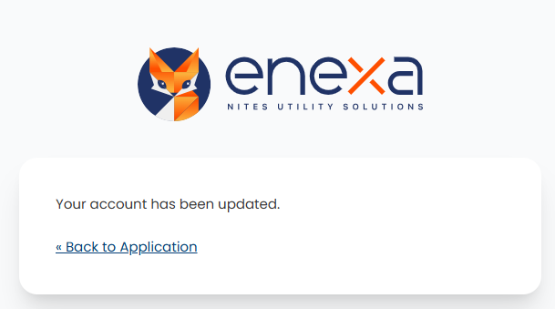
Figure 4: Account updated confirmation
« Back to Application click this link to navigate to the ENEXA sign-in page. The sign-in page opens. Enter your credentials to access the platform.

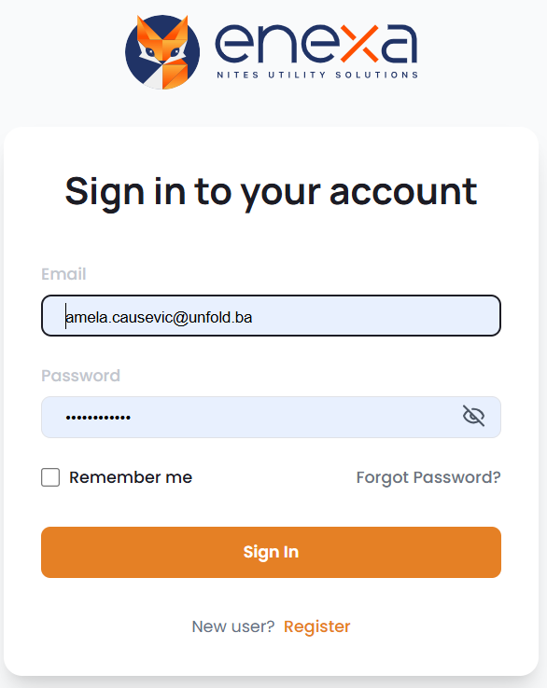
Figure 5: ENEXA sign-in page

- Email enter the email address to which the invitation was sent.
- Password enter the password you set in Step 3.
- Remember me tick this box to keep your session active on this device across browser sessions.
- Forgot Password? if you cannot remember your password, click this link to start the password reset flow.
- Sign In button click to authenticate and enter the platform.

Step 5 Receive Role Confirmation and Access Modules
After your administrator assigns your platform roles, you will receive a second automated email from the ENEXA Platform confirming which roles have been granted.

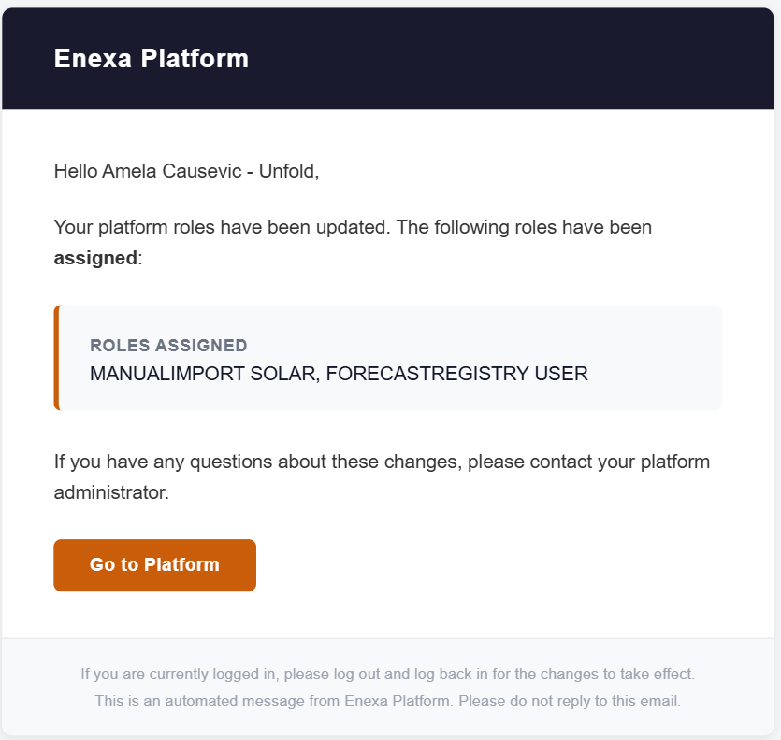
Figure 6: Platform roles update email listing the roles assigned to your account

The roles confirmation email contains
Greeting addressed to your name as registered in the platform
ROLES ASSIGNED section lists all roles that have been granted to your account (e.g. MANUALIMPORT SOLAR, FORECASTREGISTRY USER)
Go to Platform button click to open the ENEXA platform directly. If you are already signed in, this takes you to the Modules page.
Session note the footer reminds you that if you are currently logged in, you must log out and log back in for the role changes to take effect.

Accessing ENEXA Modules
Once signed in with your assigned roles, you have access to the ENEXA Modules page. Available modules are displayed as cards, grouped by product area.
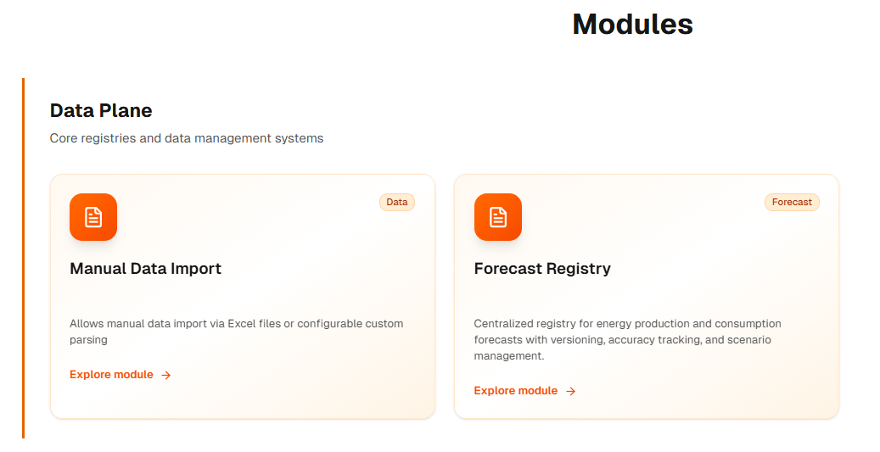
Figure 7: ENEXA Modules page — select a module card to begin working

The Data Plane group contains the core modules you will use day-to-day:
- Manual Data Import allows manual data import via Excel files or configurable custom parsing. Click Explore module to open.
- Forecast Registry centralized registry for energy forecasts. Click Explore module to open.

✅ Onboarding Complete
Your ENEXA account is active, and your platform roles have been assigned. Only modules covered by your assigned roles will be accessible. Modules for which you do not have a role will not be shown.

