

**Festival Control System.**

**Project Plan.**

Client: Mister George

Service Provider: Step-Soft

Members: Atanas Naydenov, Dimitar Markov, Dmitrii Orlov, Hristian Vasilev.

Revision 0: Date: 07.03.2016

Revision 1: Date: 08.03.2016

Revision 2: Date: 13.03.2016

Contents

**Project Plan** 3

**Overview:** 3

**Formal client:** 3

**Project Team:** 3

**Current situation:** 4

**Project justification:** 4

**Problem description:** 4

**Project goal:** 5

**Deliverables and non-deliverables:** 5

**Deliverables:** 5

**Non-Deliverables:** 5

**Constraints:** 6

**Project phasing:** 7

**Phase 1:** 7

**Phase 2:** 8

# **Project Plan**

## **Overview:**

Over the duration of 19 weeks, our team will develop a new festival control system for Mr. George. This system is meant to provide services both for the attendees and the organizers. It will rely on modern technologies and cover most of the event management aspects. Our team will implement the full-stack development of the system. It will provide an easier access for the pre-festival registration for the visitors, during-festival access management and data tracking.

## **Formal client:**

Mr. George.

An event administrator from a major event management company based in The Netherlands with a large history of successfully organized festivals. His company is focused mainly on music-related events.

Communication between the Soft-Step team and the client is established via our project coordinator.

For any additional information about the client contact:

Bert Van Gestel.  
 Organisation: Fontys Hogeschool ICT / Engelstalige opleiding  
 Email: b.vangestel@fontys.nl

Location: Rachelsmolen 1 Eindhoven

Telephone number: 08850 71186

## **Project Team:**

Atanas Naydenov

Team Member

Tel: +31 6 83 13 01 57

e-mail: a.naydenov@student.fontys.nl

Dmitrii Orlov

Team Member

Tel: +31 6 83 13 06 38  
 e-mail: dmitry-orlov@hotmail.com

Dimitar Markov

Team Member

Tel: +31 06 83 14 30 87

e-mail: dmarkov23@gmail.com

Hristian Vasilev

Team Member

Tel: +31 06 58 73 22 31

e-mail: intvasilev1@gmail.com

## **Current situation:**

Step-Soft is going to develop a full-stack platform for the undersigned client, Mr. George. The latter contacted our group with a request to produce a more efficient access management system for his future events. In our project, the initial version of the system will be developed and used for the music festival “Universe of Sound”. The system will be agile and developed in regard for an easy optimization for the future events organized by the formal client’s company in prospective.

In the system, currently used by the formal client, the ticketing process is organized in the following way.

The advertisement of the event relies on the physical publishing means, i.e newspapers, flyers, leaflets etc. The potential attendees can order a ticket only by telephoning formal client’s company. The only payment methods are the following: a cash payment at the entrance or a direct bank transfer. Once the transfer is processed, the purchased ticket is delivered to the visitor via post. If the visitor opts for the cash payment, the ticket is issued at the cash desk.

All the visitor information is documented manually and is stored in an excel spreadsheet.

No during-the-event access management is implemented. The formal customer’s company cannot track the status of the system and does not have any real time atomized control over the event’s processes like authorization, reservation, entrance, selling etc.

The average number of attendees on the event varies in the range of 4,000 – 50,000 people. The events organized by formal client’s company are mostly music festivals. If the festival is held for longer than one day, a partner company, specializing in camping site management and logistics, usually provides the accommodation on the festivals.

Mr. George intends to replace the current system with our product. He, being a formal client, is at the same time the main project sponsor.

## **Project justification:**

The client, Mr. George, is currently using an outdated and inefficient system for organizing his events. His company does not rely on any advantages of modern technologies. Having zero web-presence and implementing ‘traditional’ ways of ticketing and event-access management makes the business model of the formal client’s company inefficient, costly and error-prone.

Using a more automatized platform relying on modern technologies will not only facilitate the event management process, but also will generate a higher rate of interest in the events, lower the costs, raise the advertisement reach and increase the profit.

## **Problem description:**

The client wants to try a new event-access management system eliminate the major problems associated to with the currently used one. Thus the system has to be redesigned and replaced by a more efficient, technology-integrated, optimized and self-sustainable platform.

The final product of this project has to cover all the main phases of the event organization and management.

1. Advertisement and social media reach.

2. Registration, ticketing and reservation (accommodation, event activities, etc.)

3. Entrance and event access management

4. During-the-event data control  
 a) Sales

b) Real-time reservations

c) Status tracking

d) System reporting

5. After-the-event data management

## **Project goal:**

The project’s goal is to develop an electronic festival control system that will be highly user-friendly, accessible, and reusable for the future events, organized by the formal client’s company.

Our team has to analyze the current market and modern technologies to determine the optimal solution for our client.

The final product has to ascertain the web presence of event and establish Internet-based, user friendly technique of purchasing the tickets and make it possible to reserve different facilities provided by the event (such as camping sites).   
 The ticketing method has to increase the entrance rate, minimize the error probability, establish better security and reduce the possibility of any ticket fraud.  
 The event-access management technique has to ascertain the finest attendee experience by providing means of communication, payment, verification of the reservations and status control.  
 The data control services provided for the administration of the event have to be reusable, efficient and help to retrieve and manage the data about the current status of the system, event and finances involved in the event.

## **Deliverables and non-deliverables:**

Below are stated the main deliverables and non-deliverables for the project. The further, more detailed and additional information can be found in the Project and System Scope and other relevant documents.

### **Deliverables:**

* Website  
  *Including:*
* event information
* visitor registration
* personal account control
* personal data tracking
* Database
* Covering all the event’s activities and aspects
* Application for controlling the event entrance procedure
* Application for controlling the camping entrance procedure
* Application for the shops and sale points
* Application for the activity reservation
* Application for loaning the necessary equipment for the different event activities
* Application for visitors leaving the event
* Administrative application for data tracking and inspecting the status of the event
* Application for visitor support in cases of identification-related exceptions
* System requirements and documentation
* Presentation about the project and system demonstration
* Setup document
* Process report

### **Non-Deliverables:**

* Banks integration
* Full stock of necessary hardware
* Facility and general event services (such as medical, security, cleaning etc.) management and status tracking system or software
* Transportation services and logistics
* Stage performance and event program management services or software
* Event accommodation
* Staff activity tracking services or software
* Detailed platform costs, budgeting and financial prospects overview

## **Constraints:**

Time:

For completing the whole project our team has 19 weeks.

C# programming language:

All the developed software and applications will be built using C# programming language

Operational system:

The final product (Festival Control System) will require the use of Microsoft Windows operated machines.

Accessibility:

The design of the website and the applications has to be highly user-friendly, accessible, and intuitive so that visitors with any level of experience and computer skills could easily operate them.

Reusability:

The design of the system (including all the aspects) has to be self-sustainable and suitable for future implementation in different events without a need of redesigning the architecture.

Documentation:

Each deliverable requires a specification explaining its features, functionality and requirements.

## **Risks:**

1. Poor time management:  
    An inappropriate scheduling of tasks and activities can make it impossible to accomplish project on time.   
    Probabilty: Moderate  
    Impact on project: Very high  
    Steps to prevent: Use a detailed agenda for tasks and deadlines to guide the team.
2. Poor team dynamics:  
    Low progress in working on the project can lead to a dead end.   
    Probabilty: Low  
    Impact on project: Very high  
    Steps to prevent: Focus on the most important items of the Moscow List first and schedule the work thoughtfully.
3. Poor software quality:  
    Not meeting the quality requirements and not fulfilling the expectations of the formal client.  
    Probability: Moderate  
    Impact on project: High  
    Steps to prevent: Rely on the usual testing and quality checking.
4. Overly optimistic schedule  
    The scheduled tasks can prove themselves to be more time-consuming and complex than expected.  
    Probability: Low  
    Impact on project: High  
    Steps to prevent: Adjust the detailed schedule according to the actual progress, rely on deadlines and prioritize the tasks properly, research the field in search of best solutions and tips.
5. Inadequate designWebsite and software design can differ from the client’s expectations Probabilty: Low.  
    Impact on project: Moderate.  
    Steps to prevent: Base the designs on simplicity, ease-of-use and user-friendliness. Discuss the designs before implementing them.

# **Project phasing:**

An overview of the phases is present below.  
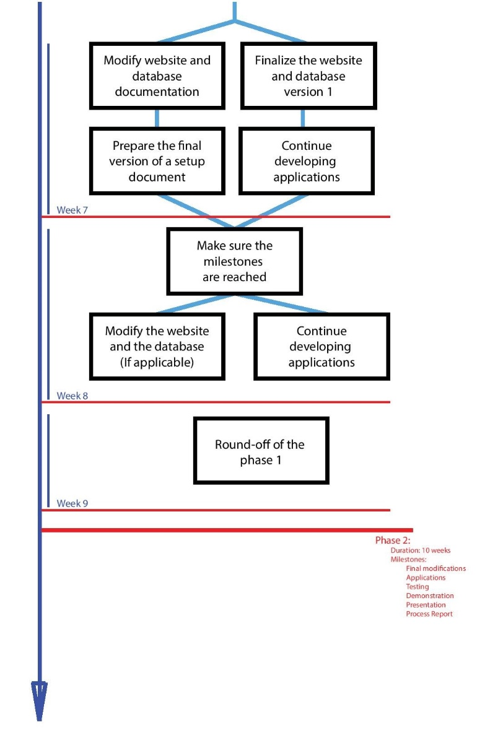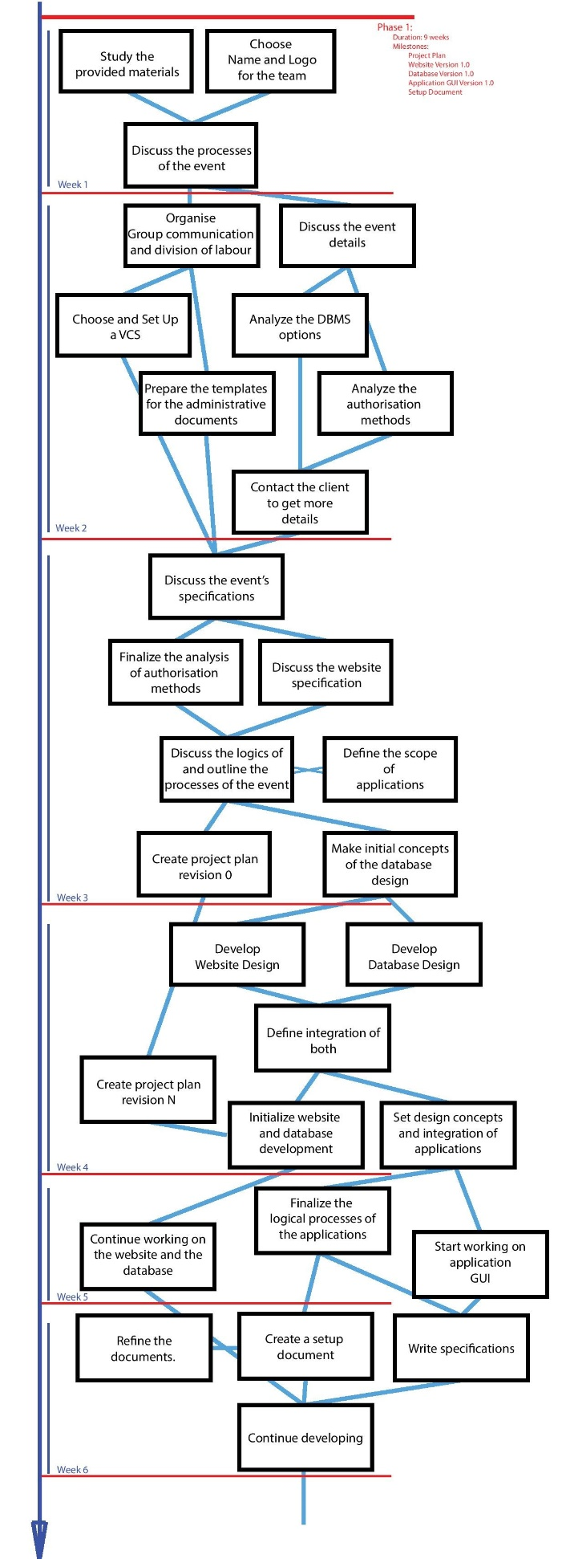

Figure 1: a) Week 1 – Week 6  
 b) Week 7 – Week 9 + Phase 2

## **Phase 1:**

Duration: 9 weeks

Milestones:

Project Plan

Website Version 1.0  
 Database Version 1.0

Application GUI Version 1.0  
 Setup Document

Week 1: Initial investigation of the assignment.

Study all the provided materials, define what is unclear and make initial assumptions about the project.

Choose a team name and create a logo.

Discuss the possible functionality and website-database integration patterns and processes involved in the system.

Week 2: Preparations, administrative work and organization

Prepare the templates of the administrative documents and start planning the task schedule, milestone list, communication plan and role schedule.

Discuss the projects uncertainties and reach the client for the discussion.

Introduce the in-group file management techniques and introduce the use of a version control system.

Week 3: Functionality study, option analysis

Discuss the event specifications, prepare the description of the event and included activities.

Analyze the authorization and ticketing techniques.

Refine the processes.

Create a project plan.

Week 4: Initial creation

Determine the website and database design. Define their integration.

Gather media for the webpage and start developing.

Refine the administrative documents.

Define the processes and logics behind the applications and define the integration between applications and the database.

Week 5: Development

Finalize the application processes and logics.

Start working on the application design.

Continue working on the website and the database.

Week 6: Development

Finalize the administrative documents

Continue working on the development.  
 Justify the decisions made.  
 Sketch out visitor-system interaction.

Week 7: Development

Finalize the website and the database.  
 Website and database documentation.

Initialize working on the setup document.   
 Continue developing.

Week 8: <exam week>

Make sure the milestones are reached.

Work on the setup document.  
 Modify the website and database. (If applicable)

On-going development process in all the spheres.

Week 9: <exam week>

Round-off of the phase 1.

## **Phase 2:**

Duration: 10 weeks

Milestones:

Final modifications

Applications

Testing

Demonstration

Presentation

Process Report