

**Setup Document.**

Client: Mister George

Service Provider: Step-Soft

Date: 11.04.2016

Members: Atanas Naydenov, Dimitar Markov, Dmitrii Orlov, Hristian Vasilev.

Contents

**Preface:** 3

**Purpose:** 3

**Chapters:** 3

**Client:** 4

Agreements: 4

**Decisions** 5

**Justification:** 5

**System Requirements** 6

Technology: 6

General: 6

**Processes** 7

**Applications:** 7

**Website:** 10

# **Preface:**

## **Purpose:**

The project setup document provides a description of processes, requirements, designs and decisions made in the scope of our festival management system. This document justifies our solutions, defines the architecture of the future applications and outlines the integration of all components.

## **Chapters:**

In the first chapter – Client - we give an overview of the client, his expectations and requirements, and the agreements made with him.

In the second chapter – Decisions - we explain the arguments and justify the solutions we chose. This covers the ticketing methods, design principles, website and application functionality. In the second part of this chapter – System Requirements we explain what is necessary (including technology and general requirements) for operating our system.

In the third chapter – Processes – we give an overview of the procedures that occur during the event and sketch out how they will be integrated with our software and a website.

// additional chapter about the results and conclusions

# **Client:**

The formal client of this project is Mr. George, an event administrator from a major event management company based in The Netherlands.

He has contacted us with an enquiry to develop a new festival control system that would replace the one that is currently used in Mr. George’s company.

### Agreements:

* Communication between the Soft-Step team and the client is established via our project coordinator.
* Expected event details:
  + Type: Music Festival
  + Target audience: may vary in range of 20-45 years old
  + Camping: expected camping spots  
    Camping spots are usually to be provided by a partner organization
  + Number of visitors: may vary in range of 4.000 to 50.000
* Formal Clients requirements

Entrance and ticketing:

* + Legitimate entrance enforcement
  + Fraud prosecution
  + Easy festival access
  + Absence of long queues at the entrance to the Festival
  + Ticket price range acceptable for the audience
  + Profitable ticketing method
  + Ticketing and entrance should not involve a lot of personnel

During the event:

* Controlling the number of products at the stores
* Status reports and tracking
* Festival rules announced in advance
* Data should be available at all times
* Applications for event-access management
* Applications to be used at the shops and entrances

Website:

* Orders to be made through via website
* Information about the festival lineup and camping
* Rules, terms and conditions

# **Decisions**

## **Justification:**

Below are listed the arguments for the solutions we chose to use for our project.

1. Ticketing method:   
     
    We had to decide what kind of authentication method to use when one of our clients is entering the event. Thus, we considered two options - barcodes and RFID chips. We chose RFID chips because:

* More secure
* Has big read range
* Easier to manage

1. Technologies

When we were deciding what technologies and programing languages to use. We concluded that we have to use something very accessible and popular with many available resources because our company is not very experienced in the sphere. So we chose:

* PHP for the back-end of the website
* MySQL for the database
* CSS and JavaScript for the front-end
* C# and Windows Forms for the applications

1. Database design:  
     
    We chose this database design because we wanted to keep everything as simple as possible and therefor have the possibility to make fast and simple queries.
2. Website and Applications design:

The design of the website and the applications has to be highly user-friendly, accessible, and intuitive so that visitors with any level of experience and computer skills could easily operate them.

1. Website functionality  
     
    The festival website does not only serve as a purely informative portal, but rather as a system for the visitors to gain access to the festival, manage their details, see current status and utilize the provided facilities with ease.
2. Authorization process:

We have considered two options of how the visitors may obtain the purchased RFID bracelets. As a final decision, we chose to have both ways of receiving and assigning the RFID chips implemented.

* Every RFID chip will be assigned to the client at the spot, this give us bigger control and increases the security level
* Assign it and send it to the client by mail for an extra price, so he will not need to wait at the entrance queue. This way we will generate more profit from the attendees who will to pay more for better comfort.

1. Reserved places:

Concerning the seats for the activities and workshops that will take place during the event, we decided that only ½ of total number of places are going to be available for reservation. Thus, it will be possible for visitors to ensure that they will have a place at a certain activity. In case the visitors, who claimed a place, are late for more than 15 minutes after the start of the activity, the reserved seats will be made available for other visitors.

1. Shop:  
     
    During the event visitors are able to buy different food products and beverages at the shops located on the festival grounds. When a certain client goes to the shop he/she initializes his purchase by scanning his/her chipped bracelet first.
2. Loaning Items:  
     
    During the festival visitors are able to loan certain items for a limited period. This is possible in the special booths equipped with the RFID reader.
3. Not returning item on time

For the clients who do not return their borrowed items on time, a fine will be set. If they are not able to pay the fine, they will face a penalty.

1. Lost bracelet  
     
    In case a client loses or detects a defect in his bracelet, he/she can go to the special RFID-support tent, where a previous client’s bracelet will be deactivated and a new bracelet is to be issued.
2. Camping  
     
    As for the camping reservation, we decided that one person is able to reserve for a group of many people only by giving people’s information and emails on the web site. Once done, every group member has to confirm the reservation.
3. Not following the rules  
     
    People who do not follow the rules are going to be kicked out from the event and put in a blacklist

## **System Requirements**

For operating our system, the festival organization is responsible for providing the following facilities:

### Technology:

* A batch of RFID bracelets in a quantity enough for all the expected visitors with surplus of at least 75% of total quantity for exception handling.
* Computers running at least Windows 8 OS for every facility, where an application is to be used (i.e. shops, support tents, entrance etc.)
* All automatized mechanism such as doors, gates, etc. and integration of our software with the required hardware.

### General:

* The personnel
* A bank of client’s choice to carry out all monetary operations
* Lineup and performance management services or software

# **Processes**

## **Applications:**

This section covers the general processes and operations that occur at the entrance and during the festival days. They involve the interaction of visitors with the facilities present at the event. Some of them require additional software to be carried out.

Below is the flowchart showing all the possible operations.

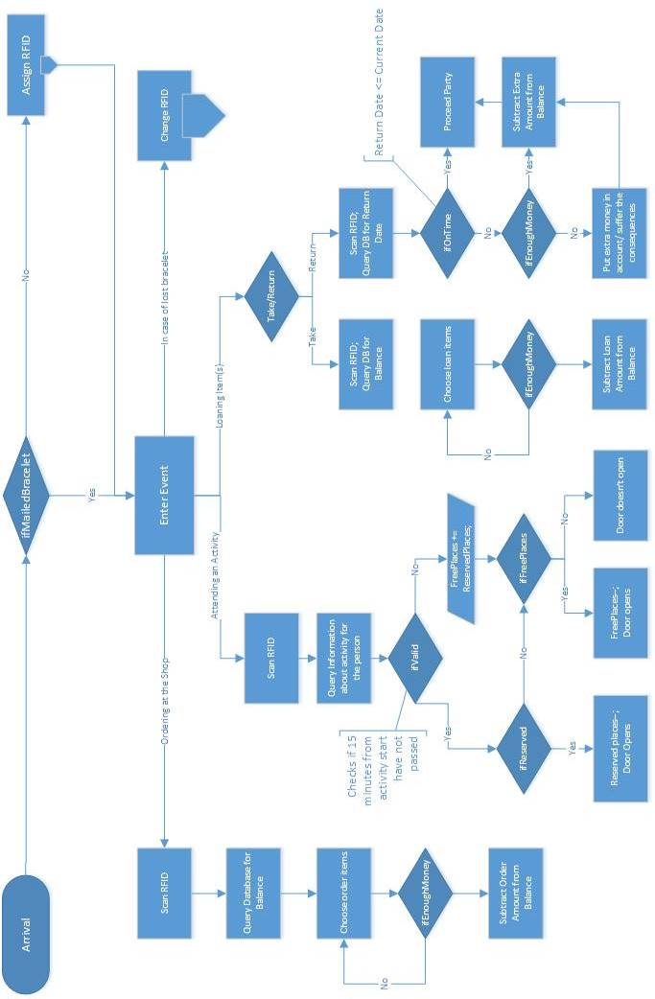

It includes purchasing products at the shops, attending the activities, loaning and returning items and RFID management.

These two flowcharts demonstrate the processes of assigning new/deactivating previous visitor RFIDs.

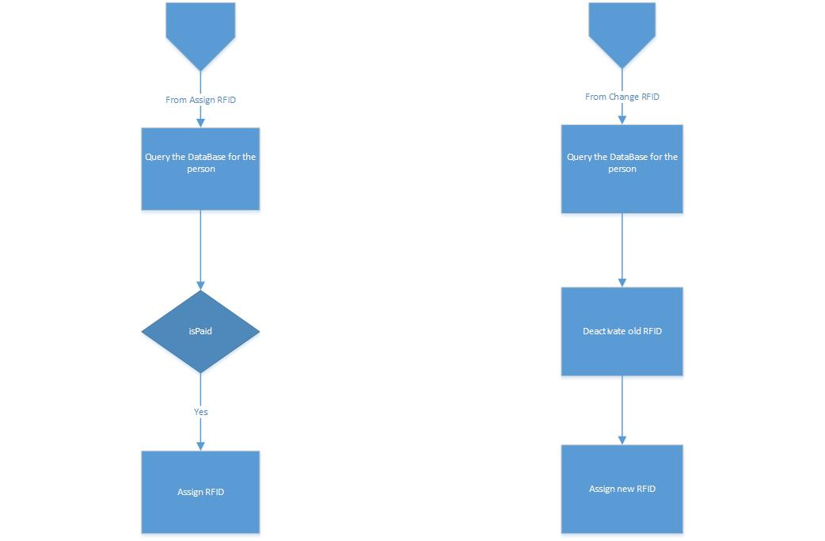

On the next page is the flowchart showing the process of issuing the bracelets with RFID chips to the visitors.

Visitors have two options of receiving the RFID bracelets:

1. Visitors pay a basic price for the bracelet and obtain them directly at the entrance.  
   The bracelets will be issued at the special booths, were one has to prove his identity and receive the bracelet he paid for.  
   The worker will take an available bracelet and create a new entry by assigning it to the visitor.  
   The same booths will serve as a place to settle troubles and exceptional occasions such as lost and forgotten bracelets, bracelet failures and defects and others.
2. Visitors can also can pay an extra amount and receive a preassigned bracelet via physical mail in form of a parcel.  
   In this case, the visitor will not have to undergo the procedure of issuing the bracelets, but can rather access the festival grounds directly upon arrival.

For the two options, there will be two different queues in order to speed up the entrance.

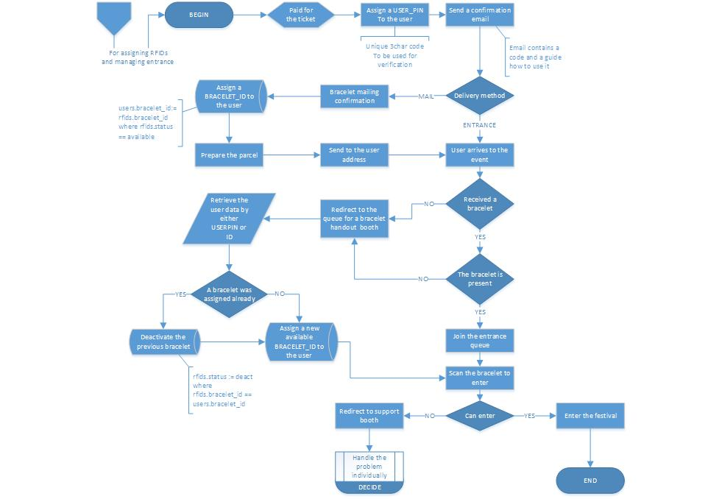

## **Website:**

The website serves as a unified system providing the functionality of purchasing tickets, reserving the camping spots, tracking personal status and managing the balance for visitors. More information concerning the design and appearance of the webiste is to be found in the website design document.

Below is the festival website sitemap.

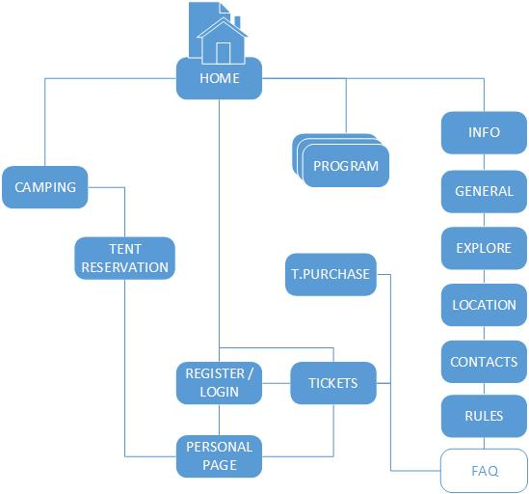

Below is the extended functional sitemap, depicting main procedures.

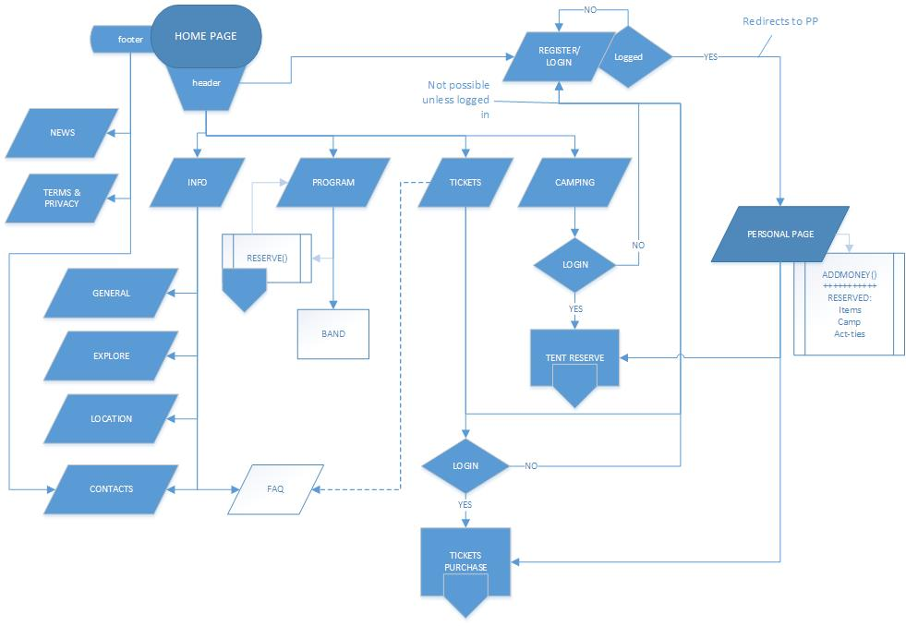

1. The index page of the website is its homepage. It holds a brief description of the festival and redirects to other pages of the website.
2. Footer and header are present at every page, thus the navigation through the website is easy and agile.
3. Non-informative pages and functionality, such as Personal Page, Tickets Purchase, Balance Management and others, are available only to registered and logged in pages – thus on the flowchart many arrows redirect to the login verification.

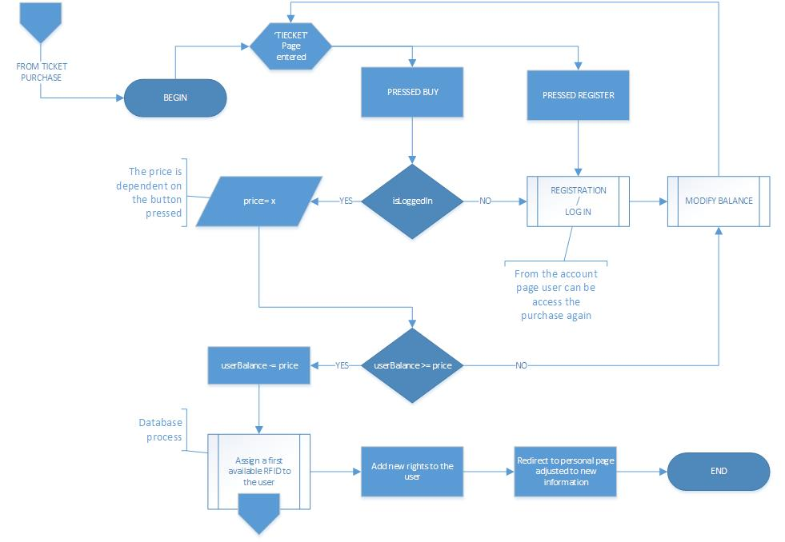

1. Above is the flowchart depicting the process of purchasing the ticket (RFID bracelet)

The page Tickets gives visitor the visitor a choice to buy the ticket or register/login first by pressing the respective buttons. To continue the purchase the user is obligated to be logged in.

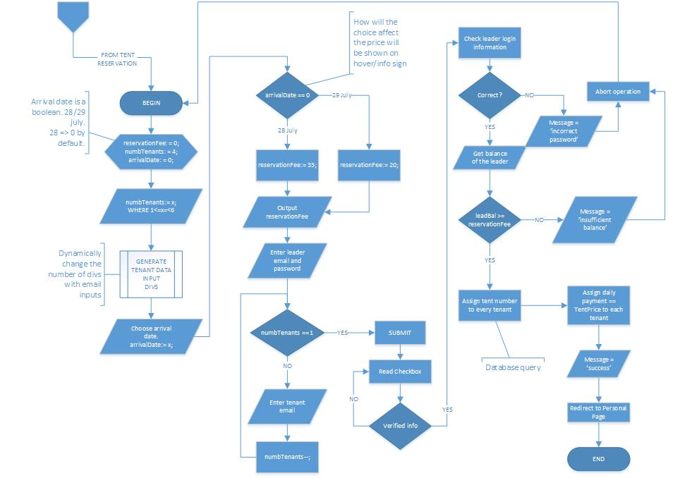

1. Above is the flowchart depicting the procedure of tent reservation.   
   The user is obligated to be logged in to continue. The users can reserve a tent for a group of tenants at one time. The page will provide the functionality for this purpose.

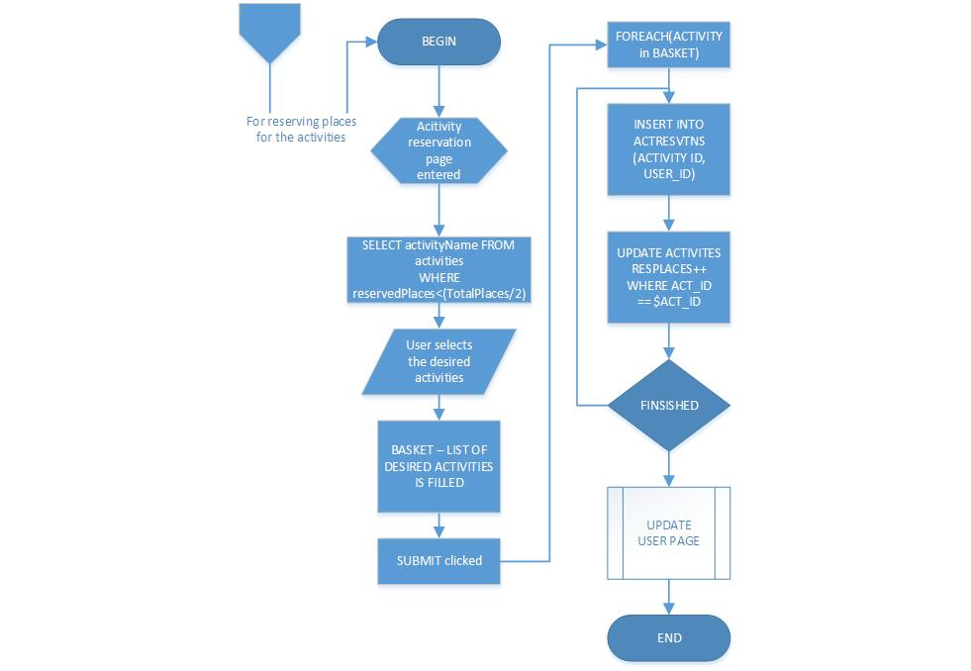

1. Above is the activity reservation process.  
   Its purpose is to provide the visitors a possibility to reserve places at the activities and workshops they would like to make sure they are able to attend.  
   It is one of the ‘should’ tasks for our project.