## Website

|  |  |  |
| --- | --- | --- |
| Testing data: | Tony Montana | Jennifer Burges |
| Email | [tm@gmail.com](mailto:tm@gmail.com) | [jb@gmail.com](mailto:jb@gmail.com) |
| Password | tnmntna | jnfr |
| Ticket | Yes | No |
| Tent | None | None |
| Activities | X2 reserved | X1 reserved |
| Items | X3 loaned | X0 loaned |

### Technologies used

Our team used different IDEs, with the mainly used being:

* Atom
* Netbeans
* Sublime
* Visual Studio Code

Our web application uses the following technologies

* PHP for the back-end of the website
* MySQL for the database
* CSS and JavaScript for the front-end

We also used some libraries and frameworks like:

* jQuery - We used because of the easier way of implementing animations and interacting with the DOM tree
* Bootstrap – Mainly we made use of the grid that the framework gives
* Sweet Alerts - Used for displaying nice looking messages (examples of use at Personal Page, Registration/Login page, and others)  
  http://t4t5.github.io/sweetalert/
* Alertifyjs – Used for displaying nice looking log notifications. Used at the Activities page and also in the framework to display the terms and conditions.  
  http://alertifyjs.com/

### Website file system organization

Our group chose this structure because it best suited the purpose of the application.  
The root folder has the following structure:

* It is divided into 11 subfolders and an ‘index’ file.
* The starting point of the application is the file ‘index.php’.
* The website directoroty is organised in such a way that the files can be easily accessed by the main file.
* Every subfolder contains data about one particular page.
* Every page folder which also contain a starting index file and subfolders with folder for every particular thing? that is used.
* The folder called ‘DEFAULT’ serves to store files that are shared between all the pages. There can be found images, header, footer, some default styles and scripts, libraries fonts and etc

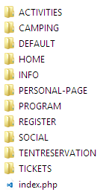

Each page folder is then separated into subfolders for the page specific media, scripts, PHP code and other data.

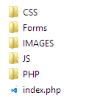This is an example taken from the activities page directory, other separate pages follow the same/similar structure:

* CSS folder stores all the page specific stylings
* Forms – stores all the additional forms and templates that are loaded in the page by AJAX during runtime
* Images – stores the media and images that are used in this page
* JS – stores the JavaScript code for the page
* PHP – stores the PHP codes for the page to process the server queries and interaction

The “DEFAULT” directory is used to store shared media, codes, frameworks and styles. A lot of references, requires and reuses in the pages refer to this folder’s contents.

* It has 9 subfolders
* Aertify.js-0.3.11 – is a folder that stores the framework

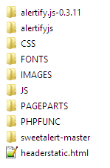

* Alertifyjs – is a folder storing a slightly different version of the Alertifyjs framework
* CSS – a directory storing the shared styles for every page  
  e.g: footer.css, integral.css
* Fonts – a directory that stores the fonts that are used on the website. These are Bauhaus93 and Odin Rounded (<http://www.1001fonts.com/odin-rounded-font.html>)
* Images – a directory for the common images. It includes the images that are used in the footer, logos, social network logos and others.
* Pageparts – a directory that stores the reused/shared parts of the pages: Footer.php, FooterLinks.php (which are nested inside of the Footer.php), FooterLinksHome.php – the part that is used in the home page (root/index.php), since it’s located on a higher level than other pages
* PHPFUNC – a directory that stores the serverside codes that are used at every page, e.g Logout.php (since the logout is accessible in the header navbar at every page)
* Sweetalert-master

### Functionality

#### Overview

For every page, except the ‘Home page’, we use the same menu and footer, which are loaded with PHP from the ‘DEFAULT’ folder. Every page shares the styling of those elements from the DEFAULT/CSS directory as well.

The header’s last link – account does not only serve as a redirect mechanism to either login/register page or personal page, but also provides the way to log out on the mouse hover.  
The footer functionality as follows: *“news & social”* redirects to a respective page, *“contact us”* opens a new window for a default client’s mailing provider with a brief template for an email to [jobsdoneuniversal@gmail.com](mailto:jobsdoneuniversal@gmail.com) (this is a valid email address), *“terms and conditions”* prompts with a message box with the terms and conditions – made using alertifyjs framework. This functionality is available at every page

#### JS and PHP

What is specific is that all our PHP scripts that are invoked on some button click, are executed via AJAX which means that to any button of that kind(e.g. register, login) is attached a click event which calls a JavaScript file who executes the PHP script, processes it and retunes a relevant response asynchronously.

While developing the codes for the website (both JS and PHP) the quality of them and their patterns were changed gradually as more good practice conventions were learned. The PHP code is very far from perfect. It uses pure PHP, and does not implement any frameworks or additional libraries, which makes it a) overly complicated; b) the separation of logic and visualization is not possible using such way. In the AJAX-PHP interaction pattern the server responses are categorized by the unique messages that are echoed from in the PHP code upon the termination of a certain method. However, for all the server and MySQL database interaction the object oriented PDO pattern was used.

E.G from the login js-php interaction at the REGISTER/LOGIN page:

|  |  |
| --- | --- |
| *// from the js/auth/ajax-login.js*  *…*  success: function(response) {  if (response.**includes('logged'**)) {  …..  } else {  ……  }  } | *// from the php/login.php*  *….*  $stmt->execute(array(":email"=>$user_email));  $row = $stmt->fetch(PDO::FETCH_ASSOC);  // $count = $stmt->rowCount();  if($row['PASSWORD']==$password && $password !="" ){  **echo "ok-you logged in"**.print_r ($row);  $_SESSION["USER_ID"] = $row['USER_ID'];  }  else{  echo "email or password does not exist.";  }  … |

PHP code was used to display the user/condition relevant data on the webpages. It was used to populate the contents of the Personal Page modules, create the forms to reserve activities, show the user reserved activities and so on. Example code provided below:

*// from the ACTIVITIES page index.php*<?php

for ($i = 0; $i < count($activities); $i++) {  
 echo '  
 <li class="act_item">  
 …   
 <!--<form action="php/processreservation.php" method="post">-->

<form class="formreservation">

<div class="activity_info">

<p class="text actname">' . $activities[$i] . /* the name 0 7 */'</p>

…  
 Places available: ' . $activities[$i+=1] . /* places 4 */'

…  
 <input type="checkbox" class="chkbox" required   
 name="reserve" checked="true" value="yes">  
 <label class="chkbox"> I want to reserve </label>

…

<button type="submit" class="btn text resbtntext">RESERVE</button>

…  
 </li>';

} ?>

As for the JS codes, a lot of JQuery code was written to interact with the DOM. It made it easy to animate the webpages and to work with the ‘static’ and user-input data. E.G: a lot of JQuery code was used in the TENT RESERVATION page.

#### APIs

For this website the following APIs were used:

* Twitter API   
  In the ‘SOCIAL and NEWS’ page reached from the footer, the twitter provided APIs are used both to present a twitter news feed and also to share the page via a ‘tweet’ by pressing the according button.
* Facebook API  
  In the ‘SOCIAL and NEWS’ page the ‘share’ button is implemented to post directly to the Facebook timeline.
* Google+ API  
  In the ‘SOCIAL and NEWS’ page the ‘share’ button is implemented to post directly to the Google+ timeline.
* Google Maps API  
  In the INFO -> LOCATION page the Google maps API was used to show display the event place and facilitate locating the venue by providing an easy way to set a route.

### Page description

#### Activieties page

This page is used to view the activities that can be attended during the festival. The registered users can book a place at the activity and cancel it at any moment. This ‘web application’ replaces the activity reservation windows application that was declared in the project plan. This page is more reasonable and user-friendly than a C# windows application with the same functionality.

The PHP and JavaScript are very faulty and is not implemented to run effectively.   
The code specifications on this page:

* JQuery to animate the activity boxes
* Ajax – to – PHP communication pattern to process reservations and cancelations
* On-page PHP to retrieve the activities from the database
* On-page PHP to display the user reserved activities, if he is registered, or a message to login if he is not.
* Alerifyjs notifications to display logs in the left lower corner of the screen about successful/unsuccessful operations.

#### Camping page

The page consist mostly of static information and a dynamic PHP script for posting a link to the tent reservation for several conditions: a) more than one camping spot available; b) only one spot available; c) no places are left. This code places an image-link by pressing which the visitor is redirected to the tent-reservation page.

a) 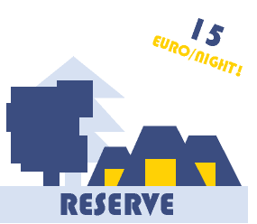b) c) 

#### Home and Info pages

Consist of static information and information about the event.   
The home page is specific as at first, a large banner appears at the top part of the window and the navigation bar is below it. Once the page is scrolled down, the navigation bar is lifted to the top of the window and fixed. For this, the JQuery code was created that changes the class of a navbar so it would fit the appropriate styling. Below is the snippet of the script from the index.php.

var logo = document.getElementById('logo');  
 var potato = document.getElementById("potato");  
 $(document).on("scroll", function() {  
 if ($(this).scrollTop() > 580) {  
 $("#header").removeClass("headernotscrolled");  
 …  
 logo.src = "DEFAULT/IMAGES/logohead.png";  
 potato.style.display = "inline";

} else {  
 $("#header").removeClass("scrolled");  
 ….  
 potato.style.display = "none";  
 }  
 });  
 </script>

#### Personal page

There the user can find all his personal information he has provided at the register page, information about his camping status, finances and etc. It consists of dynamic and static parts. The information is separated into separate modules such as “*General*” – for the general user data such as name, address, email; *“Balance”* – used to manage the visitors balance; *“Bracelet”* – used for viewing the visitor’s ticket payment and bracelet information; *“Your Tipi”* – shows the data (number and the tent leader) about the camping spot for which the visitor is registered; *“Items”* – displaying the information about the items which the visitor had loaned; “Activities” – showing the list of the activities.

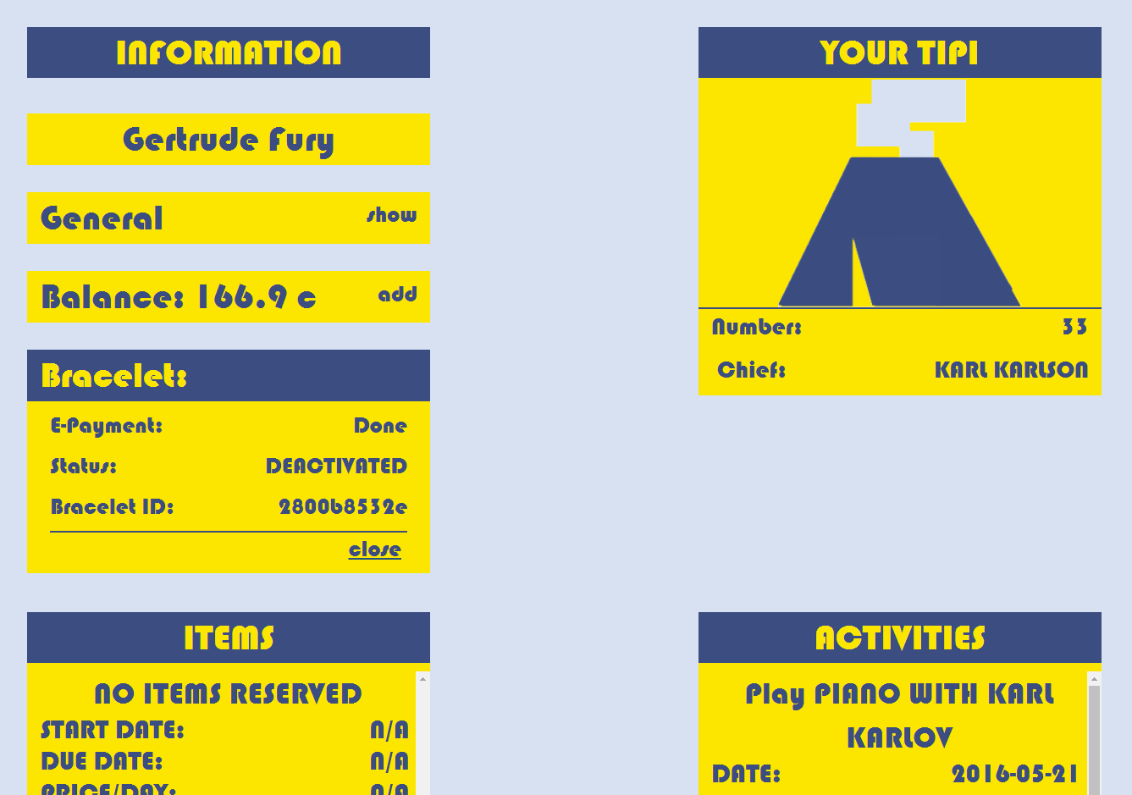

The buttons for hiding and showing are implemented with jQuery and some easy showing and hiding html elements, manipulating styles and loading content with AJAX. Every button has an attached click event, which executes a corresponding script.

Every time the user accesses the page, the system executes few PHP scripts. Via these PHP scripts are made queries to the database and the information about the particular user is retrieved. Whenever the user wants to update his balance, he can go to the balance field and fill the desired amount to be added to his account. Considering the PHP scripts they are still not very optimized in terms of security and quality of the code (a lot of repetitive code).

#### Program page

It consists of static information about the program of the event. There you can see a few tabs whose content is dynamically loaded with jQuery and AJAX. It also features some animations.

#### Register page

It has 2 tabs one of them is for registering the other is for logging in. The content is loaded dynamically with the help of jQuery and Ajax. On the page, there is also some HTML5 and JavaScript validation of inputs, e.g. the email entered is forced to be the same as the confirm email (same applies for the password).

If we look at the PHP script and the way the whole registering and logging in works, we will see as mentioned in the overview that the scripts are executed via AJAX code that is executed by clicking on the corresponding button. Considering the PHP scripts, they are still not very optimized in terms of security and the code quality (a lot of repetitive code).

#### Social page

There the users can find a twitter feed and the share buttons for Facebook, Twitter and Google+. Everything is implemented by using the respective APIs.

#### Tent reservation page

At this page the camping spots can be reserved for a group of up to 6 people. One user is required to pay the whole sum for the camping from his balance and also will be the responsible person for the camping spot. He has to enter his credentials once again to ensure the secure user authentication.   
  
The codes that are used to generate the input fields are written using JQuery and pure Javascript. The server interaction is done via the AJAX and PHP.

Tickets page   
This page is used to purchase the tickets for the events – this is a required condition for obtaining the bracelet and reserving a tent at the entrance. The user is redirected to this page right after the registration.

There are three types of tickets, which generally differ only in price and have do not affect the general user experience in any way (Our team supposes that is how all the festivals work). To purchase a ticket the visitor has to enter his credentials to ensure his validity. For the purchase a new window is loaded in the center of the page.

*For further details refer to the code and comments.

## C:\Users\Dmitry\AppData\Local\Microsoft\Windows\INetCache\Content.Word\Screenshot (137).pngDATABASE

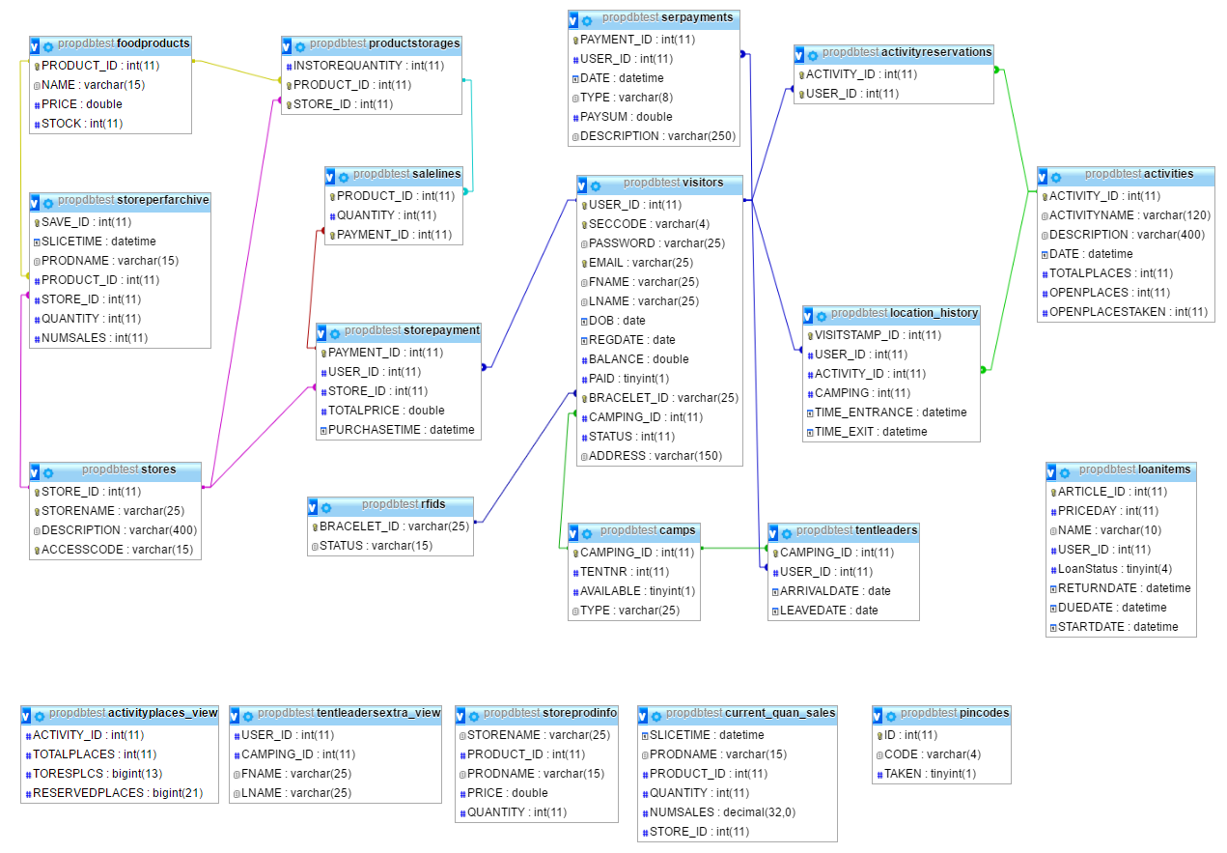

Design

The ERD diagram above depicts a complete design of the database.

It features 16 tables, 5 views, and 1 event. Those are required for different interactions with the database via the applications and the website. The 5 views were created in order to facilitate the data retrieval from the database. 1 event that is not present in the ERD diagram is called SalesSlicerEvent and is executed every hour in order to save the ‘slices’ of the quantity and sales of the products per each shop.

### Tables

* Activities.  
  The table to keep the data about the events. Includes the name, id, date, description, number of places (of three types – open/take/total)
* ActivityReservations.  
  This is an intersection table to store the data about the visitor’s reserved activities.
* Camps.  
  This is a table to store the data about the camps. It has the attributes to store the availability of a camp, its ID, number and type (which is not used for anything now).
* Foodproducts.  
  This is a table to store the data about the food products that are sold at the stores. It serves as a general warehouse – from there all the products are divided between the shops.
* Loanitems.  
  This is a table to have all the data about the items that can be loaned during the event. This table is not connected with a relation in the ERD, but in fact the USER_ID attribute references to the USER_ID of the visitors. If the item is loaned the USER_ID is retrieved from the visitor and if not it is set to 0. The dates signify the dates when the item was returned, when it is due to be returned and when it has been taken. – when a new visitor starts using the item the data is overwritten.
* Location_History.   
  This table is used to store the location of the visitors – it was designed to secure the entrances and exits to the events and camps from fraud. It has the attributes: activity_id and camping, which are set former to the activity_id of the one the visitor is entering and camping is set to 1 if the visitor is entering the camping. Potentially this table can also be used to review the statistical information about the popularity of the activities and density of the camping.
* Pincodes.   
  This table was created to store the unique 4 char

### Views

– asd asd

### Events

– asd

Applications

1.Applications overview

2.Maybe details for every particular application

3.Class diagramm

4.Uml diagrams

5.