LAYER APP

**Project Statement.**

Client: Mister Gee

Service Provider: Team D.

Leader: Dmitrii Orlov

Members: Dmitrii Orlov, Alexander Salvador, Alexandru Prodrom, Mohammad Raja.

Revision 1: Date: 27.11.2015

Revision 2: Date: 05.12.2015

Revision 3: Date: 11.12.2015

Revision 4: Date: 13.01.2016

**Table of contents**

Table of Contents

Project Statement 3

Overview 3

Formal Client 3

Project Team 3

Current Situation 4

Problem description 4

Project goal 4

Project Deliverables and Non-Deliverables 5

Project Constraints 5

Project Risks 6

Project Phasing 7

Phase 1 8

Phase 2 8

Phase 3 8

Phase 4 9

**Overview:**

Over the duration of 6 weeks, our team has to present the feasibility, scientific and market research results. Depending on the results this will determine if the application can be realized and provide income in the long-term. If so, a team of developers will be delivered to the client in a reasonable amount of time. Our team will provide the design and demonstrate the concepts of the application to potential investors to attract their support.

**Formal client:**

Mr. Gee.

An entrepreneur and the owner of the web store. He sells children’s toys, which he buys in bulk from China. His assortment varies from small to relatively big garden toys.

Contact information:  
 Mr. Gee,

Doctor Julius Röntgenlaan 79,

3723 LC, Bilthoven

Netherlands

phone: 06-64632151  
  
**Project Team:**

Leader:

Dmitrii Orlov  
 Team Leader  
 Tel: +31 6 83 13 06 38  
 e-mail: dmitry-orlov@hotmail.com

Team Members:

Alexandru Prodrom

Team Member

Tel: +31 6 57 92 71 74

e-mail: prodromalex@yahoo.com

Alexander Salvador

Team Member

Tel: +31 06 82 91 39 57

e-mail: alexandersalvador_1@hotmail.com

Mohammad Raja

Team Member

Tel: 0685217582  
 e-mail: m.raja@student.fontys.nl

**Current situation:**

Team D is going to provide the project management services to the undersigned client, Mr. Gee. The latter contacted our group with a request to carry out the scientific and market research in order to prove the feasibility of the application, and if the results are to be positive, create the design and present it to the potential investors.

The client, Mr. Gee, is currently running a web store selling children’s toys. Lately he has been experiencing many difficulties with his business. The hurdles troubled him a lot and he thought of changing the sphere. He has an idea for a new application. He intends to start a new business selling this Layer App.

Mr. Gee, being a formal client, is at the same time the main project sponsor for the initial part, of which our team is responsible. He intends to attract investors for the later development and realization of the desired software.

**Problem description:**

The client has introduced a specific framework for the application and wants us to develop his idea and help him reach the production phase.

Formal client has no knowledge neither of the sphere, to which the application will belong, nor of the areas of software design. He does not have a clear and concise view.

**Project goal:**

The projects goal is to investigate Mr. Gee’s idea, determine the operational and technical feasibility of the application, create its design, and demonstrate it to the future sponsors and developers, who will proceed on creating the application.

**Deliverables and non-deliverables**:

|  |  |
| --- | --- |
| **Deliverables** | **Non-Deliverables** |
| Feasibility study report | The Application |
| *Our team will carry out all the required research in order to determine the strengths and weaknesses of the project and deliver the detailed report to the client.* | *Our team is not supposed to create the application.* |
| A reference document from the team of developers |  |
| *Our team will negotiate with potential developers and find an appropriate group for the production of the Layer App* |  |
| Visual mockups |  |
| *Our team will create the complete design of the application.* |  |
| A reference document from the sponsors |  |
| *Our team will use the mockups and present the concept of the application to potential investors. After the successful demonstration, we will introduce the potential groups of project sponsors to the client.* |  |

**Constraints:**

Tight timeframe:

For completing the whole project our team has only 6 weeks.

Budget:

The project sponsor will provide the money only for 100 person-hours of feasibility research.

English Language:

The client specified the applications should be in English only.

Platforms:

The client demands the application that would run on two following platforms: iOS and Android.

Attractive Visual Mockup:

The design of the application has to possess all the characteristics of a “good software design” and include outstanding features in order to attract the investors.

**Risks:**

**Negative outcome of the feasibility research.**

Probability: Medium

Impact: High

With a negative result of the market research or lack of technological solutions, the project will not attract the investors.

Steps to prevent: Research if this application is possible to make. Check with third party developers with similar applications. Use already discovered solutions for the difficulties the project may face.

Clean up action: Consider a different approach to the problem.

**Users do not want the application**

Probability: Medium

Impact: High

Steps to prevent: Let users test out the mock-ups during investigation. Analyse the feedback and actively interact with the potential users.

Clean up action: Create new mock-ups

**Copyright infringements**

Probability: low

Impact: High

We might encounter the situation where the parts or the concepts of the desired application will interfere with someone else’s intellectual property.

Steps to prevent: Carefully investigate the already existing applications with similar functionality and the patents created in this sphere.

Clean up action: Find or invent the solutions that would not interfere with other intellectual property.

**Unforeseen material costs**

Probability: high

Impact: High

Part of this money the client-project sponsor pays us, will have to be spent for the feasibility studies and for creating the design of the application. The expenses might exceed the budget constraints.

Steps to prevent: analyzing the budget carefully. Creating the detailed budget plan and estimating the expenses. Regularly reviewing and determining the priority of the expenses by calculating the opportunity costs and following the most rational budget policy.

Clean up action: reviewing current budget plans and cutting low-priority expenses.

**Exceeding the amount of hours being paid for**

Probability: Medium

Impact: High

100 hours for the feasibility studies is a relatively short amount of time for such a project.

Steps to prevent: creating an efficient and detailed project plan and phasing. Following it strictly. Analyzing any unexpected delays and reviewing the project plan regularly.

Clean up action: if we encounter any critical delays during the project realization, we will contact the project sponsor for the permission to attract more people to the project team.

**Project phasing:**

The detailed visual overview of the phases including milestones, deliverables and the timeline is present below. The duration of the phases is estimated including the extra time to secure the risks of delay.

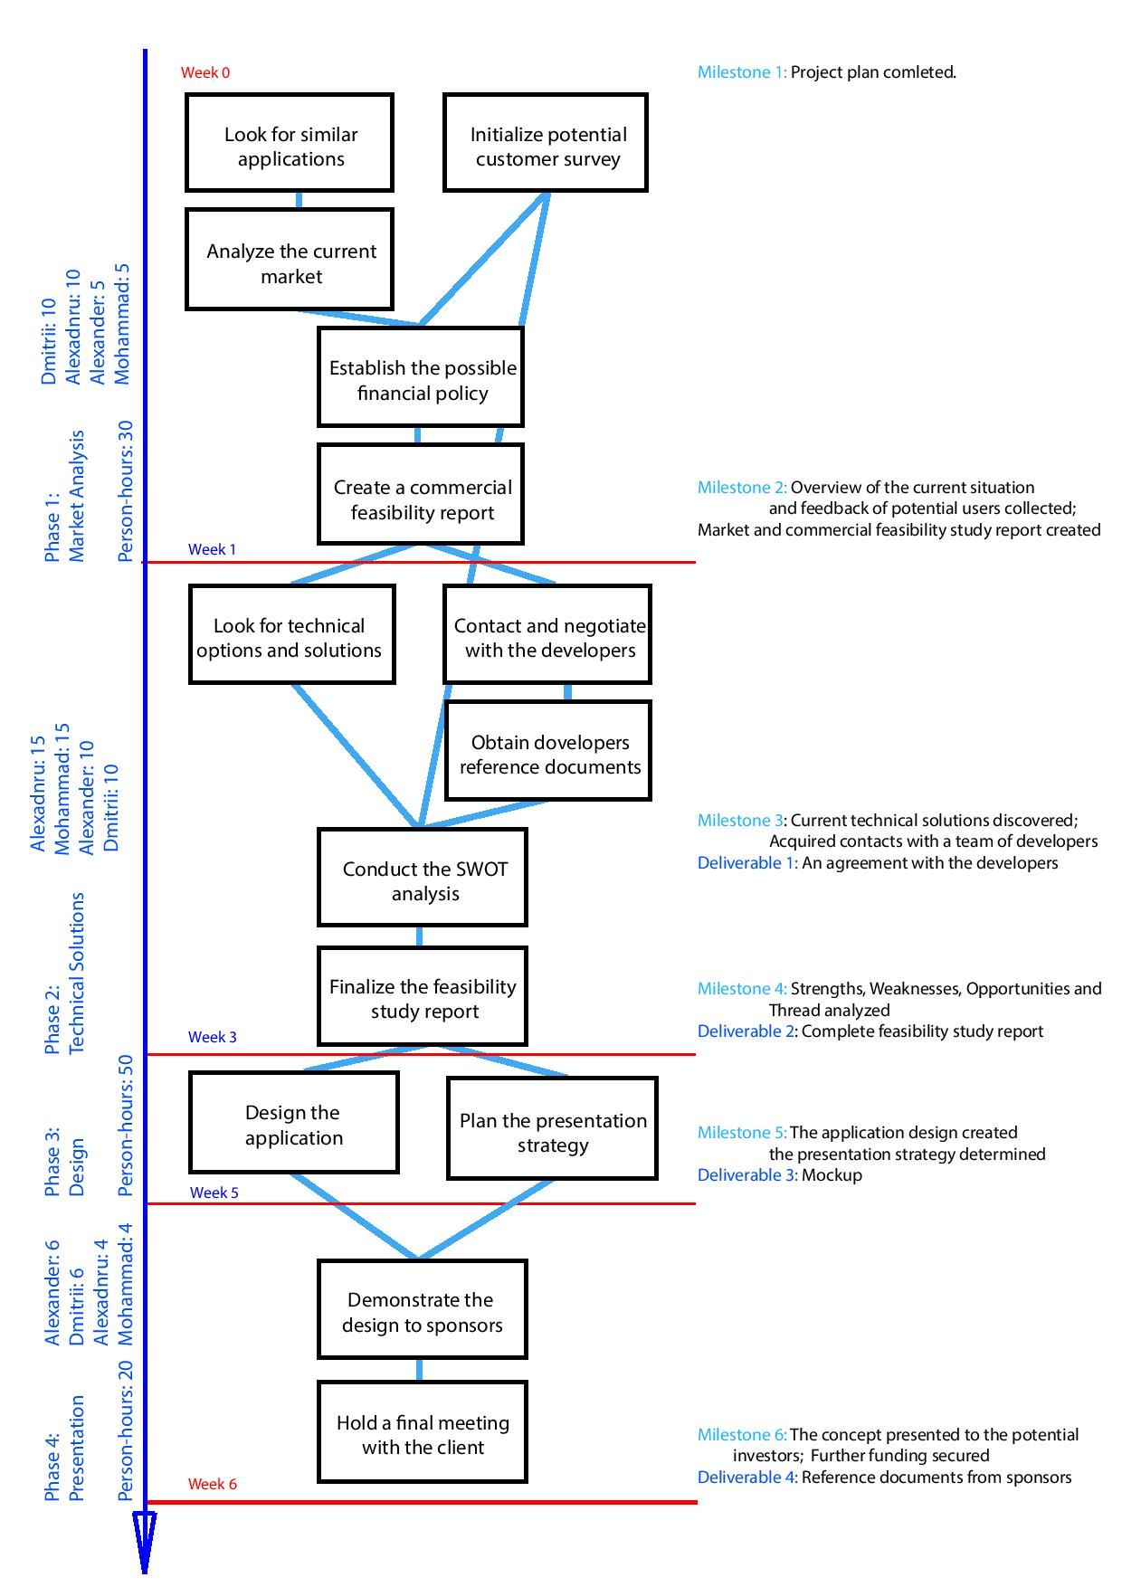

**Phase 1:**

Name: Market Analysis

Duration: 1 week

Person-hours: 30

During this phase, our team will carry out a complete research of a current market conditions, gather information from potential users by the means of online surveys and questionnaires, determine the commercial situation and establish the possible financial policy for the desired application.

Milestone: Overview of the current situation and feedback from potential users collected. A market and commercial part of feasibility study report created.

**Phase 2:**

Name: Technical solutions

Duration: 2 weeks  
 Person-hours: 25

During this phase, our team will carry out a complete research of a current technical possibilities and options, which will determine whether the application can be created. At the same time, we will contact and negotiate with different groups of developers in order to get the in-field view on the idea and obtain an agreement for the further development. The last step we will undertake to finalize the feasibility study report will be SWOT analysis.

Upon completion of this phase, we will have two deliverables.

Milestone: Current technical solutions discovered. The contacts with a team of developers acquired. Strengths, Weaknesses, Opportunities and Threads are analyzed.

Deliverable: A reference document from the team of developers and a feasibility study report

**Phase 3:**

Name: Design

Duration: 2 weeks

Person-hours:25

During this phase, our team will create the design for the future application and create a plan and an attractive presentation for the demonstrations that will follow.

Milestone: The application design created.

Deliverable: Mockup.

**Phase 4:**

Name: Presentation

Duration: 1 week

Person-hours: 20

During this phase, our team will meet potential investors and demonstrate them the concept of the application. The SWOT analysis and feasibility study report delivered in previous phases will be used during the negotiations as the proof of potential commercial success in order to obtain funding.

Milestone: The concept presented to the potential investors. Further funding secured

Deliverable: The reference documents from potential sponsors.