Platform for elderly people

Project Plan

Course: Project Management

Date: 23 November 2015

Group : 03

Students: Anzhelo Iliev – 2855569

Zlatomira Koleva – 2689073

Anna Vesnonoka – 2540002

Dimitar Markov - 2781271

Table of Contents

Formal Client 3

Project Leader 3

Current Situation 3

Problem description 4

Project goal 4

Project Deliverables and Non-Deliverables 4

Project Constraints 5

Project Risks 5

Project Phasing 7

Phase 1: Initiation 7

Phase 2: Interface 8

Phase 3: Design 9

Phase 4: Build 11

Phase 5: Add 11

Phase 6: Test 12

Phase 7: Deploy 13

In this document we will get you acquainted with our project and what we will achieve in it. There will be given the description of the following topics: the formal client, the project leader, the current situation, the problem description, the goal of our project, the deliverables and non-deliverables, the constraints and the risks.

## Formal Client

Ms Mary Smith, social worker at TBS at Mental Health Eindhoven. TBS at Mental Health is located in the Netherlands.

Ms Mary Smith works with people to support them through difficult times and ensure that vulnerable people, including children, adults and elderly people are safeguarded from harm.

Their role is to provide support to enable service users to help themselves. They maintain professional relationships with service users, acting as guides and advocates.

Contact information

Mary Smith

M.Smith@gmail.com

Landgoed De Grote Beek

Dr. Poletlaan 40

5626 ND Eindhoven

(040) 123 45 67

06 – 123 45 678

Working days: Monday, Tuesday, Friday.

## Project Leader

Ms Anna Vesnonoka, 1st year student of the ICT department from Fontys ICT Eindhoven is the project leader.

Contact information

Ms Anna Vesnonoka

Rachelsmolen 1, Eindhoven

anna.vesnenok@gmail.com

06 – 213 45 678

## Current Situation

Our client, Mary Smith who works with elderly people asked our group to create a platform for the elderly people, so they could contact their friends and family, make video calls, share files and make new friends. Our first step is making a mindmap which will give us a better view of the tasks we have to complete and afterwards it will allow us to make the proper project plan.

## 

## Problem description

The problem we are facing is loneliness. Nowadays most of the old people are living home alone. Most commonly because of the age it is quite hard for elderly people to move, therefore they are not able to visit their friends or children, which live far away and have their own families. As the result, not having enough communication causes the feeling of loneliness.

## Project goal

## The goal of this project is to make a program application for Mrs. Smith. With this program she wants to make elder people feeling less lonely. In this application the elders or “the users” will be able to:

## Make new friends.

## Make phone calls to their families or friends.

## Make video conversations.

## Share files / recipes.

## Every user will have login name and password. And we will provide:

## Servers where the application will be hosted.

## Make automatic backups of the stored data if something wrong happens.

## Admins who will support the users if they have problems with the application or forget their password/user name.

## Project Deliverables and Non-Deliverables

In this project the deliverables are:

* Desktop app working with touch, mice and keyboard with English interface
* Only the executable version (the “.exe” file) of the software application will be delivered.
* An easily accessible user interface for controlling the provided data.
* Initial guide – “How to work with the app”.
* Integrated hints, which are going to pop up runtime and helping the users.
* Functionality for sharing files.
* Name and logo of the application.

We will not deliver:

* The source code of the software application will not be delivered.

## 

## Project Constraints

***Constraint 1: Time***

**The tested prototype of the project must be complete within 7 months.**

***Constraint 2: Budget***

**The budget for this project is 2000 euro for:**

* **Hardware**
* **Software**

***Constraint 3: English Language***

Elderly people are predominantly English speakers which is the main reason for application to be in English.

***Constraint 4: Java Programming Language***

Users have different types of computers (Microsoft and Apple), so the software application should be able to run easily on every type of computer and tablet. Therefore, you should use Java to program the software application.

## Project Risks

**Risk 1: Users didn’t like the whole interface of the application.**

Probability: Very low.

Impact on project: High.

Steps to prevent: Get as much information from the users as it is possible about their wishes and take them into account. At each change of the interface give it to users to test it and ask them to give their feedback.

Clean up action: Create totally new interface.

**Risk 2: Exceed the budget.**

Probability: Medium.

Impact on project: High.

Steps to prevent: Plan the budget before the expenses.

Clean up action: Convince the client to invest more money for getting the better result.

**Risk 3: The user manual is finished after the deadline or not finished on time.**

Probability: Low.

Impact on project: Low.

Steps to prevent: Start writing a draft version after the first version of the software.

Clean up action: Use draft version of the user manual.

**Risk 4: Users are not satisfied with the application and don’t want to have it anymore.**

Probability: Medium

Impact: High

Steps to prevent: Make the users to be involved during the development of the application.

Clean up action: Discuss the current situation with client and offer him/her other options.

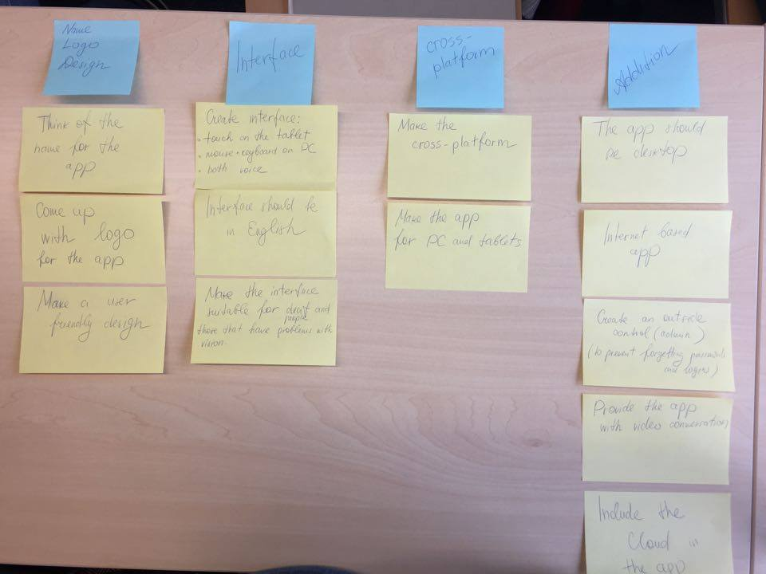Mindmap:

# Project Phasing

In this chapter we describe the phases of our project, with the activities and milestones. In figure 1 a visual overview of the activities, their dependencies and the milestones are given. The total project will take 30 weeks to complete. The critical path is made bold and red.

Add

Test

Deploy

Initiation

Build

Design

Interface

Create interface for Tablets, Mobiles and PCs

Add the outside control

(Admin)

Build application

Test system

Design application

Start-up project

Build cross-platform

Deploy system

Think of the name for the application

Make the app desktop and internet-based

Make user-friendly interface for deaf and blind people

Add Cloud

Write user manual

Create a logo

Include video conversation

**M2**

**M7**

**M6**

**M5**

**M4**

**M3**

**M1**

wk1 wk6 wk12 wk16 wk21 wk26 wk30

Figure 1. The activities and milestones.

## Phase 1: Initiation

The first phase of our project has only one activity, which we called “Start-up-project”.

Activity: Start-up the project

Despite the fact that the activity of the first phase is only one, it contains number of tasks which should be execute.

There are two main phases of which we can divide the Initiation activities.

1. First phase is meeting between the leader of the team and the formal client. The leader conduct an interview with the client, asking question in order to get more information about current situation, what is the problem exactly and what is the desired end situation. Moreover, both the leader and the client discuss what they want to achieve at the end of the project or in other words what the project goal is.
2. Second phase is working with the team. Here the main role of the leader is to organize the team, which will work on this project. Leader has to be sure that all of needed resources are organized. In our project we are going to work with Java. And the last step is conduct of kick off meeting where all of the tasks are distributed.

Duration – these phase required two weeks with 12 man-hours.

Deliverables for milestone **M1** are:

1. First deliverable of the phase is detailed allocation of the work among the team members.
2. Second one assurance that each developer has installed Java on its own computer.
3. The last one deliverable is the Project plan.

## Phase 2: Interface

The interface phase has two major activities: Create interface for Tablets, Mobiles and PCs, and Make user-friendly interface for deaf and blind people.

Activity: Interface for Tablets, Mobiles and PCs

* 1. PC application to be fast and light.
  2. Many buttons for more user-friendly interface.
  3. Easy accessible option for Video Calls.
  4. Tool tips about every option in the app
  5. Tablet and Mobile Interface to be also light and efficient

Estimated duration is four weeks.

Activity: Make user-friendly interface for deaf and blind people.

1. Text-to-Speech for blind people.
2. Voice Commands (again for blind people).

Estimated duration is one week.

Deliverables for milestone **M2** are:

* To be available in English.
* Test Text-to-Speech for bugs.
* Test Voice Commands.

## Phase 3: Design

The design phase has three major activities: Think of the name for the application, create a logo,Design the application. For each activity the tasks are described.

Activity: Think of the name for the application

1. ***The two - part name***: Use a simple convention of pairing the basic function of the app with a word that enhances it.
2. ***Be authentic*** - Make sure your name doesn't sound too conspicuously close to a popular app.
3. ***Be clear*** - Clarity and recognisability are very important, therefore we have to take them into account. For example: Can you tell what the app "PicDish" does? Of course. You take photos of dishes/meals.
4. ***Pronounceability*** - use caution when making words that are hard to say.
5. ***Stick to sentence*** - Differentiate and make the name of the app start with a lowercase letter or be all-caps, it will delegitimizes the app quicker than anything else.
6. ***Stick to under 11 characters*** – The name of the app should be short and brief. Long names are hard to read and won't look right in someone's collection of apps.
7. ***Use prefixes and suffixes*** - Get creative. Use a suffix such as "app" to distinguish yourself or a prefix like "go" or "get" to invoke action.

*Estimated duration is one and a half week.*

Activity: Create a logo

An effective logo is distinctive, appropriate, practical, graphic, and simple in. In its simplest form, a logo is there to identify but to do this effectively it must follow the basic principles of logo design:

* ***A logo must be simple*.** A simple logo design allows for easy recognition and allows the logo to be versatile and memorable. Effective logos feature something unexpected or unique without being overdrawn.
* ***A logo must be memorable.*** An effective logo design should be memorable and this is achieved by having a simple yet appropriate logo.
* ***A logo must be enduring*.** An effective logo should endure the test of time. The logo should be 'future proof', meaning that it should still be effective in 10, 20, 50+ years’ time.
* ***A logo must be versatile*.** An effective logo should be able to work across a variety of mediums and applications.

1. **Design brief.**Conduct a questionnaire or interview with the client to get the design brief.
2. **Research.**Conduct research focused on the industry itself, its history, and its competitors.
3. **Reference**. Conduct research into logo designs that have been successful and current styles and trends that are related to the design brief.
4. **Sketching and conceptualizing**. Develop the logo design concepts around the brief and research.
5. **Reflection**. Take breaks throughout the design process. This allows your ideas to mature and lets you get renewed enthusiasm. Receive feedback.
6. **Presentation**. Choose to present only a select few logos to the client or a whole collection. Get feedback and repeat until completed.
7. **Learn from others**. By knowing what other brands have succeeded in and why they have succeeded gives you great insight and you can apply that attained knowledge to your own work.
8. **Choose the right font.** Spend time researching all the various fonts that could be used for the project, narrow them down further, and then see how each gels with the logo mark, keeping in mind how the logo will used across the rest of the brand identity, in combination with other fonts and imagery.

*Estimated duration is two weeks.*

Activity: Design the application

1. The design must satisfy the needs of the users as defined in the program plan and through meetings held with the client.
2. The design must undergo a technical review and the design team must formally respond to comments received from reviewers.
3. Determine the overall, high-level design of your system. This part of the design gives an overview of the entire system.
4. During this part of the design phase, we’re going to break down the system into pieces that can be programmed. Breaking down the system into manageable modules also makes changes easier to implement.
5. Well-designed module can be reused in multiple parts of the system saving time and also ensuring that the same feature of a system looks and performs the same way throughout the system.
6. Determine how the new software system will interface with any existing system we may have.
7. Estimate resources so we can develop a schedule and cost estimate.
8. Develop plans for system installation and training.
9. Research possible methods for conducting interviews and making questionnaires.
10. Make questionnaires.
11. Interview elderly people (users).
12. Research possible methods for documenting requirements.
13. Make user requirements.
14. Install Java software for design.
15. Present possible solutions to the client.
16. Choose solution to implement.

*Estimated duration is three weeks and 10 man-hours.*

Deliverables for milestone **M3** are:

* Specified requirements (functional and technical)
* Several options of the logo, so the client could choose the one he/she likes better.
* The name of the application.
* Plans for system installation and training.
* The list of the resources so we can develop a schedule and cost estimate.
* Solution to implement the project.

## Phase 4: Build

Activity: Build an app

1. For the engine of the program we will use C#
2. implement a class diagram
3. Implementing the hints and intro
4. Make a responsive design(to look good on every screen size)
5. Building the final graphics and interface
6. Connecting all the modules together
7. Using Visual Studio integrated features for making and running Unit Tests
8. Bug fixing
9. Start writing user manual

Activity: Build cross-platform

1. With the help of the Xamarin Platform we are going to make it cross-platform(working on Android, Window, Apple OS)

Activity: Make the app Internet-based

1. Making chat
2. Implementing database functionality for user registration and file sharing

Activity: Include the video conversation

-- use the api of CTX SDK for building the video conversation functionality

Estimate duration - month and a half

Deliverables for milestone **M4** are: Finished C# application

## Phase 5: Add

The Add phase has two major activities: Create the outside control and Cloud for sharing files. For each activity the tasks are described.

Activity: Create the outside control

There are several administrative roles which should be assigned:

1. **Owner**: The Owner role grants full access to all actions and settings in the Admin Panel.
2. **Administrator**: The Administrator has full access to users, settings, and applications. An Administrator cannot view or update billing information, nor can an Administrator create, view, or modify any other Administrators.
3. **Application Manager**: The Application Manager role can add protected applications, update, and remove applications. Application managers may also view limited information about users and devices. In the Platform edition, Application Managers can assign custom policies to applications and groups, but cannot create or edit policy settings.
4. **User Manager**: The User Manager can create, update, and delete users, phones, tokens, and bypass codes. The User Manager can also configure and run Active Directory synchronization.
5. **Help Desk**: Help Desk administrators can view and update users, phones, tokens, and bypass codes; Help Desk admins cannot create or delete users or export information to a text file.
6. **Read-only**: Admins assigned the Read-only role may view (but not modify) basic information about users, groups, phones, tokens, and applications, as well as view reports.

*Estimated duration is five weeks*

Activity: Include Cloud

Three components are required in order to deploy an application as a cloud service:

1. **Service Definition**  
   The cloud service definition file (.csdef) defines the service model, including the number of roles.
2. **Service Configuration**  
   The cloud service configuration file (.cscfg) provides configuration settings for the cloud service and individual roles, including the number of role instances.
3. **Service Package**  
   The service package (.cspkg) contains the application code and configurations and the service definition file.

Deliverables for milestone **M5** are:

* Admins who will support the users if they have problems with the application or forget their password/user name.
* Possibility to share files via Cloud

*Estimated duration is one week*

## Phase 6: Test

The phase Test contained of two activities for which tasks are described. The activities are called Test system and Write user manual.

Activity: Test system

There are number of tasks which must be fulfilled:

1. Firstly, when the application is finished the database must be connected with it.
2. After that a person from the team doing a survey about test methods and create a test plan.
3. The next step is to make two test profiles for the platform. Using these two profiles we are going to verify if the video conversations, chatting and cloud functions work (Test the draft version of user manual).
4. Secondly, we are going to have a discussion with the client about the test plan and after that the test plan itself is ready to be executed.
5. Finally, when all test are performed the whole documentation for succeeded and failed tests are stored also with the list of improvements.

Duration – these phase required four weeks and 25 man-hours.

Activity: Write user manual

The main task is to write user manual. However, to create manual which will be helpful and understandable for every one we are going to do a survey among the users. Moreover, at least five of the user who are on different age (from 75 to 90) are going to use the manual with the software while we are observe them. The last step is to write new, improved manual based on the results of the survey and surveillance.

Duration – these phase required one weeks and 5 man - hours.

Deliverables for milestone **M6:**

The deliverables from this phase are test report, which include all succeeded and failed tests, all of the improvements, and document which contains the user manual.

## Phase 7: Deploy

The last phase contains only one activity, called “Deploy system”.

Activity: Deploy system

This activity contains only three tasks and in every task elderly people are involved.

1. At first the team gets a list of all people who take part in the new venture.
2. Then the software for the platform must be install on the computers/ tablets of the elderly.
3. The last task is to distribute the final version of the user manual.

Duration – these phase required four weeks and 5 man - hours.

Milestone **M5:** The deliverable for this phase is running Platform on computers and tablets of all people.