

Design Document



Version#1

Nikola Nikushev

Bilger Yahov

Lyubomir Dimov

Tao Hua

Table of Contents

Introduction 2

Class Diagram 3

Description of the classes and their members 4

Sequence Diagrams 5

Creating a component 5

Editing a component 6

Saving the Grid 7

# 

# Introduction

# Class Diagram



# Description of the classes and their members

# Sequence Diagrams

## Creating a component

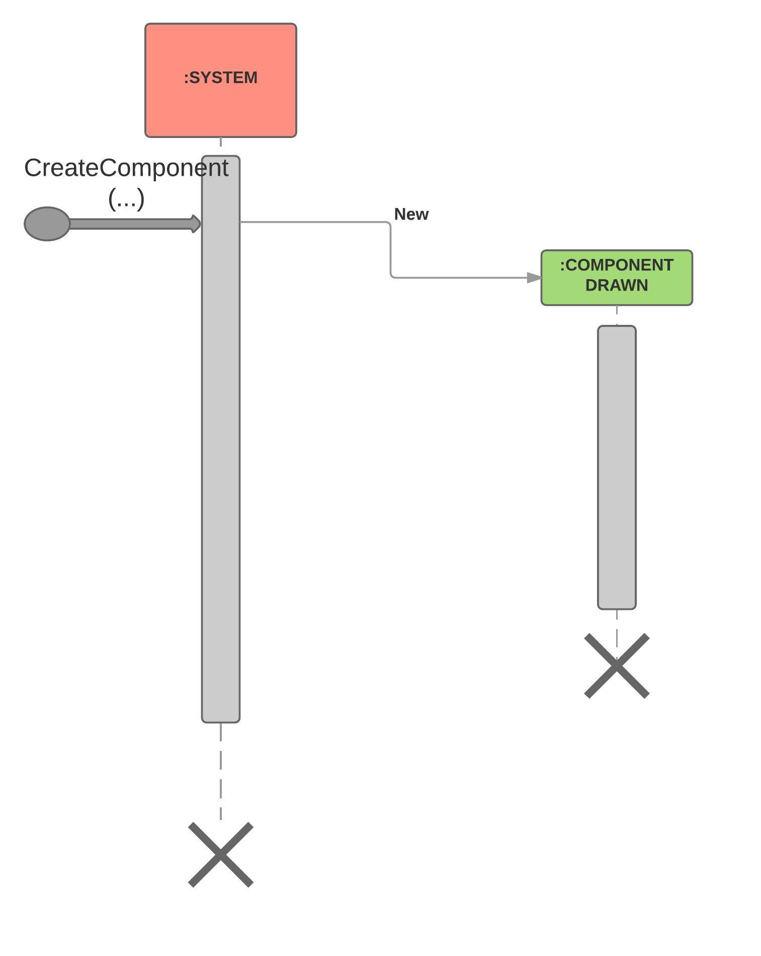

## Editing a component

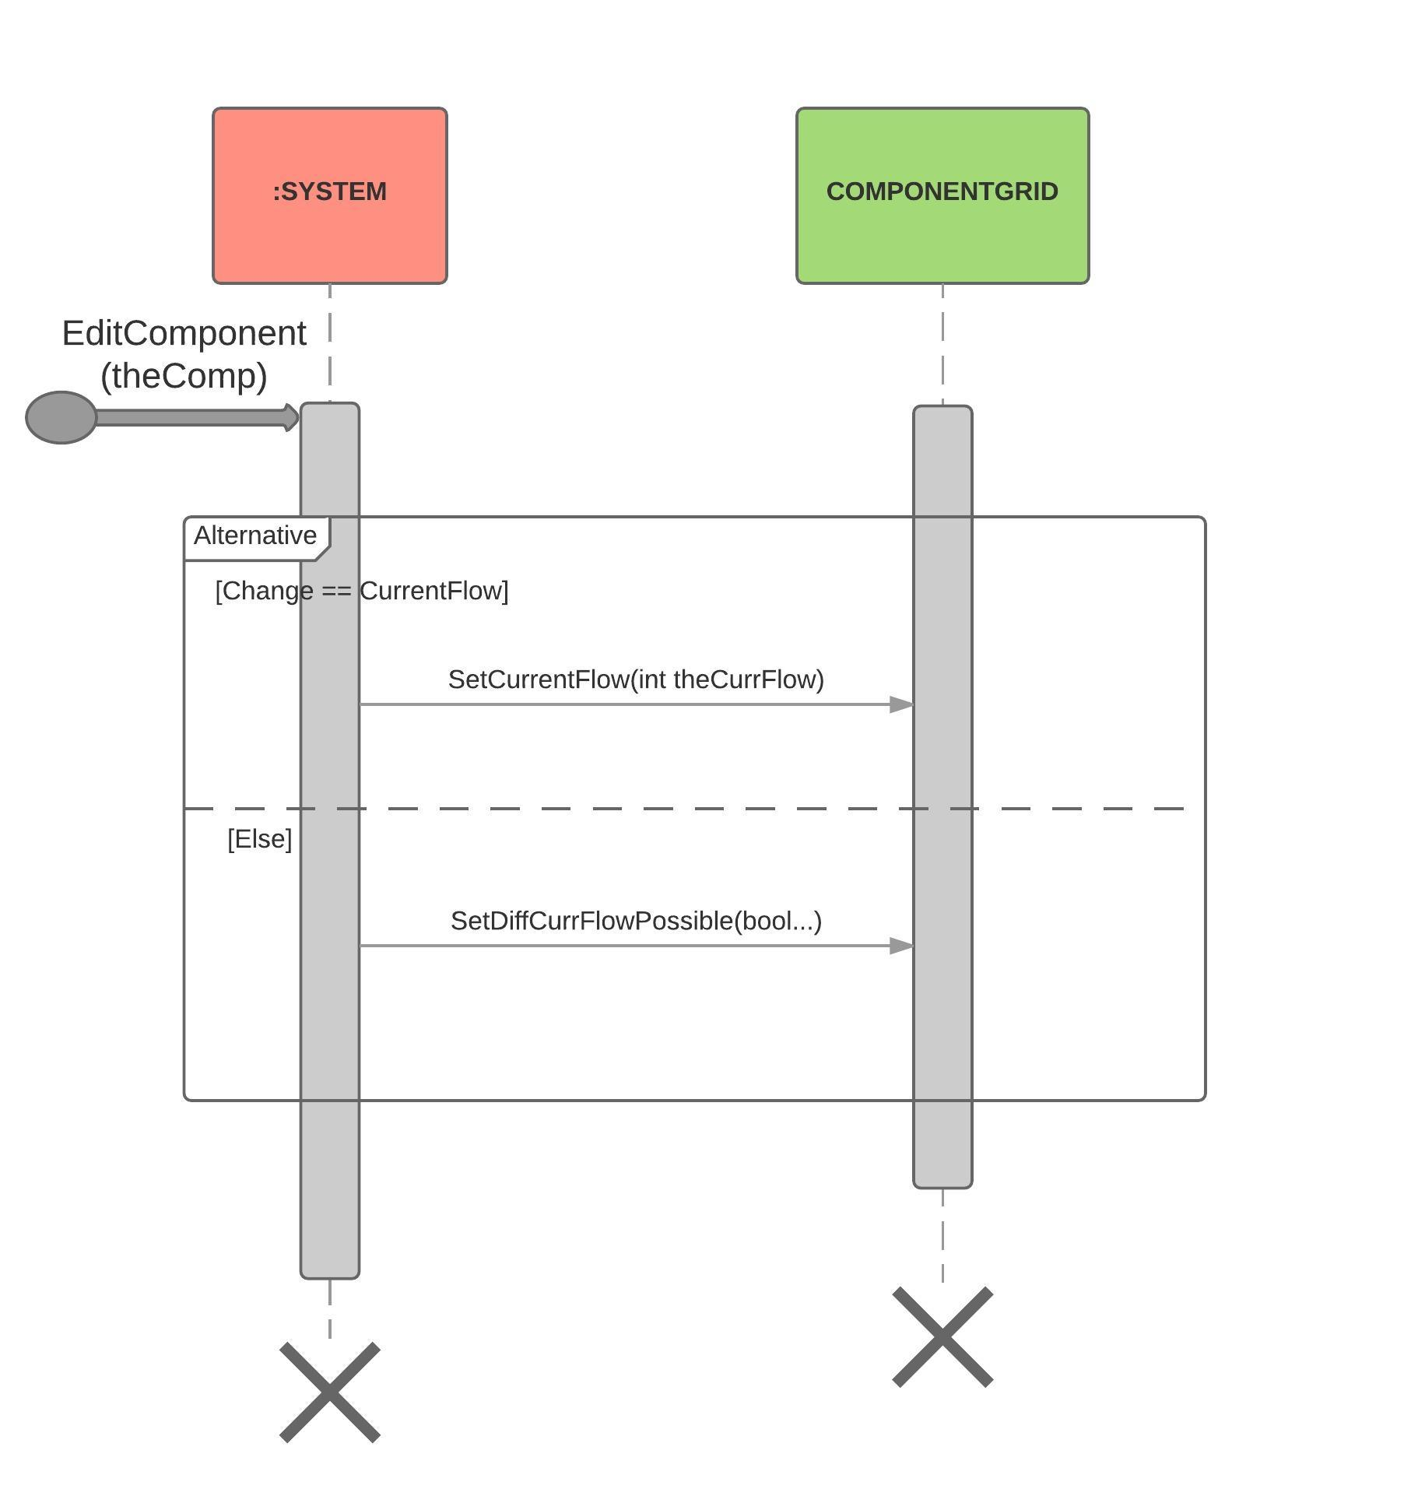

## Saving the Grid

