# C4 Software Architecture

Table of contents

C4 Software Architecture 1

1. Introduction 2

2. Architecture 2

2.1. System Context Diagram 2

2.2. Containers Diagram 4

2.3. Components Diagram 5

3. Sequence diagram 6

3.1. Buying a ticket 6

4. API documentation 6

# Introduction

The project which architecture is depicted in this document is going to be a NBA portal where users can view information about NBA games, teams and players and purchase tickets for future games.

# Architecture

## System Context Diagram

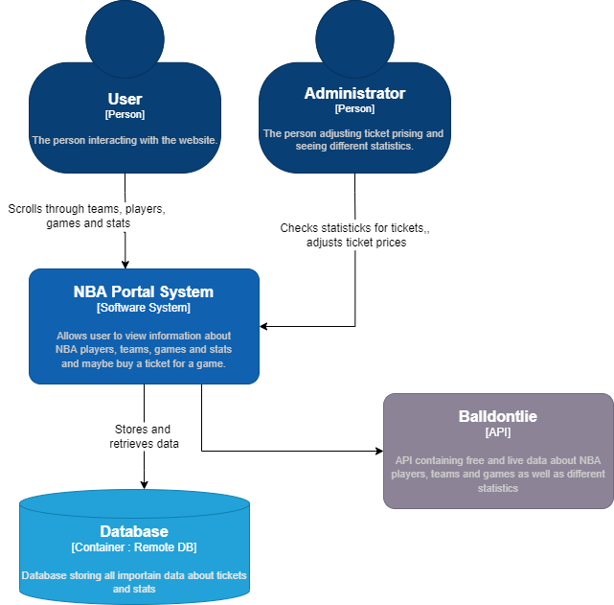

## Containers Diagram

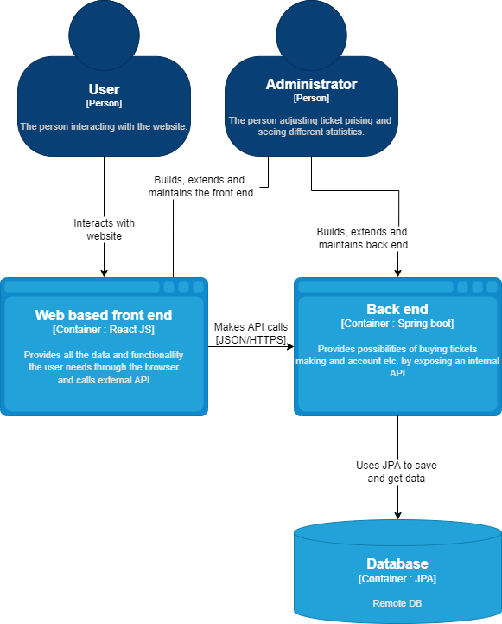

## Components Diagram

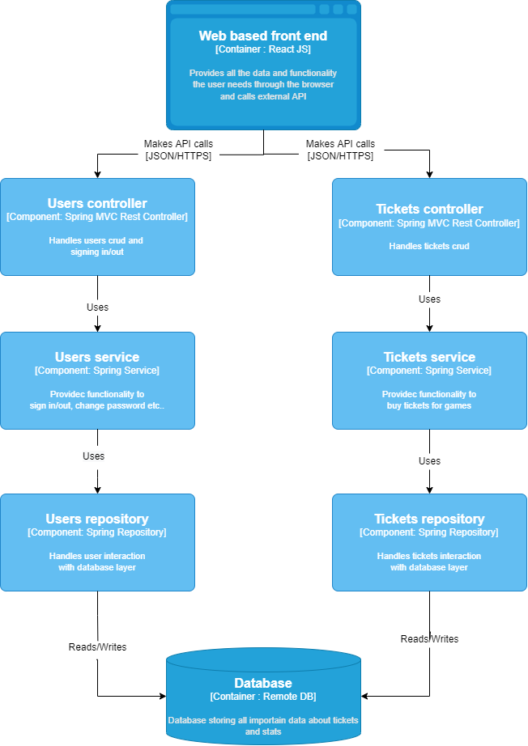

# Sequence diagram

## Buying a ticket

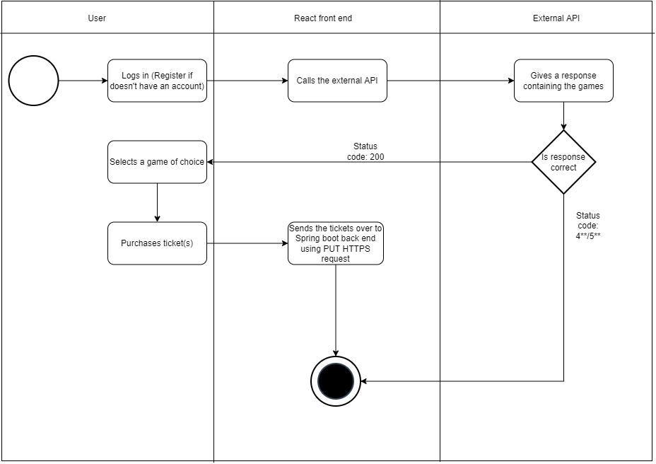

# API documentation

For this project I will make use of 2 APIs, one of which is external and contains live changing data about NBA games, players and statistics. The other one is a Spring boot back-end RESTful API that will expose and save data about tickets that have been bought for different games.

Full documentation of external ‘Balldontlie’ API:   
<https://www.balldontlie.io/#introduction>