Visoka škola strukovnih studija za informacione i

komunikacione tehnologije

Dokumentacija

http://nikolareljic.com/guitarzoom/

Predmet: Web programiranje PHP 2

Student: Nikola Reljić 195/14

Beograd, februar 2018.

Sadržaj

1. Uvod

1.1. Korišćeni programski jezici

1.2. Opis funkcionalnosti

1.3. Template

1.4. Nema tuđeg CSS koda (korišćen je Bootstrap)

2. Organizacija

2.1. Organizaciona šema

2.2. Stranice

2.2.1. home.php

2.2.2. about.php

2.2.3. shop.php

2.2.4. single-item.php

2.2.5. contact.php

2.2.6. cart.php

2.2.7. checkout.php

2.2.8. login.php

2.2.9. registracija.php

2.2.10. author.php

2.2.11. admin.php

2.2.12. admin/slider.php

2.2.13. admin/products.php

2.2.14. admin/poll.php

2.2.15. admin/menu.php

3. Kodovi

3.1. PHP + HTML + JS

3.1.1. index.php

3.1.2. home.php

3.1.3. slider.php

3.1.4. shop.php

3.1.5. search.php

3.1.6. single-item.php

3.1.7. poll.php

3.1.8. contact.php

3.1.9. cart.php

3.1.10. checkout.php

3.1.11. login.php

3.1.12. register.php

3.1.13. logout.php

3.1.14. 404.php

3.1.15. setup.php

3.1.16. about.php

3.1.17. author.php

3.1.18. admin/admin.php

3.1.19. admin/slider.php

3.1.20. admin/delete-slide.php

3.1.21. admin/update-slider.php

3.1.22. admin/products.php

3.1.23. admin/delete-product.php

3.1.24. admin/update-product.php

3.1.25. admin/poll.php

3.1.26. admin/delete-poll.php

3.1.27. admin/update-poll.php

3.1.28. admin/menu.php

3.1.29. admin/delete-menu.php

3.1.30. admin/update-menu.php

3.1.31. admin/home.php

3.2. CSS

3.2.1. style.css

3.2.2. admin/style.css

3.3. JavaScript/JQuery

3.3.1. validation.js

3.3.2. scripts.js

4. Dizajn baze

1. Uvod
   1. Korišćeni programski jezici

Za izradu sajta su korišćeni sledeći jezici, biblioteke i tehnologije:

HTML, HTML5, CSS, CSS3, JavaScript, JQuery, JQuery UI, Jquery Validate, AJAX, PHP, Bootstrap framework. Kod je pisan u Notepad++ tekstualnom editoru i PHP Storm IDE.

* 1. Opis funkcionalnosti

Sajt ima sledeće funkcionalnosti:

* Sajt je **single-page** i sve stranice se učitavaju preko **index** stranice
* **Logovanje i registracija** se nalaze u header sekciji svake stranice. Polja su zaštićena regularnim izrazima
* **Meni** se isčitava dinamički iz baze. Isto važi i za meni u admin panelu
* U gornjem delu **početne stranice** nalazi se **slider,** čiji se podaci prikazuju iz baze. Ispod njega se dinamički učitavaju **3 najnovija artikla**
* Artikli na **shop** stranici se stvaraju dinamički iz baze i to 6 po stranici. Preko **paginacije** se vrši dalji pregled artikala
* **Pretraga** je na **shop** stranici. Pretražuje artikle koji sadrže ključne reči u naslovu, opisu ili kratkom tekstu. Odvija se preko **AJAX**-a, vrši proveru za svaki uneti karakter.
* Klikom na sliku ili naziv proizvoda na shop stranici, dinamički se stvara **pojedinačna stranica artikla.** Na njima se nalazi **anketa** (upis u bazu i prikaz iz baze) gde mogu da glasaju samo ulogovani korisnici.
* Na shop i pojedinačnim stranicama artikala nalazi se dugme **Add to cart.** Klikom na njega, artikal se snima u **sesiju** i ubacuje u **cart.** Može stati samo jedna instanca svakog od artikala u korpu. Artikli se mogu pojedinačno uklanjati iz korpe pošto se označi ok u **popup**-u.
* Sa stranice cart može se preći na **checkout** stranicu (samo ukoliko je ubačen neki artikal), gde se nalazi forma za plaćanje povezana sa **stripe**-om. Sa desne strane se prikazuju proizvodi iz korpe.
* **Admin panel** – sadrži stranice **slider**, **products**, **poll**, **menu.** Na svakoj od stranica se isčitavaju kompletni podaci iz baze. Unose je moguće dodavati, editovati, brisati pojedinačno ili kao bulk. Editovanje se obavlja **AJAX**-om.
  1. Template

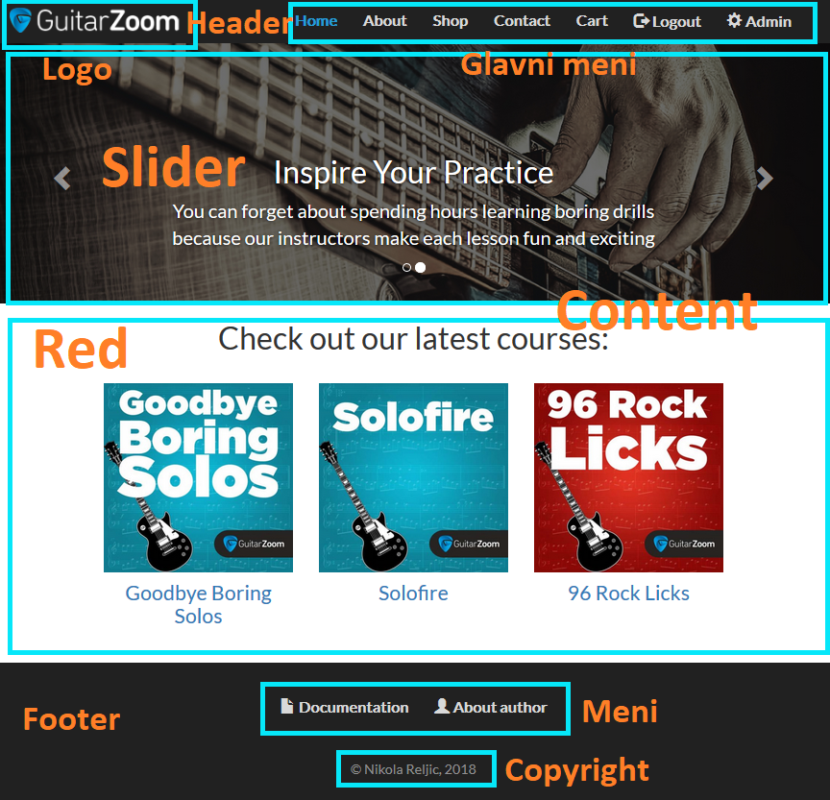

<!DOCTYPE html>

<html lang="en">

<head>

<title>Guitarzoom |

Play guitar now </title>

<meta charset="utf-8">

<meta name="viewport" content="width=device-width, initial-scale=1">

<link rel="stylesheet" href="[https://maxcdn.bootstrapcdn.com/bootstrap/3.3.7/css/bootstrap.min.css](view-source:https://maxcdn.bootstrapcdn.com/bootstrap/3.3.7/css/bootstrap.min.css)">

<script src="[https://ajax.googleapis.com/ajax/libs/jquery/3.3.1/jquery.min.js](view-source:https://ajax.googleapis.com/ajax/libs/jquery/3.3.1/jquery.min.js)"></script>

<script src="[https://maxcdn.bootstrapcdn.com/bootstrap/3.3.7/js/bootstrap.min.js](view-source:https://maxcdn.bootstrapcdn.com/bootstrap/3.3.7/js/bootstrap.min.js)"></script>

<script src="[https://code.jquery.com/ui/1.12.1/jquery-ui.min.js](view-source:https://code.jquery.com/ui/1.12.1/jquery-ui.min.js)"></script>

<script src="[https://cdnjs.cloudflare.com/ajax/libs/jquery-validate/1.17.0/jquery.validate.js](view-source:https://cdnjs.cloudflare.com/ajax/libs/jquery-validate/1.17.0/jquery.validate.js)"></script>

<link rel="stylesheet" type="text/css" href="[https://cdnjs.cloudflare.com/ajax/libs/jqueryui/1.12.1/jquery-ui.css](view-source:https://cdnjs.cloudflare.com/ajax/libs/jqueryui/1.12.1/jquery-ui.css)">

<link href="[https://fonts.googleapis.com/css?family=Lato](view-source:https://fonts.googleapis.com/css?family=Lato)" rel="stylesheet">

<link rel="stylesheet" type="text/css" href="[style.css](view-source:http://localhost/gz/style.css)">

<link rel="shortcut icon" href="[images/favicon.png](view-source:http://localhost/gz/images/favicon.png)" />

<meta name="author" content="Nikola Reljić">

<meta name="keywords" content="Play guitar, Steve Stine, passion, practice">

<meta name="description" content="Steve Stine is known as the world's most sought-after guitar instructor.">

</head>

<body>

<nav class="navbar navbar-inverse">

<div class="container-fluid">

<div class="navbar-header">

<button type="button" class="navbar-toggle" data-toggle="collapse" data-target="#myNavbar">

<span class="icon-bar"></span>

<span class="icon-bar"></span>

<span class="icon-bar"></span>

</button>

<a class="navbar-brand" href="[?page=home](view-source:http://localhost/gz/?page=home)"><img src="[images/GZ-logo.png](view-source:http://localhost/gz/images/GZ-logo.png)" alt="Logo"></a>

</div>

<div class="collapse navbar-collapse" id="myNavbar">

<ul class="nav navbar-nav">

<li><a class="active" href="[?page=1](view-source:http://localhost/gz/?page=1)">Home</a></li>

<li><a class="" href="[?page=2](view-source:http://localhost/gz/?page=2)">About</a></li>

<li><a class="" href="[?page=3](view-source:http://localhost/gz/?page=3)">Shop</a></li>

<li><a class="" href="[?page=4](view-source:http://localhost/gz/?page=4)">Contact</a></li>

<li><a class="" href="[?page=5](view-source:http://localhost/gz/?page=5)">Cart</a></li>

<li><a href="[?page=logout](view-source:http://localhost/gz/?page=logout)"><span class="glyphicon glyphicon-log-out"></span> Logout</a></li>

<li><a href="[admin/admin.php](view-source:http://localhost/gz/admin/admin.php)"><span class="glyphicon glyphicon-cog"></span> Admin</a></li>

</ul>

</div>

</div>

</nav>

<div id="myCarousel" class="carousel slide" data-ride="carousel">

<!-- Indicators -->

<ol class="carousel-indicators">

<li data-target="#myCarousel" data-slide-to="0" class="active"></li>

<li data-target="#myCarousel" data-slide-to="1"></li>

</ol>

<!-- Wrapper for slides -->

<div class="carousel-inner" role="listbox">

<div class="item active">

<img src="[images/1518787071_1518738043_slider-steve.jpg](view-source:http://localhost/gz/images/1518787071_1518738043_slider-steve.jpg)" alt="Soloing By Instinct">

<div class="carousel-caption">

<h2>Ignite Your Passion</h2>

<p class="text-large">Develop a lifelong passion for guitar and the confidence to express your creativity</p>

</div>

</div>

<div class="item ">

<img src="[images/slider-guitar.jpg](view-source:http://localhost/gz/images/slider-guitar.jpg)" alt="Guitar Strings">

<div class="carousel-caption">

<h2>Inspire Your Practice</h2>

<p class="text-large">You can forget about spending hours learning boring drills because our instructors make each lesson fun and exciting</p>

</div>

</div>

</div>

<!-- Left and right controls -->

<a class="left carousel-control" href="[#myCarousel](view-source:http://localhost/gz/#myCarousel)" role="button" data-slide="prev">

<span class="glyphicon glyphicon-chevron-left" aria-hidden="true"></span>

<span class="sr-only">Previous</span>

</a>

<a class="right carousel-control" href="[#myCarousel](view-source:http://localhost/gz/#myCarousel)" role="button" data-slide="next">

<span class="glyphicon glyphicon-chevron-right" aria-hidden="true"></span>

<span class="sr-only">Next</span>

</a>

</div>

<div class="container text-center">

<h2>Check out our latest courses:</h2><br>

<div class="row">

<div class="col-sm-4 space-bottom">

<div><a class="image-hover" href='[?page=3&course=9](view-source:http://localhost/gz/?page=3&course=9)'><img class='img-responsive' src='[images/products/Goodbye-Boring-Solos.jpg](view-source:http://localhost/gz/images/products/Goodbye-Boring-Solos.jpg)' alt='Goodbye Boring Solos'/></a></div>

<a href='[index.php?course="9](view-source:http://localhost/gz/index.php?course=%229)'><h4>Goodbye Boring Solos</h4></a>

</div>

<div class="col-sm-4 space-bottom">

<div><a class="image-hover" href='[?page=3&course=8](view-source:http://localhost/gz/?page=3&course=8)'><img class='img-responsive' src='[images/products/solofire.jpg](view-source:http://localhost/gz/images/products/solofire.jpg)' alt='Solofire'/></a></div>

<a href='[index.php?course="8](view-source:http://localhost/gz/index.php?course=%228)'><h4>Solofire</h4></a>

</div>

<div class="col-sm-4 space-bottom">

<div><a class="image-hover" href='[?page=3&course=7](view-source:http://localhost/gz/?page=3&course=7)'><img class='img-responsive' src='[images/products/96-rock-licks.jpg](view-source:http://localhost/gz/images/products/96-rock-licks.jpg)' alt='96 Rock Licks'/></a></div>

<a href='[index.php?course="7](view-source:http://localhost/gz/index.php?course=%227)'><h4>96 Rock Licks</h4></a>

</div>

</div>

</div><footer class="container-fluid text-center">

<div class="collapse navbar-collapse" id="footerNavbar">

<ul class="nav navbar-nav">

<li><a href="[dokumentacija.pdf](view-source:http://localhost/gz/dokumentacija.pdf)"><span class="glyphicon glyphicon-file"></span> Documentation</a></li>

<li><a href="[?page=author](view-source:http://localhost/gz/?page=author)"><span class="glyphicon glyphicon-user"></span> About author</a></li>

</ul>

<p class="copy">&copy; Nikola Reljic, 2018</p>

</div>

</footer>

<div id="overlay">

<div class="loader"></div>

</div>

</body>

</html>

1. Organizacija

2.1 Organizaciona šema

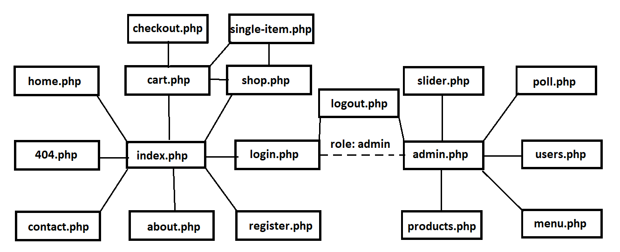

2.3 Stranice

2.2.1 Home (home.php)



2.2.2 About (about.php)

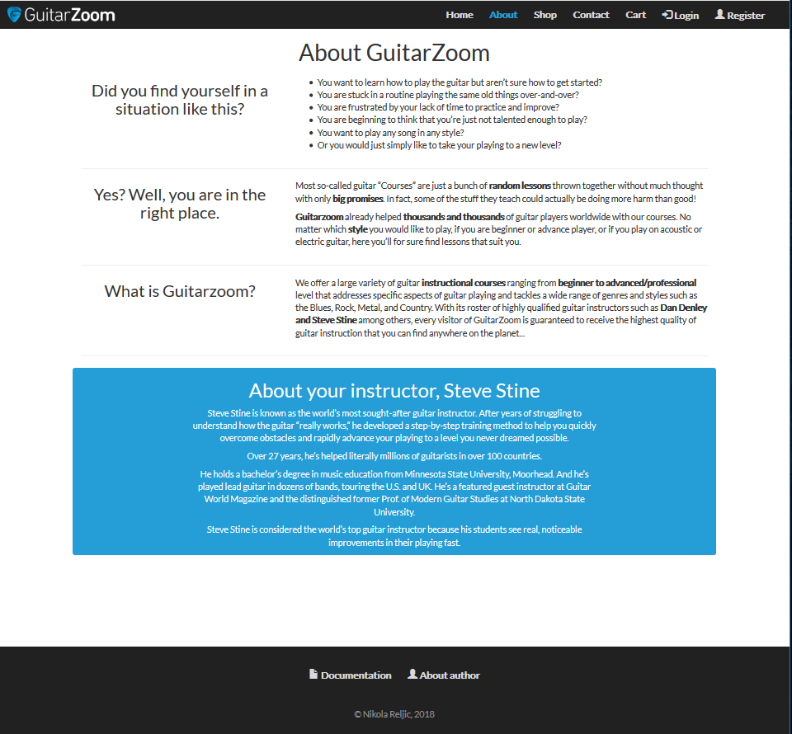

2.2.3 Shop (shop.php)

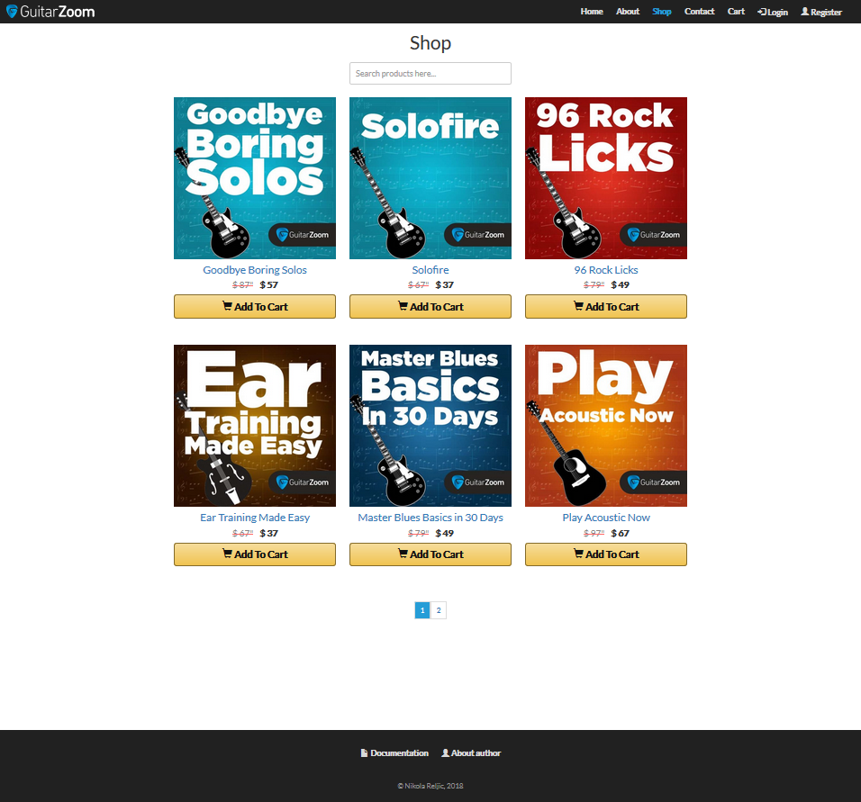

2.2.4 Single item (single-item.php)

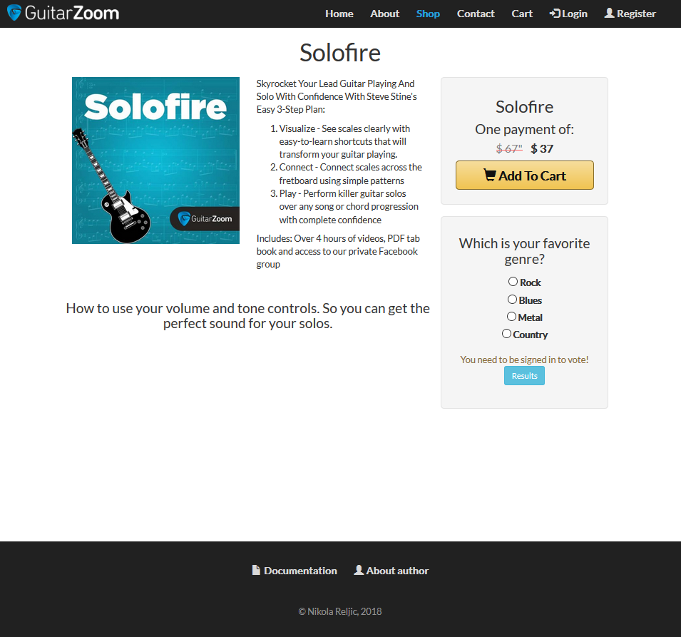

2.2.5 Contact (contact.php)

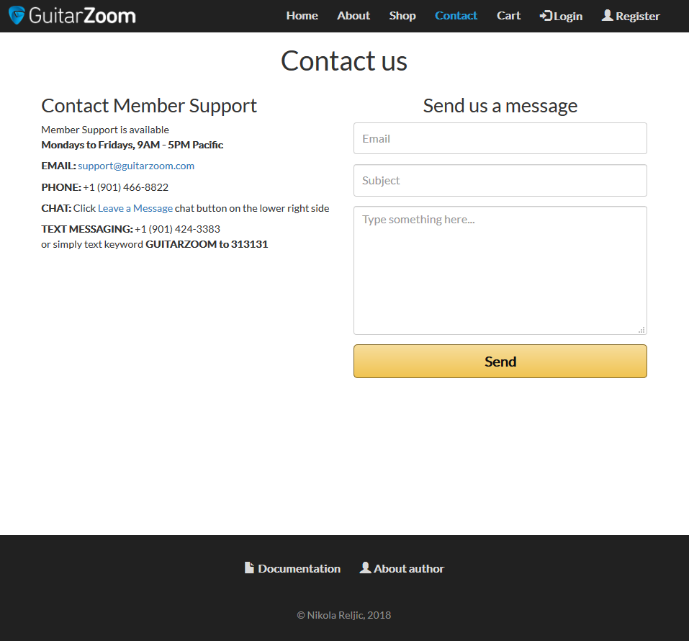

2.2.6 Cart (cart.php)

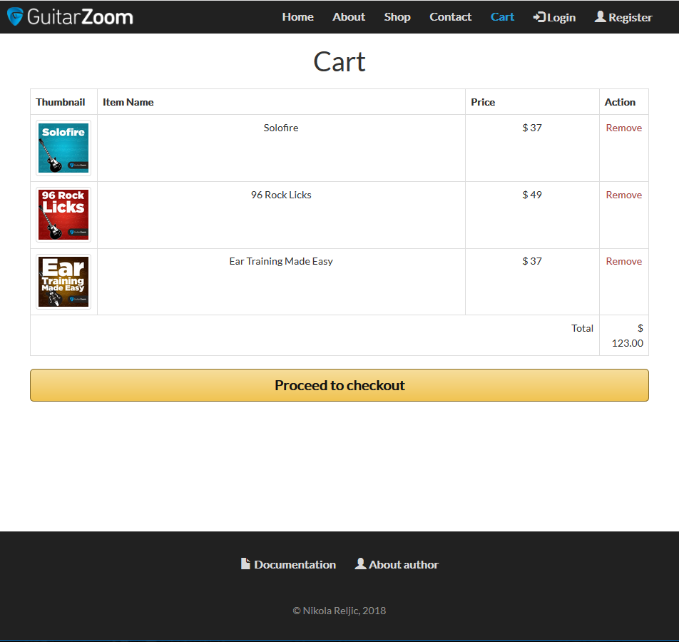

2.2.7 Checkout (checkout.php)

2.2.8 Login (login.php)

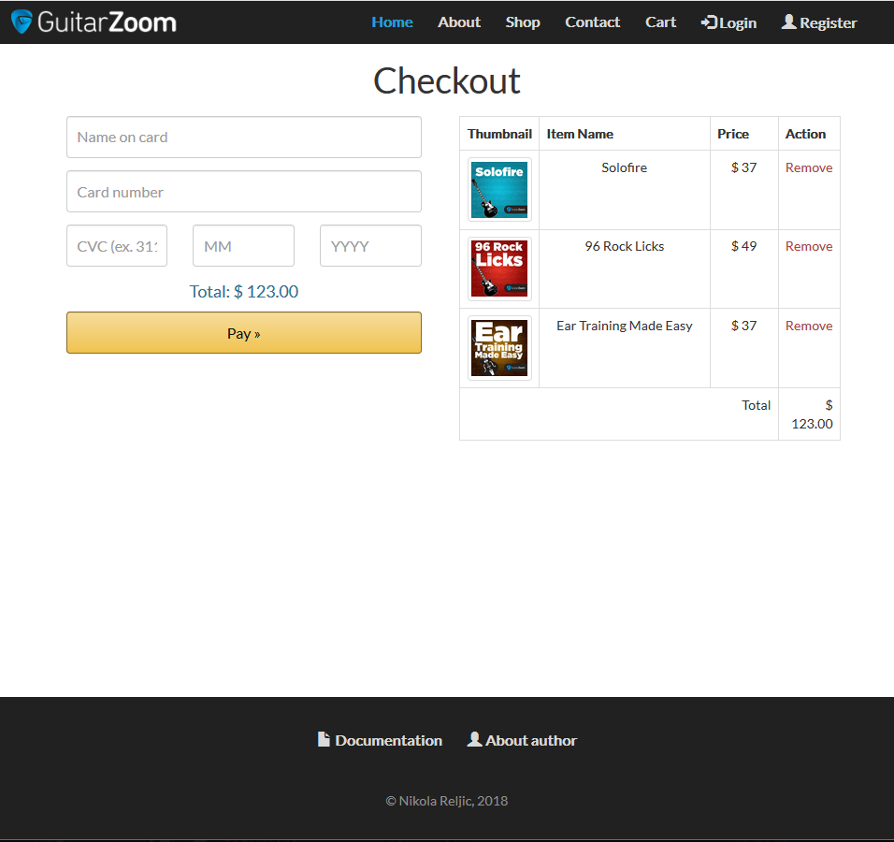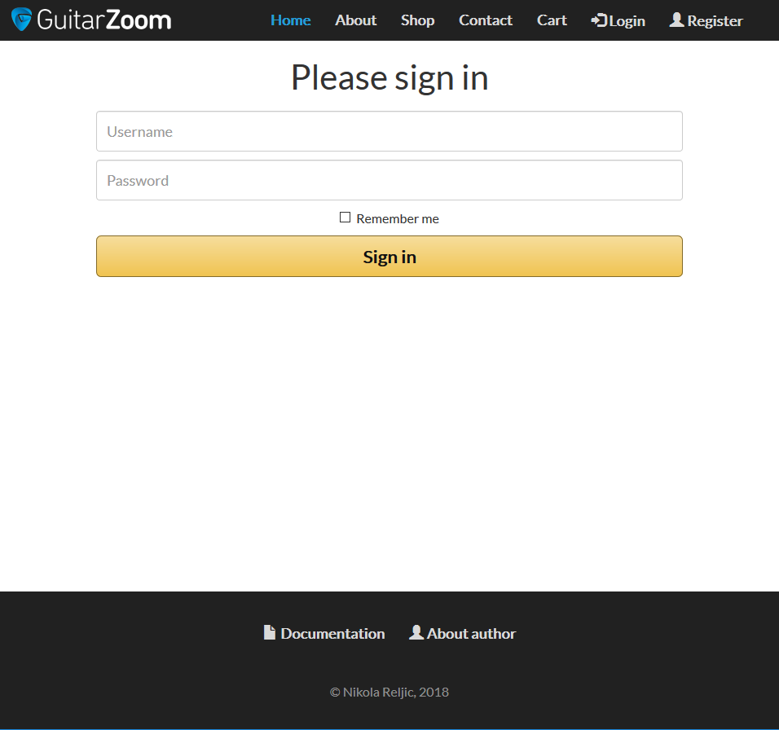

2.2.9 Register (register.php)

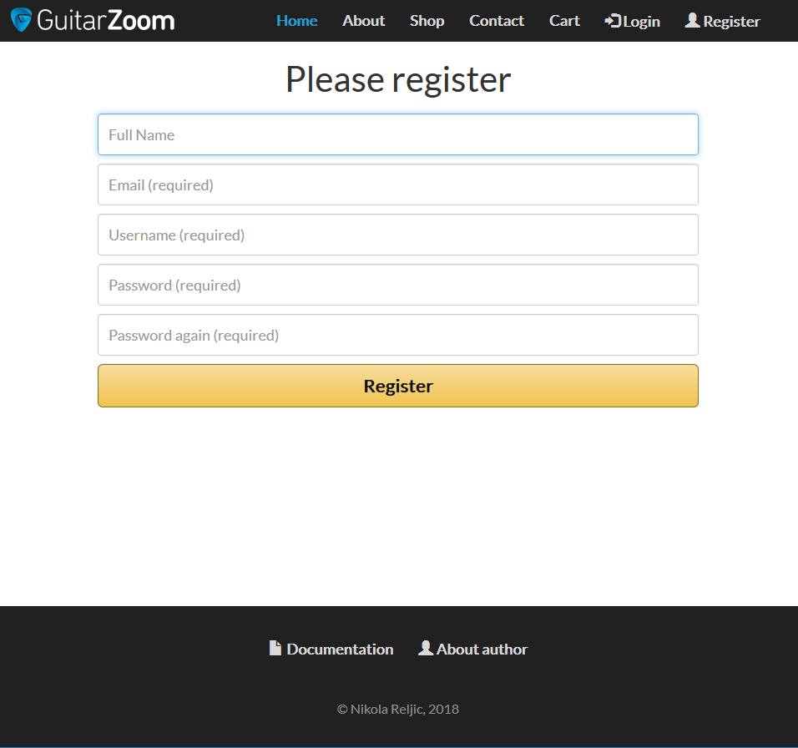

2.2.10 Author (author.php)

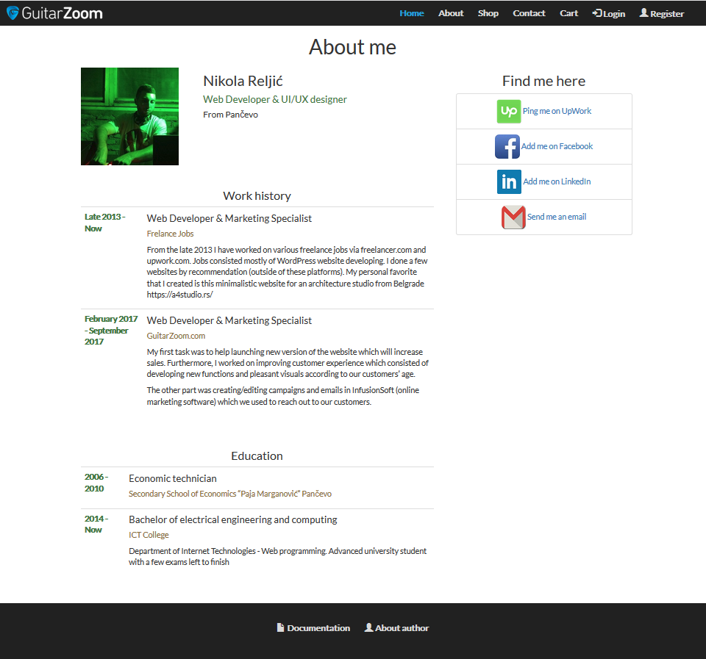

2.2.11 Admin (admin.php)

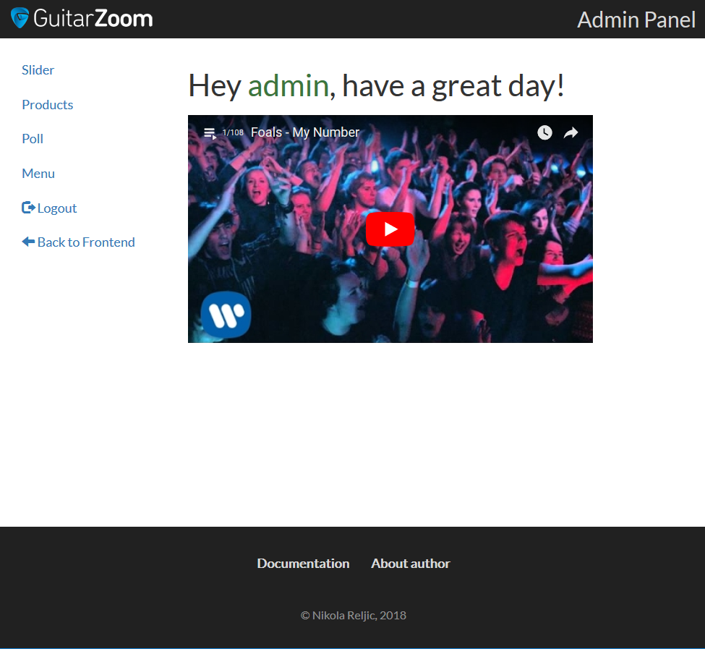

2.2.12 Admin slider (admin/slider.php)

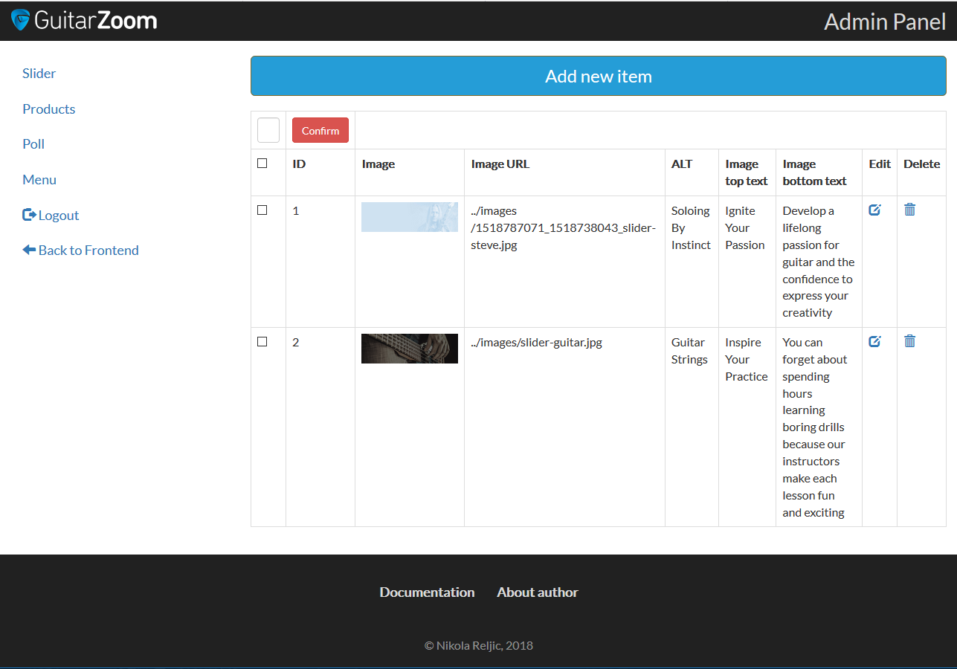

2.2.13 Admin products (admin/products.php)

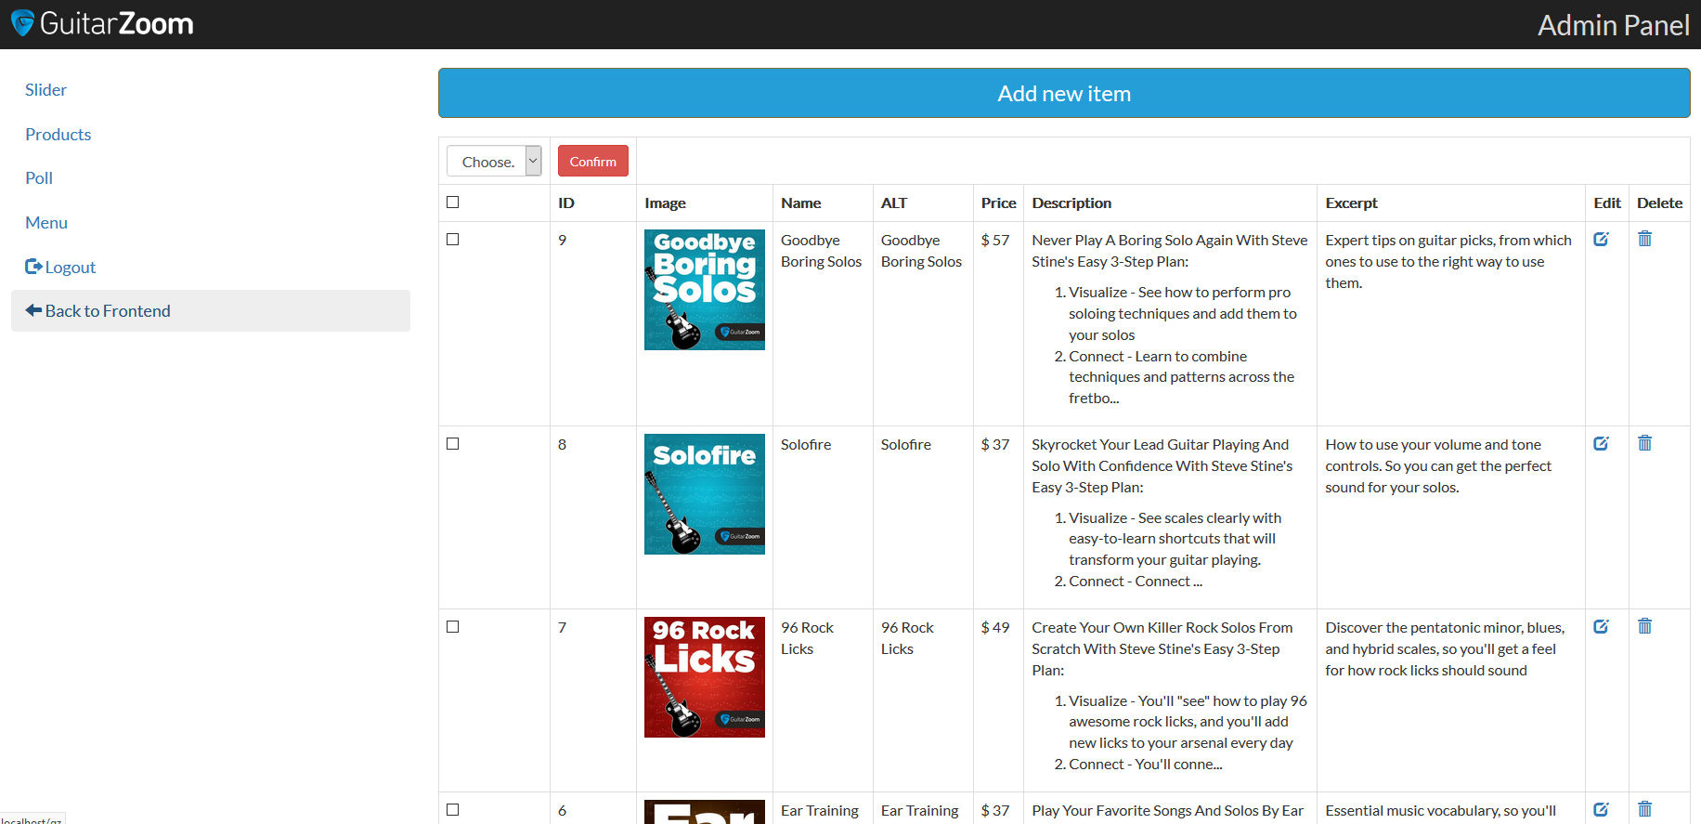

2.2.14 Admin poll (admin/poll.php)

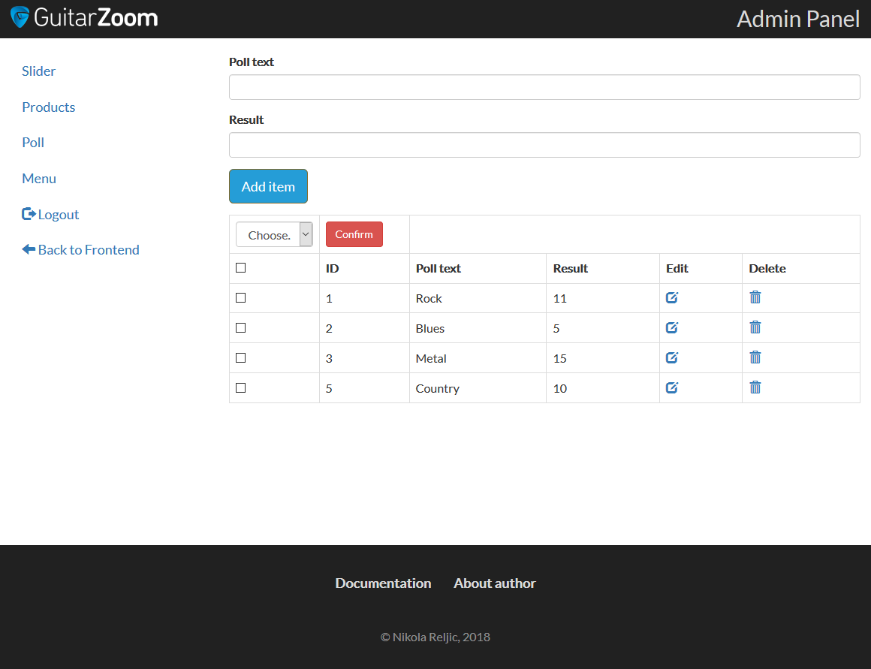

2.2.15 Admin menu (admin/menu.php)

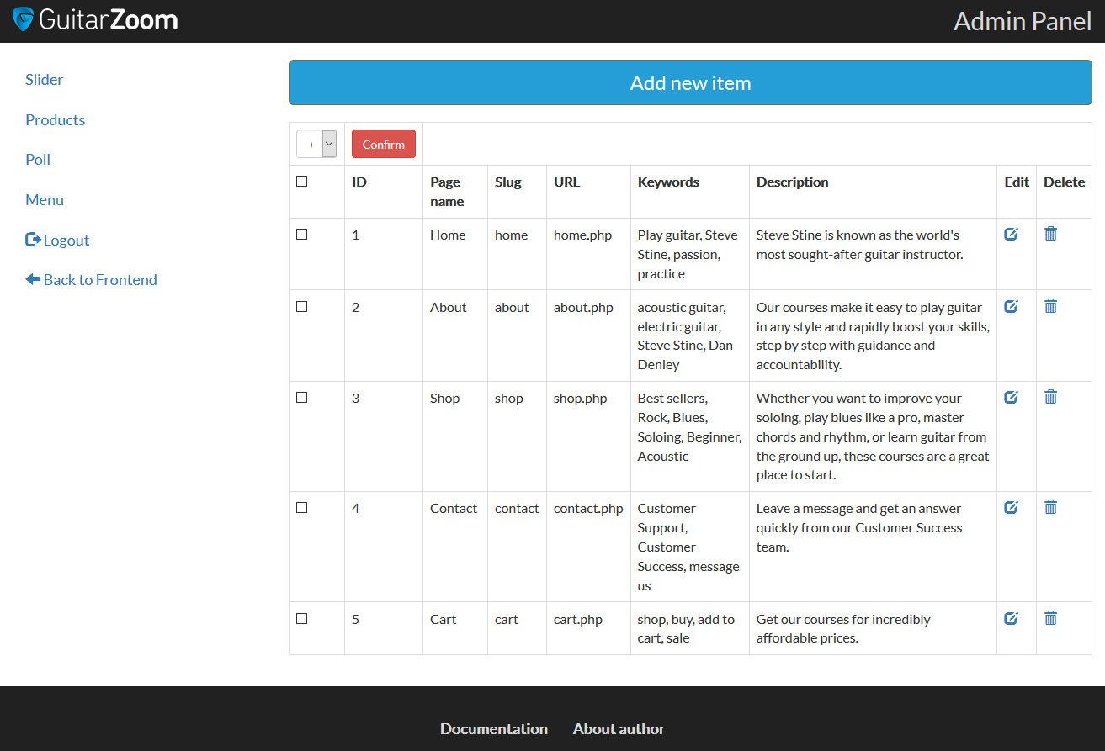

1. Kodovi
   1. PHP + HTML + JS
      1. index.php

<?php

@session_start();

include "setup.php";

?>

<!DOCTYPE html>

<html lang="en">

<head>

<title>Guitarzoom |

<?php

if($pageid == 1){

echo "Play guitar now";

}

else{

echo $pageinfo['name'];

}

?>

</title>

<meta charset="utf-8">

<meta name="viewport" content="width=device-width, initial-scale=1">

<link rel="stylesheet" href="https://maxcdn.bootstrapcdn.com/bootstrap/3.3.7/css/bootstrap.min.css">

<script src="https://ajax.googleapis.com/ajax/libs/jquery/3.3.1/jquery.min.js"></script>

<script src="https://maxcdn.bootstrapcdn.com/bootstrap/3.3.7/js/bootstrap.min.js"></script>

<script src="https://code.jquery.com/ui/1.12.1/jquery-ui.min.js"></script>

<script src="https://cdnjs.cloudflare.com/ajax/libs/jquery-validate/1.17.0/jquery.validate.js"></script>

<link rel="stylesheet" type="text/css" href="https://cdnjs.cloudflare.com/ajax/libs/jqueryui/1.12.1/jquery-ui.css">

<link href="https://fonts.googleapis.com/css?family=Lato" rel="stylesheet">

<link rel="stylesheet" type="text/css" href="style.css">

<link rel="shortcut icon" href="images/favicon.png" />

<meta name="author" content="Nikola Reljić">

<?php

$q = "SELECT * FROM menu WHERE id_menu=".$pageid;

$row = mysqli_query($conn, $q);

$r = mysqli_fetch_array($row);

?>

<meta name="keywords" content="<?php echo $r['keywords']; ?>">

<meta name="description" content="<?php echo $r['description'] ?>">

</head>

<body>

<nav class="navbar navbar-inverse">

<div class="container-fluid">

<div class="navbar-header">

<button type="button" class="navbar-toggle" data-toggle="collapse" data-target="#myNavbar">

<span class="icon-bar"></span>

<span class="icon-bar"></span>

<span class="icon-bar"></span>

</button>

<a class="navbar-brand" href="?page=home"><img src="images/GZ-logo.png" alt="Logo"></a>

</div>

<div class="collapse navbar-collapse" id="myNavbar">

<ul class="nav navbar-nav">

<?php

$q = "SELECT * FROM menu";

$r = mysqli_query($conn, $q);

while($nav = mysqli_fetch_array($r)) : ?>

<li><a class="<?php echo ($pageinfo['name'] == $nav['name']) ? "active" : ""; ?>" href="?page=<?php echo $nav['id_menu']; ?>"><?php echo $nav['name'] ?></a></li>

<?php endwhile; ?>

<?php if(isset($_SESSION['role'])) : ?>

<li><a href="?page=logout"><span class="glyphicon glyphicon-log-out"></span> Logout</a></li>

<?php if ($_SESSION['role'] == "admin"): ?>

<li><a href="admin/admin.php"><span class="glyphicon glyphicon-cog"></span> Admin</a></li>

<?php

endif;

else:

?>

<li><a href="?page=login"><span class="glyphicon glyphicon-log-in"></span> Login</a></li>

<li><a href="?page=register"><span class="glyphicon glyphicon-user"></span> Register</a></li>

<?php endif; ?>

</ul>

</div>

</div>

</nav>

<?php

//load content

if(isset($_GET['course']))

include("single-item.php");

elseif(isset($_REQUEST['page']))

if(!is_numeric($_REQUEST['page']))

include($_REQUEST['page'].".php");

elseif($_GET['page'] != $pageinfo['id_menu'])

include "404.php";

else

include $pageinfo['url'];

else

include $pageinfo['url'];

include "close.php";

?>

<footer class="container-fluid text-center">

<div class="collapse navbar-collapse" id="footerNavbar">

<ul class="nav navbar-nav">

<li><a href="dokumentacija.pdf"><span class="glyphicon glyphicon-file"></span> Documentation</a></li>

<li><a href="?page=author"><span class="glyphicon glyphicon-user"></span> About author</a></li>

</ul>

<p class="copy">&copy; Nikola Reljic, <?php echo date("Y") ?></p>

</div>

</footer>

<div id="overlay">

<div class="loader"></div>

</div>

</body>

</html>

* + 1. home.php

<?php

include "slider.php";

?>

<div class="container text-center">

<h2>Check out our latest courses:</h2><br>

<div class="row">

<?php

$query = "SELECT * FROM product ORDER BY id_product DESC LIMIT 3";

$rez = mysqli_query($conn, $query);

while($r = mysqli_fetch_array($rez)):

?>

<div class="col-sm-4 space-bottom">

<div><a class="image-hover" href='?page=3&course=<?php echo $r['id_product']; ?>'><img class='img-responsive' src='<?php echo $r['image_url']; ?>' alt='<?php echo $r["alt"]; ?>'/></a></div>

<a href='index.php?course="<?php echo $r['id_product']; ?>'><h4><?php echo $r['name']; ?></h4></a>

</div>

<?php

endwhile;

?>

</div>

</div>

* + 1. slider.php

<div id="myCarousel" class="carousel slide" data-ride="carousel">

<!-- Indicators -->

<ol class="carousel-indicators">

<li data-target="#myCarousel" data-slide-to="0" class="active"></li>

<li data-target="#myCarousel" data-slide-to="1"></li>

</ol>

<!-- Wrapper for slides -->

<div class="carousel-inner" role="listbox">

<?php

$query = "SELECT * FROM slider";

$rez = mysqli_query($conn, $query);

$i=0;

while($r = mysqli_fetch_array($rez)):

?>

<div class="item <?php if($i == 0){echo "active"; } ?>">

<img src="<?php echo $r['url']; ?>" alt="<?php echo $r['alt']; ?>">

<div class="carousel-caption">

<h2><?php echo $r['top_text']; ?></h2>

<p class="text-large"><?php echo $r['bottom_text']; ?></p>

</div>

</div>

<?php

$i++;

endwhile;

?>

</div>

<!-- Left and right controls -->

<a class="left carousel-control" href="#myCarousel" role="button" data-slide="prev">

<span class="glyphicon glyphicon-chevron-left" aria-hidden="true"></span>

<span class="sr-only">Previous</span>

</a>

<a class="right carousel-control" href="#myCarousel" role="button" data-slide="next">

<span class="glyphicon glyphicon-chevron-right" aria-hidden="true"></span>

<span class="sr-only">Next</span>

</a>

</div>

* + 1. shop.php

<div class="container text-center">

<h1>Shop</h1>

<div class="row">

<div class="col-md-4 col-md-offset-4 space-bottom-2 form-signin">

<input id="search" type="text" name="search" class="form-control" placeholder="Search products here..." />

</div>

</div>

<div class="row" id="searchResults">

<?php

if(!isset($_REQUEST['paginate']) || !is_numeric($_REQUEST['paginate'])){

$paginate = 1;

}

else{

$paginate = $_REQUEST['paginate'];

}

$onPage = 6;

$query = "SELECT * FROM product";

$rez = mysqli_query($conn, $query);

if($resultNumber = mysqli_num_rows($rez)){

$numberPaginate = ceil($resultNumber / $onPage);

$firstResult = ($paginate-1) * $onPage;

$sql = "SELECT * FROM product ORDER BY id_product DESC LIMIT ".$firstResult . ','.$onPage;

$rec = mysqli_query($conn, $sql);

while($r = mysqli_fetch_array($rec)):

$oldprice = $r['price'] + 30;

?>

<div class='col-sm-4 space-bottom'>

<div><a class="image-hover" href='?page=3&course=<?php echo $r['id_product']; ?>'><img class='img-responsive' src='<?php echo $r['image_url']; ?>' alt='<?php echo $r["alt"]; ?>'/></a></div>

<a href='index.php?course="<?php echo $r['id_product']; ?>'><h4><?php echo $r['name']; ?></h4></a>

<h5><span class='strike-price'>$ <?php echo $oldprice; ?>"</span> <span class='actual-price'>$ <?php echo $r['price']; ?></span></h5>

<form action="index.php?page=5&action=add&id=<?php echo $r['id_product'] ?>" method="POST">

<input type="hidden" name="hidden_image" value="<?php echo $r['image_url']; ?>" />

<input type="hidden" name="hidden_price" value="<?php echo $r['price']; ?>" />

<input type="hidden" name="hidden_name" value="<?php echo $r['name']; ?>" />

<button name="addToCart" class='btn btn-lg btn-primary btn-block'><span class="glyphicon glyphicon-shopping-cart"></span> Add To Cart</button>

</form>

</div>

<!--

$upit2 = "SELECT * FROM kategorije k INNER JOIN vesti_kat vk ON k.id_kategorije = vk.id_kategorije WHERE vk.id_vesti=".$red['id_vesti'];

$rez2 = mysqli_query($konekcija, $upit2);

$kategorije = array();

while($r= mysqli_fetch_array($rez2)){

$kategorije[] = $r['naziv_kategorije'];

}

echo "<span class='kategorije'>".implode(', ',$kategorije)."</span>";

echo "</div></div>";

-->

<?php

endwhile;

?>

</div>

<div class='row' id="paginationWrapper">

<ul class='pagination'>

<?php

for($str=1; $str<=$numberPaginate; $str++){

if($str == $paginate){

echo "<li><a class='active-link' href='index.php?page=3&paginate=".$str."'>".$str."</a></li>";

}

else {

echo "<li><a href='index.php?page=3&paginate=" . $str . "'>" . $str . "</a></li>";

}

}

?>

<ul>

</div>

<?php

}

?>

</div>

<script>

$(document).ready(function(){

$("#search").keyup(function(){

$("#paginationWrapper").hide();

var search = $("#search").val();

$.post("search.php", {

search: search

}, function(data, status){

$("#searchResults").html(data);

if(!search){

$("#paginationWrapper").show();

$("#searchTitle").hide();

}

});

});

});

</script>

* + 1. search.php

<?php

include "connection.inc";

?>

<?php

if(isset($_REQUEST['search'])){

$search = $_REQUEST['search'];

$query="SELECT * FROM product WHERE (name LIKE '%$search%' OR description LIKE '%$search%' OR excerpt LIKE '%$search%') ORDER BY id_product DESC ";

$result = mysqli_query($conn, $query);

if(mysqli_num_rows($result)>0) {

echo "<h4 id='searchTitle'> Results for the term: <span class='text-primary'>". $search. "</span></h4>";

while($r = mysqli_fetch_array($result)):

$oldprice = $r['price'] + 30;

?>

<div class='col-sm-4 space-bottom'>

<div><a class="image-hover" href='?page=3&course=<?php echo $r['id_product']; ?>'><img class='img-responsive' src='<?php echo $r['image_url']; ?>' alt='<?php echo $r["alt"]; ?>'/></a></div>

<a href='index.php?course="<?php echo $r['id_product']; ?>'><h4><?php echo $r['name']; ?></h4></a>

<h5><span class='strike-price'>$ <?php echo $oldprice; ?>"</span> <span class='actual-price'>$ <?php echo $r['price']; ?></span></h5>

<form action="index.php?page=5&action=add&id=<?php echo $r['id_product'] ?>" method="POST">

<input type="hidden" name="hidden_image" value="<?php echo $r['image_url']; ?>" />

<input type="hidden" name="hidden_price" value="<?php echo $r['price']; ?>" />

<input type="hidden" name="hidden_name" value="<?php echo $r['name']; ?>" />

<button name="addToCart" class='btn btn-lg btn-primary btn-block'><span class="glyphicon glyphicon-shopping-cart"></span> Add To Cart</button>

</form>

</div>

<?php

endwhile;

}

else{

echo "<div class='alert alert-warning'>

<strong>No results!</strong>

</div>";

}

}

?>

* + 1. single-item.php

<div class="container text-center">

<div class="row">

<?php

$idProduct = $_GET['course'];

$query = "SELECT * FROM product WHERE id_product = '$idProduct'";

//$upit2 = "SELECT * FROM kategorije k INNER JOIN vesti_kat vk ON k.id_kategorije = vk.id_kategorije WHERE vk.id_vesti=$vestid";

//$rez2 = mysqli_query($konekcija, $upit2);

//$kategorije = array();

//ako stranica ne postoji ili su parametar slova

if(!isset($_GET['course']) || !is_numeric($_GET['course'])){

include '404.php';

}

else{/*

if (mysqli_num_rows($rez2)>0){

while($red2 = mysqli_fetch_array($rez2)){

$kategorije[] = $red2['naziv_kategorije'];

}

}*/

$res = mysqli_query($conn, $query);

if(mysqli_num_rows($res)>0):

$r = mysqli_fetch_array($res);

$oldprice = $r['price'] + 30;

?>

<h1><?php echo $r['name']; ?></h1>

<div class="col-sm-8">

<div class="row">

<div class='col-sm-6 space-bottom'>

<img class='img-responsive' src='<?php echo $r['image_url']; ?>' alt='<?php echo $r["alt"]; ?>'/>

</div>

<div class='col-sm-6 space-bottom text-left'>

<?php echo $r['description']; ?>

</div>

</div>

<div class="row space-bottom">

<h4><?php echo $r['excerpt']; ?></h4>

</div>

</div>

<div class='col-sm-4'>

<div class="well well-lg">

<h3><?php echo $r['name']; ?></h3>

<h4>One payment of:</h4>

<h5><span class='strike-price'>$ <?php echo $oldprice; ?>"</span> <span class='actual-price'>$ <?php echo $r['price']; ?></span></h5>

<form action="index.php?page=5&action=add&id=<?php echo $r['id_product'] ?>" method="POST">

<input type="hidden" name="hidden_image" value="<?php echo $r['image_url']; ?>" />

<input type="hidden" name="hidden_price" value="<?php echo $r['price']; ?>" />

<input type="hidden" name="hidden_name" value="<?php echo $r['name']; ?>" />

<button name="addToCart" class='btn btn-lg btn-primary btn-block'><span class="glyphicon glyphicon-shopping-cart"></span> Add To Cart</button>

</form>

</div>

<?php

include "poll.php";

?>

</div>

</div>

<?php endif;

}

?>

</div>

* + 1. poll.php

<?php

$messageSuccess = "";

$messageDanger = "";

if(isset($_POST['vote'])){

if(!empty($_POST['pollVote'])){

$pollVote = $_POST['pollVote'];

$query2 = "UPDATE poll SET result=result+1 WHERE id_poll=".$pollVote;

$rez2 = mysqli_query($conn, $query2);

if($rez2){

$messageSuccess = "<span class='text-success'>Your vote is noted!</span>";

}

}

else{

$messageDanger = "<span class='text-danger'>You have to choose an answer!</span>";

}

}

if(isset($_POST['results'])){

$query3 = "SELECT * FROM poll";

$res3 = mysqli_query($conn, $query3);

while($r3 = mysqli_fetch_array($res3)){

$results[] = $r3;

}

}

?>

<div class='space-bottom'>

<div class="well well-lg">

<form method="POST" action="">

<div class="form-group">

<h4>Which is your favorite genre?</h4>

</div>

<div class="form-group">

<?php

$query1 = "SELECT * FROM poll";

$res1 = mysqli_query($conn, $query1);

while($r1 = mysqli_fetch_array($res1)):

?>

<input id="<?php echo $r1['id_poll']; ?>" value="<?php echo $r1['id_poll']; ?>" type="radio" name="pollVote">

<label class="pollLabel" for="<?php echo $r1['id_poll']; ?>"><?php echo $r1['poll_text']; ?></label><br/>

<?php endwhile; ?>

</div>

<div class="form-group">

<?php if (isset($_SESSION['role'])): ?>

<input name="vote" class="btn btn-success" value="Vote" type="submit">

<?php else: ?>

<span class="text-warning">You need to be signed in to vote!</span>

<?php endif; ?>

<input id="showResults" name="results" class="btn btn-info" value="Results" type="submit">

</div>

<?php echo $messageSuccess; ?>

<?php echo $messageDanger; ?>

<?php if(isset($_POST['results'])): ?>

<table class="table table-bordered">

<?php

$i = 0;

foreach($results as $result){

++$i;

echo "<tr>";

echo "<td>". $result['poll_text'] ."</td><td>". $result['result'] ."</td>";

echo "</tr>";

}

?>

</table>

<?php endif; ?>

</form>

</div>

</div>

* + 1. contact.php

<?php

$messageE = "";

$messageS = "";

$messageM = "";

$messageSent = "";

if(isset($_POST["messageBtn"])){

$email = $_POST["email"];

$subject = $_POST["subject"];

$message = $_POST["message"];

$regEmail = "/^\w+([\.-]?\w+)*@\w+([\.-]?\w+)*(\.\w{2,3})+$/";

$regSubject = "/^[A-z0-9]{3,20}$/";

$regMessage = "/^[A-z0-9]{10,}$/";

if(!preg_match($regEmail, $email)){

$messageE = "<span class='text-danger'>Your email is not in a valid format!</span>";

}

elseif(!preg_match($regSubject, $subject)){

$messageS = "<span class='text-danger'>Your subject is not in a valid format!</span>";

}

elseif(!preg_match($regMessage, $message)){

$messageS = "<span class='text-danger'>Your Message is not in a valid format!</span>";

}

else{

$to = "nikola.reljic.web@gmail.com";

$headers = "From: guitarzoom.com website";

if(@mail($to, $subject, $message, $headers))

{

mail($to, $subject, $message, $headers);

$messageSent = "<div class='alert alert-success'><strong>Message sent!</strong></div>";

}

else {

$messageSent = "<div class='alert alert-danger item-changed'><strong>Message was not sent!</strong></div>";

}

}

}

?>

<div class="container text-center">

<h1>Contact us</h1>

<div class="row">

<div class='col-md-6 text-left'>

<h3>Contact Member Support</h3>

<p>Member Support is available<br/> <strong>Mondays to Fridays, 9AM - 5PM Pacific</strong></p>

<p><strong>EMAIL:</strong> <a href="mailto:support@guitarzoom.com">support@guitarzoom.com</a></p>

<p><strong>PHONE:</strong> +1 (901) 466-8822</p>

<p><strong>CHAT:</strong> Click <a href="https://m.me/stevestineguitar" target="_blank">Leave a Message</a> chat button on the lower right side</p>

<p><strong>TEXT MESSAGING:</strong> +1 (901) 424-3383<br/>

or simply text keyword <strong>GUITARZOOM to 313131</strong></p>

</div>

<div class="col-md-6">

<h3>Send us a message</h3>

<div id="messageDiv">

<form id="messageForm" class="form-signin" action="" method="POST">

<div class="form-group">

<label for="email" class="sr-only">Email</label>

<input id="email" name="email" class="form-control" placeholder="Email" required="" autofocus="" type="email">

<?php echo $messageE; ?>

</div>

<div class="form-group">

<label for="subject" class="sr-only">Subject</label>

<input id="subject" name="subject" class="form-control" placeholder="Subject" required="" type="text">

<?php echo $messageS; ?>

</div>

<div class="form-group">

<label for="message" class="sr-only">Message</label>

<textarea id="message" name="message" class="form-control" placeholder="Type something here..."/></textarea>

<?php echo $messageM; ?>

</div>

<button id="messageBtn" name="messageBtn" class="btn btn-lg btn-primary btn-block space-bottom" type="submit">Send</button>

</form>

<?php echo $messageSent; ?>

</div>

</div>

</div>

</div>

<script src="js/validation.js"></script>

* + 1. cart.php

<?php

if(isset($_POST["addToCart"]))

{

if(isset($_SESSION["shopping_cart"]))

{

$item_array_id = array_column($_SESSION["shopping_cart"], "id_product");

if(!in_array($_GET["id"], $item_array_id))

{

$count = count($_SESSION["shopping_cart"]);

$item_array = array(

'id_product' => $_GET["id"],

'item_name' => $_POST["hidden_name"],

'item_price' => $_POST["hidden_price"],

'item_image' => $_POST["hidden_image"]

);

$_SESSION["shopping_cart"][$count] = $item_array;

}

else

{

echo '<script>alert("Item Already Added")</script>';

echo '<script>window.location="index.php?page=5"</script>';

}

}

else

{

$item_array = array(

'id_product' => $_GET["id"],

'item_name' => $_POST["hidden_name"],

'item_price' => $_POST["hidden_price"],

'item_image' => $_POST["hidden_image"]

);

$_SESSION["shopping_cart"][0] = $item_array;

}

}

if(isset($_GET["action"]))

{

if($_GET["action"] == "delete")

{

foreach($_SESSION["shopping_cart"] as $keys => $values)

{

if($values["id_product"] == $_GET["id"])

{

unset($_SESSION["shopping_cart"][$keys]);

echo '<script>window.location="index.php?page=5"</script>';

}

}

}

}

?>

<div class="container text-center">

<h1>Cart</h1>

<div class="row">

<?php

if(!empty($_SESSION["shopping_cart"])):

?>

<div class="table-responsive">

<table class="table table-bordered">

<tr> <th width="10%">Thumbnail</th>

<th width="55%">Item Name</th>

<th width="20%">Price</th>

<th width="5%">Action</th>

</tr>

<?php

$total = 0;

foreach($_SESSION["shopping_cart"] as $keys => $values) {

?>

<tr>

<td><img class="img-thumbnail" src="<?php echo $values["item_image"]; ?>" /></td>

<td><?php echo $values["item_name"]; ?></td>

<td>$ <?php echo $values["item_price"]; ?></td>

<td><a class="del-item" href="index.php?page=5&action=delete&id=<?php echo $values["id_product"]; ?>"><span class="text-danger">Remove</span></a></td>

</tr>

<?php

$total = $total + ($values["item_price"]);

}

?>

<tr>

<td colspan="3" align="right">Total</td>

<td align="right">$ <?php echo number_format($total, 2); ?></td>

</tr>

</table>

</div>

</div>

<div class="row">

<a href="?page=checkout" class="btn btn-lg btn-primary btn-block">Proceed to checkout</a>

</div>

<?php else: ?>

<div class="row">

<h2>Your cart is now empty :(</h2>

<h3 class="glyphicon glyphicon-shopping-cart"></h3>

</div>

<?php endif; ?>

</div>

</div>

<script language="JavaScript" src="admin/scripts.js"></script>

* + 1. . checkout.php

<div class="container text-center">

<h1>Checkout</h1>

<div class="row">

<div class='col-md-6 text-left'>

<script src='https://js.stripe.com/v2/' type='text/javascript'></script>

<form accept-charset="UTF-8" action="/" class="require-validation form-signin" data-cc-on-file="false" data-stripe-publishable-key="pk_bQQaTxnaZlzv4FnnuZ28LFHccVSaj" id="payment-form" method="post"><div style="margin:0;padding:0;display:inline"><input name="utf8" type="hidden" value="✓" /><input name="_method" type="hidden" value="PUT" /><input name="authenticity_token" type="hidden" value="qLZ9cScer7ZxqulsUWazw4x3cSEzv899SP/7ThPCOV8=" /></div>

<div class='form-row'>

<div class='col-xs-12 form-group required'>

<label class='control-label sr-only'>Name on Card</label>

<input class='form-control' size='4' type='text' placeholder="Name on card">

</div>

</div>

<div class='form-row'>

<div class='col-xs-12 form-group card required'>

<label class='control-label sr-only'>Card Number</label>

<input autocomplete='off' class='form-control card-number' size='20' type='text' placeholder="Card number">

</div>

</div>

<div class='form-row'>

<div class='col-xs-4 form-group cvc required'>

<label class='control-label sr-only'>CVC</label>

<input autocomplete='off' class='form-control card-cvc' placeholder='CVC (ex. 311)' size='4' type='text' placeholder="CVC">

</div>

<div class='col-xs-4 form-group expiration required'>

<label class='control-label sr-only'>Expiration</label>

<input class='form-control card-expiry-month' placeholder='MM' size='2' type='text' placeholder="Expiration">

</div>

<div class='col-xs-4 form-group expiration required'>

<label class='control-label sr-only'>Expiry year</label>

<input class='form-control card-expiry-year' placeholder='YYYY' size='4' type='text'>

</div>

</div>

<div class='form-row'>

<div class='col-md-12'>

<div class='text-info total'>

Total:

<?php

$total = 0;

foreach($_SESSION["shopping_cart"] as $keys => $values){

$total = $total + ($values["item_price"]);

}

?>

<span class='amount'>$ <?php echo number_format($total, 2); ?></span>

</div>

</div>

</div>

<div class='form-row'>

<div class='col-md-12 form-group'>

<button class='form-control btn btn-primary submit-button' type='submit'>Pay »</button>

</div>

</div>

<div class='form-row'>

<div class='col-md-12 error form-group hide'>

<div class='alert-danger alert'>

Please correct the errors and try again.

</div>

</div>

</div>

</form>

</div>

<div class="col-md-6">

<?php

?>

<div class="table-responsive">

<table class="table table-bordered">

<tr> <th width="10%">Thumbnail</th>

<th width="55%">Item Name</th>

<th width="20%">Price</th>

<th width="5%">Action</th>

</tr>

<?php

$total = 0;

foreach($_SESSION["shopping_cart"] as $keys => $values) {

?>

<tr>

<td><img class="img-thumbnail" src="<?php echo $values["item_image"]; ?>" /></td>

<td><?php echo $values["item_name"]; ?></td>

<td>$ <?php echo $values["item_price"]; ?></td>

<td><a class="del-item" href="index.php?page=5&action=delete&id=<?php echo $values["id_product"]; ?>"><span class="text-danger">Remove</span></a></td>

</tr>

<?php

$total = $total + ($values["item_price"]);

}

?>

<tr>

<td colspan="3" align="right">Total</td>

<td align="right">$ <?php echo number_format($total, 2); ?></td>

</tr>

</table>

</div>

</div>

</div>

</div>

<script>

$(function() {

$('form.require-validation').bind('submit', function(e) {

var $form = $(e.target).closest('form'),

inputSelector = ['input[type=email]', 'input[type=password]',

'input[type=text]', 'input[type=file]',

'textarea'].join(', '),

$inputs = $form.find('.required').find(inputSelector),

$errorMessage = $form.find('div.error'),

valid = true;

$errorMessage.addClass('hide');

$('.has-error').removeClass('has-error');

$inputs.each(function(i, el) {

var $input = $(el);

if ($input.val() === '') {

$input.parent().addClass('has-error');

$errorMessage.removeClass('hide');

e.preventDefault(); // cancel on first error

}

});

});

});

$(function() {

var $form = $("#payment-form");

$form.on('submit', function(e) {

if (!$form.data('cc-on-file')) {

e.preventDefault();

Stripe.setPublishableKey($form.data('stripe-publishable-key'));

Stripe.createToken({

number: $('.card-number').val(),

cvc: $('.card-cvc').val(),

exp_month: $('.card-expiry-month').val(),

exp_year: $('.card-expiry-year').val()

}, stripeResponseHandler);

}

});

function stripeResponseHandler(status, response) {

if (response.error) {

$('.error')

.removeClass('hide')

.find('.alert')

.text(response.error.message);

} else {

// token contains id, last4, and card type

var token = response['id'];

// insert the token into the form so it gets submitted to the server

$form.find('input[type=text]').empty();

$form.append("<input type='hidden' name='reservation[stripe_token]' value='" + token + "'/>");

$form.get(0).submit();

}

}

})

</script>

<script language="JavaScript" src="admin/scripts.js"></script>

* + 1. login.php

<?php

$message="";

$messageU="";

$messageP="";

if(isset($_POST['btnLogin']))

{

$username = $_POST['username'];

$password = $_POST['password'];

$regUsername = "/^[A-z0-9]{3,30}$/";

$regPassword = "/^[A-z0-9]{6,20}$/";

if(!preg_match($regUsername, $username))

{

$messageU = "<span class='text-danger'>Username is in the wrong format!</span>";

}

else if(!preg_match($regPassword, $password))

{

$messageP = "<span class='text-danger'>Password is in the wrong format!</span>";

}

else

{

$query = "SELECT * FROM user u

INNER JOIN user_role ru

ON u.id_user = ru.user_id

INNER JOIN role r

ON r.id_role = ru.role_id

WHERE u.username = '".$username."' AND u.password = '".md5($password)."'";

$res = mysqli_query($conn, $query) or die("Query is not executed!".mysqli_error());

if(mysqli_num_rows($res) == 1)

{

if($_POST["rememberMe"]=='1' || $_POST["rememberMe"]=='on')

{

$hour = time() + 3600 * 24 * 30;

setcookie('username', $username, $hour);

setcookie('password', $password, $hour);

}

$role = mysqli_fetch_array($res);

$role = $role['role_name'];

$_SESSION['role'] = $role;

if ($_SESSION['role'] == "admin"){

header("Location: admin/admin.php");

}

else{

header("Location: index.php");

}

}

else

{

$message = "<span class='text-danger'>There is no user with given username and password!</span>";

}

}

}

?>

<div class="container text-center">

<h1>Please sign in</h1>

<div class="row col-md-6 col-md-offset-3">

<div id="login">

<form id="loginForm" class="form-signin" action="" method="POST">

<p>

<label for="username" class="sr-only">Username</label>

<input id="username" name="username" class="form-control" placeholder="Username" required="" autofocus="" type="text">

<?php echo $messageU; ?>

</p>

<p>

<label for="password" class="sr-only">Password</label>

<input id="password" name="password" class="form-control" placeholder="Password" required="" type="password">

<?php echo $messageP; ?>

</p>

<div class="checkbox">

<label>

<input name="rememberMe" type="checkbox"> Remember me

</label>

</div>

<button form="loginForm" id="loginBtn" name="btnLogin" class="btn btn-lg btn-primary btn-block" type="submit">Sign in</button>

</form>

<?php echo $message; ?>

</div>

</div>

</div>

<script src="js/validation.js"></script>

3.1.12. register.php

<?php

$messageFN = "";

$messageE = "";

$messageU = "";

$messageP = "";

$messagePA = "";

$message = "";

if(isset($_POST["btnRegister"]))

{

$fullName = $_POST["fullName"];

$email = $_POST["email"];

$username = $_POST["username"];

$password = $_POST["password"];

$passwordAgain = $_POST["passwordAgain"];

$regFullName = "/^[A-z\s]{2,30}(\s[A-z]{2,30})+$/";

$regEmail = "/^\w+([\.-]?\w+)*@\w+([\.-]?\w+)*(\.\w{2,3})+$/";

$regUsername = "/^[A-z0-9]{2,30}$/";

$regPassword = "/^[A-z0-9]{5,20}$/";

if(!preg_match($regFullName, $fullName)){

$messageFN = "<span class='text-danger'>Your full name is not in a valid format!</span>";

}

else{

$fullName = mysqli_real_escape_string($conn, $fullName);

}

if(!preg_match($regEmail, $email)){

$messageE = "<span class='text-danger'>Your email is not in a valid format!</span>";

}

else{

$email = mysqli_real_escape_string($conn, $email);

}

if(!preg_match($regUsername, $username)){

$messageU = "<span class='text-danger'>Your username is not in a valid format!</span>";

}

else{

$username = mysqli_real_escape_string($conn, $username);

}

if(!preg_match($regPassword, $password)){

$messageP = "<span class='text-danger'>Your password is not good enough!</span>";

}

elseif ($password != $passwordAgain){

$messagePA = "<span class='text-danger'>Your password and confirmation password do not match!</span>";

}

else{

$password = md5(mysqli_real_escape_string($conn, $password));

$query = "INSERT INTO user VALUES (NULL, '$fullName', '$password', 2, '$username', '$email')";

if(mysqli_query($conn, $query)){

$message = "<span class='text-success'>Registration succesful! Please go to login page to sign in.</span>";

}

else{

$message = "<span class='text-danger'>Registration failed!</span>".mysqli_error();

}

}

}

?>

<div class="container text-center">

<h1>Please register</h1>

<div class="row col-md-6 col-md-offset-3">

<div id="register" class="space-bottom">

<form id="registerForm" class="form-signin space-bottom" action="" method="POST">

<p>

<label for="fullName" class="sr-only">Full Name</label>

<input id="fullName" name="fullName" class="form-control" placeholder="Full Name" required="" autofocus="" type="text">

<?php echo $messageFN; ?>

</p>

<p>

<label for="email" class="sr-only">Email</label>

<input id="email" name="email" class="form-control" placeholder="Email (required)" required="" autofocus="" type="text">

<?php echo $messageE; ?>

</p>

<p>

<label for="username" class="sr-only">Username</label>

<input id="username" name="username" class="form-control" placeholder="Username (required)" required="" autofocus="" type="text">

<?php echo $messageU; ?>

</p>

<p>

<label for="password" class="sr-only">Password</label>

<input id="password" name="password" class="form-control" placeholder="Password (required)" required="" type="password">

<?php echo $messageP; ?>

</p>

<p>

<label for="passwordAgain" class="sr-only">Password again</label>

<input id="passwordAgain" name="passwordAgain" class="form-control" placeholder="Password again (required)" required="" type="password">

<?php echo $messagePA; ?>

</p>

<button name="btnRegister" class="btn btn-lg btn-primary btn-block" type="submit">Register</button>

</form>

<?php echo $message; ?>

</div>

</div>

</div>

<script src="js/validation.js"></script>

3.1.13. logout.php

<?php

@session_start();

unset($_SESSION['role']);

session_destroy();

header("Location: index.php");

?>3.1.14. 404.php

<div class="container text-center">

<h1>Er...</h1>

<h2>Congratulations, you broke the Internet</h2>

<h4>The page you are after no longer exists or never existed.</h4>

<img class="space-bottom space-top" src="images/skinner.jpg" alt="skinner" />

</div>

3.1.15. setup.php

<?php

include 'connection.inc';

if(!isset($_REQUEST['page']) || !is_numeric($_REQUEST['page']))

{

$pageid = 1;

}

else

{

$pageid = $_REQUEST['page'];

}

$query = "SELECT * FROM menu WHERE id_menu = $pageid";

$r = mysqli_query($conn, $query);

$pageinfo = mysqli_fetch_assoc($r);

?>

3.1.16. about.php

<div class="container text-center">

<h1>About GuitarZoom</h1>

<div class="row">

<div class="col-sm-4"><h3>Did you find yourself in a situation like this?</h3></div>

<div class="col-sm-8 text-left"><ul><li>You want to learn how to play the guitar but aren’t sure how to get started?</li><li>You are stuck in a routine playing the same old things over-and-over?</li><li>You are frustrated by your lack of time to practice and improve?</li><li>You are beginning to think that you’re just not talented enough to play?</li><li>You want to play any song in any style?</li><li>Or you would just simply like to take your playing to a new level?</li></ul></div>

</div>

<hr/>

<div class="row">

<div class="col-sm-4"><h3>Yes? Well, you are in the right place.</h3></div>

<div class="col-sm-8 text-left"><p>Most so-called guitar “Courses” are just a bunch of <strong>random lessons</strong> thrown together without much thought with only <strong>big promises</strong>. In fact, some of the stuff they teach could actually be doing more harm than good!</p><p><strong>Guitarzoom</strong> already helped <strong>thousands and thousands</strong> of guitar players worldwide with our courses. No matter which <strong>style</strong> you would like to play, if you are beginner or advance player, or if you play on acoustic or electric guitar, here you’ll for sure find lessons that suit you.</p></div>

</div>

<hr/>

<div class="row">

<div class="col-sm-4"><h3>What is Guitarzoom?</h3></div>

<div class="col-sm-8 text-left"><p>We offer a large variety of guitar <strong>instructional courses</strong> ranging from <strong>beginner to advanced/professional</strong> level that addresses specific aspects of guitar playing and tackles a wide range of genres and styles such as the Blues, Rock, Metal, and Country. With its roster of highly qualified guitar instructors such as <strong>Dan Denley and Steve Stine</strong> among others, every visitor of GuitarZoom is guaranteed to receive the highest quality of guitar instruction that you can find anywhere on the planet...</p></div>

</div>

<hr/>

<div class="row about-steve space-bottom panel">

<h2>About your instructor, Steve Stine</h2>

<div class="col-sm-8 col-md-offset-2"><p>Steve Stine is known as the world’s most sought-after guitar instructor. After years of struggling to understand how the guitar “really works,“ he developed a step-by-step training method to help you quickly overcome obstacles and rapidly advance your playing to a level you never dreamed possible.</p>

<p>Over 27 years, he’s helped literally millions of guitarists in over 100 countries.</p>

<p>He holds a bachelor’s degree in music education from Minnesota State University, Moorhead. And he’s played lead guitar in dozens of bands, touring the U.S. and UK. He’s a featured guest instructor at Guitar World Magazine and the distinguished former Prof. of Modern Guitar Studies at North Dakota State University.</p>

<p>Steve Stine is considered the world’s top guitar instructor because his students see real, noticeable improvements in their playing fast.</p>

</div>

</div>

</div>

3.1.17. author.php

<div class="container text-center">

<h1>About me</h1>

<div class="row">

<div class='col-md-8 text-left'>

<div class="col-md-4 space-bottom">

<img src="images/social/nikola.jpg" alt="Nikola Reljic"/>

</div>

<div class="col-md-8 space-bottom">

<h3>Nikola Reljić</h3>

<h5 class="text-success">Web Developer & UI/UX designer</h5>

<h6>From Pančevo</h6>

</div>

<div class="col-md-12 space-bottom">

<table class="table">

<h4 class="text-center">Work history</h4>

<tbody>

<tr>

<td><strong class="text-success">Late 2013 - Now</strong></td>

<td><h5>Web Developer & Marketing Specialist</h5>

<p class="text-warning">Frelance Jobs</p>

<p>From the late 2013 I have worked on various freelance jobs via freelancer.com and upwork.com. Jobs consisted mostly of WordPress website developing. I done a few websites by recommendation (outside of these platforms). My personal favorite that I created is this minimalistic website for an architecture studio from Belgrade https://a4studio.rs/</p>

</td>

</tr>

<tr>

<td><strong class="text-success">February 2017 - September 2017</strong></td>

<td><h5>Web Developer & Marketing Specialist</h5>

<p class="text-warning">GuitarZoom.com</p>

<p>My first task was to help launching new version of the website which will increase sales. Furthermore, I worked on improving customer experience which consisted of developing new functions and pleasant visuals according to our customers’ age.</p>

<p>The other part was creating/editing campaigns and emails in InfusionSoft (online marketing software) which we used to reach out to our customers.</p>

</td>

</tr>

</tbody>

</table>

</div>

<div class="col-md-12 space-bottom">

<table class="table">

<h4 class="text-center">Education</h4>

<tbody>

<tr>

<td><strong class="text-success">2006 - 2010</strong></td>

<td><h5>Economic technician</h5>

<p class="text-warning">Secondary School of Economics “Paja Marganović” Pančevo</p>

</td>

</tr>

<tr>

<td><strong class="text-success">2014 - Now</strong></td>

<td><h5>Bachelor of electrical engineering and computing</h5>

<p class="text-warning">ICT College</p>

<p>Department of Internet Technologies - Web programming. Advanced university student with a few exams left to finish</p>

</td>

</tr>

</tbody>

</table>

</div>

</div>

<div class="col-md-4">

<h3>Find me here</h3>

<ul class="list-group">

<li class="list-group-item justify-content-between">

<a href="https://www.upwork.com/o/profiles/users/_~01a0ebda92a25beefd/"><img src="images/social/upwork.png" alt="upwork"/> <span>Ping me on UpWork</span></a>

</li>

<li class="list-group-item justify-content-between">

<a href="https://facebook.com/ReljaWeb"><img src="images/social/facebook.jpg" alt="facebook"/> <span>Add me on Facebook</span></a>

</li>

<li class="list-group-item justify-content-between">

<a href="https://www.linkedin.com/in/nikola-relji%C4%87-648b48100/"><img src="images/social/linkedin.png" alt="facebook"/> <span>Add me on LinkedIn</span></a>

</li>

<li class="list-group-item justify-content-between">

<a href="mailto:nikola.reljic.web@gmail.com"><img src="images/social/gmail.png" alt="facebook"/> <span>Send me an email</span></a>

</li>

</ul>

</div>

</div>

</div>

3.1.18. admin/admin.php

<?php

@session_start();

include "../setup.php";

if ($_SESSION['role'] != "admin"){

header("Location: index.php");

}

?>

<!DOCTYPE html>

<html lang="en">

<head>

<title>Guitarzoom |

<?php

if(!isset($_REQUEST['page'])){

echo "Admin panel";

}

else{

echo ucfirst($_REQUEST['page']) ." Admin Panel";

}

?>

</title>

<meta charset="utf-8">

<meta name="viewport" content="width=device-width, initial-scale=1">

<link rel="stylesheet" href="https://maxcdn.bootstrapcdn.com/bootstrap/3.3.7/css/bootstrap.min.css">

<script src="https://ajax.googleapis.com/ajax/libs/jquery/3.3.1/jquery.min.js"></script>

<script src="https://maxcdn.bootstrapcdn.com/bootstrap/3.3.7/js/bootstrap.min.js"></script>

<script src="https://code.jquery.com/ui/1.12.1/jquery-ui.min.js"></script>

<link rel="stylesheet" type="text/css" href="https://cdnjs.cloudflare.com/ajax/libs/jqueryui/1.12.1/jquery-ui.css">

<link href="https://fonts.googleapis.com/css?family=Lato" rel="stylesheet">

<link rel="stylesheet" type="text/css" href="style.css">

<link rel="shortcut icon" href="../images/favicon.png" />

</head>

<body class="admin-panel">

<nav class="navbar navbar-inverse">

<div class="container-fluid">

<div class="navbar-header">

<button type="button" class="navbar-toggle" data-toggle="collapse" data-target="#myNavbar">

<span class="icon-bar"></span>

<span class="icon-bar"></span>

<span class="icon-bar"></span>

</button>

<a class="navbar-brand" href="?page=home"><img src="../images/GZ-logo.png" alt="Logo"></a>

</div>

<div class="admin-header">

<h3>Admin Panel</h3>

</div>

</div>

</nav>

<div class="container-fluid">

<div class="row content">

<div class="col-sm-3 sidenav">

<ul class="nav nav-pills nav-stacked">

<?php

$q = "SELECT * FROM admin_menu";

$r = mysqli_query($conn, $q);

while($nav = mysqli_fetch_array($r)) : ?>

<li><a href="?page=<?php echo $nav['slug']; ?>"><?php echo $nav['name'] ?></a></li>

<?php endwhile; ?>

<li><a href="logout.php"><span class="glyphicon glyphicon-log-out"></span> Logout</a></li>

<li><a href="/gz"><span class="glyphicon glyphicon-arrow-left"></span> Back to Frontend</a></li>

</ul>

</div>

<div class="col-sm-9">

<?php

//load content

if(isset($_GET['course']))

include("single-item.php");

elseif(isset($_REQUEST['page']))

if(!is_numeric($_REQUEST['page']))

include($_REQUEST['page'].".php");

elseif($_GET['page'] != $pageinfo['id_menu'])

include "404.php";

else

include $pageinfo['url'];

else

include $pageinfo['url'];

include "../close.php";

?>

</div>

</div>

</div>

<footer class="container-fluid text-center">

<div class="collapse navbar-collapse" id="footerNavbar">

<ul class="nav navbar-nav">

<li><a href="dokumentacija.pdf">Documentation</a></li>

<li><a href="author.php">About author</a></li>

</ul>

<p class="copy">&copy; Nikola Reljic, <?php echo date("Y") ?></p>

</div>

</footer>

<div id="overlay">

<div class="loader"></div>

</div>

</body>

</html>

<script language="JavaScript" src="scripts.js"></script>

3.1.19. admin/slider.php

<?php

if(isset($_REQUEST['page'])&& isset($_REQUEST['order'])){

if(is_numeric($_REQUEST['order'])){

$order = trim($_REQUEST['order']);

$query = "SELECT * FROM slider WHERE id_slider = $order";

$r=mysqli_query($conn, $query);

if(mysqli_num_rows($r) == 0){

echo "There are no items!";

}

else{

$r= mysqli_fetch_array($r);

?>

<div class="col-sm-9">

<form class="order" id="edit_item" method="POST" action = "" enctype="multipart/form-data">

<input type="hidden" id="id" name ="id" value="<?php echo $r['id_slider']; ?>" />

<div class="form-group">

<img src="../<?php echo $r['url']; ?>" alt="Slider image" class="img-responsive img-panel-slider" />

</div>

<div class="form-group">

<label for="altTag">Alt</label>

<input type="text" id="altTag" name="altTag" value="<?php echo $r['alt']; ?>" class="form-control" />

</div>

<div class="form-group">

<label for="topText">Top text</label>

<input type="text" id="topText" name="topText" value="<?php echo $r['top_text']; ?>" class="form-control" />

</div>

<div class="form-group">

<label for="bottomText">Bottom text</label>

<input type="text" id="bottomText" name="bottomText" value="<?php echo $r['bottom_text']; ?>" class="form-control" />

</div>

<div class="form-group">

<label class="btn btn-default">

Browse images <input class="myImg" name="uploadImage" id="uploadImage" type="file" hidden>

</label> <span class="text-warning">Recommended size is 1920x600px</span>

</div>

<div class="form-group">

<input type="submit" class="edit_item btn btn-lg btn-primary" value="Confirm editing"/>

</div>

</form>

<div class="rez"></div>

</div>

<?php

}

}

else{

echo "<div class='alert alert-danger item-changed'><strong>Image upload error</strong></div>";

}

}

else if(isset($_REQUEST['page'])){

$messageAdd = "";

if(isset($_REQUEST['addItem'])){

$alt = $_REQUEST['altTag'];

$topText = $_REQUEST['topText'];

$bottomText = $_REQUEST['bottomText'];

$path = "../images/uploads/";

$fileName = $_FILES['uploadImageNew']['name'];

$tmpImage = $_FILES['uploadImageNew']['tmp_name'];

$size = $_FILES['uploadImageNew']['size'];

$type = $_FILES['uploadImageNew']['type'];

$errors = $_FILES['uploadImageNew']['type'];

$newFile = time()."_".$fileName;

if($errors > 0){

echo "<div class='alert alert-danger item-changed'><strong>Image upload error</strong></div>";

}

else{

if(move_uploaded_file($tmpImage, $path.$newFile)){

$query = "INSERT INTO slider (id_slider, url, alt, top_text, bottom_text) VALUES (NULL, 'images/uploads/$newFile', '$alt', '$topText', '$bottomText')";

if (mysqli_query($conn, $query)) {

$messageAdd = "<div class='alert alert-success item-changed'><strong>New record created successfully</strong></div>";

}

else {

$messageAdd = "Error: " . $sql . "<br>" . mysqli_error($conn);

}

}

}

}

?>

<button id="addItemBtn" class="btn btn-lg btn-primary btn-block">Add new item</button>

<div id = "addItemDiv">

<form action ="" method="POST" enctype="multipart/form-data">

<div class="form-group">

<label for="alt">Alt</label>

<input type="text" id="altTag" name="altTag" class="form-control" />

</div>

<div class="form-group">

<label for="topText">Top text</label>

<input type="text" id="topText" name="topText" class="form-control" />

</div>

<div class="form-group">

<label for="bottomText">Bottom text</label>

<input type="text" id="bottomText" name="bottomText" class="form-control" />

</div>

<div class="form-group">

<label class="btn btn-default">

Browse images <input class="myImg" name="uploadImageNew" id="uploadImageNew" type="file" hidden>

</label> <span class="text-warning">Recommended size is 1920x600px</span>

</div>

<div class="form-group">

<input type="submit" name="addItem" class="btn btn-lg btn-primary" value="Add new slide">

</div>

</form>

</div>

<?php echo $messageAdd; ?>

<?php //checkbox deletion of slides

if(isset($_POST['delItem']))

{

$cnt=array();

$cnt=count($_POST['del']);

for($i=0;$i<$cnt;$i++)

{

$del_id=$_POST['del'][$i];

$query="delete from slider where id_slider=".$del_id;

mysqli_query($conn, $query);

}

}

?>

<form method="POST" action="">

<table class="table table-bordered">

<tr>

<td>

<select class="form-control form-control-sm">

<option value = "0" >Choose...</option>

<option value = "remove" >Delete selected</option>

</select>

</td>

<td>

<input name="delItem" type="submit" value="Confirm" class="btn btn-danger" />

</td>

</tr>

<tr>

<th><input type="checkbox" class="all" name="all" value="all"></th>

<th>ID</th>

<th>Image</th>

<th>Image URL</th>

<th>ALT</th>

<th>Image top text</th>

<th>Image bottom text</th>

<th>Edit</th>

<th>Delete</th>

</tr>

<?php

$q = "SELECT * FROM slider";

$r=mysqli_query($conn, $q);

while($data = mysqli_fetch_assoc($r))

{

echo "<tr>";

echo '<td><input type="checkbox" name="del[]" class="rest" value="'.$data["id_slider"].'"></td>';

?>

<td> <?php echo $data['id_slider']; ?> </td>

<td> <img src="<?php echo "../" . $data['url']; ?>" width="130px" alt="slika"/> </td>

<td> <?php echo "../" . $data['url']; ?> </td>

<td> <?php echo $data['alt']; ?> </td>

<td> <?php echo $data['top_text']; ?> </td>

<td> <?php echo $data['bottom_text']; ?> </td>

<td><a href="?page=slider&order=<?php echo $data['id_slider']; ?>"><i class="glyphicon glyphicon-edit"></i></a></td>

<td><a class="del-item" href="delete-slide.php?page=slider&order=<?php echo $data['id_slider'];?>"><i class="glyphicon glyphicon-trash" ></i></a></td>

<?php

echo "</tr>";

}

?>

</table>

</form>

<?php

}

if(isset($_REQUEST['deleted'])):

?>

<div class="alert alert-danger item-changed">

<strong>Item deleted!</strong>

</div>

<?php endif; ?>

<script type="text/javascript">

function obrada(e){

e.preventDefault();

$("#overlay").show();

$(".rez").show();

var formId = $("#edit_item");

var formData = new FormData(formId[0]);

$.ajax({

type:"POST",

url: "update-slider.php",

processData: false,

contentType: false,

data : formData,

cache: false,

success: function(data){

$(".rez").html("<div class='alert alert-success'><strong>Update successful!</strong></div>");

setTimeout(function(){ $('.rez').fadeOut('slow');

} , 3000);

$("#overlay").hide();

setTimeout(function(){// wait for 5 secs(2)

location.reload(); // then reload the page.(3)

}, 3000);

},

error: function (xhr, ajaxOptions, thrownError){

alert(xhr.status);

alert(thrownError);

}

});

}

$(document).ready(function(){

//$(".loader").hide();

$('#edit_item').on("submit", obrada);

});

</script>

3.1.20. admin/delete-slide.php

<?php

include '../connection.inc';

if(isset($_REQUEST['page']) && isset($_REQUEST['order'])){

if(is_numeric($_REQUEST['order'])){

$order = $_REQUEST['order'];

$q = "DELETE from slider WHERE id_slider =".$order;

mysqli_query($conn, $q) or die("Error during deletion");

echo "Deleted";

}

else{

echo "Not deleted";

}

}

?>

<?php

include '../close.php';

header("Location: admin.php?page=slider&deleted");

?>

3.1.21. admin/update-slider.php

<?php

include '../connection.inc';

if(isset($_REQUEST['id'])){

$id = $_REQUEST['id'];

$alt = $_REQUEST['altTag'];

$topText = $_REQUEST['topText'];

$bottomText = $_REQUEST['bottomText'];

$path = "../images/uploads/";

$fileName = $_FILES['uploadImage']['name'];

$tmpImage = $_FILES['uploadImage']['tmp_name'];

$size = $_FILES['uploadImage']['size'];

$type = $_FILES['uploadImage']['type'];

$errors = $_FILES['uploadImage']['type'];

$newFile = time()."_".$fileName;

if($errors > 0){

echo "<div class='alert alert-danger item-changed'><strong>Image upload error</strong></div>";

}

else{

if(move_uploaded_file($tmpImage, $path.$newFile)){

$q = "UPDATE slider

SET url = 'images/uploads/$newFile', alt = '$alt', top_text='$topText', bottom_text='$bottomText'

WHERE id_slider = $id";

$r = mysqli_query($conn, $q) or die("<div class='alert alert-danger item-changed'><strong>Error in query</strong></div>");

echo "<div class='alert alert-success'><strong>Update successful!</strong></div>";

}

else{

echo "<div class='alert alert-danger item-changed'><strong>Image upload error</strong></div>";

}

}

}

else{

echo "<div class='alert alert-danger item-changed'><strong>Error during the update</strong></div>";

}

?>

3.1.22. admin/products.php

<?php

if(isset($_REQUEST['page'])&& isset($_REQUEST['order'])){

if(is_numeric($_REQUEST['order'])){

$order = trim($_REQUEST['order']);

$query = "SELECT * FROM product WHERE id_product = $order";

$r=mysqli_query($conn, $query);

if(mysqli_num_rows($r) == 0){

echo "There are no items!";

}

else{

$r= mysqli_fetch_array($r);

?>

<div class="col-sm-9">

<form class="order" id="edit_item" method="POST" action = "" enctype="multipart/form-data">

<input type="hidden" id="id" name ="id" value="<?php echo $r['id_product']; ?>" />

<div class="form-group">

<img src="../<?php echo $r['image_url']; ?>" alt="Product image" class="img-responsive img-panel" />

</div>

<div class="form-group">

<label for="productName">Name</label>

<input type="text" id="productName" name="productName" value="<?php echo $r['name']; ?>" class="form-control" />

</div>

<div class="form-group">

<label for="altTag">Alt</label>

<input type="text" id="altTag" name="altTag" value="<?php echo $r['alt']; ?>" class="form-control" />

</div>

<div class="form-group">

<label for="price">Price</label>

<input type="text" id="price" name="price" value="<?php echo $r['price']; ?>" class="form-control" />

</div>

<div class="form-group">

<label for="description">Description</label>

<textarea id="description" name="description" class="form-control" /><?php echo htmlspecialchars($r['description']); ?> </textarea>

</div>

<div class="form-group">

<label for="excerpt">Excerpt</label>

<input type="text" id="excerpt" name="excerpt" value="<?php echo htmlspecialchars($r['excerpt']); ?>" class="form-control" />

</div>

<div class="form-group">

<label class="btn btn-default">

Browse images <input class="myImg" name="uploadImage" id="uploadImage" type="file" hidden>

</label> <span class="text-warning">Recommended size is 510x510px</span>

</div>

<div class="form-group">

<input type="submit" class="edit_item btn btn-lg btn-primary" value="Confirm editing"/>

</div>

</form>

<div class="rez"></div>

</div>

<?php

}

}

else{

echo "<div class='alert alert-danger item-changed'><strong>Image upload error</strong></div>";

}

}

else if(isset($_REQUEST['page'])){

$messageAdd = "";

if(isset($_REQUEST['addItem'])){

$productName = $_REQUEST['productName'];

$alt = $_REQUEST['altTag'];

$price = $_REQUEST['price'];

$description = $_REQUEST['description'];

$excerpt = $_REQUEST['excerpt'];

$path = "../images/uploads/";

$fileName = $_FILES['uploadImageNew']['name'];

$tmpImage = $_FILES['uploadImageNew']['tmp_name'];

$size = $_FILES['uploadImageNew']['size'];

$type = $_FILES['uploadImageNew']['type'];

$errors = $_FILES['uploadImageNew']['type'];

$newFile = time()."_".$fileName;

if($errors > 0){

echo "<div class='alert alert-danger item-changed'><strong>Image upload error</strong></div>";

}

else{

if(move_uploaded_file($tmpImage, $path.$newFile)){

$query = "INSERT INTO product (id_product, name, image_url, alt, price, description, excerpt) VALUES (NULL, '$productName', 'images/uploads/$newFile', '$alt', '$price', '$description', '$excerpt')";

if (mysqli_query($conn, $query)) {

$messageAdd = "<div class='alert alert-success item-changed'><strong>New record created successfully</strong></div>";

} else {

$messageAdd = "Error: " . "<br>" . mysqli_error($conn);

}

}

}

}

?>

<button id="addItemBtn" class="btn btn-lg btn-primary btn-block">Add new item</button>

<div id="addItemDiv">

<form action ="" method="POST" enctype="multipart/form-data">

<div class="form-group">

<label for="productName">Name</label>

<input type="text" id="productName" name="productName" class="form-control" />

</div>

<div class="form-group">

<label for="altTag">Alt</label>

<input type="text" id="altTag" name="altTag" class="form-control" />

</div>

<div class="form-group">

<label for="price">Price in dollars</label>

<input type="text" id="price" name="price" class="form-control" />

</div>

<div class="form-group">

<label for="description">Description</label>

<textarea id="description" name="description" class="form-control" /> </textarea>

</div>

<div class="form-group">

<label for="excerpt">Excerpt</label>

<input type="text" id="excerpt" name="excerpt" class="form-control" />

</div>

<div class="form-group">

<label class="btn btn-default">

Browse images <input class="myImg" name="uploadImageNew" id="uploadImageNew" type="file" hidden>

</label>

</div>

<div class="form-group">

<input type="submit" name="addItem" class="btn btn-lg btn-primary" value="Add item">

</div>

</form>

</div>

<?php echo $messageAdd; ?>

<?php //checkbox deletion of items

if(isset($_POST['delItem']))

{

$cnt=array();

$cnt=count($_POST['del']);

for($i=0;$i<$cnt;$i++)

{

$del_id=$_POST['del'][$i];

$query="delete from product where id_product=".$del_id;

mysqli_query($conn, $query);

}

}

?>

<form method="POST" action="">

<table class="table table-bordered">

<tr>

<td style="width: 120px;">

<select class="form-control form-control-sm">

<option value = "0" >Choose...</option>

<option value = "remove" >Delete selected</option>

</select>

</td>

<td>

<input name="delItem" type="submit" value="Confirm" class="btn btn-danger" />

</td>

</tr>

<tr>

<th><input type="checkbox" class="all" name="all" value="all"></th>

<th>ID</th>

<th>Image</th>

<th>Name</th>

<th>ALT</th>

<th>Price</th>

<th>Description</th>

<th>Excerpt</th>

<th>Edit</th>

<th>Delete</th>

</tr>

<?php

if(!isset($_REQUEST['paginate']) || !is_numeric($_REQUEST['paginate'])){

$paginate = 1;

}

else{

$paginate = $_REQUEST['paginate'];

}

$onPage = 4;

$q = "SELECT * FROM product";

$rn = mysqli_query($conn, $q);

if($resultNumber = mysqli_num_rows($rn)){

$numberPaginate = ceil($resultNumber / $onPage);

$firstResult = ($paginate-1) * $onPage;

$sql = "SELECT * FROM product ORDER BY id_product DESC LIMIT ".$firstResult . ','.$onPage;

$rec = mysqli_query($conn, $sql);

while($data = mysqli_fetch_assoc($rec))

{

echo "<tr>";

echo '<td><input type="checkbox" name="del[]" class="rest" value="'.$data["id_product"].'"></td>';

?>

<td> <?php echo $data['id_product']; ?> </td>

<td> <img src="<?php echo "../" . $data['image_url']; ?>" width="130px" alt="slika"/> </td>

<td> <?php echo $data['name']; ?> </td>

<td> <?php echo $data['alt']; ?> </td>

<td> <?php echo "$ ".$data['price']; ?> </td>

<td> <?php echo mb_strimwidth($data['description'], 0, 250, "..."); ?> </td>

<td> <?php echo htmlspecialchars($data['excerpt']); ?> </td>

<td><a href="?page=products&order=<?php echo $data['id_product']; ?>"><i class="glyphicon glyphicon-edit"></i></a></td>

<td><a class="del-item" href="delete-product.php?page=products&order=<?php echo $data['id_product'];?>"><i class="glyphicon glyphicon-trash" ></i></a></td>

<?php

echo "</tr>";

}

?>

</table>

</form>

<div class='row text-center'>

<ul class='pagination'>

<?php

for($str=1; $str<=$numberPaginate; $str++){

if($str == $paginate){

echo "<li><a class='active-link' href='admin.php?page=products&paginate=".$str."'>".$str."</a></li>";

}

else {

echo "<li><a href='admin.php?page=products&paginate=" . $str . "'>" . $str . "</a></li>";

}

}

?>

<ul>

</div>

<?php

}

}

if(isset($_REQUEST['deleted'])):

?>

<div class="alert alert-danger item-changed">

<strong>Item deleted!</strong>

</div>

<?php endif; ?>

<script type="text/javascript">

function obrada(e){

e.preventDefault();

$(".loader").show();

$(".rez").show();

$.ajax({

type:"POST",

url: "update-product.php",

data : $('#edit_item').serialize(),

success: function(data){

if(data == 1){

$(".rez").html("<div class='alert alert-success'><strong>Update successful!</strong></div>");

setTimeout(function(){ $('.rez').fadeOut('slow');

} , 3000);

}

else

$(".rez").html(data);

console.log(data);

$(".loader").hide();

},

error: function (xhr, ajaxOptions, thrownError){

alert(xhr.status);

alert(thrownError);

}

});

}

$(document).ready(function(){

//$(".loader").hide();

$('#edit_item').on("submit", obrada);

});

</script>

3.1.23. admin/delete-product.php

<?php

include '../connection.inc';

if(isset($_REQUEST['page']) && isset($_REQUEST['order'])){

if(is_numeric($_REQUEST['order'])){

$order = $_REQUEST['order'];

$q = "DELETE from product WHERE id_product =".$order;

mysqli_query($conn, $q) or die("Error during deletion");

echo "Deleted";

}

else{

echo "Not deleted";

}

}

?>

<?php

include '../close.php';

header("Location: admin.php?page=products&deleted");

?>

3.1.24. admin/update-product.php

<?php

include '../connection.inc';

if(isset($_REQUEST['id'])){

$id = $_REQUEST['id'];

$productName = $_REQUEST['productName'];

$alt = $_REQUEST['altTag'];

$price = $_REQUEST['price'];

$description = $_REQUEST['description'];

$excerpt = $_REQUEST['excerpt'];

$path = "../images/uploads/";

$fileName = $_FILES['uploadImage']['name'];

$tmpImage = $_FILES['uploadImage']['tmp_name'];

$size = $_FILES['uploadImage']['size'];

$type = $_FILES['uploadImage']['type'];

$errors = $_FILES['uploadImage']['type'];

$newFile = time()."_".$fileName;

if($errors > 0){

echo "<div class='alert alert-danger item-changed'><strong>Image upload error</strong></div>";

}

else{

if(move_uploaded_file($tmpImage, $path.$newFile)){

$q = "UPDATE product

SET name='$productName', alt='$alt', price=$price, decription = '$description', excerpt = '$excerpt', url = 'images/uploads/$newFile'

WHERE id_product = $id";

$r = mysqli_query($conn, $q) or die("<div class='alert alert-danger item-changed'><strong>Error in query</strong></div>");

echo "<div class='alert alert-success'><strong>Update successful!</strong></div>";

}

else{

echo "<div class='alert alert-danger item-changed'><strong>Image upload error</strong></div>";

}

}

}

else{

echo "<div class='alert alert-danger item-changed'><strong>Error during the update</strong></div>";

}

?>

3.1.25. admin/poll.php

<?php

if(isset($_REQUEST['page'])&& isset($_REQUEST['order'])){

if(is_numeric($_REQUEST['order'])){

$order = trim($_REQUEST['order']);

$query = "SELECT * FROM poll WHERE id_poll = $order";

$r=mysqli_query($conn, $query);

if(mysqli_num_rows($r) == 0){

echo "There are no items!";

}

else{

$r= mysqli_fetch_array($r);

?>

<div class="col-sm-9">

<form class="order" id="edit_item" method="POST" action = "">

<input type="hidden" id="id" name ="id" value="<?php echo $r['id_poll']; ?>" />

<div class="form-group">

<label for="poll_text">Poll text</label>

<input type="text" id="pollText" name="pollText" value="<?php echo $r['poll_text']; ?>" class="form-control" />

</div>

<div class="form-group">

<label for="result">Result</label>

<input type="text" id="result" name="result" value="<?php echo $r['result']; ?>" class="form-control" />

</div>

<div class="form-group">

<input type="submit" class="edit_item btn btn-lg btn-primary" value="Confirm editing"/>

</div>

</form>

<div class="rez"></div>

</div>

<?php

}

}

else{

echo "<div class='alert alert-danger item-changed'><strong>Page does not exist!</strong></div>";

}

}

else if(isset($_REQUEST['page'])){

$messageAdd = "";

if(isset($_REQUEST['addItem'])){

$pollText = $_REQUEST['pollText'];

$result = $_REQUEST['result'];

$query = "INSERT INTO poll (id_poll, poll_text, result) VALUES (NULL, '$pollText', '$result')";

if (mysqli_query($conn, $query)) {

$messageAdd = "<div class='alert alert-success item-changed'><strong>New record created successfully</strong></div>";

} else {

$messageAdd = "Error: " . "<br>" . mysqli_error($conn);

}

}

?>

<button id="addItemBtn" class="btn btn-lg btn-primary btn-block">Add new item</button>

<div id = "addItemDiv">

<form action ="" method="POST">

<div class="form-group">

<label for="pollText">Poll text</label>

<input type="text" id="pollText" name="pollText" class="form-control" />

</div>

<div class="form-group">

<label for="result">Result</label>

<input type="text" id="result" name="result" class="form-control" />

</div>

<div class="form-group">

<input type="submit" name="addItem" class="btn btn-lg btn-primary" value="Add item">

</div>

</form>

</div>

<?php echo $messageAdd; ?>

<?php //checkbox deletion of items

if(isset($_POST['delItem']))

{

$cnt=array();

$cnt=count($_POST['del']);

for($i=0;$i<$cnt;$i++)

{

$del_id=$_POST['del'][$i];

$query="DELETE FROM poll WHERE id_poll=".$del_id;

mysqli_query($conn, $query);

}

}

?>

<form method="POST" action="">

<table class="table table-bordered">

<tr>

<td style="width: 120px;">

<select class="form-control form-control-sm">

<option value = "0" >Choose...</option>

<option value = "remove" >Delete selected</option>

</select>

</td>

<td style="width: 120px;">

<input name="delItem" type="submit" value="Confirm" class="btn btn-danger" />

</td>

</tr>

<tr>

<th><input type="checkbox" class="all" name="all" value="all"></th>

<th>ID</th>

<th>Poll text</th>

<th>Result</th>

<th>Edit</th>

<th>Delete</th>

</tr>

<?php

$q = "SELECT * FROM poll";

$r=mysqli_query($conn, $q);

while($data = mysqli_fetch_assoc($r))

{

echo "<tr>";

echo '<td><input type="checkbox" name="del[]" class="rest" value="'.$data["id_poll"].'"></td>';

?>

<td> <?php echo $data['id_poll']; ?> </td>

<td> <?php echo $data['poll_text']; ?> </td>

<td> <?php echo $data['result']; ?> </td>

<td><a href="?page=poll&order=<?php echo $data['id_poll']; ?>"><i class="glyphicon glyphicon-edit"></i></a></td>

<td><a class="del-item" href="delete-poll.php?page=poll&order=<?php echo $data['id_poll'];?>"><i class="glyphicon glyphicon-trash" ></i></a></td>

<?php

echo "</tr>";

}

?>

</table>

</form>

<?php

}

if(isset($_REQUEST['deleted'])):

?>

<div class="alert alert-danger item-changed">

<strong>Item deleted!</strong>

</div>

<?php endif; ?>

<script type="text/javascript">

function obrada(e){

e.preventDefault();

$("#overlay").show();

$(".rez").show();

var formId = $("#edit_item");

var formData = new FormData(formId[0]);

$.ajax({

type:"POST",

url: "update-poll.php",

processData: false,

contentType: false,

data : formData,

cache: false,

success: function(data){

$(".rez").html("<div class='alert alert-success'><strong>Update successful!</strong></div>");

setTimeout(function(){ $('.rez').fadeOut('slow');

} , 3000);

$("#overlay").hide();

setTimeout(function(){// wait for 5 secs(2)

location.reload(); // then reload the page.(3)

}, 3000);

},

error: function (xhr, ajaxOptions, thrownError){

alert(xhr.status);

alert(thrownError);

}

});

}

$(document).ready(function(){

//$(".loader").hide();

$('#edit_item').on("submit", obrada);

});

</script>

3.1.26. admin/delete-poll.php

<?php

include '../connection.inc';

if(isset($_REQUEST['page']) && isset($_REQUEST['order'])){

if(is_numeric($_REQUEST['order'])){

$order = $_REQUEST['order'];

$q = "DELETE from poll WHERE id_poll =".$order;

mysqli_query($conn, $q) or die("Error during deletion");

echo "Deleted";

}

else{

echo "Not deleted";

}

}

?>

<?php

include '../close.php';

header("Location: admin.php?page=poll&deleted");

?>

3.1.27. admin/update-poll.php

<?php

include '../connection.inc';

if(isset($_REQUEST['id'])){

$id = $_REQUEST['id'];

$pollText = $_REQUEST['pollText'];

$result = $_REQUEST['result'];

$q = "UPDATE poll

SET poll_text='$pollText', result = '$result'

WHERE id_poll = $id";

$r = mysqli_query($conn, $q) or die("<div class='alert alert-danger item-changed'><strong>Error in query</strong></div>");

echo "<div class='alert alert-success'><strong>Update successful!</strong></div>";

}

else{

echo "<div class='alert alert-danger item-changed'><strong>Error during the update</strong></div>";

}

?>

3.1.28. admin/menu.php

<?php

if(isset($_REQUEST['page'])&& isset($_REQUEST['order'])){

if(is_numeric($_REQUEST['order'])){

$order = trim($_REQUEST['order']);

$query = "SELECT * FROM menu WHERE id_menu = $order";

$r=mysqli_query($conn, $query);

if(mysqli_num_rows($r) == 0){

echo "There are no items!";

}

else{

$r= mysqli_fetch_array($r);

?>

<div class="col-sm-9">

<form class="order" id="edit_item" method="POST" action = "">

<input type="hidden" id="id" name ="id" value="<?php echo $r['id_menu']; ?>" />

<div class="form-group">

<label for="pageName">Page name</label>

<input type="text" id="pageName" name="pageName" value="<?php echo $r['name']; ?>" class="form-control" />

</div>

<div class="form-group">

<label for="slug">Slug</label>

<input type="text" id="slug" name="slug" value="<?php echo $r['slug']; ?>" class="form-control" />

</div>

<div class="form-group">

<label for="url">Url</label>

<input type="text" id="url" name="url" value="<?php echo $r['url']; ?>" class="form-control" />

</div>

<div class="form-group">

<label for="keywords">Keywords</label>

<input type="text" id="keywords" name="keywords" value="<?php echo $r['keywords']; ?>" class="form-control" />

</div>

<div class="form-group">

<label for="description">Description</label>

<textarea id="description" name="description" class="form-control"><?php echo $r['description']; ?></textarea>

</div>

<div class="form-group">

<input type="submit" class="edit_item btn btn-lg btn-primary" value="Confirm editing"/>

</div>

</form>

<div class="rez"></div>

</div>

<?php

}

}

else{

echo "<div class='alert alert-danger item-changed'><strong>Page does not exist!</strong></div>";

}

}

else if(isset($_REQUEST['page'])){

$messageAdd = "";

if(isset($_REQUEST['addItem'])){

$pageName = $_REQUEST['pageName'];

$slug = $_REQUEST['slug'];

$url = $_REQUEST['url'];

$keywords = $_REQUEST['keywords'];

$description = $_REQUEST['description'];

$query = "INSERT INTO menu (id_menu, name, slug, url, keywords, description) VALUES (NULL, '$pageName', '$slug', '$url', '$keywords', '$description')";

if (mysqli_query($conn, $query)) {

$messageAdd = "<div class='alert alert-success item-changed'><strong>New record created successfully</strong></div>";

} else {

$messageAdd = "Error: " . "<br>" . mysqli_error($conn);

}

}

?>

<button id="addItemBtn" class="btn btn-lg btn-primary btn-block">Add new item</button>

<div id = "addItemDiv">

<form action ="" method="POST">

<div class="form-group">

<label for="pageName">Page name</label>

<input type="text" id="pageName" name="pageName" class="form-control" />

</div>

<div class="form-group">

<label for="slug">Slug</label>

<input type="text" id="slug" name="slug" class="form-control" />

</div>

<div class="form-group">

<label for="url">URL</label>

<input type="text" id="url" name="url" class="form-control" />

</div>

<div class="form-group">

<label for="keywords">Keywords</label>

<input type="text" id="keywords" name="keywords" class="form-control" />

</div>

<div class="form-group">

<label for="description">Description</label>

<textarea id="description" name="description" class="form-control" /></textarea>

</div>

<div class="form-group">

<input type="submit" name="addItem" class="btn btn-lg btn-primary" value="Add item">

</div>

</form>

</div>

<?php echo $messageAdd; ?>

<?php //checkbox deletion of items

if(isset($_POST['delItem']))

{

$cnt=array();

$cnt=count($_POST['del']);

for($i=0;$i<$cnt;$i++)

{

$del_id=$_POST['del'][$i];

$query="DELETE FROM menu WHERE id_menu=".$del_id;

mysqli_query($conn, $query);

}

}

?>

<form method="POST" action="">

<table class="table table-bordered">

<tr>

<td>

<select class="form-control form-control-sm">

<option value = "0" >Choose...</option>

<option value = "remove" >Delete selected</option>

</select>

</td>

<td>

<input name="delItem" type="submit" value="Confirm" class="btn btn-danger" />

</td>

</tr>

<tr>

<th><input type="checkbox" class="all" name="all" value="all"></th>

<th>ID</th>

<th>Page name</th>

<th>Slug</th>

<th>URL</th>

<th>Keywords</th>

<th>Description</th>

<th>Edit</th>

<th>Delete</th>

</tr>

<?php

$q = "SELECT * FROM menu";

$r=mysqli_query($conn, $q);

while($data = mysqli_fetch_assoc($r))

{

echo "<tr>";

echo '<td><input type="checkbox" name="del[]" class="rest" value="'.$data["id_menu"].'"></td>';

?>

<td> <?php echo $data['id_menu']; ?> </td>

<td> <?php echo $data['name']; ?> </td>

<td> <?php echo $data['slug']; ?> </td>

<td> <?php echo $data['url']; ?> </td>

<td> <?php echo $data['keywords']; ?> </td>

<td> <?php echo $data['description']; ?> </td>

<td><a href="?page=menu&order=<?php echo $data['id_menu']; ?>"><i class="glyphicon glyphicon-edit"></i></a></td>

<td><a class="del-item" href="delete-menu.php?page=menu&order=<?php echo $data['id_menu'];?>"><i class="glyphicon glyphicon-trash" ></i></a></td>

<?php

echo "</tr>";

}

?>

</table>

</form>

<?php

}

if(isset($_REQUEST['deleted'])):

?>

<div class="alert alert-danger item-changed">

<strong>Item deleted!</strong>

</div>

<?php endif; ?>

<script type="text/javascript">

function obrada(e){

e.preventDefault();

$("#overlay").show();

$(".rez").show();

var formId = $("#edit_item");

var formData = new FormData(formId[0]);

$.ajax({

type:"POST",

url: "update-menu.php",

processData: false,

contentType: false,

data : formData,

cache: false,

success: function(data){

$(".rez").html("<div class='alert alert-success'><strong>Update successful!</strong></div>");

setTimeout(function(){ $('.rez').fadeOut('slow');

} , 3000);

$("#overlay").hide();

setTimeout(function(){// wait for 5 secs(2)

location.reload(); // then reload the page.(3)

}, 3000);

},

error: function (xhr, ajaxOptions, thrownError){

alert(xhr.status);

alert(thrownError);

}

});

}

$(document).ready(function(){

//$(".loader").hide();

$('#edit_item').on("submit", obrada);

});

</script>

3.1.29. admin/delete-menu.php

<?php

include '../connection.inc';

if(isset($_REQUEST['page']) && isset($_REQUEST['order'])){

if(is_numeric($_REQUEST['order'])){

$order = $_REQUEST['order'];

$q = "DELETE from menu WHERE id_menu =".$order;

mysqli_query($conn, $q) or die("Error during deletion");

echo "Deleted";

}

else{

echo "Not deleted";

}

}

?>

<?php

include '../close.php';

header("Location: admin.php?page=menu&deleted");

?>

3.1.30. admin/update-menu.php

<?php

include '../connection.inc';

if(isset($_REQUEST['id'])){

$id = $_REQUEST['id'];

$pageName = $_REQUEST['pageName'];

$slug = $_REQUEST['slug'];

$url = $_REQUEST['url'];

$keywords = $_REQUEST['keywords'];

$description = $_REQUEST['description'];

$q = "UPDATE menu

SET name='$pageName', slug = '$slug', url = '$url', keywords = '$keywords', description = '$description'

WHERE id_menu = $id";

$r = mysqli_query($conn, $q) or die("<div class='alert alert-danger item-changed'><strong>Error in query</strong></div>");

echo "<div class='alert alert-success'><strong>Update successful!</strong></div>";

}

else{

echo "<div class='alert alert-danger item-changed'><strong>Error during the update</strong></div>";

}

?>

3.1.31. admin/home.php

<h1>Hey <span class="text-success"><?php echo $_SESSION['role']; ?></span>, have a great day!</h1>

<iframe width="560" height="315" src="https://www.youtube.com/embed/videoseries?list=PLLy3BfoQcz1Mnl4h6SHOT44lPmrky9-Rt" frameborder="0" allow="autoplay; encrypted-media" allowfullscreen></iframe>

3.2.1 CSS (style.css)

body{

font-family: 'Lato', sans-serif;

font-size: 16px;

min-height: 100vh;

position: relative;

margin: 0;

padding-bottom: 165px;

}

.container{

min-height: 400px;

}

h1{

font-size: 42px;

margin-bottom: 20px;

}

h2{

font-size: 36px;

}

h3{

font-size: 30px;

margin-top: 10px;

}

h4{

font-size: 24px;

}

h5{

font-size: 20px;

}

h6{

font-size: 18px;

}

a:hover{

text-decoration: none;

}

textarea{

max-width: 100%;

min-width: 100%;

min-height: 200px;

}

table h5{

margin-top: 2px;

}

/* LOGIN */

.form-signin .form-control{

font-size: 18px;

height: 50px;

}

.btn-lg {

font-size: 22px;

font-weight: bold;

}

.error{

font-size: 12px;

color: #a94442;

}

/* NAVIGATION */

.navbar {

margin-bottom: 0;

border-radius: 0;

border: 0;

}

.navbar-inverse .navbar-nav > .active > a, .navbar-inverse .navbar-nav > .active > a:focus, .navbar-inverse .navbar-nav > .active > a:hover {

color: #259dd7;

}

.navbar-inverse .navbar-nav > li > a {

color: #d9d9d9;

}

.navbar-nav > li {

font-weight: bold;

}

.navbar-inverse {

background-color: #212121;

}

.navbar-brand {

height: auto;

padding: 10px 15px;

}

.navbar-nav{

float: right;

font-size: 18px;

}

.navbar-nav .active{

color: #259dd7 !important;

}

.text-large{

font-size: 1.4em;

}

/*FOOTER NAVIGATION*/

#footerNavbar .nav{

float: none;

display: inline-block;

}

#footerNavbar .nav a{

color: #d9d9d9;

}

#footerNavbar .nav a:hover {

background-color: transparent;

color: #FFF;

}

footer {

background-color: #212121;

padding: 25px;

position: absolute;

bottom: 0;

width: 100%;

}

.carousel-inner img {

width: 100%; /* Set width to 100% */

margin: auto;

min-height:200px;

}

.copy{

color: #909090;

margin-top: 30px;

}

/* SHOP */

.space-bottom{

margin-bottom: 5%;

}

.space-bottom-2{

margin-bottom: 2.5%;

}

.space-top{

margin-top: 5%;

}

.active-link{

background-color: #259dd7 !important;

color: #FFF !important;

}

.strike-price{

text-decoration: line-through;

text-decoration-color: #FF0000;

opacity: 0.6;

}

.actual-price{

font-weight: 900;

padding-left: 10px;

}

.image-hover {

transition: all 0.3s;

}

.image-hover:hover {

opacity: 0.8;

}

/* BUTTONS */

.btn-primary {

background: linear-gradient(to bottom, rgba(246,221,156,1) 0%, rgba(243,208,118,1) 50%, rgba(240,195,80,1) 100%);

color: #111111;

border: 1px solid #846b2a;

}

.btn-primary:hover, .btn-primary:active:focus, .btn-primary:active, .btn-primary:focus{

background: #f0c048;

color: #000000;

}

/* ABOUT */

.about-steve{

background: #259DD7;

color: #FFF;

}

/*SINGLE PRODUCT*/

.pollLabel:hover{

cursor: pointer;

}

/* CHECKOUT */

.submit-button {

margin-top: 10px;

}

.total{

font-size: 20px;

text-align: center;

}

/* POPUP */

.ui-dialog-titlebar{

color: #a94442;

background-color: #f2dede;

border-color: #ebccd1;

}

/* LOADER */

#overlay {

position: fixed;

display: none;

width: 100%;

height: 100%;

top: 0;

left: 0;

right: 0;

bottom: 0;

background-color: rgba(0,0,0,0.5);

z-index: 2;

}

.loader {

border: 16px solid #f5f5f5;

border-radius: 50%;

border-top: 16px solid #259dd7;

width: 120px;

height: 120px;

-webkit-animation: spin 2s linear infinite; /* Safari */

animation: spin 2s linear infinite;

position: fixed;

left: 50%;

margin-left: -60px;

top: 20%;

z-index: 3;

}

/* Safari */

@-webkit-keyframes spin {

0% { -webkit-transform: rotate(0deg); }

100% { -webkit-transform: rotate(360deg); }

}

@keyframes spin {

0% { transform: rotate(0deg); }

100% { transform: rotate(360deg); }

}

/*MEDIA QUERIES*/

@media (max-width: 767px) {

.img-responsive {

margin: 0 auto;

}

}

/* Hide the carousel text when the screen is less than 600 pixels wide */

@media (max-width: 600px) {

.carousel-caption {

display: none;

}

}

3.2.2 CSS (admin/style.css)

@import url("../style.css");

/*LOGO AND NAV*/

.navbar-brand {

height: auto;

padding: 10px 15px;

}

.admin-header{

color: #d9d9d9;

float: right;

}

.nav-pills{

font-size: 18px;

}

.content{

padding: 20px 0;

}

.form-control{

font-size: 16px;

}

/*BUTTONS*/

.btn-primary{

color: #fff;

background: #259dd7;

}

.btn-primary:hover, .btn-primary:active, .btn-primary:focus, .btn-primary:active:focus {

color: #fff;

background: #138bc5;

}

.btn-lg {

font-size: 18px;

font-weight: normal;

}

[hidden] {

display: none !important;

}

#addItemBtn{

font-size: 24px;

margin-bottom: 20px;

}

#addItemDiv{

display: none;

}

.img-panel{

max-width: 120px;

margin: 0 auto;

}

.img-panel-slider{

max-width: 100%;

}

3.3. JavaScript/jQuery

3.3.1. validation.js

$(document).ready(function(){

$('#loginForm').validate({

rules: {

username: {

required: true,

minlength: 3

},

password: {

required: true,

minlength: 6

}

},

messages: {

username: {

required: "Please enter your username",

minlength: "Your username need to be at least 3 charaters long"

},

password: {

required: "Password field cannot be blank!",

minlength: "Your password must be at least 6 characters long"

}

},

submitHandler: function(form){

form.submit();

}

});

$('#registerForm').validate({

rules: {

email: {

required: true,

email: true

},

username: {

required: true,

minlength: 3

},

password: {

required: true,

minlength: 6

},

passwordAgain: {

required: true,

minlength: 6,

equalTo: '#password'

}

},

messages: {

email: {

required: "Email field cannot be blank!",

email: "Your email is not in a valid format"

},

username: {

required: "Please enter your username",

minlength: "Your username need to be at least 3 charaters long"

},

password: {

required: "Password field cannot be blank!",

minlength: "Your password must be at least 6 characters long"

},

passwordAgain: {

required: "Please confirm your password!",

minlength: "Your password must be at least 6 characters long",

equalTo: "Your password and confirmation password do not match!"

}

},

submitHandler: function(form){

form.submit();

}

});

$('#messageForm').validate({

rules: {

email: {

required: true,

email: true

},

subject: {

required: true,

minlength: 3

},

message: {

required: true,

minlength: 10

}

},

messages: {

email: {

required: "Email field cannot be blank!",

email: "Your email is not in a valid format"

},

subject: {

required: "Subject field cannot be blank!",

minlength: "Your password must be at least 6 characters long"

},

message: {

required: "Please enter a message!",

minlength: "Your message could be longer..."

}

},

submitHandler: function(form){

form.submit();

}

});

});

3.3.2. scripts.js

$(document).ready(function(){

//disappearing text

setTimeout(function() {

$(".item-changed").fadeOut().empty();

}, 3000);

//pull down add new item

$("#addItemBtn").click(function(){

$("#addItemDiv").slideDown();

$("#addItemBtn").hide();

});

//select all checkboxes

$(".all").click(function(){

$('input:checkbox').not(this).prop('checked', this.checked);

});

$("a.del-item").on("click", function(e) {

var link = this;

e.preventDefault();

$("<div>Are you sure you want to continue?</div>").dialog({

title: "Removing an item",

buttons: {

"Ok": function() {

window.location = link.href;

},

"Cancel": function() {

$(this).dialog("close");

}

}

});

});

});

1. Dizajn baze

menu

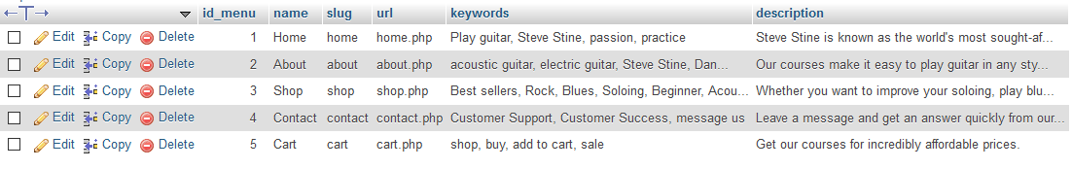

admin_menu

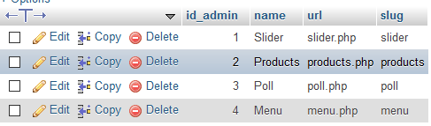

poll

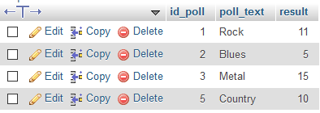

product

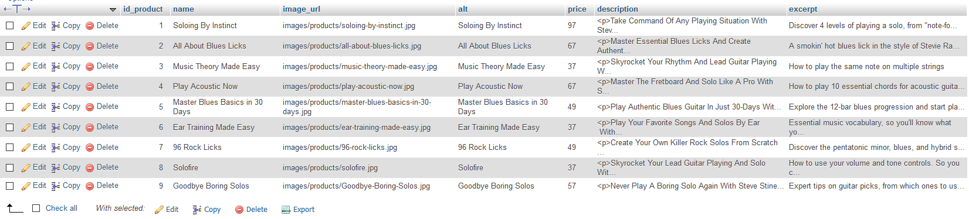

role

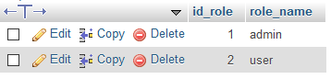

slider



user

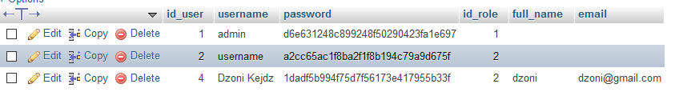

user_role

