4.

a.

b.

c.

12.

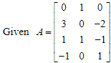 and 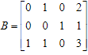

b.

c.

24.

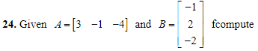

a. A is 1X3, B is 3X1, so the answer is 1X1

b. B is 3X1, A is 1X3, so BA is 3X3

c. 1X3\*3X1 = 1X1

d.

28



a.

d.

68.

g.

a.

i.

b.

k.

c.

70