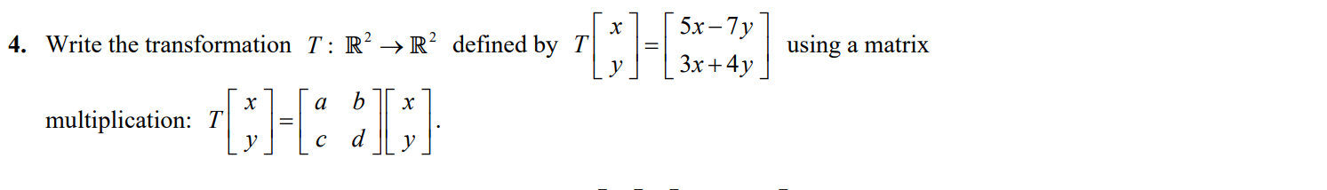

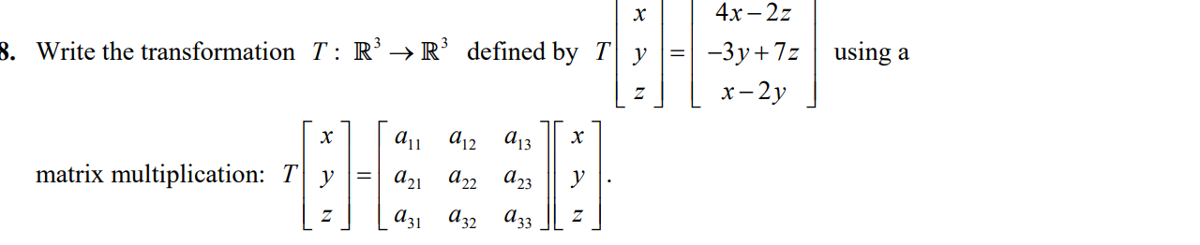

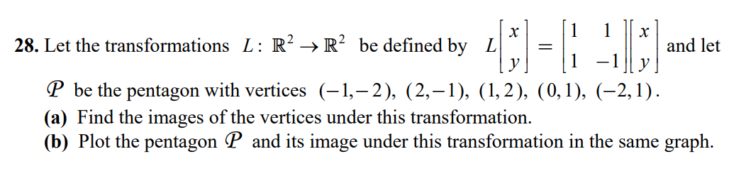

a.

b.

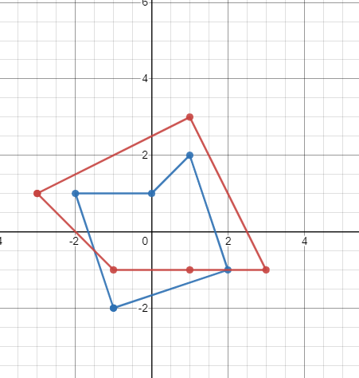

Blue figure is the original pentagon. Red is the pentagon’s image.

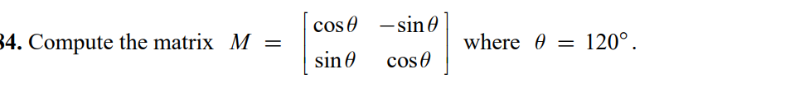

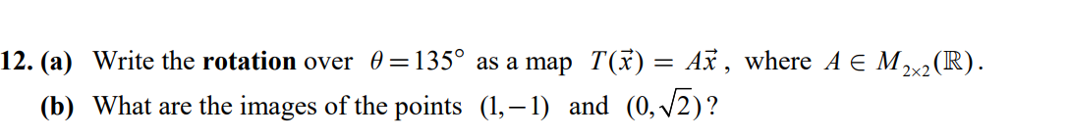

a.

b.

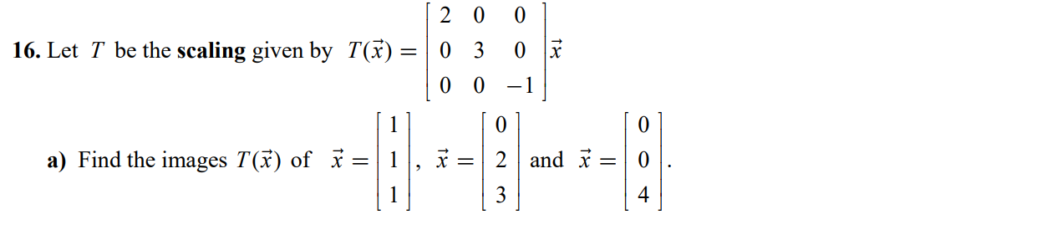

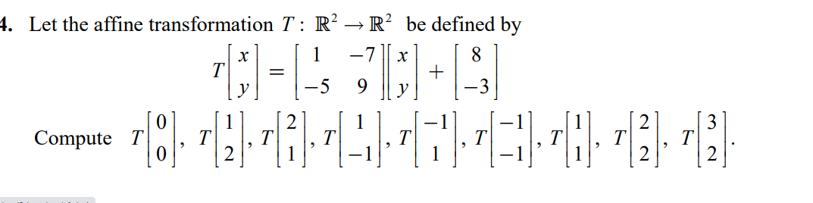

**Part 2**

1. Build a 2D translation matrix, which translates by (1;2). Use column-major.

2.Build a 2D rotation matrix, which rotates by -90 degrees. Use column-major.

3.Build a 2D scale matrix, which scales by 2 on the x-axis and 3 on the y-axis. Use column-major.

4.Build a 2D transformation matrix, which scales by 2 on the x-axis and 3 on the y-axis, then rotates by -90 degrees, then translates by (1;2). Show your work.

5.Apply the above transformation (question 4) to the following point P(1,2). Show your work