Mandatory Assignment 1 – Machine Learning IDATG2208

Exercise- 1:

Q1.1.1)
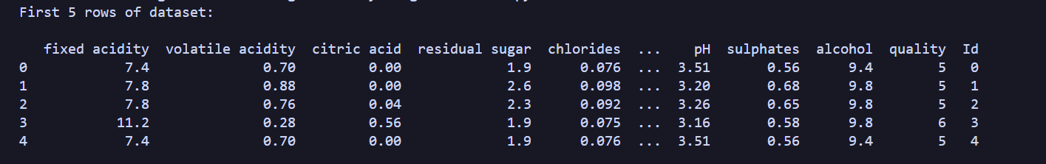
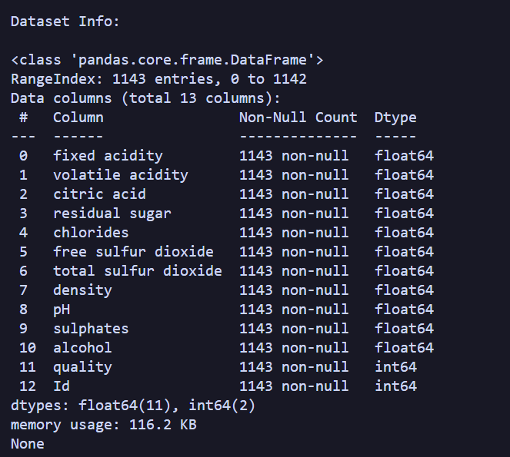
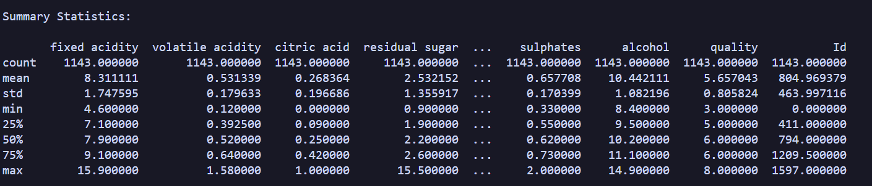

Q1.1.2)
by using this:
print(df.describe().sort_values(by="std", axis=1, ascending=False))
We can sort the entries in the dataframe based on variation. Total sulfur dioxide has the highest variation in our dataset with a value of 32.8.

Q1.2.1)
corr = df.corr()
By using this we can compute a correlation matrix. It will look something like this:
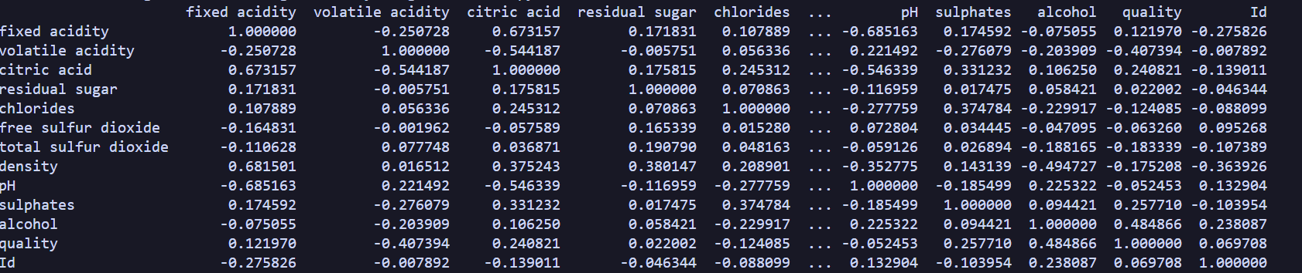

Q1.2.2)
sns.heatmap(corr, annot=True, fmt=".2f", cmap="coolwarm", cbar=True)
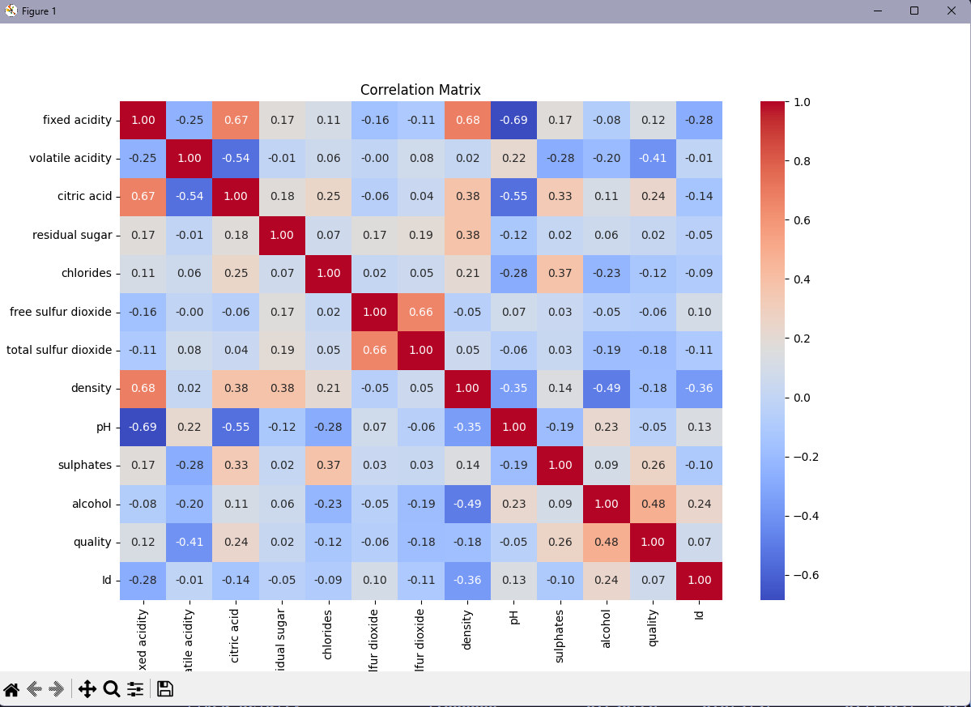

Q1.2.3)
quality_corr = df.corr()["quality"].drop("quality")
By using this python line, we can fetch all the correlations with the quality entry in our dataframe. Now we just have to find the biggest and the smallest values, which will be:

Q1.2.4)
Looking at the outprint of quality_corr we find:
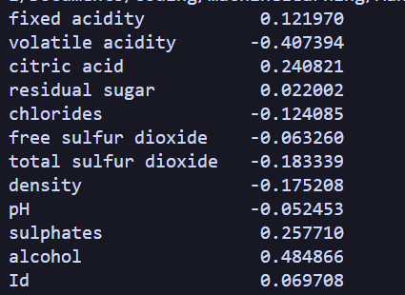
By Examining the entries for alcohol and pH, we find that alcohol has a much stronger correlation than pH, making it the logical answer for what we think would be a better predictor.

Q1.3.1)
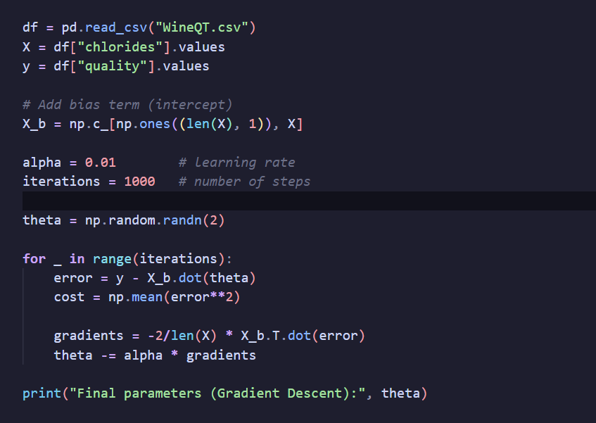

Q1.3.2)

