**Laboratorul 6**

0)Elemente Youtube cu video deschis: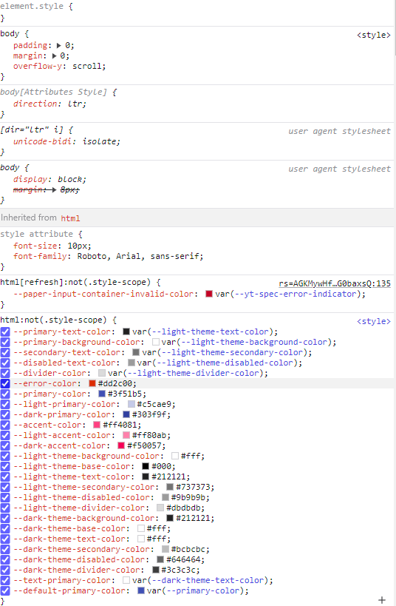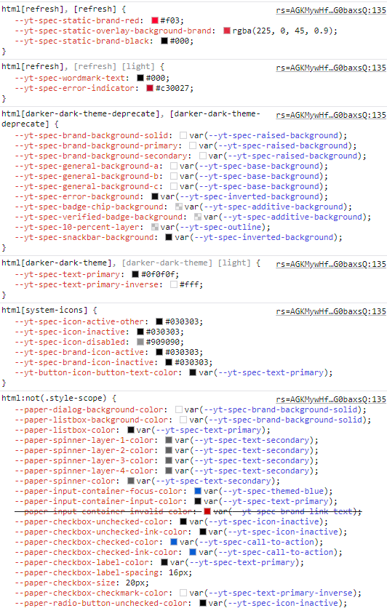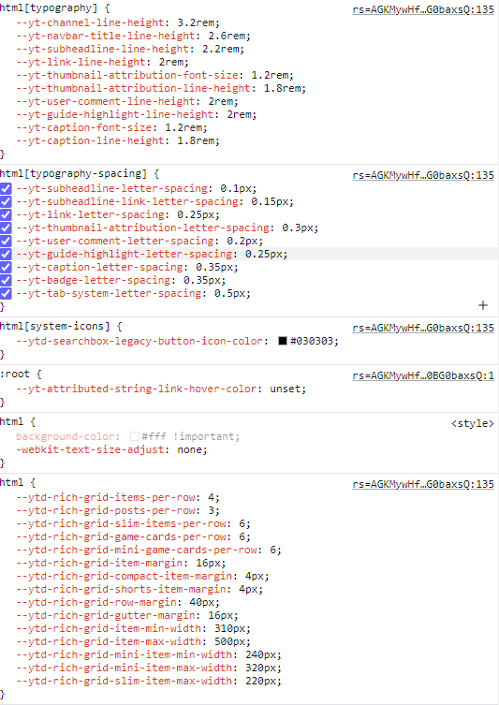

1) <!DOCTYPE html>

<html lang="ro">

<head>

<meta charset="UTF-8">

<meta name="viewport" content="width=device-width, initial-scale=1.0">

<title>Profil Personalizat</title>

<style>

body {

background-color: #800080;

font-family: Arial, sans-serif;

margin: 0;

padding: 0;

}

.header {

display: flex;

align-items: center;

padding: 20px;

background-color: #000000;

color: #FFFFFF;

}

.header img {

width: 100px;

height: auto;

border-radius: 8px;

margin-right: 15px;

}

.info p {

margin: 5px 0;

}

.citat {

color: #000000;

background-color: #A3A3A3;

padding: 10px;

border-radius: 8px;

margin: 20px;

text-align: center;

}

.disciplina {

color: #FFFFFF;

background-color: #800080;

padding: 10px;

border-radius: 8px;

margin: 20px;

text-align: center;

}

ul.a, ul.b {

padding: 10px;

border: 2px solid #A3A3A3;

border-radius: 8px;

margin: 20px;

list-style-position: inside;

}

ul.a {

list-style-type: upper-roman;

background-color: #FFFFFF;

color: #000000;

}

ul.b {

list-style-type: lower-alpha;

background-color: #A3A3A3;

color: #000000;

}

ul li {

margin: 10px 0;

}

ul.a li a {

color: #800080;

text-decoration: none;

font-weight: bold;

}

</style>

</head>

<body>

<div class="header">

<img src="D:\CV\stitch.jpg" alt="Poza Profil">

<div class="info">

<p><strong>Nume si Prenume:</strong> Tamas Nikolas</p>

<p><strong>Email:</strong> nikolas20052701@gmail.com</p>

</div>

</div>

<div class="citat">

<p><strong>Citat inspirational:</strong> “Educația este îmblânzirea unei flăcări, nu umplerea unui vas”</p>

</div>

<div class="disciplina">

<h2>Lista discipline</h2>

<ul class="a">

<li><a href="https://etti.utcluj.ro/files/Acasa/Site/FiseDisciplina/TstRo/04a.pdf">Programarea calculatoarelor Limbaje</a></li>

<li><a href="https://etti.utcluj.ro/files/Acasa/Site/FiseDisciplina/TstRo/15.pdf">Grafica asistata de calculator</a></li>

<li><a href="https://etti.utcluj.ro/files/Acasa/Site/FiseDisciplina/TstRo/29a.pdf">Inginerie Software</a></li>

</ul>

</div>

<div class="disciplina">

<h2>Hobby-uri</h2>

<ul class="b">

<li>Gaming</li>

<li>Gatit</li>

<li>Vizionat Anime-uri</li>

</ul>

</div>

</body>

</html>

2) <!DOCTYPE html>

<html lang="en">

<head>

<meta charset="UTF-8">

<meta name="viewport" content="width=device-width, initial-scale=1.0">

<title>Agenda</title>

<link rel="stylesheet" href="Agenda.css">

</head>

<body>

<div class="continut">

<h1>CUPRINS</h1>

<ol>

<li><a href="file:///D:/CV/Fisa%20Personala-Tamas%20Nikolas.html">Tamas Nikolas</a></li>

<li><a href="file:///C:/Users/nikol/AppData/Local/Temp/Rar$EXa19552.29040/Ia/Fisa%20Personala-%20Ruscanu%20Ioana.html">Ruscanu Ioana</a></li>

<li><a href="file:///D:/CV/Cosmin_Irimiciuc.html">Irimiciuc Cosmin</a></li>

</ol>

</div>

</body>

</html>

3) <!DOCTYPE html>

<html lang="en">

<head>

<meta charset="UTF-8">

<meta name="viewport" content="width=device-width, initial-scale=1.0">

<title>Agenda</title>

<link rel="stylesheet" href="https://www.w3schools.com/w3css/4/w3.css">

</head>

<body class="w3-light-grey">

<div class="w3-container w3-card w3-white w3-margin w3-padding">

<h1 class="w3-center w3-text-blue">CUPRINS</h1>

<ol class="w3-ul w3-hoverable">

<li class="w3-padding-16"><a class="w3-text-teal" href="file:///D:/CV/Fisa%20Personala-Tamas%20Nikolas.html">Tamas Nikolas</a></li>

<li class="w3-padding-16"><a class="w3-text-teal" href="file:///C:/Users/nikol/AppData/Local/Temp/Rar$EXa19552.29040/Ia/Fisa%20Personala-%20Ruscanu%20Ioana.html">Ruscanu Ioana</a></li>

<li class="w3-padding-16"><a class="w3-text-teal" href="file:///D:/CV/Cosmin_Irimiciuc.html">Irimiciuc Cosmin</a></li>

</ol>

</div>

</body>

</html>

Link Repository: <https://github.com/Nikolas2701/Informatica-Aplicata>