Grazioso Salvare Rescue Dog Dashboard

About the Project
This project is a web dashboard for Grazioso Salvare, a company that identifies shelter dogs that are good candidates for search and rescue training. The dashboard reads the Austin Animal Center outcomes data from a MongoDB database and lets a user filter it by the type of rescue Grazioso Salvare trains for. It is the second phase of a full stack project. The first phase built the database and a reusable Python module, CRUD_Python_Module.py, that provides create, read, update, and delete access to it. This phase builds the client facing dashboard on top of that module.

Required Functionality
The dashboard shows the Grazioso Salvare logo, which links to the client's home page, and a unique identifier with my name. Below them are four radio buttons: Water Rescue, Mountain or Wilderness Rescue, Disaster or Individual Tracking, and Reset. Selecting a rescue type runs a MongoDB query through the CRUD module and updates every other widget with the results. Reset runs the retrieve all query and returns every widget to its unfiltered state.
Each rescue query comes from the Rescue Type and Preferred Dog Breeds table in the Dashboard Specifications Document. Each one matches dogs of that rescue type's preferred breeds and preferred sex whose age_upon_outcome_in_weeks falls in the training age range. Water rescue looks for intact female Labrador Retriever Mixes, Chesapeake Bay Retrievers, and Newfoundlands from 26 to 156 weeks old. Mountain or wilderness rescue looks for intact male German Shepherds, Alaskan Malamutes, Old English Sheepdogs, Siberian Huskies, and Rottweilers from 26 to 156 weeks. Disaster or individual tracking looks for intact male Doberman Pinschers, German Shepherds, Golden Retrievers, Bloodhounds, and Rottweilers from 20 to 300 weeks.
Three widgets respond to the filter. The interactive data table shows the matching records ten rows at a time, with sorting and a filter box on every column, and lets the user select a single row. A pie chart shows the breeds in the table's current view. A geolocation chart shows where the selected animal is on a map of the Austin area, with the breed on hover and the name in a popup. Both charts read from the table's current view, so they also follow any sorting or column filtering the user applies on top of the rescue filter. Figures 1 through 5 show each state of the dashboard.
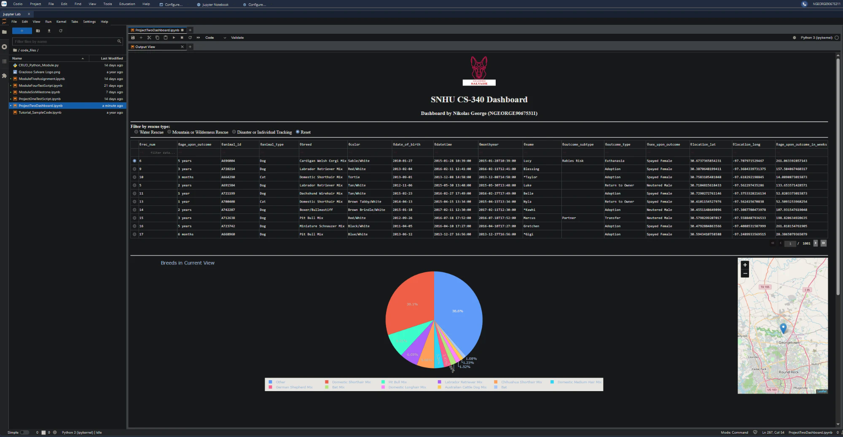
Figure 1. Starting state. All 10,000 records across 1,001 pages, with the breed chart and the map for the first record.
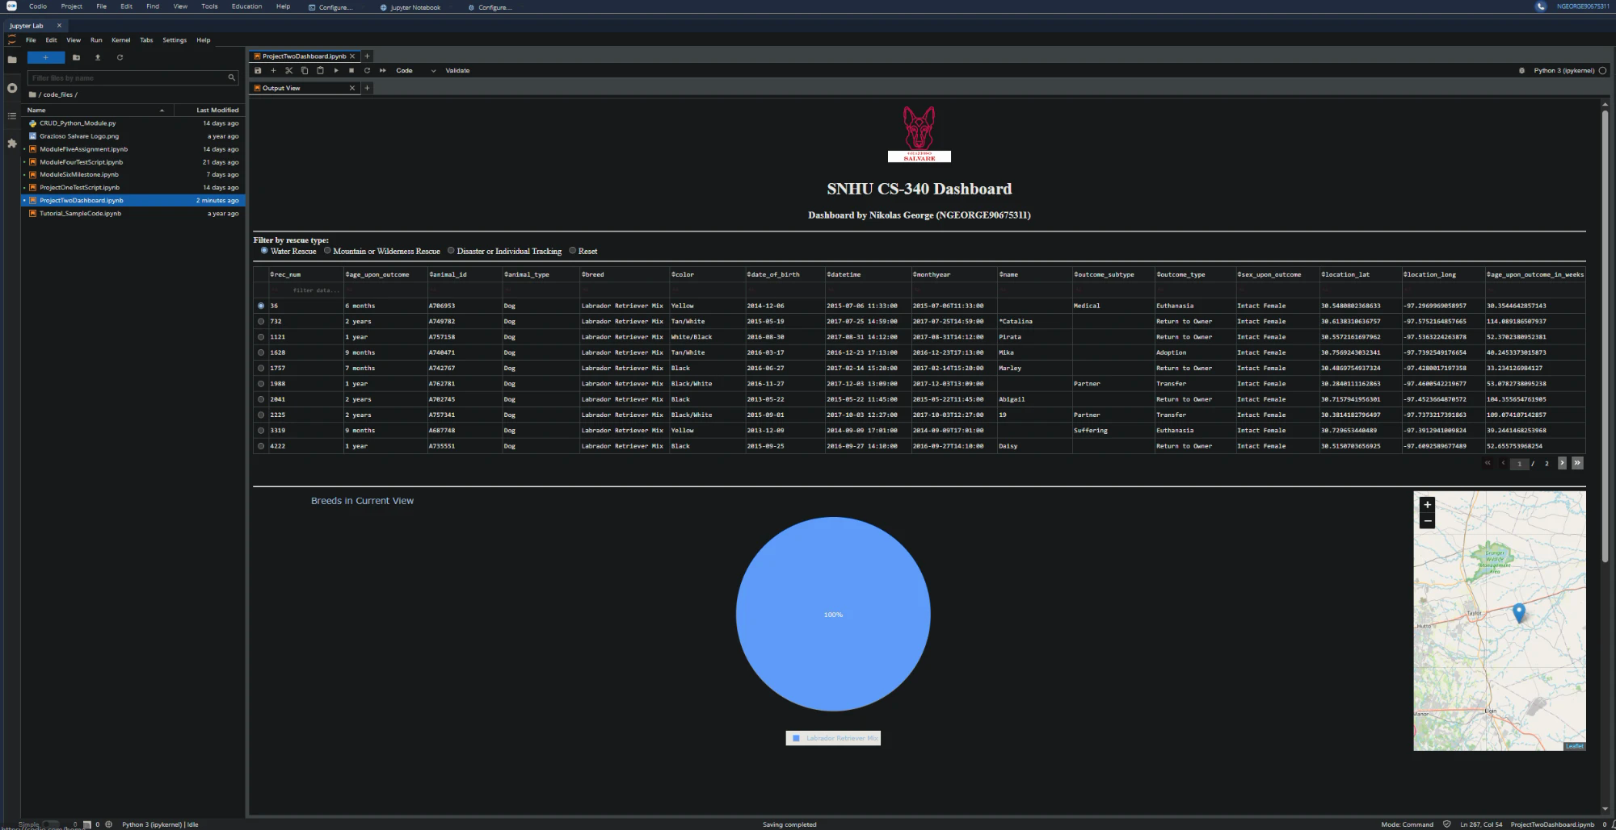
Figure 2. Water Rescue. Intact female Labrador Retriever Mixes in the training age range.
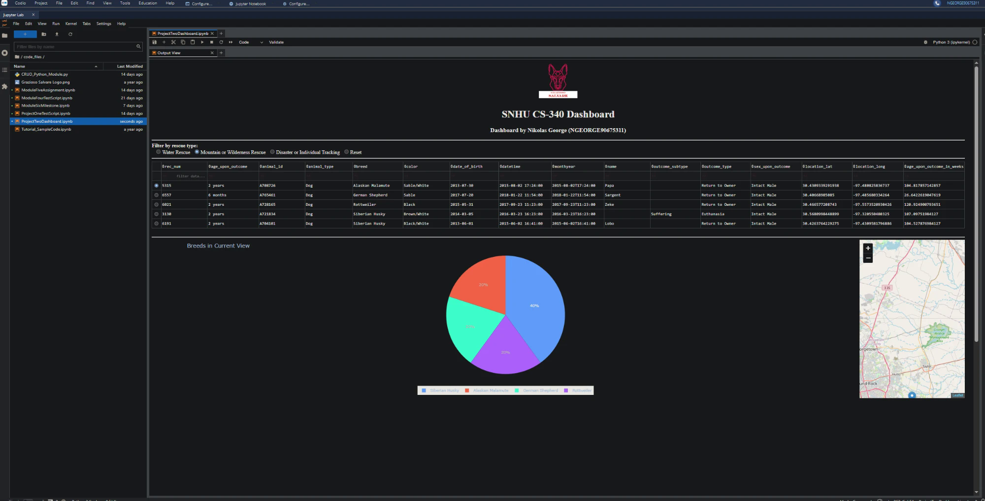
Figure 3. Mountain or Wilderness Rescue. Five intact male dogs across four of the preferred breeds.
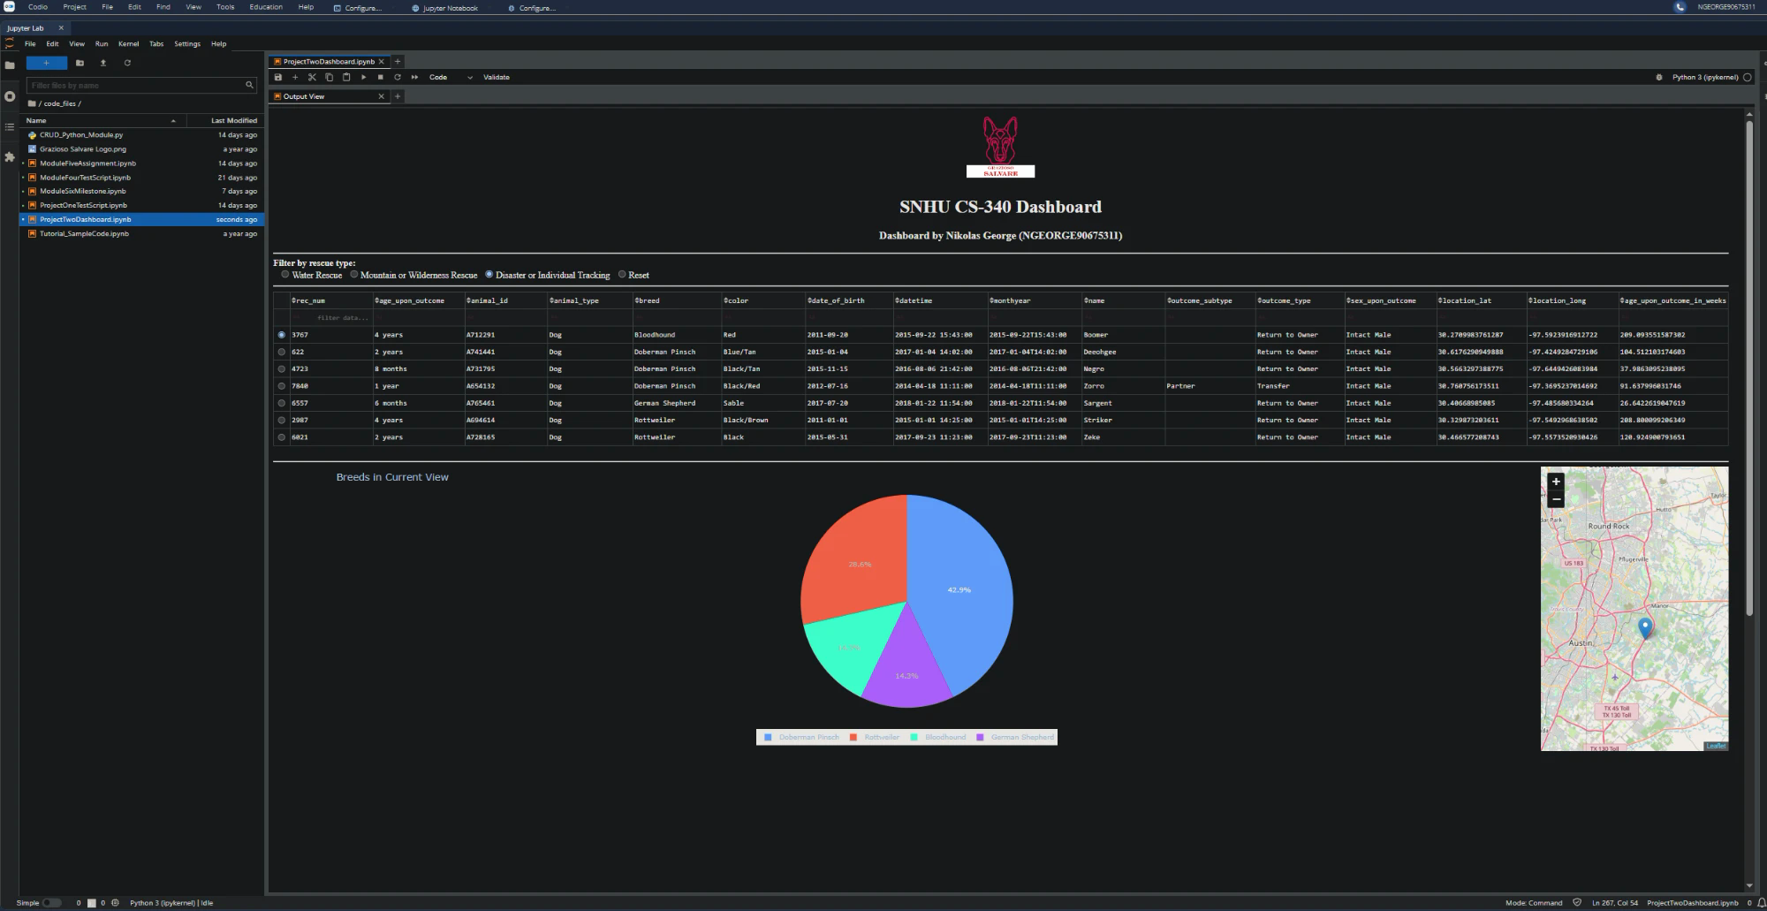
Figure 4. Disaster or Individual Tracking. Seven intact male dogs, including three Doberman Pinschers.
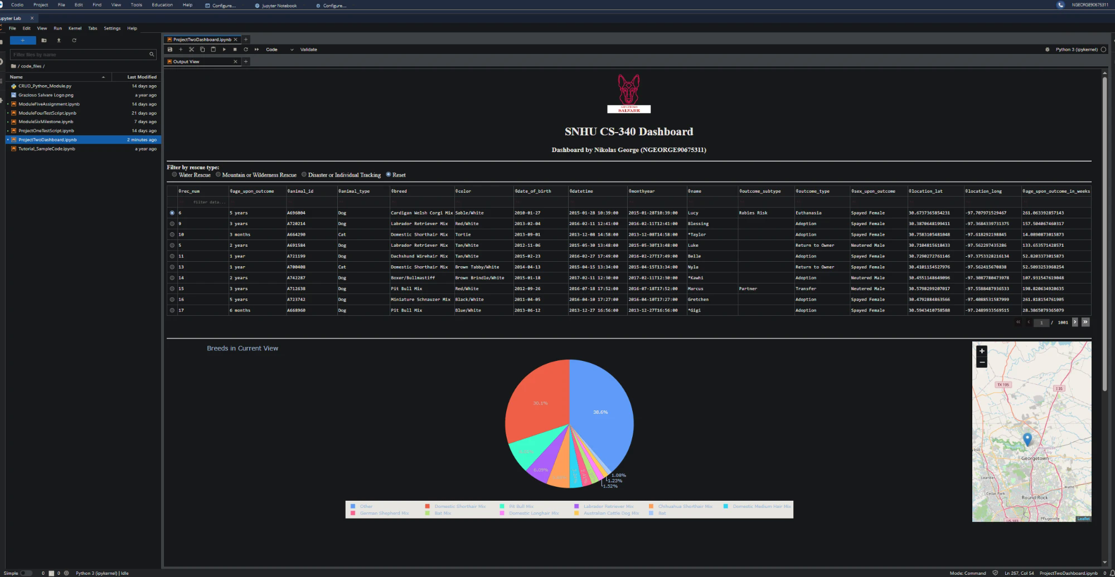
Figure 5. Reset. Every widget returns to the unfiltered state shown in Figure 1.

Tools and Rationale
MongoDB is the model component. Its documents are made of key and value pairs that map directly onto Python dictionaries, so a record goes from the database to the code and back without any conversion layer. That made the rescue filters straightforward to write, because each filter is a Python dictionary passed as is to the CRUD module's read method, using MongoDB's own operators: $in for the list of preferred breeds, and $gte and $lte for the age range. MongoDB also does not require every document to share a structure, which suits shelter data where fields such as outcome_subtype are often empty. Python reaches MongoDB through PyMongo, the official MongoDB driver for Python, which the CRUD module wraps.
Dash provides the view and the controller. Dash is a Python framework for building web applications, and the dashboard's layout is a tree of Dash components: html components for the logo, title, and identifier, dcc.RadioItems for the filter, dash_table.DataTable for the table, and dcc.Graph for the chart. The controller is a set of Dash callbacks, functions that run when an input component changes and write their results to an output component. One callback runs the MongoDB query when the filter changes and refreshes the table. Two more watch the table's current view and redraw the pie chart and the map. Because the view and the controller are both written in Python, the whole application, from database query to rendered chart, is in one language.
The other tools are Pandas, which turns query results into DataFrames for the table and charts, Plotly Express for the pie chart, Dash Leaflet for the map, and Jupyter Lab in the Codio lab environment to run the notebook.
Resources used:
MongoDB: https://www.mongodb.com/docs/
PyMongo: https://pymongo.readthedocs.io/
Dash: https://dash.plotly.com/
Dash Leaflet: https://pypi.org/project/dash-leaflet/
Plotly Express: https://plotly.com/python/plotly-express/
Pandas: https://pandas.pydata.org/docs/
Data set: Austin Animal Center. (2020). Austin animal center outcomes [Data set]. City of Austin, Texas Open Data Portal. https://doi.org/10.26000/025.000001

Reproducing the Project
The project was built in stages. The Austin Animal Center CSV was imported into the aac database's animals collection with mongoimport, using --type=csv and --headerline, and a user named aacuser was created in the admin database with the readWrite role on aac. The CRUD module came next, with create and read first and then update and delete, each tested from a Jupyter notebook. The Dash work began with a login form that passed credentials through to MongoDB, then a data table and map, and finally this dashboard.
To run the dashboard, place CRUD_Python_Module.py, ProjectTwoDashboard.ipynb, and Grazioso Salvare Logo.png in the same directory, with MongoDB running and the aac database and aacuser account set up as above. Open the notebook in Jupyter Lab and run the cell. The dashboard appears under the cell once the table loads. To view it larger, right click the output and choose Create New View for Output.

Challenges
Several problems came up, and each one changed the final code.
Opening the dashboard. By default the notebook prints a link to the dashboard instead of drawing it, and opening that link in a new browser tab returned a 401 Authorization Required error from Codio, because the new tab was outside the authenticated Codio session. Running the app with mode='inline' draws it inside the notebook instead. The inline frame was then too small to show the whole dashboard, and the Create New View for Output command in Jupyter Lab solved that by opening the output in its own tab.
Missing Doberman Pinschers. The specification lists Doberman Pinscher as a disaster rescue breed, but the Austin data stores the name truncated as Doberman Pinsch, so a query on the full name would silently miss those dogs. The disaster query includes both spellings, and Figure 4 shows three Doberman Pinsch records that the query would otherwise have missed.
A selected row that no longer exists. The map shows the selected row, but after switching from the unfiltered data to a filter with only a few results, the previously selected row number could be past the end of the new data. The filter callback now also resets the selected row and the table page to the first one.
An unreadable pie chart. Without a filter, the data has far too many breeds for a pie chart, and the chart's legend covered the slices in the narrow column. The chart now shows the ten most common breeds and groups the rest as Other, and the legend sits below the pie.
Fragile column positions. The provided map code located the latitude, longitude, breed, and name by column position. I changed it to look them up by column name, which returns the same values but keeps working if the column order ever changes.

Contact
Nikolas George

