Nicolas Mejia

Ch 8 lab

Map and Exercise 8.21 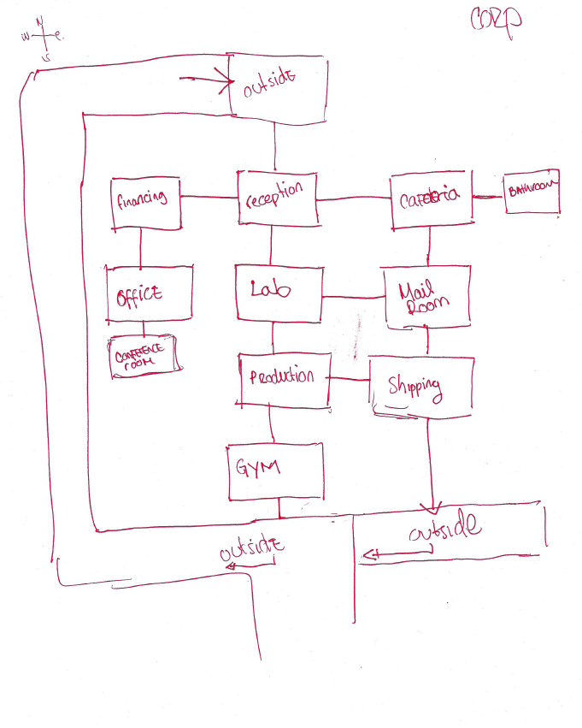

Exercise 8.21

-The items exist in the room. When the player enters the room, then the room creates the information about existing items in a room.

-The Item class can create the string of the items description.

-The game class is responsible for displaying the games’ text; therefore it should also print the items information.