**Introduction**

New York City and the city of Toronto are very diverse cities and both the financial capitals of their respective countries. Sometimes it is very useful to compare both cities to find out their structure. City segmentation will be useful mostly for tourists, using this they can plan their trip and save more time.

**Data description**

For this problem, we will get the services of Foursquare API to explore the data of two cities, in terms of their neighborhoods. The data also include the information about the places around each neighborhood like restaurants, hotels, coffee shops, parks, theaters, art galleries, museums and many more. We selected all Borough from each city to analyze their neighborhoods in order to understand the size of clusters. We will use machine learning technique, “Clustering” to segment the neighborhoods with similar objects on the basis of each neighborhood data.

**Methodology**

We have selected all cities Borough to explore their neighborhoods. The data exploration, analysis and visualization for both cities are done in the same way but separately.

**Results**

Neighborhoods of Toronto before clustering are shown at figure 1 and in New York at figure 2.

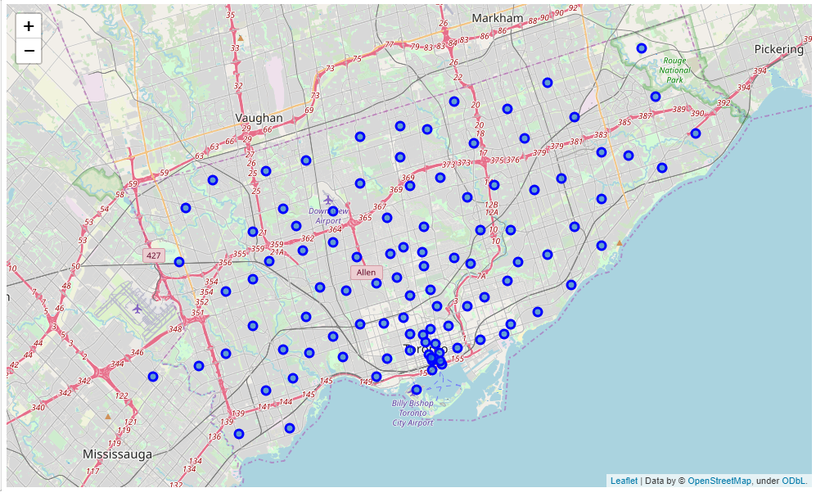

Figure 1. Neighborhoods of Toronto before clustering

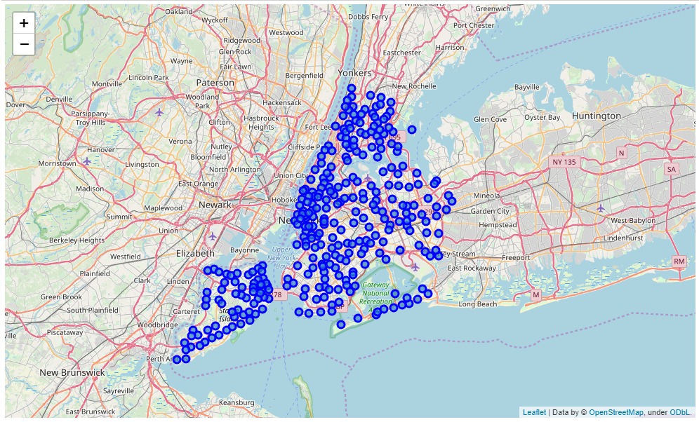

Figure 2. Neighborhoods of New York before clustering

Neighborhoods of Toronto after clustering by k-means algorithm with k parameter equals 5 are shown at figure 1 and in New York at figure 2

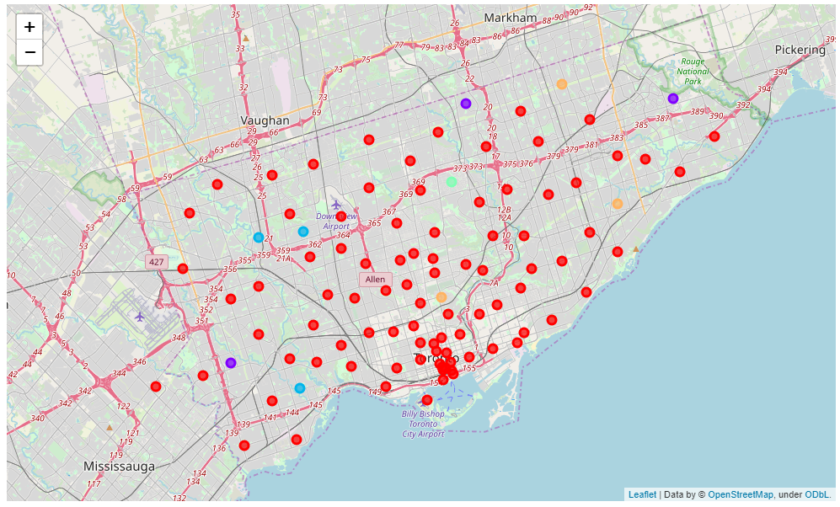

Figure 3. Neighborhoods of Toronto after clustering

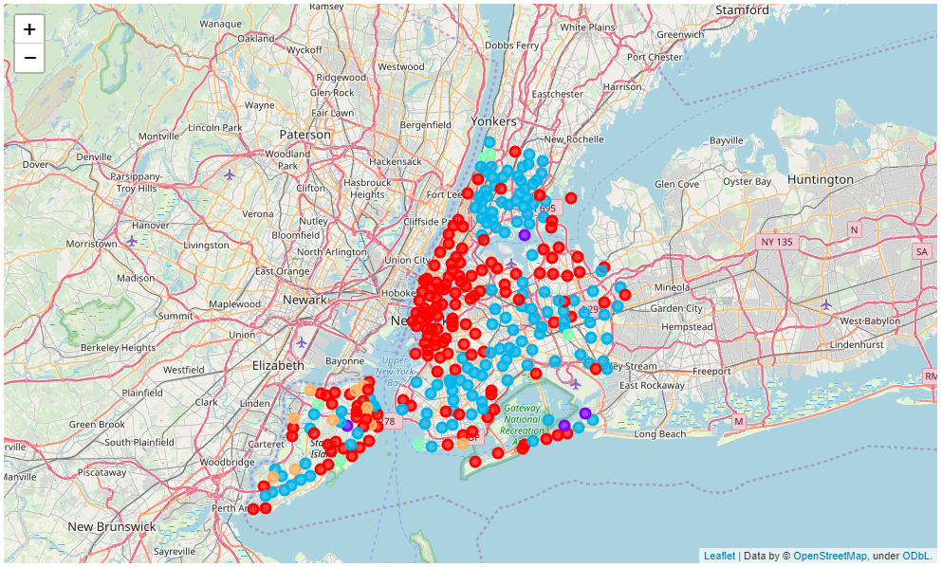

Figure 3. Neighborhoods of New York after clustering

The sizes of clusters in Toronto and New York are shown in table 1.

|  |  |  |  |  |
| --- | --- | --- | --- | --- |
| Number of cluster | Toronto | | New York | |
| Amount of Neighborhoods | Percentage | Amount of Neighborhoods | Percentage |
| 1 | 90 | 90.0% | 149 | 48.9% |
| 2 | 3 | 3.0% | 134 | 43.9% |
| 3 | 3 | 3.0% | 12 | 3.9% |
| 4 | 3 | 3.0% | 6 | 2.0% |
| 5 | 1 | 1.0 | 4 | 1.3% |

**Discussion**

It can be seen that Toronto has one big cluster (90.0% of the neighborhoods) and other are much smaller (about 3.0%).  For New York, there are two big clusters (48.9% and 43.9% of the neighborhoods) and other are much smaller (about 3.0% too). Segmentation of two cities are different. Toronto has more uniform neighborhood type.  New York has much more varieties.

**Conclusion**

As it was said in discussion there are two big clusters for New York and one large cluster for Toronto. If you are going to visit two cities and don’t know what to visit first it is better to first visit Toronto because it has more uniform neighborhood type as were determined in this report.