***Sport Disciplines Conduct, Rules and Regulations***

**AUBG Olympics**

The Bachinovo Marathon

1. **THE ROUTE:**

The predetermined route starts after restaurant “Sheri” at 10:30 am reaching the wooden bridge before the lake, making a U-turn and coming back to restaurant Sheri, where the start/finish is located.

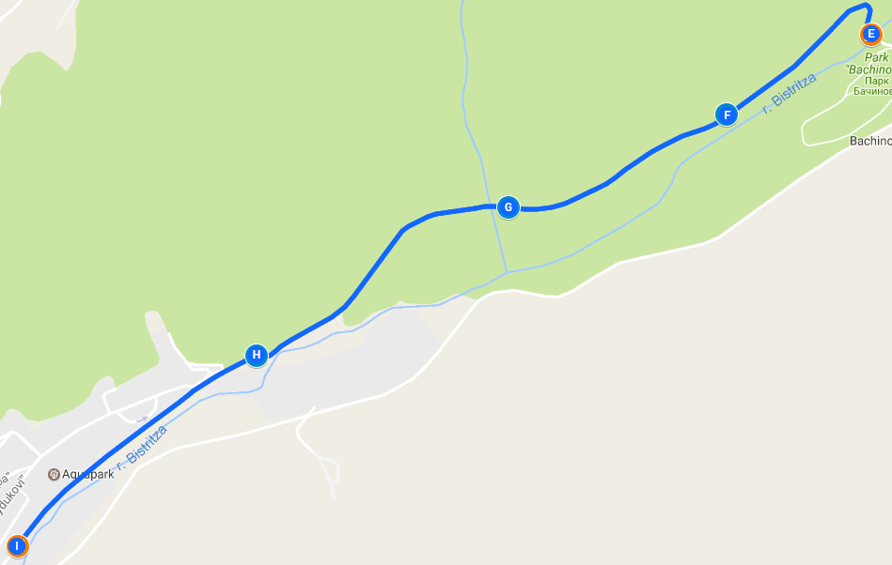

**Start/Finish Point:** 42.02627, 23.10759

1. **RULES:**

* There will be a male and female division.
* Participants will be placed in 1-st; 2-nd and 3-rd place based on division and time result.
* There will be only one attempt per person.
* Participants are required to wear numbered stickers on the front of their body to identify themselves at the finish line (provided by the Olympics crew).
* Participants will start in pairs at the mark of an Olympics crew member. There will be a 30 second interval between each pair of participants.
* Each participant will be timed based on the difference between his/her starting and finishing time.
* Every participant MUST stay on the predetermined route. Any violation of this rule will result in disqualification.
* There will be an Olympics representative on checkpoint areas along the route in case a participant feels the need for medical attention or tries to deviate from the predetermined route.

1. **RULE ENFORCEMENT:**

* The decisions of the crew members at the location are final.
* Participants need to be there between 9:30 and 10:00 to check-in. On the spot sign ups can be done 15 minutes prior to the beginning of the marathon.