**C# Discount application.**

Application uses SQLlite to create small sql base and add/get info from this base by standard SQL queries.

Options:

* Add new record
* Find record
* Correct record
* Delete record

Application creates base if it not exists (path is specified in the code for now). General table has following structure:

ID (primary) Name Phone Bonus

ID and bonus fields are numbers, Name and Phone – text.

Interface:

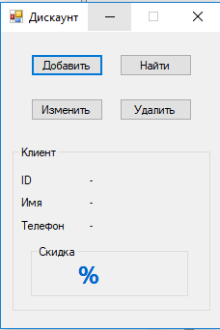

There are 4 main buttons for each operation and general output window to show the results.

“Добавить” window:

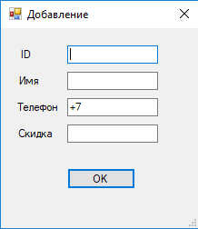

There are 4 input parameters. All values are checked for empty and incorrect format. After successful adding - corresponding message is shown.

“Найти” and “Удалить” window:

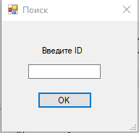

There is one input value. If such ID exists – it will be outputted:

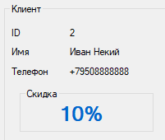

Otherwise – user will get corresponding message.

“Изменить” window:

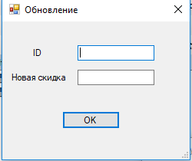

There are 2 input values. For now we need to update only bonus value but functional can be corrected in next versions.

**Known issues.**

* There is incorrect behavior for the next situation:

“Добавить” -> click OK with empty values -> close window:

