**POPULAR DEVELOPMENT ENVIRONMENTS (IDEs)**

**1. MonoDevelop:**

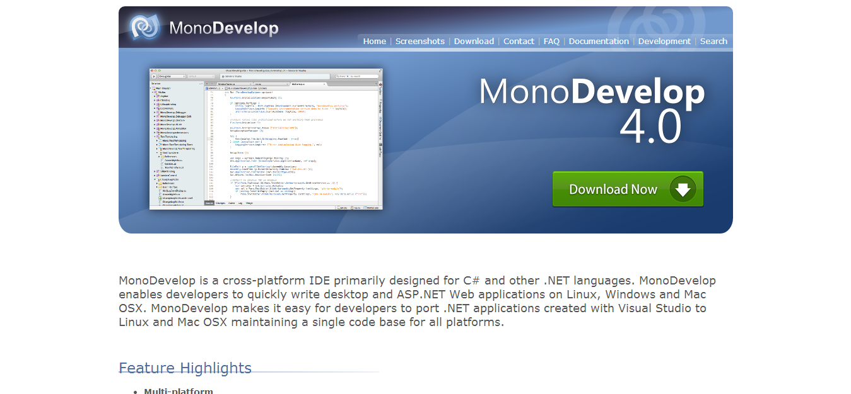

MonoDevelop is a free GNOME IDE designed primarily for C# and other .NET languages, but is open to other programming languages too. MonoDevelop enables the rapid development of desktop and ASP.NET web applications for Windows, Linux, and Mac platforms, with the option to **port applications created with Visual Studio to Max and Linux platforms**, allowing for a consistent code base across platforms.

**Languages Supported:** C#, Visual Basic, Java (IKVM), C/C++, Python, Boo, Vala.

**2. SharpDevelop (#Develop):**

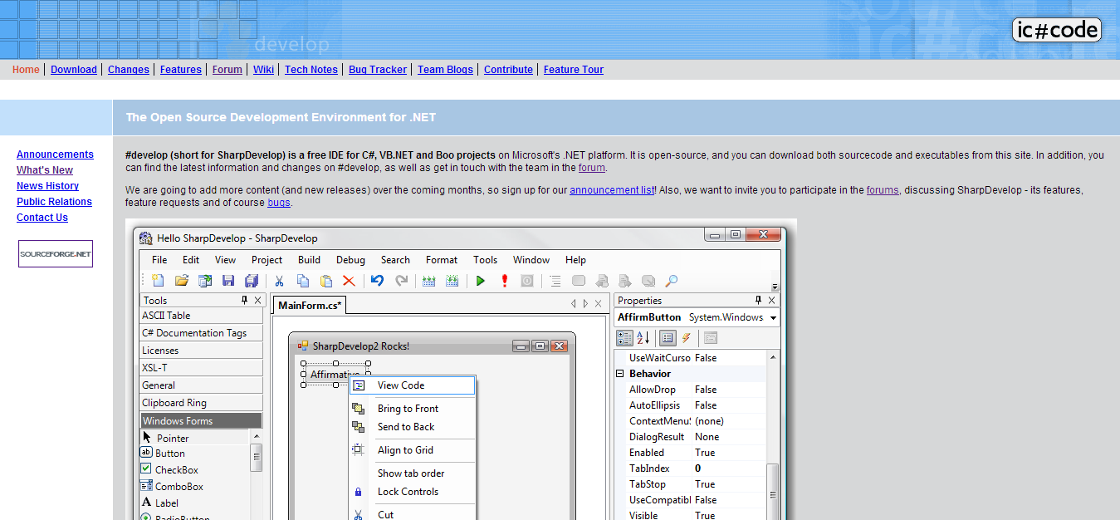

SharpDevelop is a free IDE for  Microsoft’s .NET platform, with support for all .NET programming languages. SharpDevelop is regularly updated, with the SharpDevelop 5.1 release candidate being made available in July 2015. It’s designed to be a competitor to industrial-strength IDEs but without the added weight of unnecessary features, aiming instead to offer a pure .NET IDE.

**Languages Supported:** C#, VB.NET, Boo, IronPython, IronRuby, F#.

### 3. ****NetBeans:****

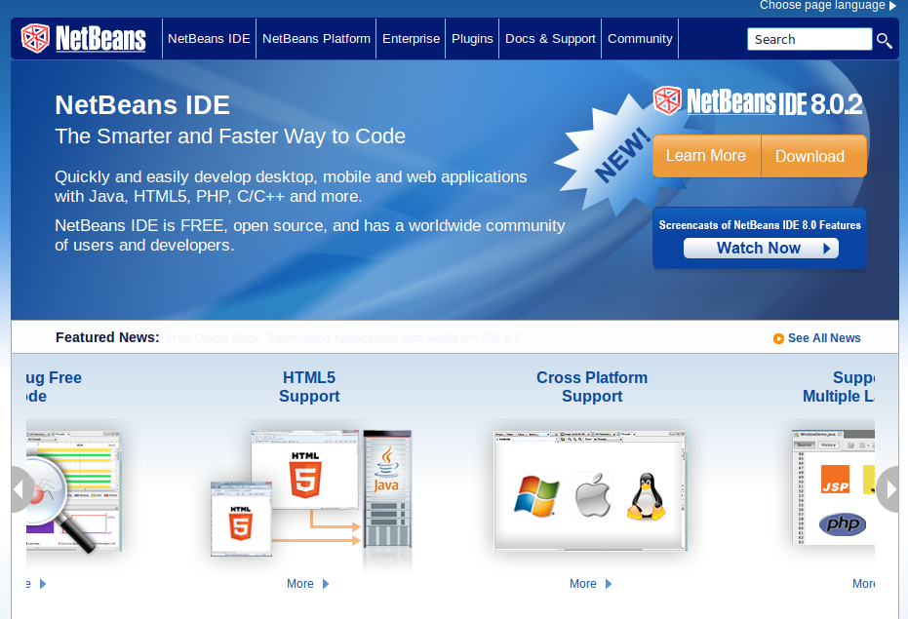

An intuitive, drag-and-drop interface with project templates, binary and static libraries, and many useful functions to make your life simpler, NetBeans is a popular IDE for C and C++ projects. It also supports Fortan and Assembler files, with GNU Debugger Integration and code assistance. NetBeans is a functional IDE for editing existing projects, building on templates, or building from scratch on most leading platforms. There are also multiple NetBeans Enterprise IDE Download Bundles with options that support several additional technologies, including Java, PHP, HTML5, and more.

**Languages Supported:** C, C++, C++11, Fortan, Assembler.

**4. Eclipse //@EclipseFdn:**

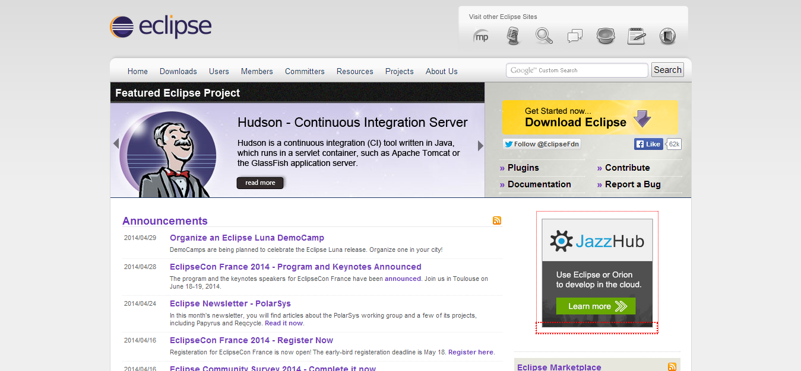

Many development frameworks are built on Eclipse, a free, open source editor that was initially a Java environment but a variety of plug-ins have extended its capabilities considerably. The Eclipse Standard 4.3.2 version, for instance, includes the Eclipse Platform along with the tools required to debug it, plus Java and Plugin Development Tooling, and Git/CVS support. If your requirements are different, you can choose from a variety of Eclipse Package Solutions, including tools for Java developers, Scout Developers, RCP and RAP Developers ,and more.

**Languages Supported:** C, C++, Python, Perl, PHP, Java, Ruby, and more.

**5. CodeLite:**

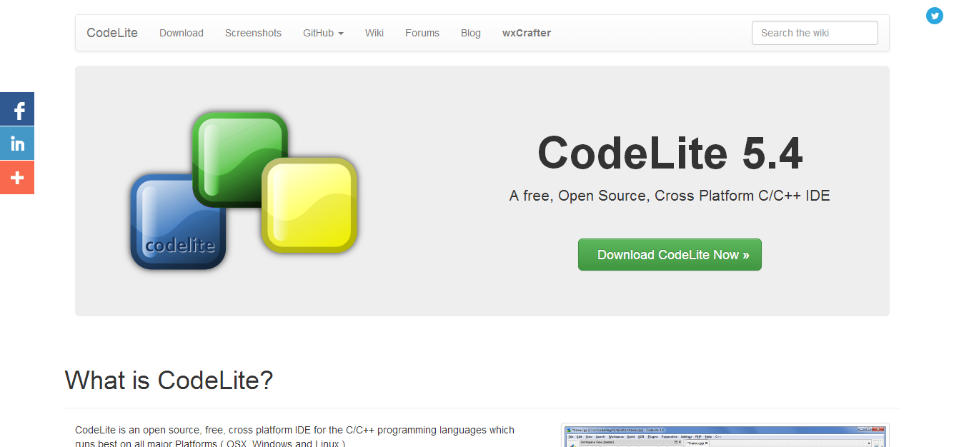

An open source, cross platform ID for C, C++, PHP, and Node.js coding languages, CodeLite works across all major platforms. CodeLite offers a variety of features, including two built-in completion engines, compilers, refactoring, code navigation, and more.

**Languages Supported:** C, C++, PHP, Node.js.

Article: <https://blog.profitbricks.com/top-integrated-developer-environments-ides/>.