**Differences between C# and .NET Framework**

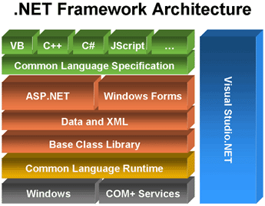

**.NET Framework** is a software framework developed by Microsoft that runs primarily on Microsoft Windows. It includes a large class library known as **Framework Class Library (FCL)** and provides language interoperability (each language can use code written in other languages) across several programming languages. Programs written for .NET Framework execute in a software environment (as contrasted to hardware environment), known as **Common Language Runtime (CLR)**, an application virtual machine that provides services such as security, memory management, and exception handling. **FCL and CLR together constitute .NET Framework.**

**C#** is a programming language, which uses .NET Framework (.NET supports many languages, but the main are: C#, Visual Basic.NET, C++, JScript). It’s developed by Microsoft for .NET.