**MOST POPULAR PROGRAMMING LANGUAGES**

There are many opinions about the ranking of the most popular programming languages. Some prefer one language, other – another. The truth is that the best programming language depends on its intended application. The following ranking was calculated with help from computational journalist Nick Diakopoulos. It’s based on weighting and the combination of 12 metrics from 10 data sources, including the IEEE Xplore digital library, GitHub, and CareerBuilder, to determine the popularity of languages. The column on the left is the 2015 ranking; the column on the right – 2014.

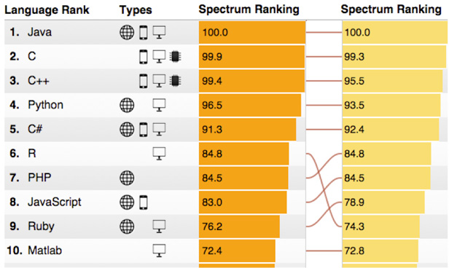

And now let write a couple of sentences about some of them:

**1. JAVA** – JAVA is an object-oriented language released in 1995 by Sun Microsystems. Java is the number one programming language today for many reasons. First, it is a well-organized language with a strong library. Second, programs written in Java can run on many different computer architectures and operating systems because of the use of the JVM ( Java virtual machine ). Sometimes this is referred to as code portability or even WORA ( write once, run anywhere ). Third, Java is the language most likely to be taught in university computer science classes.

Java Strengths: WORA, popularity.  
Java Weaknesses: Slower than natively compiled languages.

Similarities with C#: object-orienting, syntax, libraries.

Differences: can run on many different computer architectures and operating systems (C# - only on Windows platform).

**2. C** – C is a compiled, procedural language developed in 1972 by Dennis Ritchie for use in the UNIX operating system. Although designed to be portable in nature, C programs must be specifically compiled for computers with different architectures and operating systems. This helps make them lightning fast. Although C is a relatively old language, it is still widely used for system programming, writing other programming languages, and in embedded systems.

Strengths: Speed.  
Weaknesses: Memory management can be difficult to maste.

Similarities with C#: it’s compiled like C#.

Differences: procedural language (not object-oriented), syntax, not for web Apps.

**3. C++** - C++ is a compiled, multi-paradigm language written as an update to C in 1979 by Bjarne Stroustrup. It attempts to be backwards-compatible with C and brings object-orientation, which helps in larger projects. Despite it's age, C++ is used to create a wide array of applications from games to office suites.   
 Strengths: Speed  
 Weaknesses: C++ is older and considered more clumsy than newer object-oriented languages such as Java or C#.

Similarities: it’s compiled, object-oriented.

Differences: older, syntax, not for web Apps.

**4. Python** - Python is an interpreted, multi-paradigm programming language written by Guido van Rossum in the late 1980's and intended for general programming purposes. Python was not named after the snake but actually after the Monty Python comedy group. Python is characterized by its use of indentation for readability, and its encouragement for elegant code by making developers do similar things in similar ways. Python is used as the main programming choice of both Google and Ubuntu.   
 Strengths: Excellent readability and overall philosophy.   
 Weaknesses: None.

Similarities: None.

Differences: interpreted, not compiled, syntax.

**5. PHP** - PHP uses a run-time interpreter, and is a multi-paradigm language originally developed in 1996 by Rasmus Lerdorf to create dynamic web pages. At first it was not even a real programming language, but over time it eventually grew into a fully featured object-oriented programming language. Although PHP has been much criticized in the past for being a bit sloppy and insecure, it's been pretty good since version 5 came out in 2004. It's hard to argue with success. Today, PHP is the most popular language used to write web applications. Even English 4 IT, the program you are currently using, is written in PHP ;)   
 Strengths: Web programming, good documentation.   
 Weaknesses: Inconsistent syntax, too many ways to do the same thing, a history of bizarre security decisions.

Similarities: object-orienting.

Differences: not compiled, syntax, only for web Apps.

**6. C#** - C# is a compiled, object-oriented language written by Microsoft. It is an open specification, but rarely seen on any non-Windows platform. C# was conceived as Microsoft's premium language in its .NET Framework. It is very similar to Java in both syntax and nature.   
 Strengths: Powerful and pretty fast.   
 Weaknesses: Only really suitable for Windows (also Linux, but using Mono).

The information is from following articles:

1. <http://www.english4it.com/unit/9/reading>

2. <http://spectrum.ieee.org/computing/software/the-2015-top-ten-programming-languages>