

**Social Network Analysis**

**Title: Music as a network**

|  |  |  |
| --- | --- | --- |
| **Ονοματεπώνυμο** | **Αριθμός Μητρώου** | **email** |
| Θοδωρής Τσίγκανος | 3160180 | teotsi@gmail.com |

**Ακαδημαϊκό έτος 2019-2020**

I. Introduction 3

II. Resources 3

III. Tools used 4

IV. Dataset 4

V. Visualization 4

VI. Analyzing the Network 7

a) Topology 7

b) Component measures 7

c) Degree measures 9

d) Centrality measures 12

e) Clustering effects 17

1. Introduction

Music has always picked the interest of man. An absurd amount of time and resources have been spent through the ages, in many artists’ quest to compose the perfect musical piece. Any musical piece can be considered as a unique permutation of the elements in a set of notes (for the sake of simplicity beat patterns won’t be examined in this report). For example, (B, B, B, C#, D, D, D, C#, C#, B) is the main riff of “Satisfaction”, by The Rolling Stones. A dilemma that’s always pestering every artist is how can one determine whether or not a certain permutation “makes sense”? Of course, over the years certain music patterns have become more prevalent. The purpose of this report is to explore a different composing method. Instead of following patterns and scales, can one study the work of an artist and find out how they compose music? Would the use of a certain note set be beneficial in regards to mainstream success? Music has always been deeply subjective, but is it possible to extract a pattern or set that “objectively” works?

1. Resources

The dataset used for the study was extracted from <https://kithara.to/>, a Greek website where users can submit musical compositions and the corresponding chords for each composition. It is mostly focused on guitar-based pieces but not exclusively. With almost 40,000 songs on the website’s database, I decided to pick songs from a single artist. This was done for two main reasons: 1) Computational restrictions, 2) to minimize the range of genres covered by the dataset. That is what led me to pick [Xatzifragketa](https://kithara.to/ci/xatfgvracketa) as the artist. With over 100 unique songs submitted, a sufficient sample was available.

1. Tools used

The crawler/scraper used for the extraction of the chords was developed using Python 3.7. It is available in [this GitHub repository](https://github.com/teotsi/SNAProject), and should be included with the report as well. It makes use of the BeautifulSoup module that allows easy access to website elements (which was mandatory since kithara.to doesn’t provide an API to access songs). A high level explanation of the code is the following: First, it retrieves [Xatzifragketa’s artist page](https://kithara.to/ci/xatfgvracketa), and then extracts the unique ID of each song available. There are quite a few duplicates submitted, but since user ratings are available, we keep the ID of the most popular version. Then, we go over the list of songs, retrieve its lyrics and chords from [https://kithara.to/ssbd.php?id=<song_id](https://kithara.to/ssbd.php?id=%3csong_id)>, extract the chords, translate them where it’s needed (i.e. Eb is the same note as D#), normalize them, and add them as new nodes, while making sure to record the transitions between each chord (those are the edges of our graph). After that’s done, all we have to do is create a “nodes.csv” file, containing each chord and its name, and an “edges.csv” file, that contains all the transitions that take place. Those files are imported in Gephi, which is a tool that allows us to visualize graphs, as well as draw conclusions by using integrated metrics and resources. As the previous statement implies, all graphs, pictures, and screenshots presented in this report were produced by Gephi.

1. Dataset

The dataset, as mentioned above, consists of two files, a “nodes.csv” file, and an “edges.csv” one. Both files should be bundled with this report, but they can also be generated using the scraper that’s also included. All that is needed for the scraper to work properly, is to create a file called “cookie.txt”, and add there the user session cookie from kithara.to. Otherwise, requests to the site will be blocked after a few songs.

Over a total of 103 distinct songs, 45 unique music chords were used. These are the nodes of the graph. Between these nodes, 3664 chord transitions were performed. Note that repeated patterns are not recorded on kithara.to (i.e. since each chorus, verse and bridge sequence is defined once), so the actual number of chords transitions is much higher.

It is also crucial to keep in mind that the first chord of a song does not have a chord preceding it. That means that there previously examined songs have no effect on newer ones.

1. Visualization

As mentioned above, Gephi handled all the visualization duties for this project. On the next page, a basic visualization (that is explained thoroughly in the report) is available.

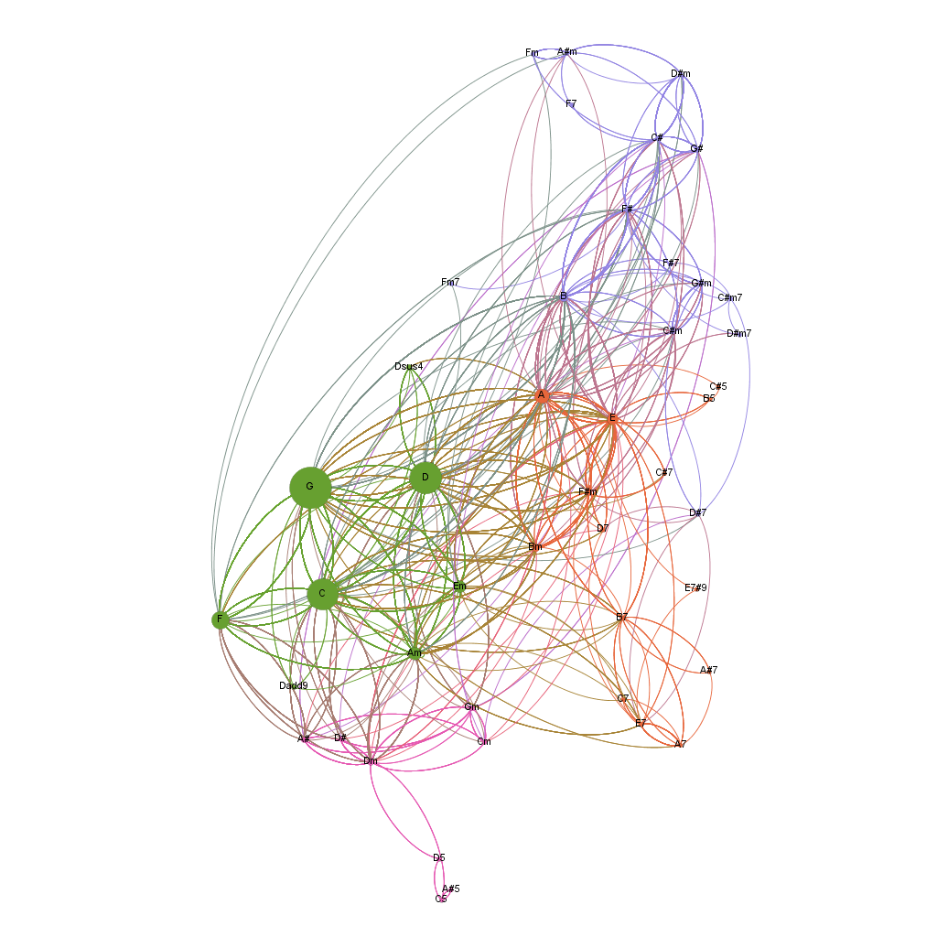

1. Analyzing the Network
2. Topology

Formally, a graph G is defined by two sets, V and E. In this case, V contains chords and (variations of them) that are labeled following the English notation for notes and chords (opposed to Romance or Solfege, i.e. Do, Re, Mi…). Overall size of V is: |V|=45.

Set E contains the edges of the graph, which in this case are the chords transitions that take place during each song. Since the direction of each transition in a song is strictly defined by the artist, every edge on the graph is directed. Overall size of E is: |E|=3664.

Calculating the average path length on this type of graph may seem irrelevant or meaningless at first glance, but it actually allows us to understand how certain harmonic scales work when applied to an actual musical piece. There are always going to be limitations in accessing certain nodes, depending on the note on which the traversal begins. Furthermore, the diameter of the graph (aka the longest shortest path) sheds light into the necessary transitions to use two notes that normally are not combined. Do note that certain notes included in the graph (such as Dsus4 or Dsus2) have the same root note as D and Dm. That means that usually (but not always) they are used in alternating patterns with D and Dm, which minimizes their distance.

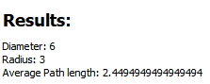

As expected, the average path length is significantly smaller than the diameter of the graph, coming in at 2.45, while the diameter of the graph is 6.

1. Component measures

In this section we are going to explore the number of components in the graph. A component is essentially a subgraph whose vertices are connected solely to other vertices in the same subgraph. For example, if we consider the graph defined by “Satisfaction” once again, (B, B, B, C#, D, D, D, C#, C#, B) it is easy to observe that there are only transitions between chords B, C#, and D. In a hypothetical network where is coexists only with the song “Bulls on Parade” by Rage Against the Machine, which has a riff that consists solely of octaves of F, then there are two components, since there are no common vertices between the two subgraphs defined by each riff.

Of course, the graph that this report is focused on consists of a multitude of songs. Since nodes are not distinct for each song, it is highly likely that the graph consists of just one component, regardless of whether it’s treated as a directional or undirected graph. After all, studying how chords can be combined is partially the purpose of this analysis, and music theory has shown how with simple scales any two notes can coexist in a pattern. 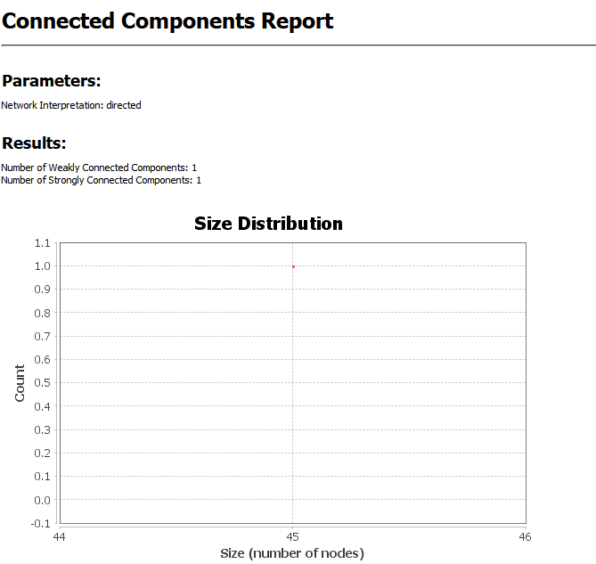So, it is mostly a question of whether or not those patterns appear in Xatzifragketa songs.

Sure enough, they do! As stated by the Gephi report, there’s a single component in the graph, consisting of 45 nodes. While trivial, this is evidence of the numerous applications of music theory in actual compositions. Any chord can coexist in a pattern with any other chord.

1. Degree measures

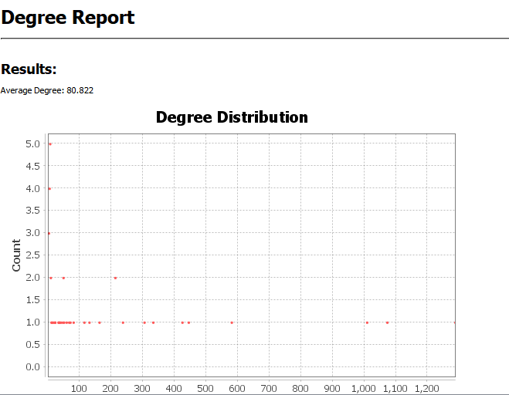Next, various degree measures are presented. The degree of a node is defined as the number of edges that are adjacent to the node. In-Degree and Out-Degree define, as one can probably guess without much effort, the number of edges that have said node as target and source, respectively. This is undoubtedly an important measure in the graph that is being examined, since it allows to examine how certain chords may be considered for a certain position in a chord pattern.

According to Gephi, the average Degree of the nodes in the graph is 80.8.

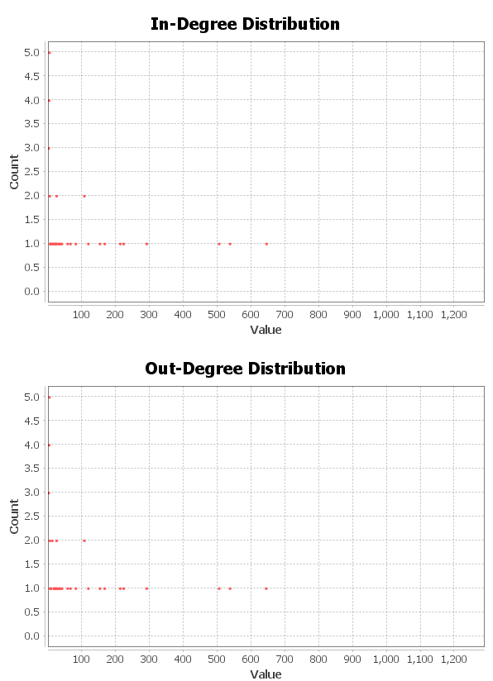

From the graphs above, certain conclusions can be drawn. First of all, the majority of nodes’ degree is less than 100%, with a few notable exceptions that have degrees over 1000. These are the chords G, C, and D. In fact, the distance between the degree of G and the degree of A, the chord with the fourth highest degree, is greater than the distance between A and the last place (Fm7, with a degree of 2). These results can be easily viewed in the Gephi “Data Laboratory” view.

The maximum degree in the graph is that of G, with an In-Degree of 644 and an Out-Degree of 643, for a total Degree of 1287. Interestingly, the vast majority of nodes have the same In-Degree and Out-Degree.

One could also conclude that G, C and D are the most popular chords in Xatzifragketa’s songs, and they would not be necessarily mistaken. A significant amount of their songs is based on a chord progression of the three notes. However, using solely the degree to draw said conclusion is not enough.

The following visualization is using Gephi’s size ranking to resize every node based on its Degree, while coloring the edges and vertices to signify transitions between high and low degree nodes. Deeper shades of green represent a high degree node, while the color transitions to a reddish shade when representing lower degree ones.

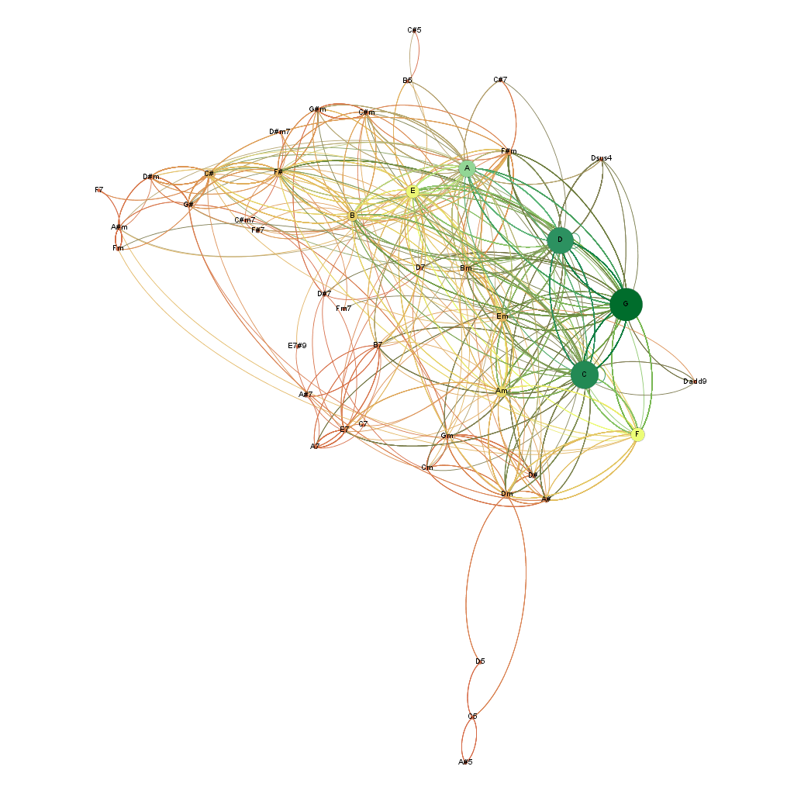

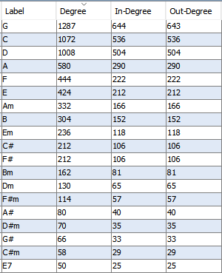

1. Centrality measures

Each node has been resized and colored relative to the measure that is being examined. Below each graph is a sample of the top ranked nodes, according to each measure.

1. 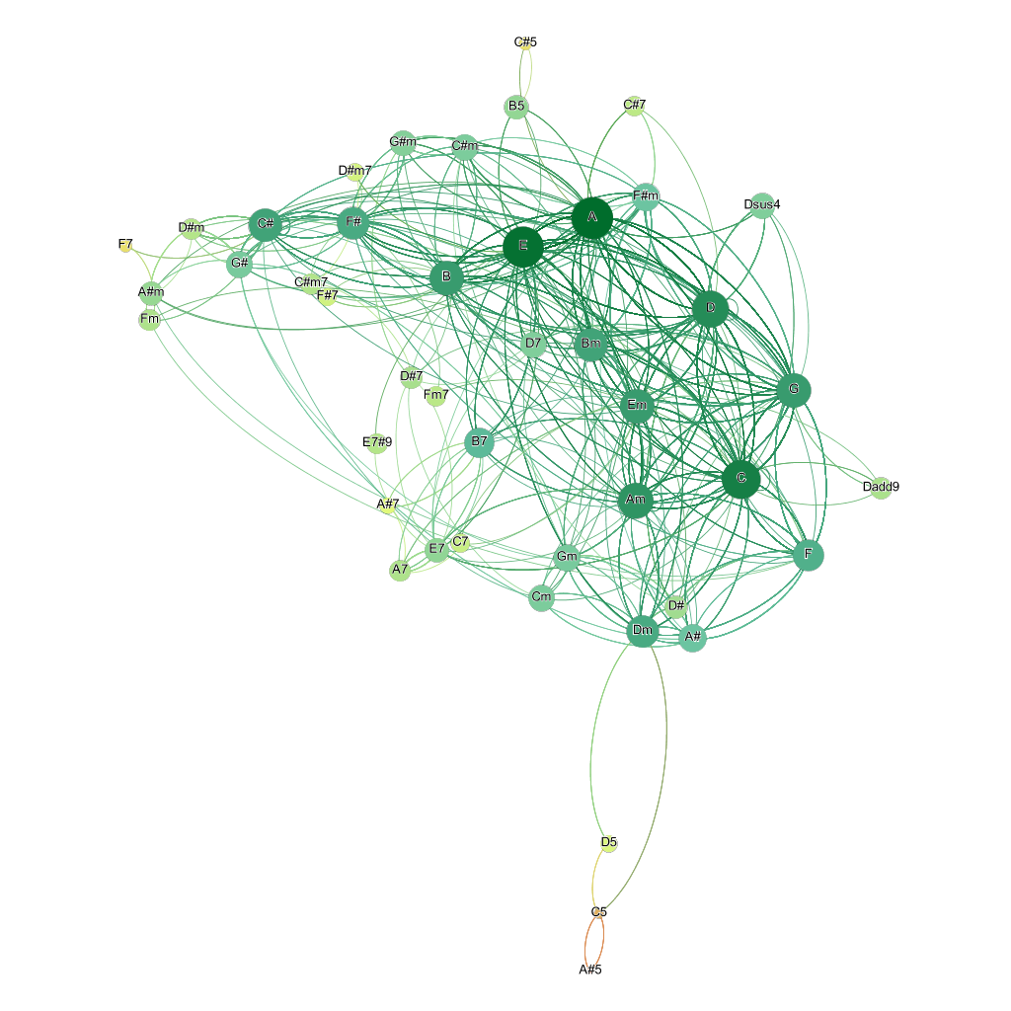**Closeness Centrality**

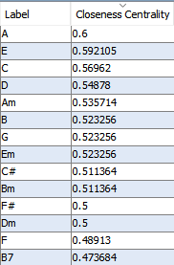

A comparison between the Degree Graph and the Closeness Centrality one reveals quite a bit about the way each measure perceives the dataset. Closeness Centrality scores appear to be on the upper percentile of the color gamut available, with only a few nodes painted orange. However, that should not come as a surprise. Closeness centrality attempts to locate nodes that spread information in the graph. It only makes sense that on a graph that consists of nodes that allow the artist to form paths that signify musical scales, that measure tends to be on the higher side.

1. **Betweenness Centrality**

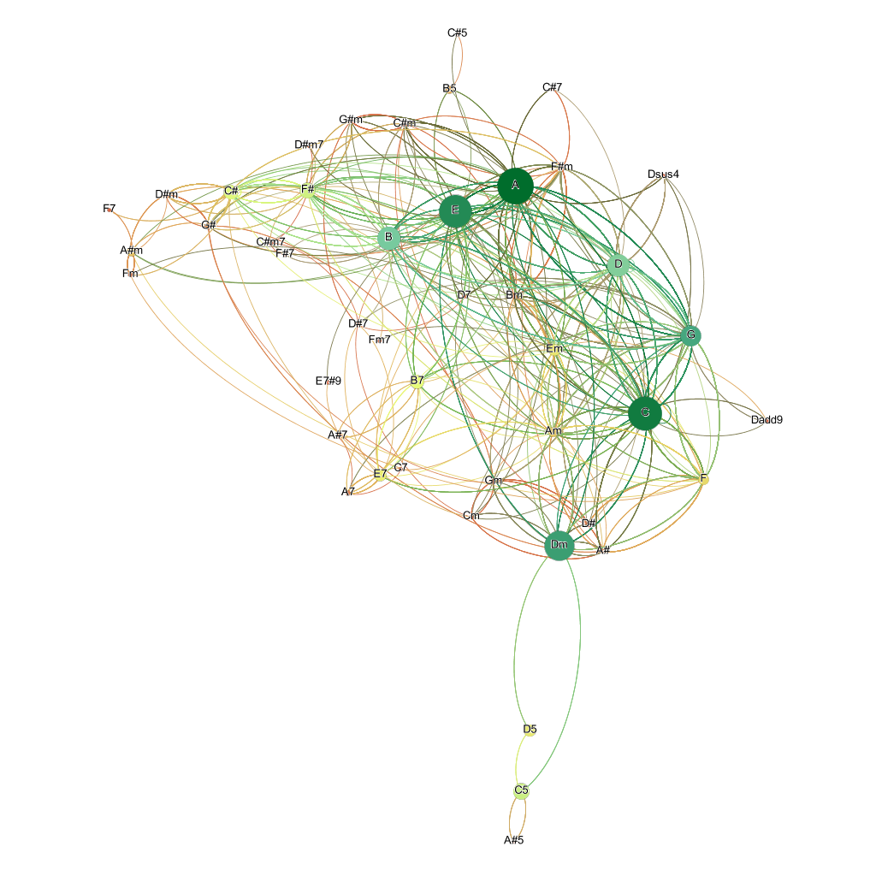

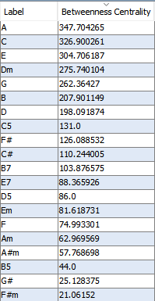

Betweenness centrality attempts to measure how the flow of information is affected by each node, keeping in mind that the shortest path is being preferred. This results in a graph (when node size and color is proportional to its betweenness centrality) that appears to be kind of a middle ground between the Degree graph and the Closeness Centrality graph. There are quite a few more weak nodes, but still there’s a significant number of nodes that are close in size and shade of green. This goes to show how while Closeness Centrality does a good job of evaluating the actual capability of a node, a higher degree node is more likely to be involved in a shortest path. The top nodes/chords in this particular graph are A, E and C, both of which are in the Top 5 nodes when sorted by degree.

1. 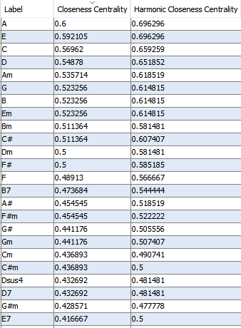**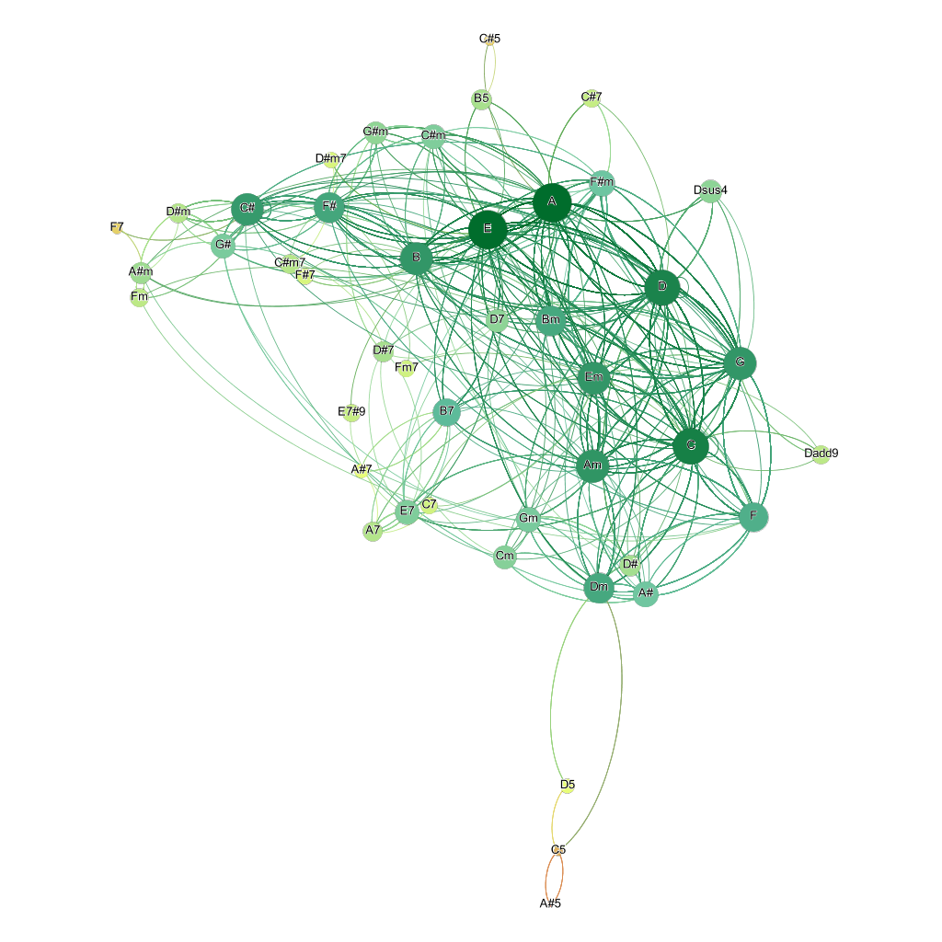Harmonic Closeness Centrality**

Harmonic Closeness Centrality (HCC) is a measure that is closely related to Closeness Centrality, and thus the results are expected to be pretty close, and so they are. A notable difference is that while both metrics normalize the score in [0,1], HCC has scored every node higher than Closeness Centrality, with a deviation of almost 20% in some cases. For example, in the table to the left (taken from Gephi’s Data Laboratory), node E7 is scored 0.5 on HCC, while Closeness Centrality rated it at just 0.416.

1. 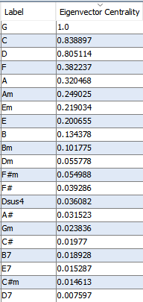**Eigenvector Centrality**

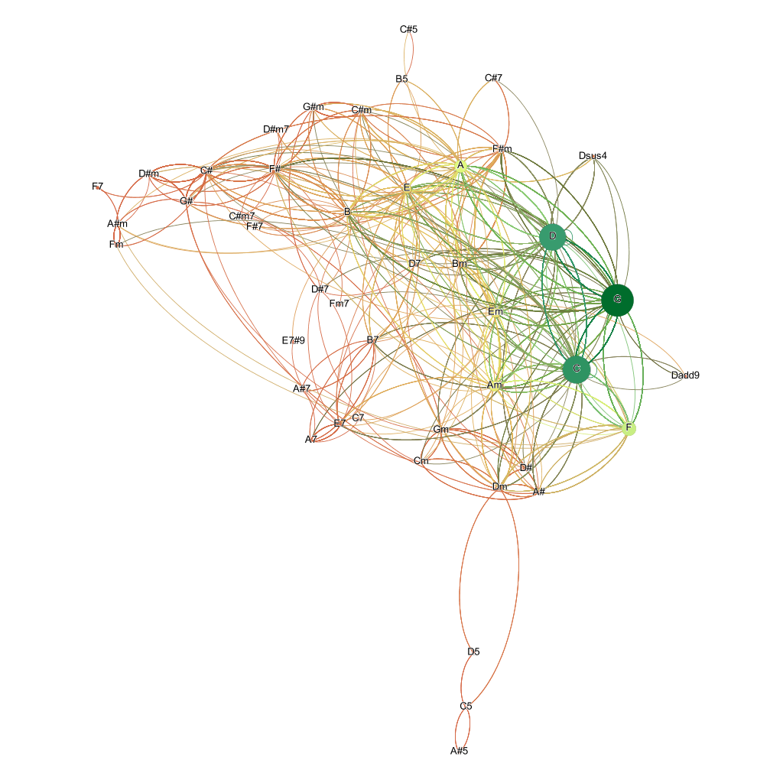Eigenvector Centrality is yet another measure of the influence of each node on the graph. In this instance, the graph coloring and node sizes bear quite a resemblance to the Degree Graph, while the scores tend to be concentrated at the extremes of [0,1]. That is not a surprise when one considers the idea between Eigenvector Centrality. Nodes are scored based on whether or not they are connected to high score nodes. So, it only makes sense that high-degree nodes that rank highly in every metric so far to do just as well when evaluated with this measure.

1. 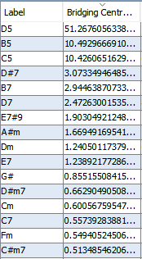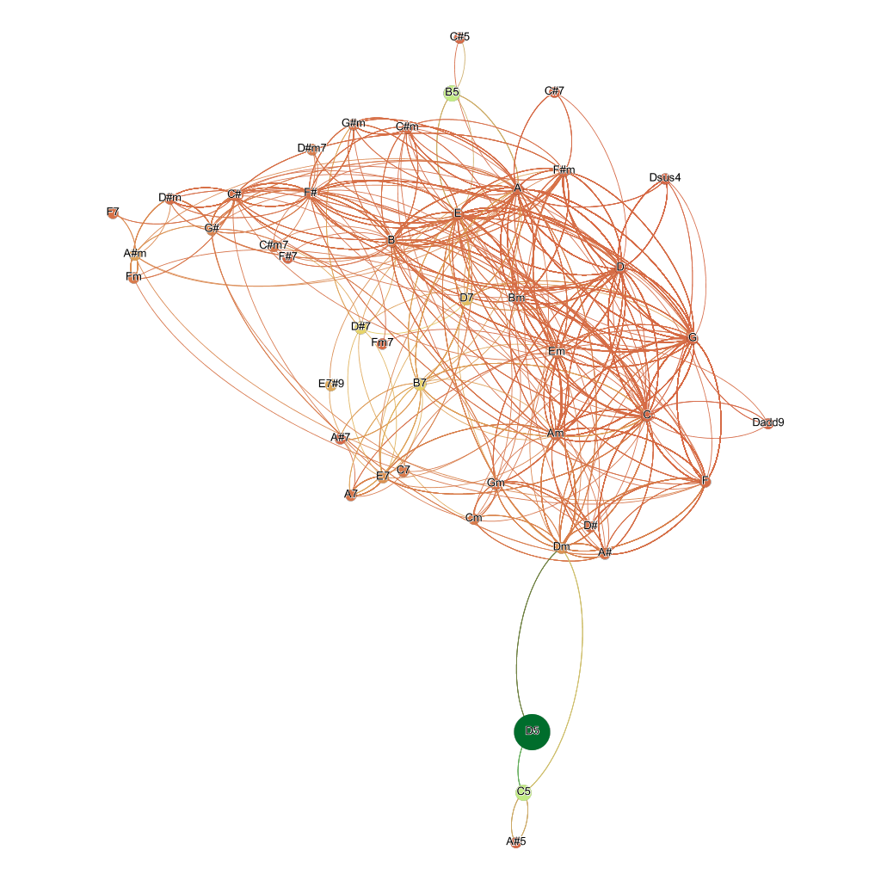**Bridging Centrality**

The last centrality measure that we’re going to use is Bridging Centrality. This is not included in the stock version of Gephi; however, it is available by installing the homonymous plugin. This allows us to run a Bridging Centrality statistic, and color or resize the graph according to the results of said statistic. The reason Bridging Centrality is included in this report, is the fact that it is one of the few metrics that focuses both on information flow and potential local bridges. That produces a graph that is radically different from all other graphs produced so far. Nodes like D5, C5, B5 or D#7 are rated highly, because they are the sole bridge to other nodes in the group above, due to the fact that the graph is directed.

1. Clustering effects

Examining clustering in a graph of this nature is quite important. An attempt to color the nodes based on a metric, as well as rearranging the position of the nodes in the 2D plane may reveal tendencies (in regards to certain nodes being more likely to be connected with certain others) that cannot be observed otherwise.

The first clustering measure to examine will be Gephi’s Average Clustering Coefficient, which in this case stands at 0.447. This would suggest that the nodes in the graph tend to avoid clustering ever so slightly.

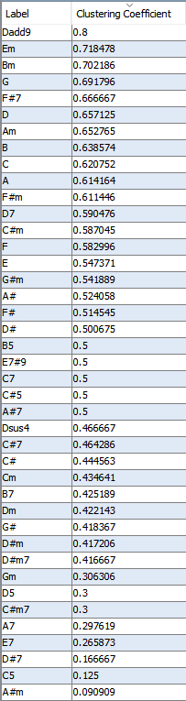 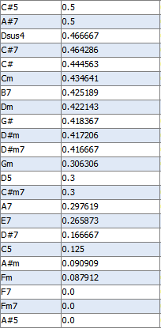

However, average results tend to be affected by the extreme values of a set. It is obvious that the bottom three nodes in Clustering Coefficient, F7, Fm7 and A#5 have a non-existent value. This is can be misleading. In fact, over half the nodes in the graph show a strong to mild tendency to form clusters.

At this point it is important to mention that yet another Gephi plugin was tested. It is called Clustering Coefficient, and claims to calculate (obviously) the Clustering Coefficient and also the number of triangles present in the graph, among other metrics. The Clustering Coefficient that was produced by said plugin was on almost every node quite a bit higher than the stock Gephi calculation. The average clustering coefficient, when calculated from the aforementioned column, was a significantly stronger 0.588.

Clustering is also affected by the number of triangles in the graph. Using the same plugin as previously, the total triangles in the graph were found to be 245891, along with an average Clustering Coefficient of 0.77. It must be noted that this was calculated using a triangle method, and thus yielded different results from the previous two implementations of Clustering Coefficient.

The last clustering effect that is going to be considered is whether or not triadic closure exists in this graph. Triadic closure is often dependent on metrics like the Clustering Coefficient. Assuming a high clustering coefficient, triadic closure does exist between three given nodes. By examining the graph, it becomes apparent that strong ties tend to appear in triangles that involve high-degree nodes like G, C and D. However, one could argue that while triadic closure does appear, due to the fact that these chords tend to appear in quite a few songs, and can be combined quite easily through some quite easy scales and patterns, it could be merely a side effect. On the other hand, there’s an argument to be made about what qualifies as friendship in this type of graph. Could co-existence in music theory scales be considered valid as a friendship factor? There seem to be quite a few indications that that is the case, especially if someone takes in consideration the Centrality measures analyzed previously.

The current state of the graph, in terms of the position of the nodes on the plane, was produced using Force-Atlas, suggested by the Gephi tutorials. Searching for a way to visualize the tendency (or lack thereof) to form clusters, the following graphs were produced using another Gephi plugin called Circular Layout. The name may be a bit misleading, since the plugin introduces a both a Circular Layout option in the Layout menu, as well as a Radial Axis Layout, that claimed to be able to visualize said tendencies.

Radial Axis Layout offers a wide range of options, such as grouping nodes by a certain measure (Clustering Coefficient was used) as well as an option to select the measure with which the nodes will be ordered. The idea was to determine whether or not we could notice a clustering trend between certain nodes, by attempting to rearrange the nodes not in a way that is necessarily user-friendly, but easier to study from this specific standpoint.

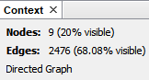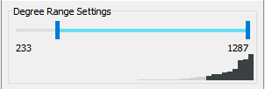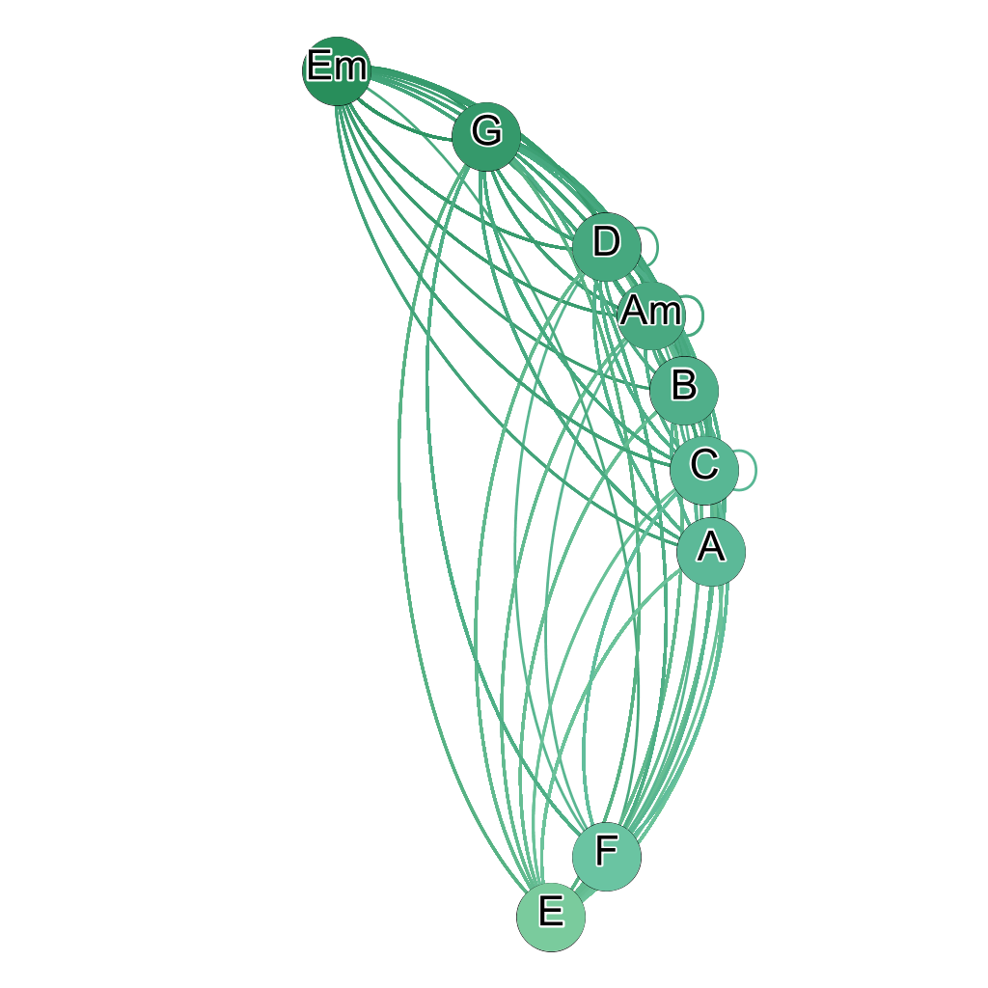

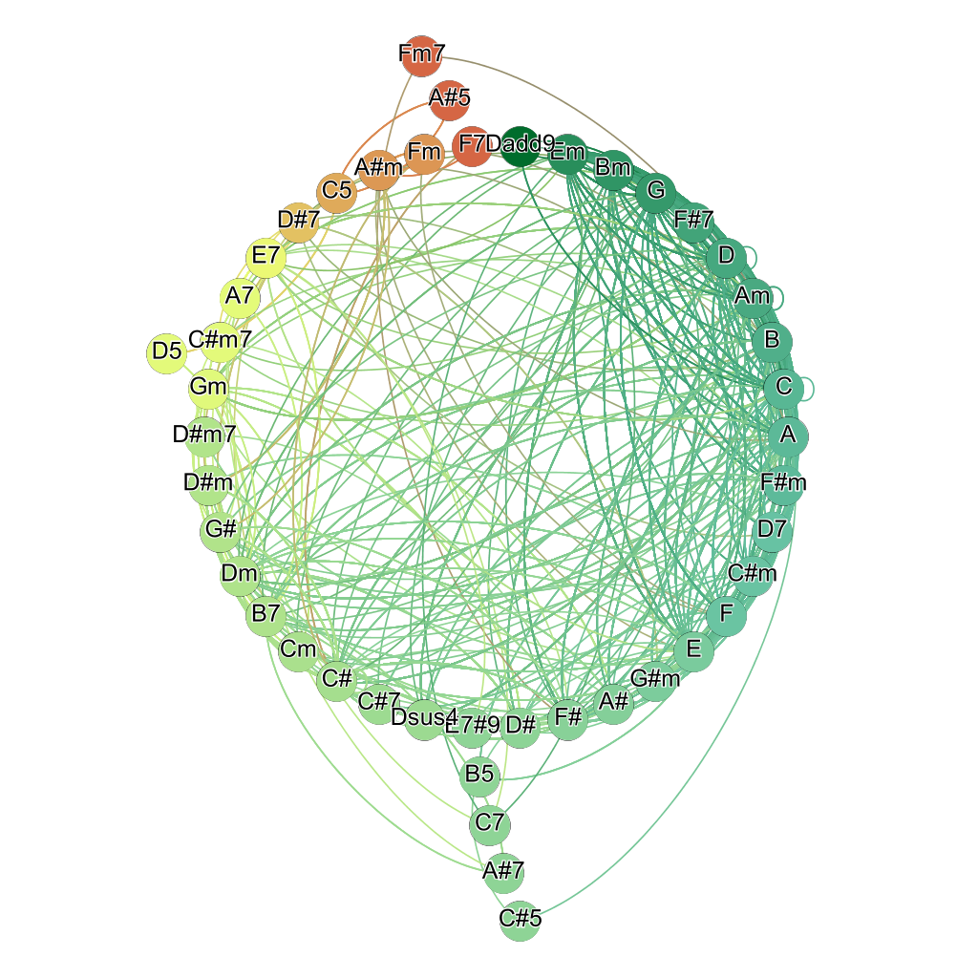

The graph to the left is the same graph as before, colored by Clustering Coefficient and arranged on a Radial Axis. At first glance, there’s no clear conclusion, since even high value nodes have plenty of edges that are connected to supposedly weaker nodes.

In order to focus on the nodes most likely to produce a clustering symptom, a Degree Filter was used in Gephi. That created a subgraph that consisted of just 9 nodes, which even without using a metric show a very clustering tendency. To confirm this suspicion, the subgraph was evaluated once again using Gephi’s Average Clustering Coefficient, which made an impressive jump from 0.447 to 0.70! This shows beyond doubt that clustering does take place in the graph, even in some smaller subsets. This particular one consists of just 20% of the nodes, but these nodes account for 68% of the graph’s total edges. So it can actually be argued that this cluster plays a pivotal role extracting information from the graph.

1. **Hhhh**
2. **Hhhh**