Rules

1. Your program must not crash under any circumstances(even if it runs out of memory) or terminate unexpectedly. – Make sure to break it enough times so you prevent that. When will the program crash? How will it runs out of memory? Terminate unexpectedly???

2. Any external library and Boost libraries are forbidden. – Why using external libraries, where?? What may calls for different library?? -
Where - was already found during research for the opening of a configuration file, ai said that to boost the performance I should include boost library.

Mandatory part
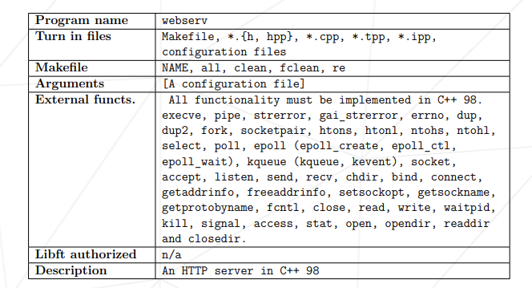
Requirements

1. Your program must take a configuration file as an argument, or use a default path. - Taking a configuration file as an argument means that a program or application is designed to read and use settings or parameters from an external file, rather than relying on command-line arguments or hard-coded values. This approach allows for more flexibility, easier management of settings, and separation of configuration from code. – What I see from analizing this part so far is that I must write open(), read(), write(), readdir(), closedir().

2. You cannot execve another web server. – What does this mean??
the program you are developing should not directly replace the current process with another web server executable. This is typically due to the design and operational constraints of web servers and the nature of the execve system call.
The execve system call replaces the current process image with a new process image, meaning that the current process is entirely replaced by the new program. For a web server, this would mean that the current process, which might be handling requests, would be replaced by another web server process. This is generally not desirable because it would terminate the current server process and start a new one, which could lead to service interruptions or loss of state.
If you need to start another web server, you would typically use mechanisms like fork followed by execve to create a new process that runs the web server. This way, the original process can continue to handle other tasks or remain as a parent process that manages the child process.
If you are encountering issues where execve is not launching the expected web server, it could be due to several reasons such as incorrect file paths, permission issues, or the target executable not being compatible with the current environment. However, if this is a design decision rather than an error, it means that your program should be structured to avoid directly replacing the current process with another web server, instead using appropriate process management techniques. – execve(), fork()…

3. Your server must remain non-blocking at all times and properly handle client disconnections when necessary.

