Современный номер банковской карты состоит из 16 цифр. Первая цифра означает платежную систему:

|  |  |
| --- | --- |
| **Первая цифра банковской карты** | **Платежная система** |
| 2 | Мир |
| 3 | American Express, Maestro, JCB |
| 4 | Visa |
| 5 | Mastercard, Maestro |
| 6 | Maestro, Union Pay |

<https://bankirsha.com/nomer-bankovskoi-karty-nomer-karty.html>

Исходные данные:

|  |  |
| --- | --- |
| Алфавит | Цифры 0..9 (обзн. «ц»), пробел (обозн. «п»), дефис (обозн. «-») |
| Состояния | A1, B1, C1, D1, E1,  A21, B21, C21, D21, E21, A31, B31, C31, D31, E31, A41, B41, C41, D41,  A22, B22, C22, D22, E22, A32, B32, C32, D32, E32, A42, B42, C42, D42,  A23, B23, C23, D23, A33, B33, C33, D33, A43, B43, C43,  K |
| Начальное состояние | A1 |
| Конечное состояние | K |

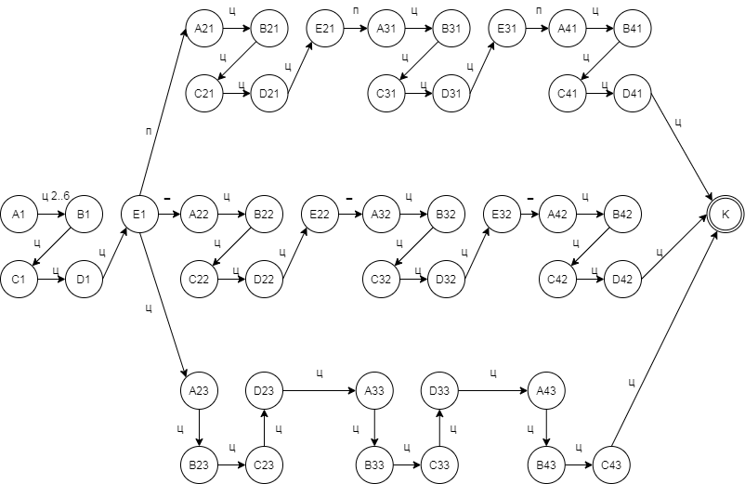

Рис. 1 – ДКА распознающий номер карты

|  |  |  |  |  |  |  |  |  |  |  |  |  |
| --- | --- | --- | --- | --- | --- | --- | --- | --- | --- | --- | --- | --- |
|  | 0 | 1 | 2 | 3 | 4 | 5 | 6 | 7 | 8 | 9 | п | - |
| A1 |  |  | B1 | | | | |  |  |  |  |  |
| B1 | C1 | | | | | | | | | |  |  |
| C1 | D1 | | | | | | | | | |  |  |
| D1 | E1 | | | | | | | | | |  |  |
| E1 | A23 | | | | | | | | | | A21 | A22 |
| A21 | B21 | | | | | | | | | |  |  |
| B21 | C21 | | | | | | | | | |  |  |
| C21 | D21 | | | | | | | | | |  |  |
| D21 | E21 | | | | | | | | | |  |  |
| E21 |  | | | | | | | | | | A31 |  |
| A31 | B31 | | | | | | | | | |  |  |
| B31 | C31 | | | | | | | | | |  |  |
| C31 | D31 | | | | | | | | | |  |  |
| D31 | E31 | | | | | | | | | |  |  |
| E31 |  | | | | | | | | | | A41 |  |
| A41 | B41 | | | | | | | | | |  |  |
| B41 | C41 | | | | | | | | | |  |  |
| C41 | D41 | | | | | | | | | |  |  |
| D41 | K | | | | | | | | | |  |  |
|  |  | | | | | | | | | |  |  |
| A22 | B22 | | | | | | | | | |  |  |
| B22 | C22 | | | | | | | | | |  |  |
| C22 | D22 | | | | | | | | | |  |  |
| D22 | E22 | | | | | | | | | |  |  |
| E22 |  | | | | | | | | | |  | A32 |
| A32 | B32 | | | | | | | | | |  |  |
| B32 | C32 | | | | | | | | | |  |  |
| C32 | D32 | | | | | | | | | |  |  |
| D32 | E32 | | | | | | | | | |  |  |
| E32 |  | | | | | | | | | |  | A42 |
| A42 | B42 | | | | | | | | | |  |  |
| B42 | C42 | | | | | | | | | |  |  |
| C42 | D42 | | | | | | | | | |  |  |
| D42 | K | | | | | | | | | |  |  |
|  |  | | | | | | | | | |  |  |
| A23 | B23 | | | | | | | | | |  |  |
| B23 | C23 | | | | | | | | | |  |  |
| C23 | D23 | | | | | | | | | |  |  |
| D23 | A33 | | | | | | | | | |  |  |
| A33 | B33 | | | | | | | | | |  |  |
| B33 | C33 | | | | | | | | | |  |  |
| C33 | D33 | | | | | | | | | |  |  |
| D33 | A43 | | | | | | | | | |  |  |
| A43 | B43 | | | | | | | | | |  |  |
| B43 | C43 | | | | | | | | | |  |  |
| C43 | K | | | | | | | | | |  |  |

Рис. 2 – Функция переходов

Листинг (c#):

//Rextester.Program.Main is the entry point for your code. Don't change it.

//Microsoft (R) Visual C# Compiler version 2.9.0.63208 (958f2354)

using System;

using System.Collections.Generic;

using System.Linq;

using System.Text.RegularExpressions;

namespace Rextester

{

public class Program

{

public static bool validChain(string chain, Func<string, string, string> transFunction, string startState, string endState)

{

string state = startState;

int i = 0;

int lenght = chain.Length;

while (state != endState)

{

if (i >= lenght) return false;

string new_state = transFunction(state, chain[i++].ToString());

if (new_state == state) return false;

state = new_state;

}

return true;

}

public static string transFunction(string state, string _char)

{

if (state == "A" && _char == "a") return "B";

if (state == "B" && _char == "b") return "C";

if (state == "C" && _char == "c") return "D";

return state;

}

public static void Main(string[] args)

{

Console.WriteLine(validChain("ab", transFunction, "A", "D"));

}

}

}