Git / GitHub convention in our Team
As several people are working on the project at the same time, it is important to create the commits according to certain standards and regulations. In this way, we want to avoid confusion and misunderstandings and achieve a standardised form.
GIT-Commits:
We follow this convention for commit messages: https://www.conventionalcommits.org/en/v1.0.0/
Examples:
New feature: feat(drag&drop)!: added drag&drop
New documentation: doc: added git convention documentations
Bug fix: fix: fixed bug
Refactor code: refactor: refactor navbar

Branches:
The branch name (in lower case) should be:
{Name-abbreviation}_{title of issue or functionality}
Example for Max Mustermann: mm_add_navbar

Pull Request:
First, the developer creates a pull request on the development branch.
The various pull requests from the development branch are merged and pushed into the main branch with the next major release.
Format Pull Request:
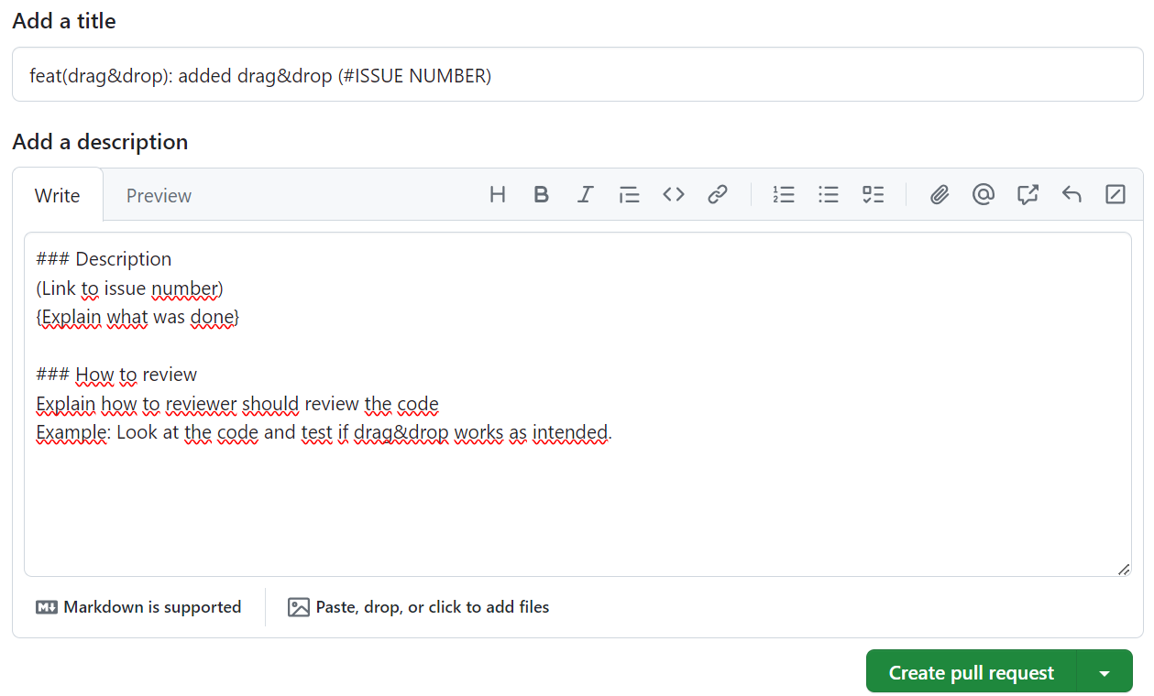
Reviewers:
Each pull request is checked and tested by at least one person.

