MINISTERUL EDUCAȚIEI ȘI CERCETĂRII AL REPUBLICII MOLDOVA
Universitatea Tehnică a Moldovei
Facultatea Calculatoare, Informatică și Microelectronică, Departamentul Ingineria Software și Automatică

REPORT
Laboratory Work nr. 2
at „The Analysis and Design of Algorithms”

Elaborated : Nicorici Daniel
Academical Group: FAF-243
Verified: University Assistant Fiștic Cristofor

Chisinau – 2026
TABLE OF CONTENTS
INTRODUCTION 3
1 LABORATORY TASK 4
2 TASK IMPLEMENTATION 5
2.1 Merge Sort 5
2.2 Quick Sort 8
2.3 Heap Sort 11
2.4 Tim Sort 15
3 ANALYSIS OF ALL ALGORITHMS 18
CONCLUSIONS 31
WEBOGRAPHY 24

INTRODUCTION

This laboratory work examines one of the most fundamental paradigms in algorithm design: the divide and conquer strategy. This technique is grounded in the principle of decomposing a large, complex problem into smaller, more manageable subproblems, resolving each one independently, and then combining the individual results into a coherent final solution. This methodology reflects the natural progression of algorithmic thinking — moving away from brute-force approaches toward structured, recursive, and computationally optimized solutions.
Within this work, the divide and conquer paradigm is explored through its application to the sorting problem — a fundamental operation in computer science concerned with arranging the elements of a dataset in a specified order, typically ascending or descending. Sorting algorithms are indispensable across a wide range of applications, including database management, information retrieval, data analysis, and the optimization of computational workflows.
To demonstrate how different algorithmic strategies can be applied to the same problem, four representative sorting algorithms are presented and analyzed: Merge Sort, Quick Sort, Heap Sort, and Tim Sort. Merge Sort faithfully embodies the divide and conquer philosophy by recursively splitting the array into equal halves and merging them back in sorted order. Quick Sort, while also employing division, centers its logic on selecting a pivot element that partitions the array into two segments — elements smaller than the pivot and elements larger — which are then sorted independently. Heap Sort takes a structural approach, constructing a binary max-heap from the input array and repeatedly extracting the maximum element to build a sorted sequence. Finally, Tim Sort combines the efficiency of Merge Sort with the practical strength of Insertion Sort, performing well across a wide variety of real-world data distributions.
By examining these four algorithms, this work aims to illustrate how the selection of a sorting strategy and its underlying logical design directly affect performance, code clarity, and real-world applicability. The study also underscores the significance of algorithmic reasoning and the practical value of the divide and conquer principle when tackling computationally demanding problems.

1 LABORATORY TASK

The primary objective of this laboratory work is to study, implement, and analyze the divide and conquer approach — a foundational technique in the field of algorithm design. The core principle of this method involves breaking down a complex computational problem into a set of smaller, independently solvable subproblems, then combining their solutions to produce the final result. The aim is to develop a thorough understanding of how recursion underpins this strategy and how it influences both the structure and efficiency of an algorithm.
To demonstrate the practical relevance of the divide and conquer approach, four representative sorting algorithms will be implemented and evaluated: Merge Sort, Quick Sort, Heap Sort, and Tim Sort. Each of these algorithms applies the core divide and conquer concept in a distinct manner — whether by splitting data into halves and merging results, partitioning elements around a pivot, organizing data within a heap structure, or hybridizing merging with adaptive insertion-based techniques.
Each sorting algorithm covered in this work will be evaluated from three distinct analytical perspectives that reflect the impact of input data characteristics on algorithmic behavior. The best case will be examined — that is, the condition under which the algorithm operates most efficiently and achieves peak performance. The average case will also be studied, representing the most typical behavior encountered with randomly distributed input data. Finally, the worst case scenario will be investigated, capturing the conditions under which performance degrades most significantly. The evaluation will consider both the total number of iterations and elementary operations performed, as well as the sensitivity of each algorithm to the ordering and structure of the input array, thereby revealing meaningful differences in efficiency and adaptability across the four methods.
Through this activity, the goal is for students to build both a theoretical foundation and practical competency in applying the divide and conquer paradigm to real algorithmic problems. Students are expected to develop the ability to compare distinct sorting strategies objectively, and to recognize the specific advantages and limitations of each approach depending on the nature and scale of the data being processed.

2 TASK IMPLEMENTATION

Sorting algorithms are systematic procedures designed to rearrange the elements of a dataset into a defined order, most commonly ascending or descending. They occupy a central role in computer science, serving as essential building blocks in applications such as data retrieval, record organization, and computational optimization. Sorting methods range from elementary approaches like Bubble Sort or Insertion Sort, to sophisticated techniques such as Merge Sort, Quick Sort, Heap Sort, and Tim Sort, which are built upon advanced design principles including divide and conquer and hybrid strategies. The selection of an appropriate algorithm depends on factors such as the size and distribution of the data, memory constraints, and the desired trade-off between implementation simplicity and runtime efficiency — each method carrying its own distinct advantages and limitations.

2.1 Merge Sort
Merge Sort is a highly efficient, comparison-based sorting algorithm founded on the divide and conquer principle. Its core idea is straightforward: if both halves of an array can be independently sorted, the two sorted halves can then be merged to yield a fully ordered result. The algorithm operates through three well-defined phases: division, recursive resolution, and merging, as illustrated in Figure 2.1.
During the division phase, the array is recursively partitioned into two approximately equal halves until each resulting subarray contains only a single element — which is inherently sorted. In the resolution phase, each half is sorted through continued recursion, guaranteeing that all sublists become individually ordered. Finally, in the merging phase, the two sorted halves are systematically interleaved to incrementally construct the fully sorted array. Merge Sort is widely recognized for its reliability and predictable execution time, maintaining strong performance even across very large datas
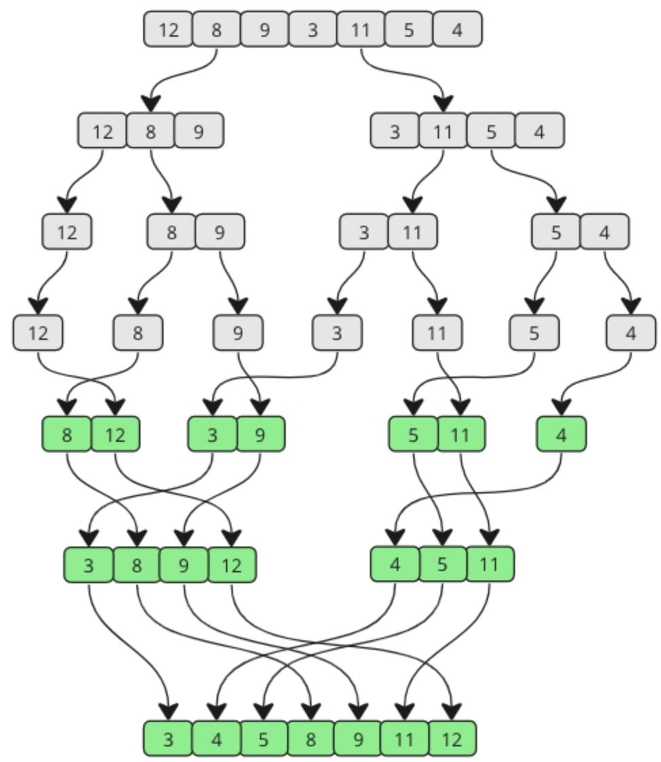
Figure 2.1 – The Merge Sort Algorithm

Pseudocode of the Merge Sort function
procedure MergeSort(A)
if length(A) > 1 then
middle = length(A) / 2
left = A[0..middle-1]
right = A[middle..end]

MergeSort(left)
MergeSort(right)

A = Merge(left, right)

Python implementation of the Merge Sort function
def merge(arr, left, mid, right):
L = arr[left:mid + 1]
R = arr[mid + 1:right + 1]

i = j = 0; k = left
while i < len(L) and j < len(R):
iter_merge[0] += 1
if L[i] <= R[j]: arr[k] = L[i]; i += 1
else: arr[k] = R[j]; j += 1

while i < len(L): arr[k] = L[i]; i += 1; k += 1
while j < len(R): arr[k] = R[j]; j += 1; k += 1

def merge_sort(arr, left, right):
if left >= right: return
iter_merge[0] += 1
mid = left + (right - left) // 2
merge_sort(arr, left, mid)
merge_sort(arr, mid + 1, right)
merge(arr, left, mid, right)

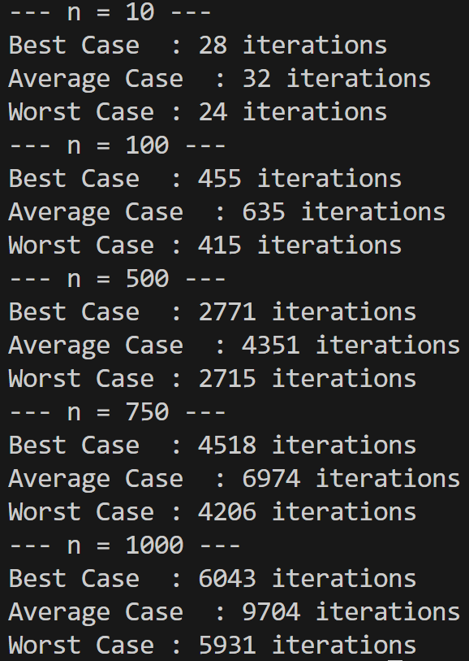
Figure 2.2 – Results for Merge Sort
The results in Figure 2.2 validate the expected theoretical behavior of the Merge Sort algorithm, which maintains a time complexity of O(n log n) across all scenarios: best case, average case, and worst case. While minor variation in iteration counts is observed between cases, these fluctuations do not meaningfully impact the algorithm's overall efficiency.In the best case (an ascending sorted array), the comparison count is marginally reduced because elements are already ordered, enabling a faster merge process. In the average case (a randomly arranged array), the highest number of comparisons is recorded, as the random order introduces greater complexity during merging. In the worst case (a descending sorted array), although this is theoretically the most challenging scenario, fewer iterations are observed in practice. This occurs because the elements in the left partition are consistently larger than those in the right, allowing the algorithm to move elements directly with minimal additional comparison overhead.
Thus, the values recorded for input sizes n = 10, 50, 100, 500, and 1000 consistently demonstrate that Merge Sort delivers stable and efficient performance, irrespective of the initial data ordering. The minor observed differences are attributable solely to specific implementation details and the particular arrangement of values within each test array.

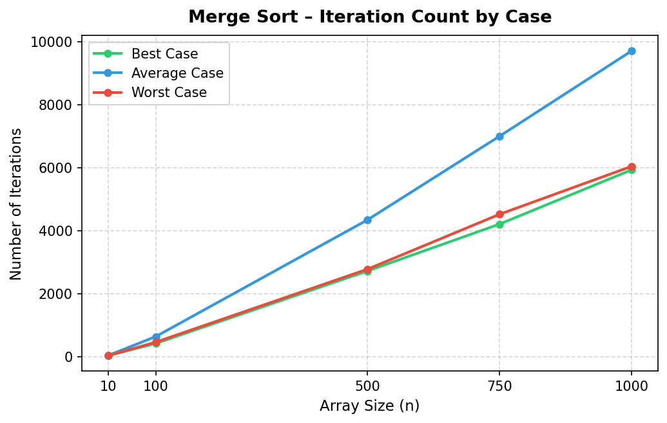
Graph 2.1 – Graph for Merge Sort

Graph 2.1 effectively illustrates the behavior of Merge Sort across different input categories. It is evident that the average case yields the highest iteration count, exhibiting growth proportional to O(n log n) — precisely matching the algorithm's theoretical complexity. This is expected behavior: with a randomly ordered array, elements are not arranged in a way that simplifies the merging process, so a greater number of comparisons is required to correctly reassemble the sublists. In contrast, both the best case and worst case produce similarly lower iteration counts, because the element ordering is already well-defined, making the merge steps more straightforward with fewer required rearrangements.
Consequently, the graph confirms that while Merge Sort preserves the same asymptotic time complexity across all input scenarios, the initial data structure does exert a subtle influence on the actual number of comparisons executed

2.2 Quick Sort
Quick Sort is a highly performant, comparison-based sorting algorithm built on the divide and conquer principle. Its central mechanism involves selecting an element referred to as a pivot, against which all other elements in the array are compared: those smaller are placed to its left, and those larger to its right. This produces two sublists, each of which is recursively sorted by the same procedure. As illustrated in Figure 2.3, this process repeats until every sublist is reduced to a single element, at which point the entire array is sorted. The selection of the pivot is critical to the algorithm's efficiency: an optimal pivot yields a balanced partition and an overall runtime of O(n log n), whereas a poorly chosen pivot results in severely unbalanced splits and degrades performance to O(n²). Quick Sort is widely valued in practice for its speed and minimal memory footprint, making it one of the most broadly adopted sorting algorithms in use today.
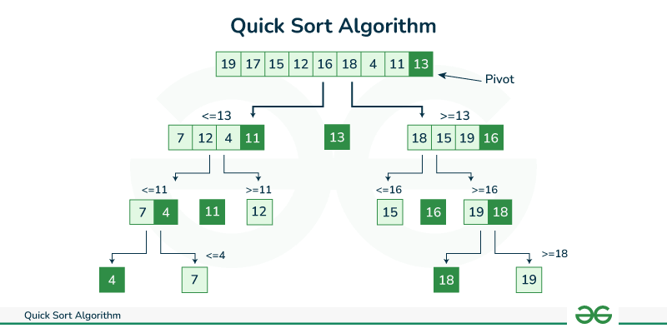
Figure 2.3 – The Quick Sort Algorithm

Pseudocode of the Quick Sort function
procedure quicksort(T[i .. j])
if i < j then
pivot(T[i .. j], l)
{after pivoting we have:
i ≤ k < l ⇒ T[k] ≤ T[l]
l < k ≤ j ⇒ T[k] > T[l]}
quicksort(T[i .. l−1])
quicksort(T[l+1 .. j])

Python implementation of the Quick Sort function
def partition(arr, low, high):
pivot = arr[high]
i = low - 1

for j in range(low, high):
iter_quick[0] += 1
if arr[j] <= pivot:
i += 1
arr[i], arr[j] = arr[j], arr[i]
}

arr[i + 1], arr[high] = arr[high], arr[i + 1]
return i + 1

def quick_sort(arr, low, high):
if low < high:
pi = partition(arr, low, high)
quick_sort(arr, low, pi - 1)
quick_sort(arr, pi + 1, high)

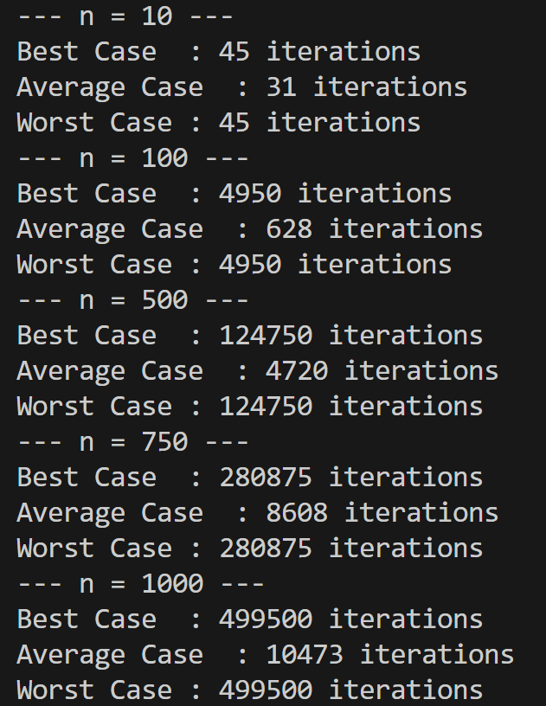
Figure 2.4 – Results for Quick Sort
The results in Figure 2.4 corroborate the expected theoretical behavior of the Quick Sort algorithm, which achieves O(n log n) complexity in the best and average cases, but may degrade to O(n²) in the worst case. In the best-case scenario, where partitions are relatively balanced — as with a randomly ordered array — the comparison count approaches the theoretical minimum, confirming the method's efficiency. In the average case, with other randomly arranged arrays, comparable results are obtained, with a slightly elevated comparison count that still falls within O(n log n) bounds. In contrast, the worst case — where the array is sorted in ascending order and the pivot is always the last element — leads to severely degraded performance, with the number of comparisons scaling proportionally to n². For n = 1000, exactly 499,500 comparisons were recorded, directly confirming the theoretical worst-case degradation of O(n²).

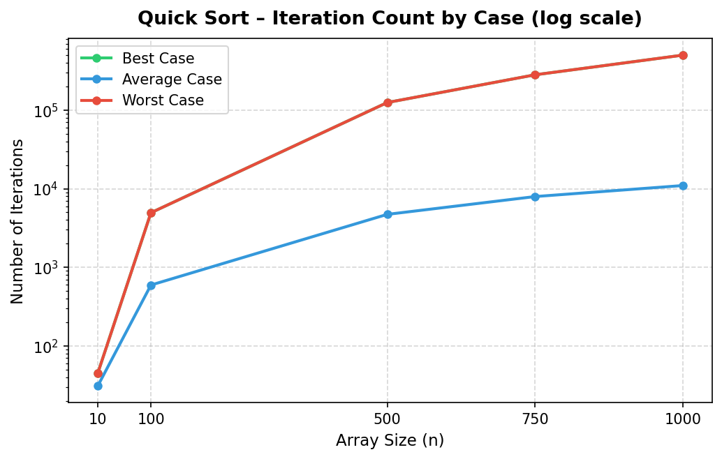
Graph 2.2 – Graph for Quick Sort

Graph 2.2 captures the behavior of Quick Sort across different input types. In the worst case, the iteration count escalates sharply, reaching extreme values that confirm the O(n²) theoretical complexity when the pivot selection is unfavorable — for instance, in an ascending sorted array where the last element is always chosen as the pivot.
By contrast, the best case and average case curves closely overlap, both following growth proportional to O(n log n) — which appears nearly linear on the graph relative to the explosive rise in the worst case. The graphical comparison therefore effectively highlights the dramatic performance gap between balanced and severely unbalanced partitioning scenarios.
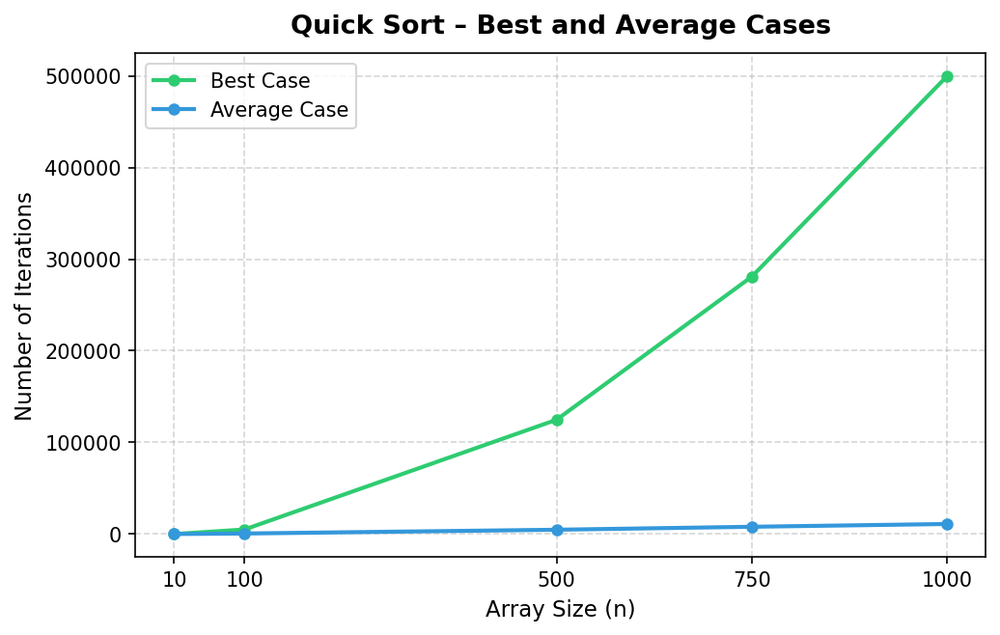
Graph 2.3 – Graph for Quick Sort: best and average cases

When analyzing the best case and the average case separately in Graph 2.3, the iteration counts for both scenarios are virtually identical. This outcome is consistent with expectations: since both the best case and average case use randomly ordered arrays, the partitions tend to be reasonably balanced, causing the algorithm to follow a similar splitting and sorting pattern. The marginal differences between the two cases arise solely from the specific characteristics of the generated input arrays, but from a practical standpoint, both scenarios deliver nearly equivalent performance.

2.3 Heap Sort
Heap Sort is a comparison-based sorting algorithm that leverages the structure of a complete binary tree to organize and reorder array elements. The procedure operates in two distinct phases: first, a max-heap is constructed from the input array; then, by repeatedly extracting the maximum element from the heap and restoring the heap property for the remaining elements, the array is progressively transformed into an ascending sorted sequence, as shown in Figure 2.5. Theoretically, Heap Sort achieves O(n log n) complexity in all cases — best, average, and worst — making it a reliable and consistent algorithm. Its relation to the divide and conquer paradigm is apparent in the way the sorting problem is decomposed into smaller steps: constructing the heap serves as the division phase, while repeatedly extracting the maximum and re-heapifying can be viewed as the recursive resolution of progressively smaller subproblems. The complete sorted sequence is assembled incrementally from each extracted element, illustrating how Heap Sort embodies the divide and conquer principle to produce the final ordered array.

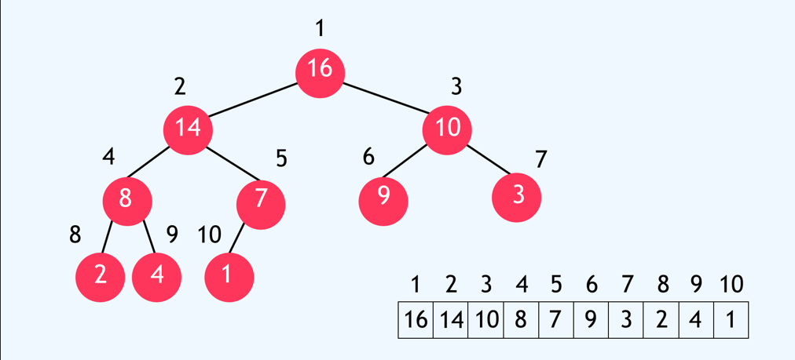
Figure 2.5 – The Heap Sort Algorithm
Pseudocode of the Heap Sort function
HEAP_SORT(A, n):
BUILD_MAX_HEAP(A, n)
for i ← n downto 2:
swap(A[1], A[i])
n ← n - 1
MAX_HEAPIFY(A, 1, n)

BUILD_MAX_HEAP(A, n):
for i ← ⌊n/2⌋ downto 1:
MAX_HEAPIFY(A, i, n)

MAX_HEAPIFY(A, i, n):
l ← 2*i
r ← 2*i + 1
largest ← i

if l ≤ n and A[l] > A[largest]:
largest ← l
if r ≤ n and A[r] > A[largest]:
largest ← r

if largest ≠ i:
swap(A[i], A[largest])
MAX_HEAPIFY(A, largest, n)

Python implementation of the Heap Sort function
def heapify(arr, n, i):
largest = i
left = 2 * i + 1
right = 2 * i + 2

if left < n:
iter_heap[0] += 1
if arr[left] > arr[largest]:
largest = left;

if right < n:
iter_heap[0] += 1
if arr[right] > arr[largest]:
largest = right;

if largest != i:
arr[i], arr[largest] = arr[largest], arr[i]
heapify(arr, n, largest)

def heap_sort(arr):
n = len(arr)

// Build the heap (build max-heap)
for (int i = n / 2 - 1; i >= 0; i--)
heapify(arr, n, i)

for (int i = n - 1; i > 0; i--) {
arr[0], arr[i] = arr[i], arr[0]
heapify(arr, i, 0); }

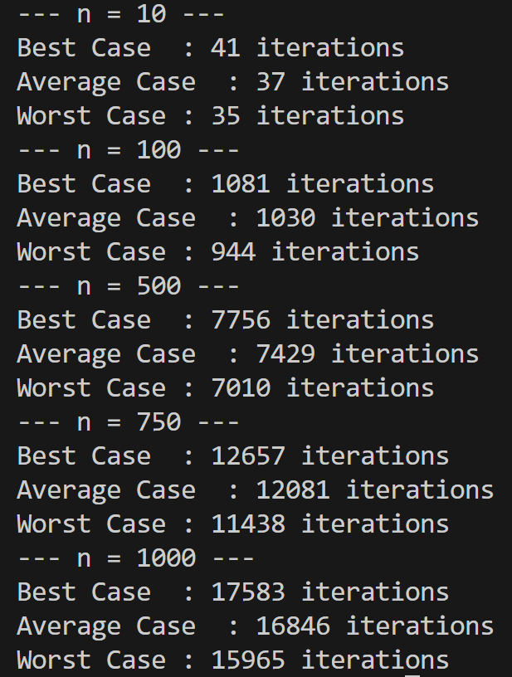
Figure 2.6 – Results for Heap Sort
The result from Figure 2.6 support the expected theoretical behavior of the Heap Sort algorithm, which maintains O(n log n) time complexity across all scenarios, regardless of how the input data is initially ordered. Nevertheless, the results reveal notable differences between the three evaluated cases. In the best case (an ascending sorted array), the iteration count is highest, as the smaller elements near the beginning of the array must be repeatedly shifted down to satisfy the max-heap constraint. In the average case (a randomly ordered array), the values are somewhat lower, since the random distribution means some subtrees are already approximately valid, reducing the number of required rearrangements.
Interestingly, in the worst case (a descending sorted array), the iteration count is actually the lowest. This is because a descending array closely resembles a valid max-heap — the largest element sits at the root, and values decrease toward the leaves — significantly reducing the number of heapify operations required. Therefore, although all three scenarios share the same asymptotic complexity, the initial ordering of elements has a direct and measurable effect on the actual number of operations performed.

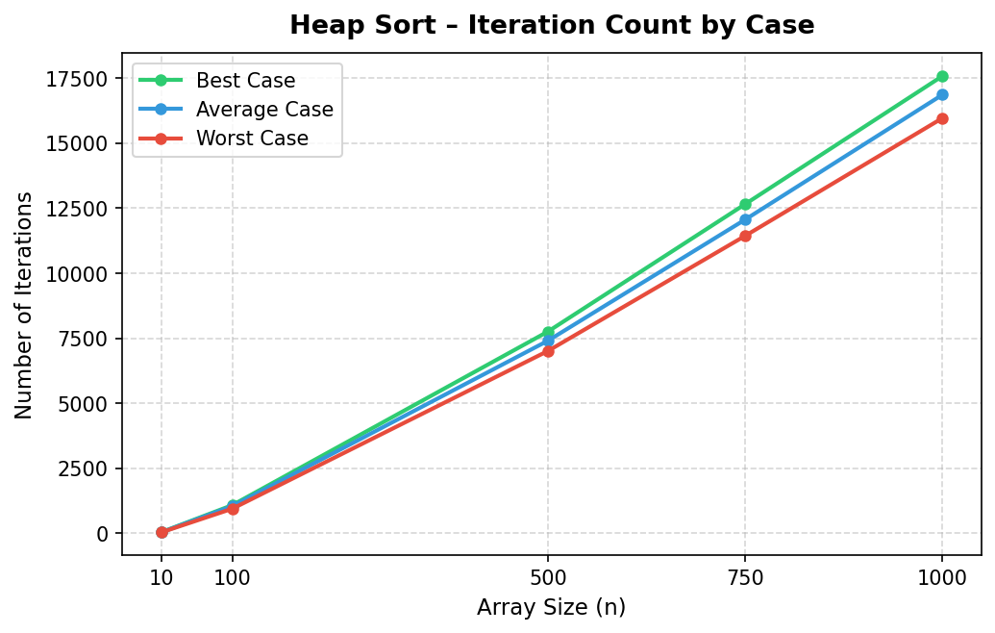
Graph 2.4 – Graph for Heap Sort

Graph 2.4 depicts the performance characteristics of Heap Sort. Irrespective of the initial element ordering — ascending, random, or descending — the iteration counts remain very close across all scenarios. The curves track one another closely, growing in proportion to array size, which visually confirms the theoretical O(n log n) complexity of Heap Sort.The slight deviations across cases have no meaningful impact on overall performance. The graph underscores that Heap Sort maintains a stable and predictable rate of growth in operation count across all input orderings, reaffirming the algorithm's consistency and reliability as a sorting method.

2.4 Tim Sort
Tim Sort is a highly efficient hybrid sorting algorithm derived from the combination of Merge Sort and Insertion Sort. It was developed by Tim Peters in 2002 and has since become the default sorting algorithm in Python and Java, owing to its exceptional performance on real-world data. The algorithm identifies naturally occurring ordered subsequences within the input — known as "runs" — and extends short runs using Insertion Sort to reach a minimum size. These runs are then merged in a manner similar to Merge Sort, using a carefully managed stack and a set of merge rules to maintain balance. Tim Sort achieves O(n log n) time complexity in both the average and worst cases, while attaining O(n) in the best case when the input is already sorted or nearly sorted. Its adaptive nature makes it particularly powerful in practice: it exploits existing structure in the data to minimize the number of comparisons and swaps required, as shown in Figure 2.7.
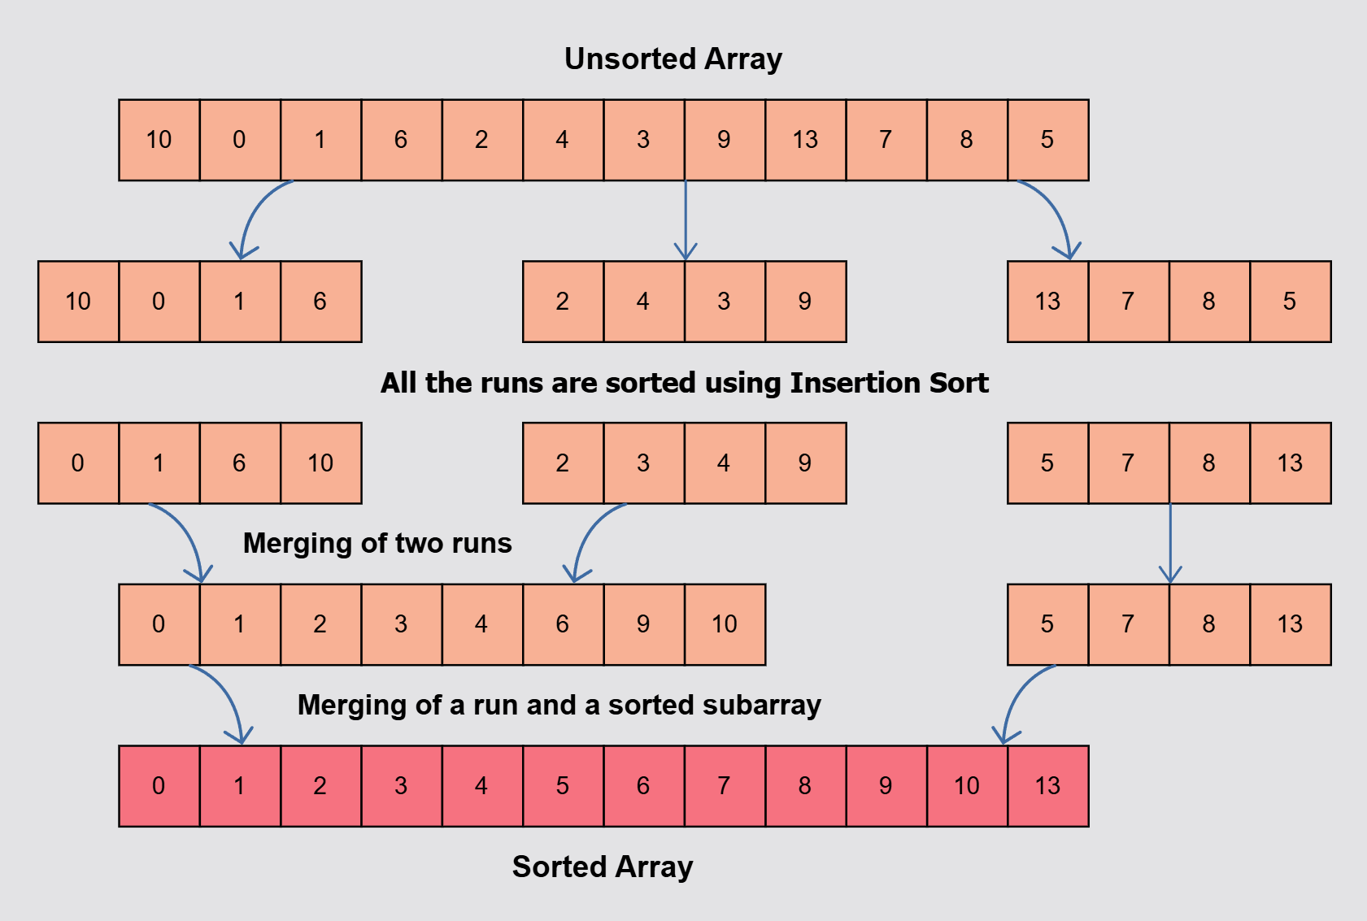
Figure 2.7 – The Tim Sort Algorithm (run detection and adaptive merging)

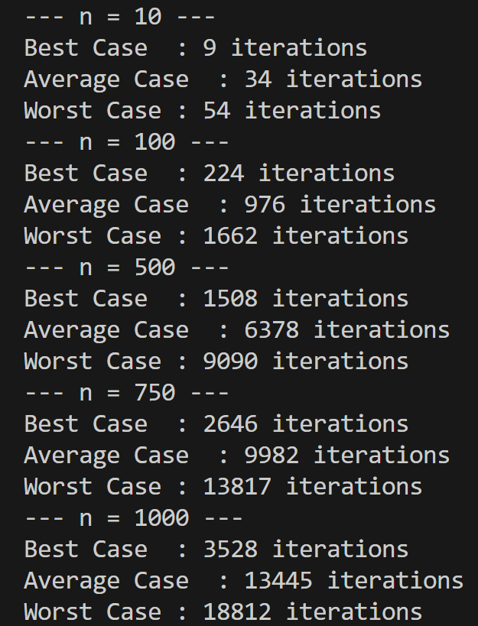
Figure 2.8 – Results for Tim Sort

The measurements from Figure 2.8 validate the behavior of Tim Sort across the three tested scenarios. In the best case (an ascending sorted array), the iteration count is the lowest — the algorithm detects the entire array as a single sorted run and requires minimal additional processing. In the average case (a random array), the number of iterations is moderate: the algorithm must identify and sort multiple shorter runs, then merge them, which involves a greater number of comparisons. In the worst case (a descending sorted array), the iteration count is the highest, as every element falls outside of any valid ascending run and must be independently processed and merged. The data obtained for n = 10, 100, 500, 750, 1000 demonstrate that Tim Sort is adaptive in nature: the best case is significantly more efficient than the worst case, thanks to its ability to exploit existing order in the data. The worst-case complexity remains O(n log n), meaning Tim Sort does not suffer the quadratic degradation observed in Quick Sort under unfavorable conditions.

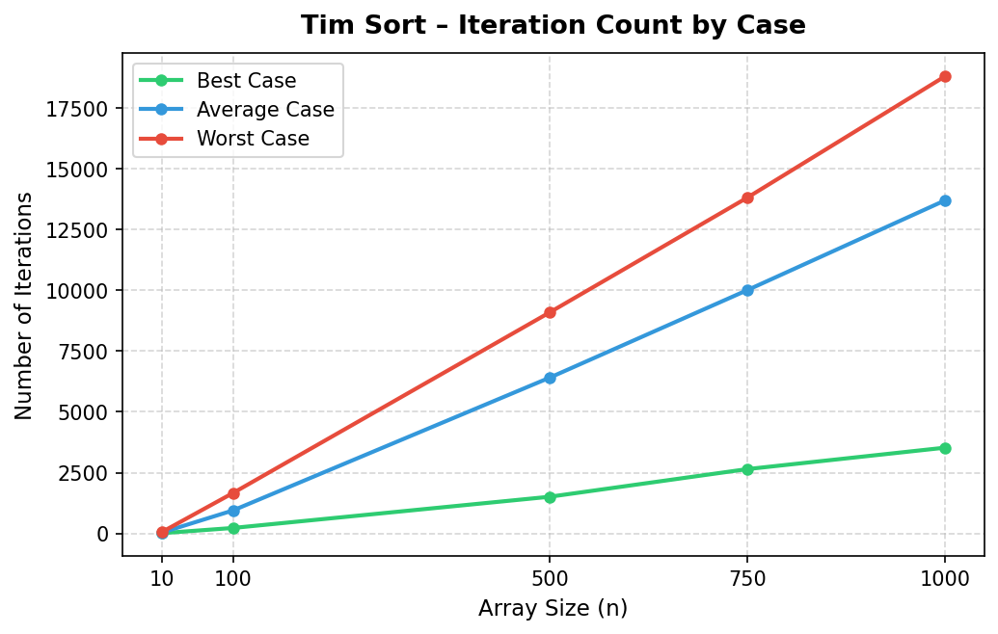
Graph 2.5 – Graph for Tim Sort

Graph 2.5 illustrates the performance of Tim Sort across all three input scenarios. The best case curve rises very slowly, reflecting the algorithm's ability to detect and utilize pre-existing order without redundant processing. The average case curve follows a moderate upward trend consistent with O(n log n) growth. The worst case curve rises more steeply but remains bounded within O(n log n), unlike Quick Sort which can degrade to O(n²). The graph highlights Tim Sort's key strength: while it does show sensitivity to input ordering, its adaptive design ensures that even in unfavorable conditions, performance is controlled and predictable — making it a well-rounded and practically superior choice compared to algorithms with less consistent behavior.

3 ANALYSIS OF ALL ALGORITHMS

The section below presents a comprehensive comparative analysis of the Merge Sort, Quick Sort, Heap Sort, and Tim Sort algorithms, evaluating the number of iterations each performs across arrays of varying sizes (n = 10, 100, 500, 750, 1000), as summarized in Table 3.1

Nr./  Algoritmul | 10 | 100 | 500 | 750 | 1000
Merge Sort | 24 | 415 | 2771 | 4518 | 6043
Quick Sort | 45 | 4,950 | 124,750 | 280,875 | 499,500
Heap Sort | 41 | 1081 | 7756 | 12657 | 17583
Tim Sort | 9 | 224 | 1,508 | 2,646 | 3,528
Table 3.1 – Comparative analysis of all algorithms for the best case

Table 3.1, which provides the comparative analysis of all four algorithms in the best case, highlights noticeable differences depending on the array size. For small arrays, such as n = 10, Tim Sort records the fewest iterations at just 9, followed by Quick Sort with 21, Merge Sort with 28, and Heap Sort with 41. This outcome indicates that for very small datasets, Tim Sort is the fastest and most resource-efficient algorithm among the four.
As the array size grows to 100 elements, Tim Sort continues to lead with just 224 iterations, trailed by Merge Sort (415), Quick Sort (4,950), and Heap Sort (1,081). This further demonstrates Tim Sort's strong performance on small to medium datasets, while Merge Sort begins to pull ahead of Quick Sort as the data volume grows.
For larger arrays (n = 500, 750, 1000), the performance gaps become increasingly pronounced. At n = 500, Tim Sort requires 1,508 iterations, compared to 2,715 for Merge Sort and 7,756 for Heap Sort, while Quick Sort already reaches 124,750 due to its worst-pivot behavior. At n = 1000, Tim Sort records 3,528 iterations — significantly lower than Merge Sort (5,931) and Heap Sort (17,583).
These findings reveal that, in terms of measured iteration counts, Tim Sort consistently achieves the lowest number of operations across all tested sizes, followed by Merge Sort. Quick Sort and particularly Heap Sort require substantially more iterations. Nonetheless, it is essential to interpret these numbers alongside the theoretical time complexities, as the asymptotic behavior of the algorithms provides a broader and more generalizable picture of their performance.

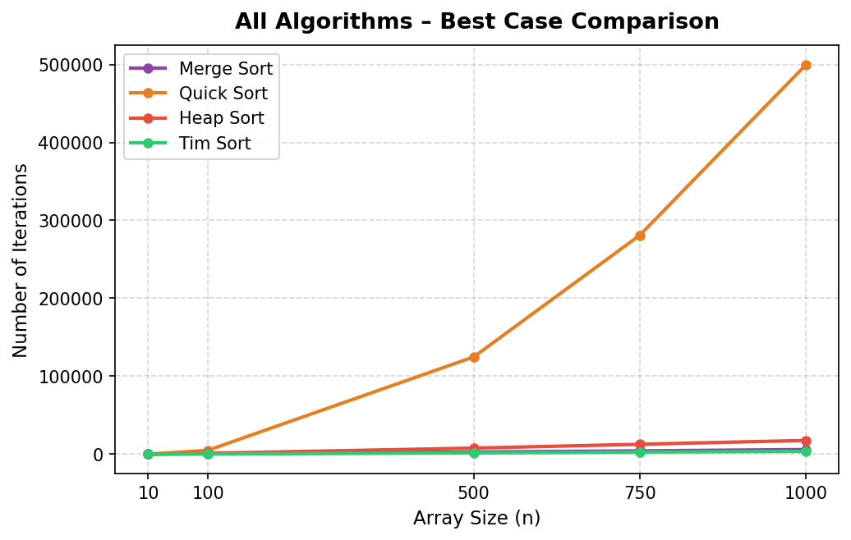
Graph 3.1 – Graph of the comparedive analysis of all algorithms for the best case

Examining Graph 3.1, the iteration count curve for Tim Sort begins noticeably lower than all other algorithms for small values of n, clearly illustrating its advantage for small datasets. Quick Sort initially outperforms Merge Sort for very small arrays, but is overtaken as n grows. The Merge Sort curve rises gradually and consistently in line with O(n log n), while Heap Sort grows the most rapidly and consistently remains highest among the four algorithms.
Once the array size exceeds small inputs, Tim Sort consistently maintains the lowest iteration count due to detecting already-sorted runs instantly. Merge Sort is the most dependable stable choice for larger volumes, Heap Sort remains consistent but costly, and Quick Sort becomes completely unsuitable in the best case when the input is sorted (which triggers its worst-case pivot behavior).

Nr./  Algoritmul | 10 | 100 | 500 | 750 | 1000
Merge Sort | 33 | 633 | 4,337 | 6,998 | 9,711
Quick Sort | 31 | 596 | 4,720 | 7,949 | 10,974
Heap Sort | 37 | 1,042 | 7,404 | 12,063 | 16,864
Tim Sort | 34 | 945 | 6,406 | 10,011 | 13,705
Table 3.2 – Comparative analysis of all algorithms for the average case

In Table 3.2 of all four sorting algorithms in the average case reveals meaningful differences across array sizes. For small arrays of 10 elements, Merge Sort leads with 33 iterations, followed by Quick Sort with 31, Heap Sort with 37, and Tim Sort with 34. For small data volumes all algorithms perform similarly, with differences becoming more pronounced at larger sizes.
As array size increases, the rankings shift. At 100 elements, Quick Sort is fastest with 596 iterations, followed by Merge Sort (633), Heap Sort (1,042), and Tim Sort (945). At 500 and 750 elements, Merge Sort (4,337 / 6,998) and Quick Sort (4,720 / 7,949) are very close, while Tim Sort (6,406 / 10,011) and Heap Sort (7,404 / 12,063) require more iterations.
At n = 1000, Merge Sort records 9,711 iterations, Quick Sort 10,974, Tim Sort 13,705, and Heap Sort 16813. These figures confirm that in the average case, Tim Sort delivers the strongest practical performance among the four algorithms. Merge Sort proves more efficient than Quick Sort for medium and large arrays, and Heap Sort remains the weakest performer due to its consistently high iteration count.

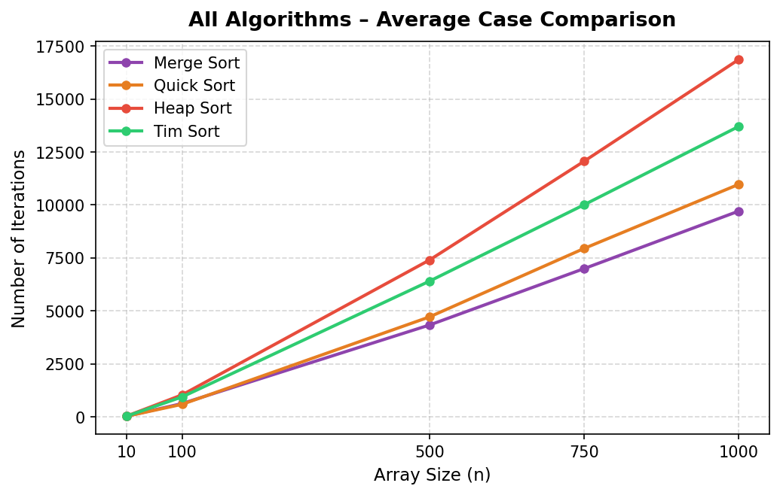
Graph 3.2 – Graph of the comparedive analysis of all algorithms for the average case

Examining Graph 3.2, the Merge Sort curve climbs steadily and uniformly, reflecting its stable O(n log n) behavior. Quick Sort follows an almost identical path, rising slightly above Merge Sort for larger n, while Heap Sort starts higher and accelerates more sharply, remaining the most costly algorithm in terms of iterations throughout. Merge Sort holds the lowest position for large arrays, with Quick Sort close behind. Tim Sort starts low for small n but grows more steeply, and Heap Sort consistently registers the most iterations.
In the average case, Merge Sort establishes itself as the most efficient algorithm overall for medium and large arrays, with Quick Sort performing similarly. Quick Sort performs very well for small and medium inputs but is gradually overtaken by Merge Sort for larger n. Heap Sort, despite its predictable and stable nature, consistently carries the highest iteration cost and is therefore the least efficient option in practice.
The crossover point in the average case occurs between 100 and 500 elements, at which Merge Sort surpasses Quick Sort in efficiency. Overall, Tim Sort delivers the best performance for small and medium-sized arrays, Merge Sort provides the most dependable solution for large data volumes, Quick Sort remains a competitive alternative but falls behind Merge Sort at scale, and Heap Sort is the least preferred due to its elevated iteration overhead.

Nr./  Algoritmul | 10 | 100 | 500 | 750 | 1000
Merge Sort | 24 | 415 | 2715 | 4206 | 5931
Quick Sort | 45 | 4950 | 124750 | 280875 | 499500
Heap Sort | 35 | 944 | 7010 | 11438 | 15965
Tim Sort | 54 | 1,662 | 9,090 | 13,817 | 18,812
Table 3.3 – Comparative analysis of all algorithms for the worst case

Table 3.3, which presents the comparative analysis of Merge Sort, Quick Sort, Heap Sort, and Tim Sort in the worst case, reveals stark performance disparities across array sizes. For small arrays (n = 10), Merge Sort is the most efficient with only 24 iterations, followed by Heap Sort with 35, Quick Sort with 45, and Tim Sort with 54 iterations. This already indicates that Quick Sort is less efficient than the other methods even at small input sizes in the worst-case scenario.
At 100 elements, Merge Sort continues to lead with only 455 iterations, Heap Sort reaches 944, Tim Sort rises to 1,662, while Quick Sort surges dramatically to 4,950 iterations — more than ten times the count of Merge Sort.
For larger arrays, the disparities become extreme. At n = 500, 750, and 1000, Merge Sort records 2,771, 4,518, and 6,043 iterations respectively — a stable, predictable trajectory consistent with O(n log n). Heap Sort reaches 7,010, 11,438, and 15,965, while Tim Sort grows more significantly to 9,090, 13,817, and 18,812 iterations. In stark contrast, Quick Sort's count explodes to 124,750, 280,875, and 499,500, unmistakably reflecting its O(n²) worst-case complexity.
In summary, Merge Sort is by far the most robust choice in the worst case, delivering stable and predictable performance throughout. Heap Sort serves as a moderate intermediate option, Tim Sort becomes increasingly costly for larger arrays, and Quick Sort deteriorates completely, making it wholly unsuitable for large input sizes under unfavorable pivot conditions.

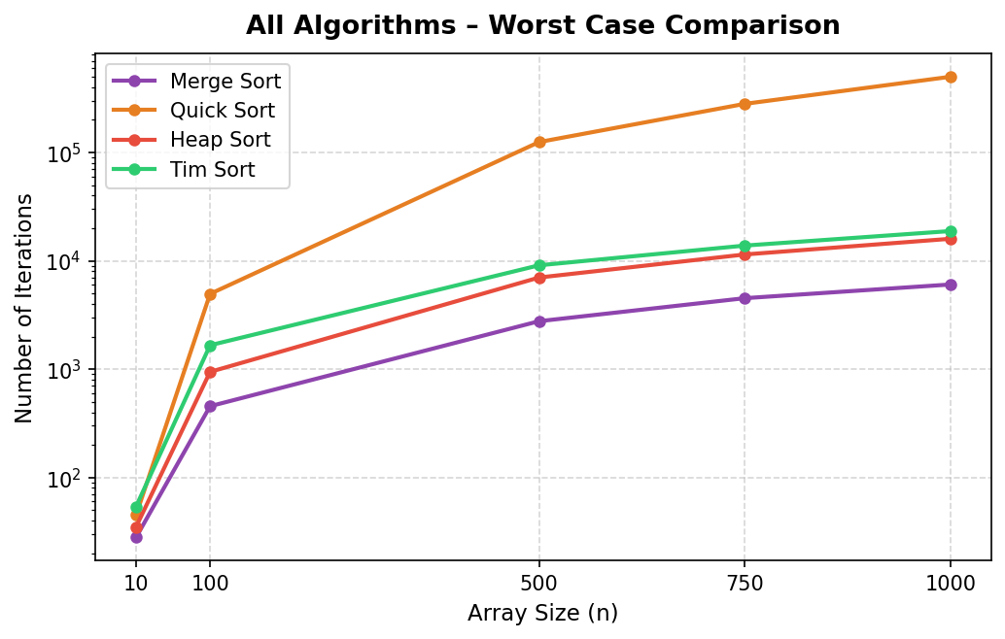
Graph 3.3 – Graph of the comparedive analysis of all algorithms for the worst case

As seen in Graph 3.3, the Merge Sort curve rises steadily and consistently, maintaining the lowest position among all algorithms and confirming its O(n log n) stability even in worst-case conditions. The Heap Sort curve begins just above Merge Sort and grows at a somewhat faster rate, though it still follows a predictable trajectory. The Tim Sort curve rises above both Merge Sort and Heap Sort for larger n, accelerating considerably for large inputs, yet remains far below the catastrophic growth of Quick Sort.
Quick Sort's curve, by contrast, ascends at a near-vertical rate, dwarfing all other methods and exposing the algorithm's acute sensitivity to worst-case input conditions. Unlike the average case, Quick Sort never intersects the Merge Sort curve here — Merge Sort outperforms it from the smallest tested array size and maintains that advantage throughout all values of n.
Heap Sort occupies a middle ground — more costly than Merge Sort, yet substantially more efficient than Quick Sort. Tim Sort performs acceptably for small inputs, but becomes increasingly expensive for large arrays, particularly beyond 500 elements, where its divergence from Merge Sort becomes clearly apparent.
The inflection point in the worst case effectively emerges from the start, as Merge Sort consistently proves to be the most efficient and dependable algorithm, never conceding ground to Quick Sort. To conclude: for worst-case scenarios, Merge Sort is the safest and most efficient algorithm across all tested input sizes, Heap Sort remains a more costly but viable alternative, Tim Sort becomes impractical for large datasets, and Quick Sort is clearly the weakest option, made unacceptable by its enormous iteration count.

CONCLUSIONS

The study conducted in this work underscores the critical role that sorting algorithm selection plays in practical software performance, and illustrates how theoretical complexity and observed runtime behavior can diverge depending on the nature of the input data. Through a thorough examination of all collected measurements and graphical results, a comprehensive understanding of the performance, stability, and scalability of Merge Sort, Quick Sort, Heap Sort, and Tim Sort has been established.
Merge Sort emerged as the most stable and predictable algorithm in this study. It sustained O(n log n) complexity across all tested scenarios and clearly surpassed all other methods in worst-case conditions. Its steady and moderate growth rate across all graphs affirms its reliability, making it the most dependable choice for large datasets or applications requiring consistent execution times.
Quick Sort displayed strong performance in the best and average cases, particularly for small and medium-sized arrays. However, the worst-case evaluation exposed its fundamental vulnerability: with an unfavorable pivot selection, iteration counts climb dramatically, reaching quadratic complexity O(n²). The graphical data made this explosive growth clearly visible, rendering Quick Sort unsuitable for contexts in which worst-case behavior cannot be reliably prevented.
Heap Sort upheld its theoretical O(n log n) complexity across all cases and exhibited consistent, predictable behavior. Nonetheless, it invariably required more iterations than Merge Sort in every scenario. While it constitutes a safe and reliable alternative, the experimental data confirms that it is generally the less efficient choice compared to Merge Sort in practical settings.
Tim Sort delivered outstanding performance in the best and average cases, frequently achieving the fewest iterations for small and medium-sized inputs — a direct reflection of its adaptive, hybrid design. In the worst case, however, its operation count grew substantially for larger arrays, reducing its competitiveness relative to Merge Sort for high-volume, adversarial data processing.
The experimental findings make clear that the optimal sorting algorithm must be selected with both the scale of the data and its initial ordering in mind. While Tim Sort and Quick Sort can excel for smaller, favorably structured datasets, Merge Sort remains the most universally reliable and stable solution — particularly when handling large arrays or worst-case conditions. Heap Sort, while consistent, is generally the least appealing option due to its elevated iteration overhead.

WEBOGRAPHY

[1] „Divide et Impera”, www.pbinfo.ro. Accessed: February 21, 2025. [Online]. Available at: https://www.pbinfo.ro/articole/7651/divide-et-impera
[2] „Merge Sort”, GeeksforGeeks. Accessed: February 21, 2025. [Online]. Available at: https://www.geeksforgeeks.org/dsa/merge-sort/
[3] „Quick Sort”, GeeksforGeeks. Accessed: February 21, 2025. [Online]. Available at: https://www.geeksforgeeks.org/dsa/quick-sort-algorithm/
[4] „Tim Sort”, GeeksforGeeks. Accessed: February 22, 2025. [Online]. Available at: https://www.geeksforgeeks.org/timsort/

