###### NewWebApp

CONTINUOUS AND AGILE SOFTWARE ENGINEERING

Coursework

* Nikolaos Polykandriotis
* Ioannis Thanos

21/05/2021

Table of Contents

Prefix and Scope of the Document 3

First Enhancement 3

1-3. Git Clone, Import Project & Switch Branch 3

4-7. Extra Shapes Creation – Pull Request 4

8. Jenkins Pipeline Setup 5

9-10. Screenshots 6

Second Enhancement 8

11. Database Integration 8

12-18. View Statistics & Reset Statistics 8

19-20. Webhooks – Screenshots 9

Prefix and Scope of the Document

This section provides a high-level view of the coursework

NewWebApp is a project that aims to present its readers geometric shapes in a web application and ultimately collect and provide data about visits to individual geometric shape pages and generate a report with usage statistics.

This document aims to explain to its readers the steps (functional & technical) that were followed and the respective methodologies that were applied / incorporated into the respective codes. In addition, this document is aiming to hand over, with the help of screenshots and tool outputs throughout the development of the project, the deployment of the application along with some conclusions and issues that we faced during its creation.

After becoming familiar with this document, a reader will be able to:

* Understand the use of build tools and use Maven for expressing dependencies and automating the software building process.
* Understand source control management and use Git and Github for maintaining code bases.
* Understand Continuous Integration and Deployment and use Jenkins to support CI/CD pipelines.
* Understand containers and use Docker for fast deployment of applications.
* Apply automated deployment as part of the CI/CD pipeline to a remote virtual machine.

Finally, below is the link to our GitHub repository “NewWebApp.git”:

<https://github.com/Nikpolik/NewWebApp>

First Enhancement

## 1-3. Git Clone, Import Project & Switch Branch

First step, instead of cloning the repository (“https://github.com/oefremidis/NewWebApp.git”) and then push it into our own remote, we decided to use “Fork”. Fork will create a copy of the repository in our Github account so that we can make changes to the project. Below are the steps:

1. Go to the desired GitHub repository
2. Click the button “Fork” at the top right corner
3. A new repository with the exact same name will be created into our repository

We then imported the project to IntelliJ using the "Get from Version Control" option.

For Git operations we used the command line.

There are a few ways you can create new branches in Git, with many of them differing in how your branch is created from the main branch, whether it be from your current branch, a different branch, a tag, etc.

The most common way to create a new branch is the following:

1. “$ git checkout -b <branch-name>”

or

1. “$ git branch <branch-name>”

“$ git checkout new-branch”

## 4-7. Extra Shapes Creation – Pull Request

Each member of the team created the corresponding shapes in his local branch, committed them and finally pushed them to GitHub.

After that, each member opened a pull request and waited the review from the other.

Below are some screenshots from the aforementioned actions on GitHub:

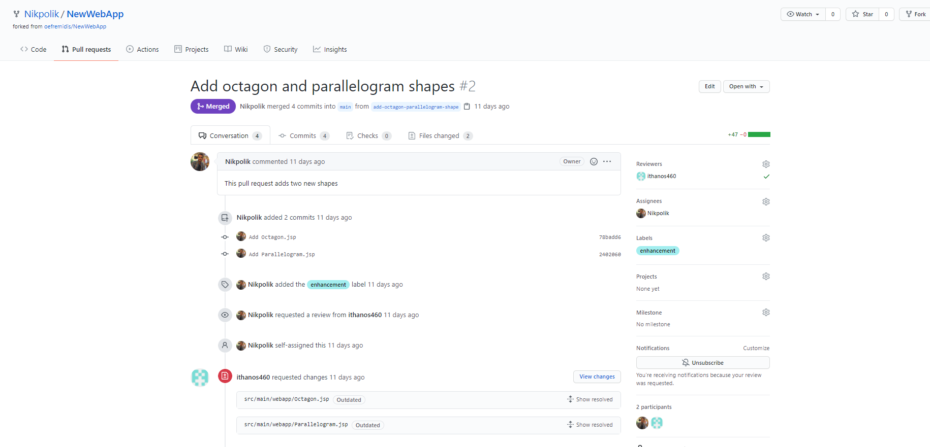

*<<Pull request by Nikos Polykandriotis>>*

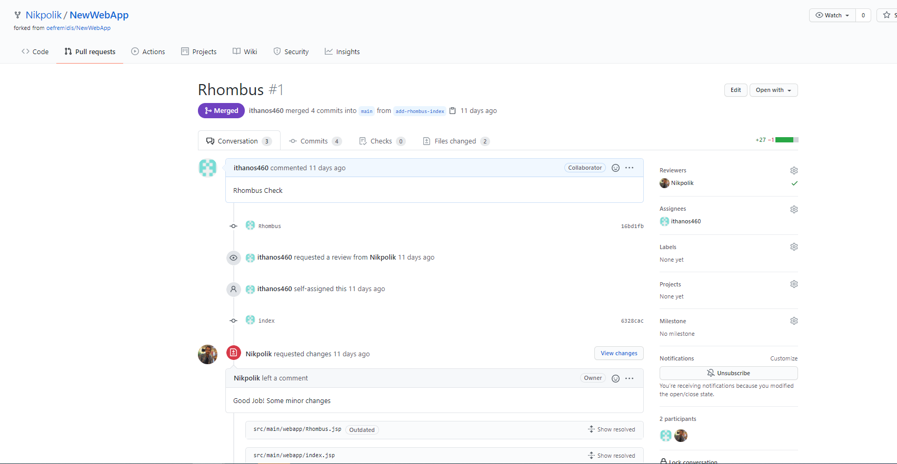

*<<Pull request by Ioannis Thanos>>*

## 8. Jenkins Pipeline Setup

For creating our pipeline script there where two choices. Either use the built in editor of Jenkins or create our own script in our repository. We decided the second was better since we could use our project with any Jenkins instance. The steps we needed to take in order to deploy our application where :

1. Package our application in a war file
2. Create a docker image that runs tomcat and contains our site
3. Deploy the app by running the image we just created

The first two steps where easy since we just had to execute a set of predefined commands from maven and docker. By far the hardest part was deploying our application. We decided to deploy it in the same machine that Jenkins was running. To achieve this we had to find a way to stop a previously running container in order to restart the new one. After some research we found that it was possibly by running the “docker ps -a -q” and saving its output in environment variable. This then allowed us to have a stage that run conditionally only when running containers where present (Stop Instances Stage in our Jenkinsfile). We also leveraged environment variables to simplify our script by defining the image name and our credentials (hardcoding them would be a security risk). After some failed attempts we managed to have the pipeline working.

## 9-10. Screenshots

You can also view the output of Jenkin execution for this build in the below attached “Console_Output_Jenkins_shapes.txt” file:



Latest Jenkinsfile Link : “<https://github.com/Nikpolik/NewWebApp/blob/main/Jenkinsfile>”

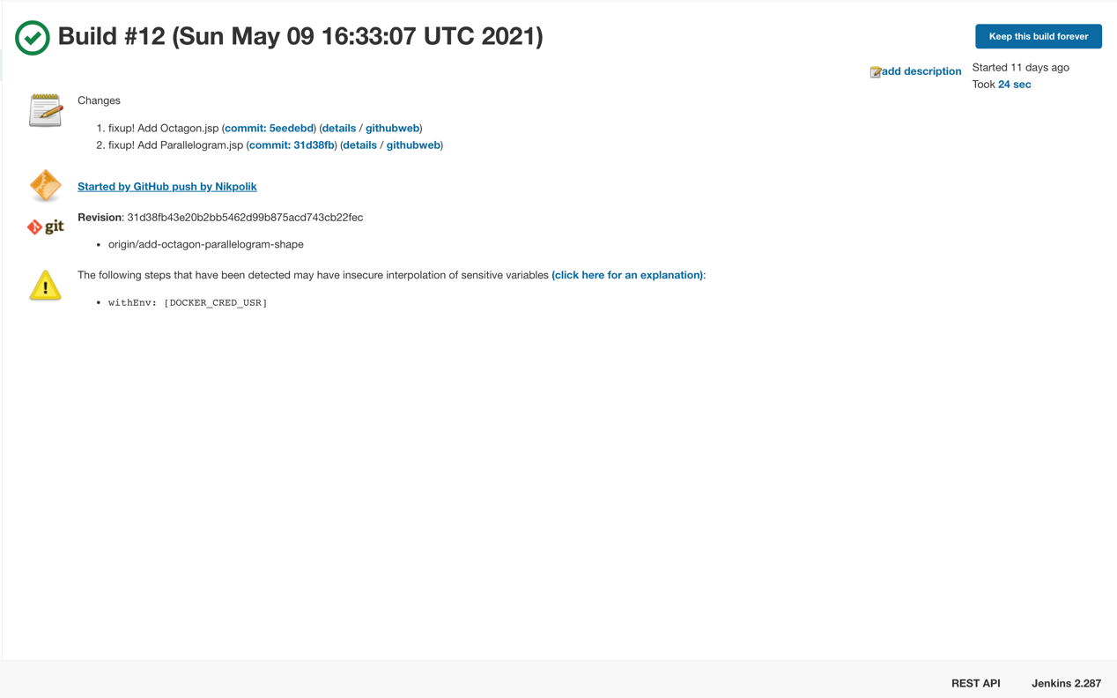

*<<Jenkins execution after GitHub merge>>*

*<<Page - Parallelogram>>*

*<<Page - Index>>*

*<<Page - Rhombus>>*

*<<Page - Octagon>>*

Second Enhancement

## 11. Database Integration

In order to setup database integration for our project we had to add a maven dependency to our database driver. We searched on https://mvnrepository.com and found the corresponding driver in <https://mvnrepository.com/artifact/mysql/mysql-connector-java>. After that we put our new ShapeStatistics class in src/main/java so that maven can compile it and move it the proper directory where tomcat will have access to it.

The second thing we had to do is update our deployment script to also start a database container. This at first seemed easy as the only thing we had to do was run an instance of <https://hub.docker.com/_/mysql>. However we found it quite difficult to pre seed our database with the proper tables. After reading the documentation we knew we had to put a *.sql script in /docker-entrypoint-initdb.d . Our first thought was to create a new docker volume that would map our /scripts folder with the corresponding directory inside the container. This proved quite hard since we had to set up proper permissions for docker to view the file as well as manage the volumes which had to be destroyed or reused so that they don’t take up space on our vm. This made us decide to move in another direction. We created our own version of a mysql image with the seed files copied in the proper directory.

At this point we also realized that our command for stopping all containers was wrong and worked only for a single container. We had to update it work with both the web app container and the database container.

## 12-18. View Statistics & Reset Statistics

After finishing the database setup we switched to a new branch to develop the statistics tracking of each shape using the “git checkout -b <branch-name>” command.

Next steps were the same as in step “4-7. Extra Shapes Creation – Pull Request”, where we collaborated through GitHub to create View Statistics & Reset Statistics functionalities and finally merge the corresponding codes.

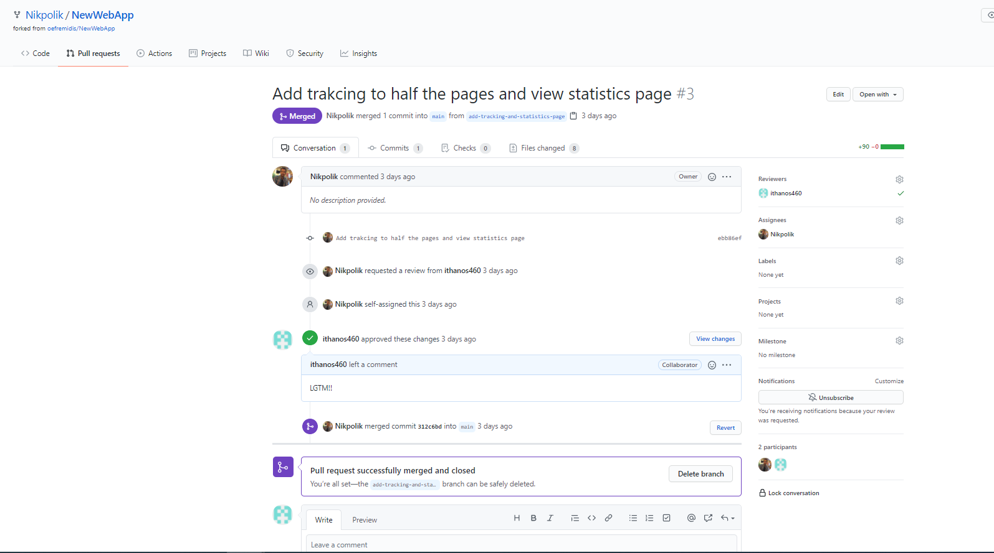

*<<Pull request by Nikos Polykandriotis>>*

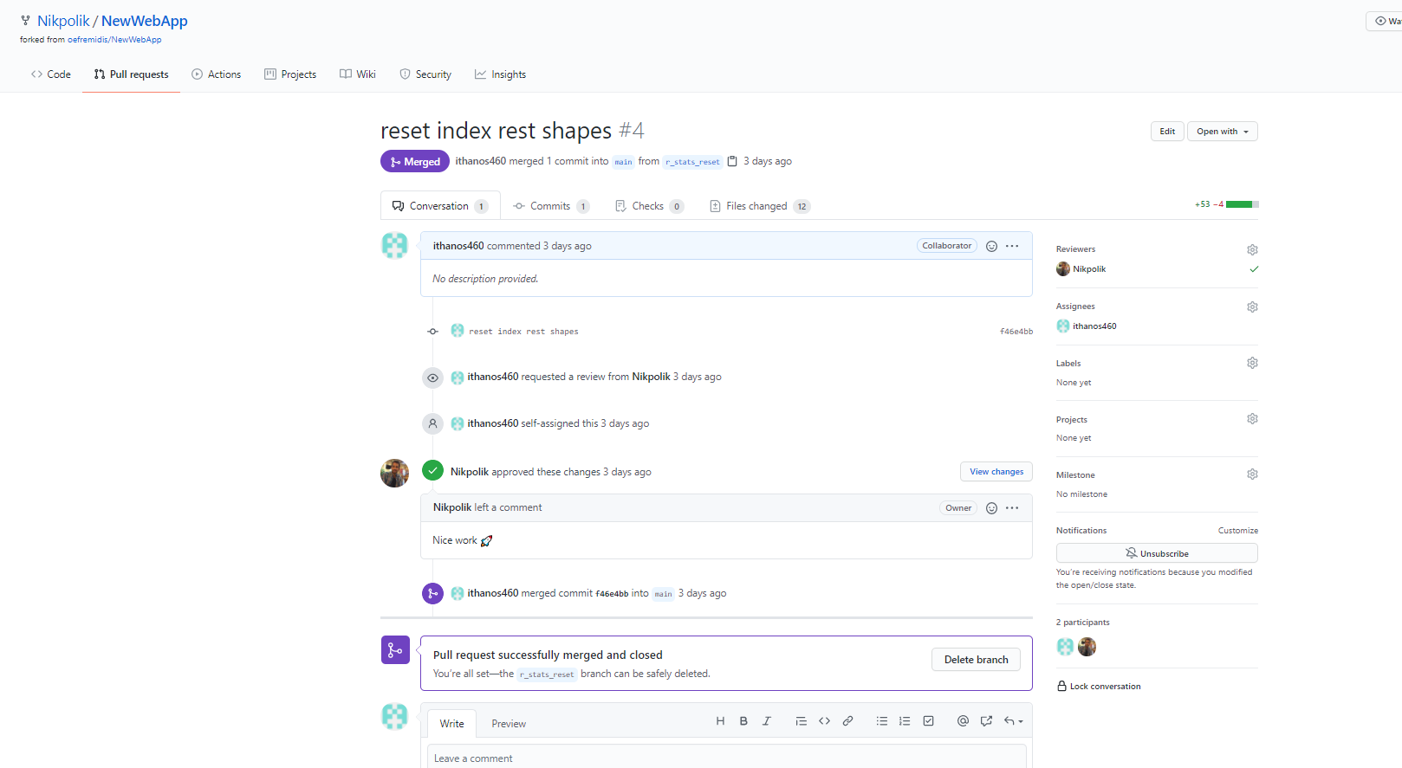

*<<Pull request by Ioannis Thanos>>*

## 19-20. Webhooks – Screenshots

You can also view the output of Jenkin execution for this build in the below attached “Console_Output_Jenkins_database.txt” file:



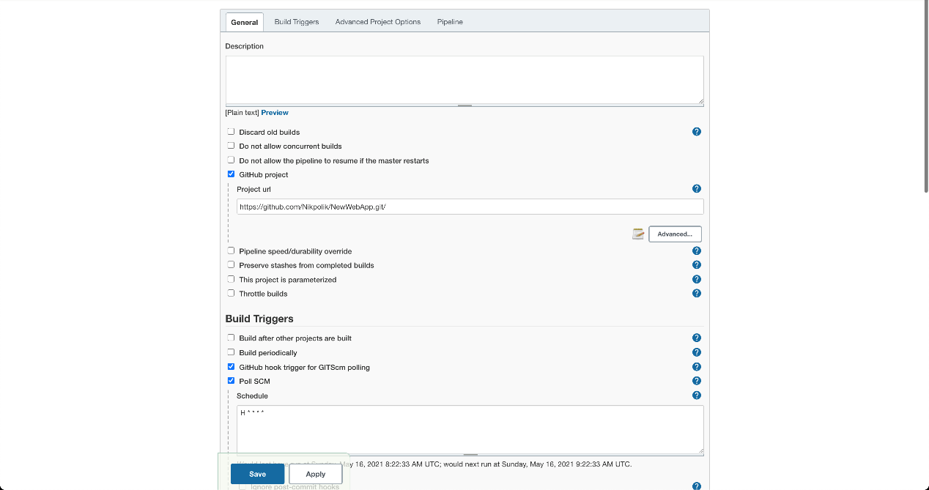

*<<Jenkins Project Congiguration_1>>*

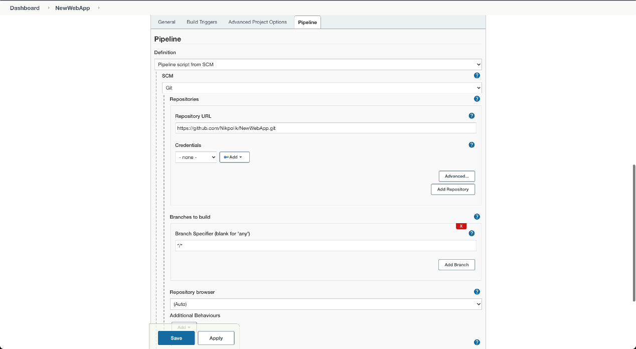

*<<Jenkins Project Congiguration_2>>*

*<<Jenkins Build>>*

*<<Jenkins Build_2>>*

*<<Page – Reset Statistics>>*

*<<Page – Index Final>>*

*<<Page – View Statistics>>*