1. KPI’s

PIZZA SALES SQL QUERIES

1. Total Revenue

Select SUM(total_price) as Total_Revenue from pizza_sales;

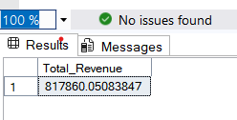

1. Average Order Value

select (SUM(total_price) / COUNT(DISTINCT(order_id))) as Average_order_value from pizza_sales;

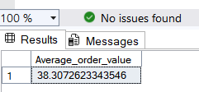

3. Total pizzas sold

select SUM(quantity) as total_pizas_sold from pizza_sales;

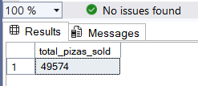

4. Total Orders placed

select COUNT(DISTINCT(order_id)) as Total_orders from pizza_sales;

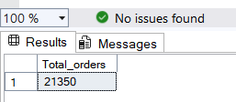

5. Average number of Pizzas sold per order

Select (CAST(SUM(quantity) AS Decimal(10, 2)) / CAST(COUNT(DISTINCT(order_id)) AS

Decimal(10,2)) as Average_pizzs_sold_per_order from pizza_sales;

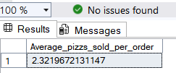

CHARTS REQUIREMENT

-- 1. Daily Trend for total orders

Select DATENAME(DW, order_date) as order_day, COUNT(DISTINCT(order_id)) as Total_orders from pizza_sales

group by DATENAME(DW, order_date);

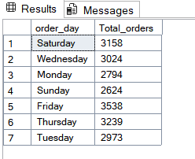

2. Monthly Trend for total orders to identify highest orders by month

select DATENAME(MONTH, order_date) as Month_Name, COUNT(DISTINCT(order_id)) as Total_orders from pizza_sales

group by DATENAME(MONTH, order_date)

Order by COUNT(DISTINCT(order_id)) desc; -- to identify highest order sales by month

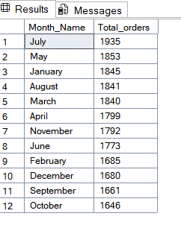

-- 3. Percentage of sales by pizza category

select pizza_category,

CONCAT(ROUND((SUM(total_price) / (SELECT SUM(total_price) FROM pizza_sales)) * 100, 2), '%') AS PCT_Sales from pizza_sales

Where MONTH(order_date) = 1 -- filtering the data month wise

group by pizza_category;

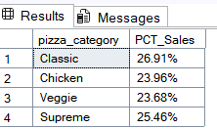

select pizza_category,

CONCAT(ROUND((SUM(total_price) / (SELECT SUM(total_price) FROM pizza_sales Where MONTH(order_date) = 1)) * 100, 2), '%')

AS PCT_Sales from pizza_sales

Where MONTH(order_date) = 1 -- filtering the data month wise

group by pizza_category;

For January sales 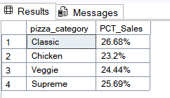

-- 4. % sales by pizza size

select pizza_size,

CONCAT(ROUND((SUM(total_price) / (SELECT SUM(total_price) FROM pizza_sales)) * 100, 2), '%')

AS PCT_Sales from pizza_sales

group by pizza_size;

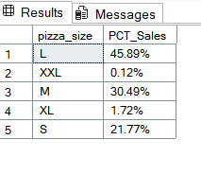

-- for quarter

select pizza_size,

CONCAT(ROUND((SUM(total_price) / (SELECT SUM(total_price) FROM pizza_sales where DATEPART(QUARTER, order_date) = 1)) * 100, 2), '%')

AS PCT_Sales from pizza_sales

where DATEPART(QUARTER, order_date) = 1

group by pizza_size;

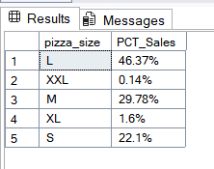

5. Top 5 Best sellers by Revenue, Total Qunatity & Total Orders

SELECT TOP 5 pizza_name, sum(total_price) as Total_sales from pizza_sales

group by pizza_name

Order by Total_sales desc;

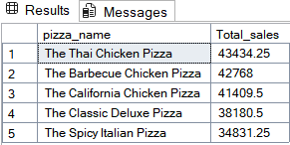

-- 6. Top 5 Best sellers by Total Qunatity

SELECT TOP 5 pizza_name, sum(quantity) as Total_sales from pizza_sales

group by pizza_name

Order by Total_sales desc;

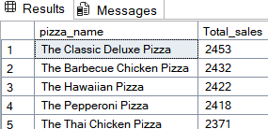

-- . Bottom 5 Best sellers by Total Qunatity

SELECT TOP 5 pizza_name, sum(quantity) as Total_sales from pizza_sales

group by pizza_name

Order by Total_sales;

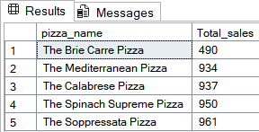

-- 7. Top 5 Best sellers by Total orders

SELECT TOP 5 pizza_name, COUNT(DISTINCT(order_id)) as Total_sales from pizza_sales

group by pizza_name

Order by Total_sales desc;

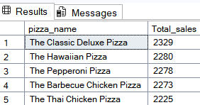

-- Bottom 5 Best sellers by Total orders

SELECT TOP 5 pizza_name, COUNT(DISTINCT(order_id)) as Total_sales from pizza_sales

group by pizza_name

Order by Total_sales;

