**ANITA CHAUDHARY KURMI**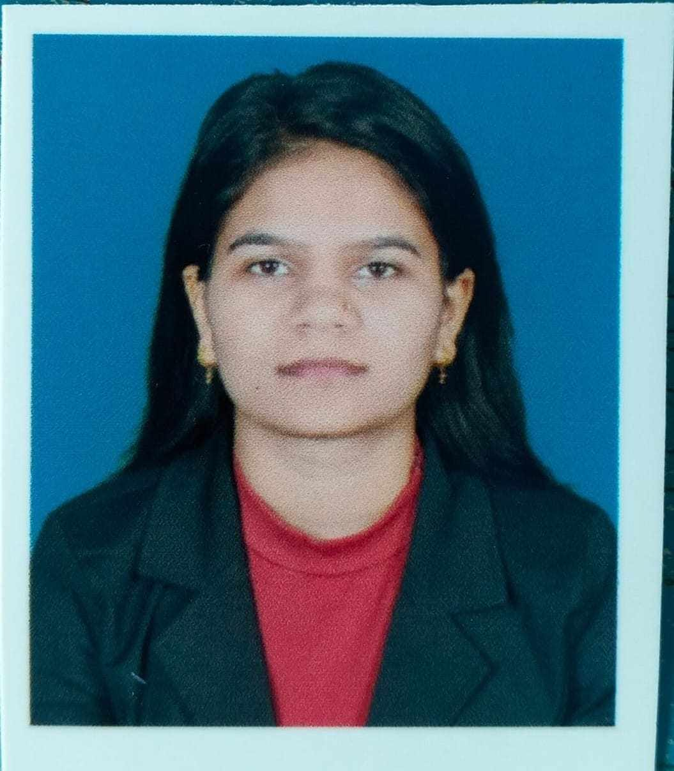

Mobile: +977 9766220134

Email:anitachaudhary13125@gmail.com

Address: mayadevi-07,kapilvastu

**Objectives**

A Fresher Electrical Engineer with a passion for electrical systems, electrical systems design and troubleshooting. Also a collaborative team player with good communication skills and commitment to safety and compliance.

**Education**

**Bachelor in Electrical Engineering**

*IOE Purwanchal Campus, Dharan / November 2018 – April 2023*

**+2 Science**

*Tilottama Secondry School Shankarnagar Rupendehi/August 2015 – August 2017*

**School Leaving Certificate**

*Shree Saraswati Viddya Mandir English Boarding School Maharajgunj -03, Gaidahawa Kapilvastu / Passed in June 2015*

**Training**/**Certificates**

**House Wiring Training (Basic + Advance)**

**Projects**

**Static VAR Compensation Using FC-TCR**

A static VAR Compensator (SVC) also known as Static Reactive Compensator is a device used to improve the power factor of an electrical power system. It is a type of static reactive power compensation device that is used to inject or absorb reactive power into or out of the system to maintain a desired voltage level and improve system stability.

**Skills**

* Microsoft Office – Experienced
* C Programming / C++ – Experienced
* MATLAB/Simulink - Experienced
* Report Writing – Experienced
* Communication – Experienced
* Problem Solving Skills – Experienced
* Leadership - Experienced

**Languages**

* English
* Nepali
* Maithili
* Hindi