**How To Install and Configure Zabbix to Securely Monitor Remote Servers on CentOS 7**

**Prerequisites:**

* Install a LAMP stack that consists of ****L****inux, ****A****pache, ****M****ariaDB, and ****P****HP

**Server1: Zabbix Server**

**Step 1 — Disable Or Permissive SELinux**

setenforce 0

**Step 2 — Install and Configure Apache**

yum -y install httpd

**Start & Enable the httpd service.**

systemctl start httpd.service

systemctl enable httpd.service

systemctl status httpd.service

**Step 3 — Configure Needed Repositories, Install epel and remi repos.**

wget <https://dl.fedoraproject.org/pub/epel/epel-release-latest-7.noarch.rpm>

yum -y install epel-release-latest-7.noarch.rpm

yum install <http://rpms.remirepo.net/enterprise/remi-release-7.rpm>

**Disable PHP 5 repositories and enable PHP 7.2 repo.**

yum-config-manager --disable remi-php54

yum-config-manager --enable remi-php72

**Step 4 — Install PHP**

yum install php php-pear php-cgi php-common php-mbstring php-snmp php-gd php-pecl-mysql php-xml php-mysql php-gettext php-bcmath

**Modify the PHP time Zone by editing the php.ini file.**

vim /etc/php.ini

**Uncomment the following line and add your time zone.**

date.timezone = Asia/Kolkata

max_execution_time = 600

max_input_time = 600

memory_limit =256M

post_max_size = 32M

upload_max_filesize = 16M

**Step 5 — Install MariaDB**

yum --enablerepo=remi install mariadb-server

**Start the MariaDB service.**

systemctl start mariadb.service

**Enable MariaDB on system boot.**

systemctl enable mariadb

**Run the following command to secure MariaDB.**

mysql_secure_installation

Add a new root password and continue. Then it will ask a few questions. Type “Y” to agree to that.

**Login to DB server and verify.**

mysql -u root -p

**Step 6 — Create a Database for Zabbix**

create database zabbix_db character set utf8 collate utf8_bin;

**Create a DB user and grant privileges.**

create user 'zabbix'@'localhost' identified BY 'redhat';

grant all privileges on zabbix_db.* to zabbix@localhost ;

(Username: zabbix and Password: redhat)

**Flush privileges.**

flush privileges;

**Step 7 — Install Zabbix and needed dependencies**

**Adding Zabbix repository.**

rpm -ivh <https://repo.zabbix.com/zabbix/4.0/rhel/7/x86_64/zabbix-release-4.0-1.el7.noarch.rpm>

**Install Zabbix.**

yum install zabbix-server-mysql zabbix-web-mysql zabbix-agent zabbix-get

**Step 8 — Configure Zabbix**

**Change Time Zone by editing the Zabbix Apache configuration file.**

vim /etc/httpd/conf.d/zabbix.conf

**Uncomment the following line and add your Time Zone.**

php_value date.timezone Asia/Kolkata

**Restart HTTPD service.**

systemctl restart httpd.service

Generally, Zabbix installation package gives SQL file which includes an initial schema and data for the Zabbix server with MySQL.

**Change directory and go the Zabbix directory.**

cd /usr/share/doc/zabbix-server-mysql-4.2.8/

(for automatically take zabbix directory -> cd /usr/share/doc/zabbix-server-mys -> after this press tab key so it’s take automatically path)

**Import the MySQL dump file.**

zcat create.sql.gz | mysql -u zabbix -p zabbix_db

**Now modify the Zabbix configuration file with Database details.**

vim /etc/zabbix/zabbix_server.conf

**Modify the following parameters**

DBHost=localhost

DBName=zabbix_db

DBUser=zabbix

DBPassword=redhat

T**hen save and exit the file. Restart Zabbix service.**

systemctl restart zabbix-server.service

**Enable Zabbix on system boot.**

systemctl enable zabbix-server.service

**Modify firewall rules.**

firewall-cmd --add-service={http,https} --permanent

firewall-cmd --add-port={10051/tcp,10050/tcp} --permanent

firewall-cmd --reload

**Now restart httpd service.**

systemctl restart httpd

**Step 9 — Setup Zabbix**

**You can access Zabbix using following URL:**

http:// Agent Server IP/zabbix/

**Server2: Zabbix Agent**

**Step 10 — Monitor Servers with Zabbix Agent**

**Zabbix Agent collects the data from the client machine and sends them to the Zabbix Server.**

**Adding Zabbix repository.**

rpm -ivh <https://repo.zabbix.com/zabbix/4.0/rhel/7/x86_64/zabbix-release-4.0-1.el7.noarch.rpm>

**Install Zabbix.**

yum install zabbix-server-mysql zabbix-web-mysql zabbix-agent zabbix-get

**Agent Configuration:**

yum install zabbix-agent

**Now modify the agent configuration file.**

vim /etc/zabbix/zabbix_agentd.conf

**Modify the following parameters. Replace IP and hostname with yours in the below command: (Agent Server IP pass here)**

Server=0.0.0.0

ServerActive=0.0.0.0

Hostname=Zabbix-Agent

Save and exit the file.

**Restart Zabbix agent.**

systemctl restart zabbix-agent

**Enable on system boot.**

systemctl enable zabbix-agent

**Step 11 — Add host to monitor on Zabbix server**

Go to Configuration -) Hosts -) Create host.

Then you will get the interface as follows:

Add Hostname, Visible Name and agent interface IP. Select a group from the list. In our scenario, we are going to monitor the Ubuntu server. So we will select Linux servers from the list.

Select and go to Template Tab. Then click on the select button and select “Template OS Linux” from the list.

Click “add,” and it will list linked templates.

Click on the update button to update.

**Step 12 — View Graphs**

Go to Monitoring -) Graphs. You can select needed group, host and graph to display the graphs.

If any issues come then follow steps and check:

setenforce 0

systemctl stop firewalld

Zabbix front Login:

Admin

zabbix

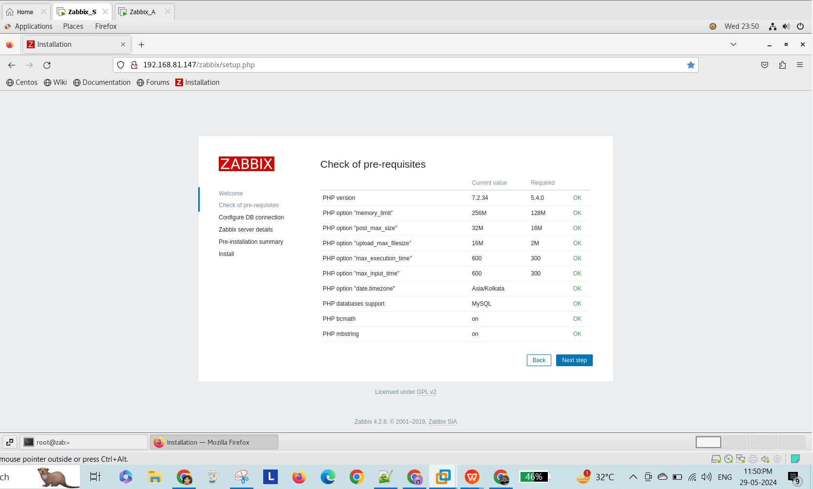

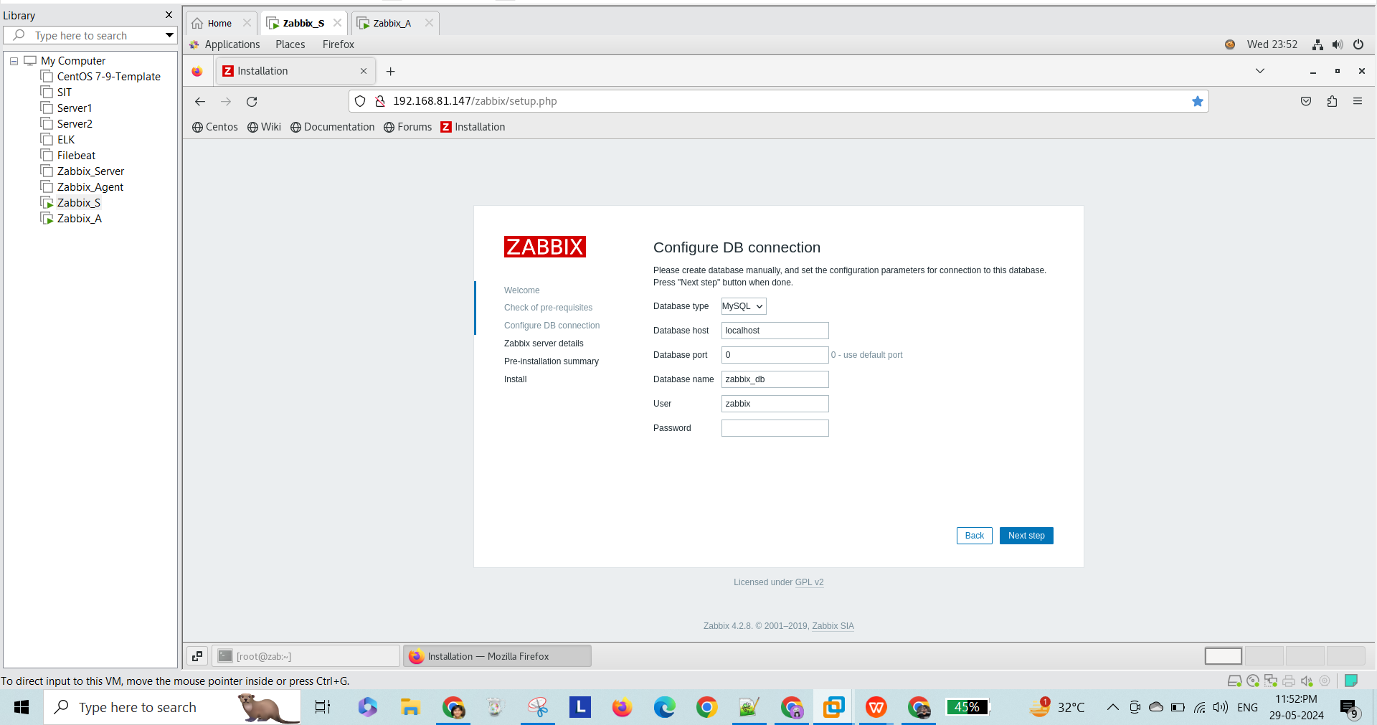

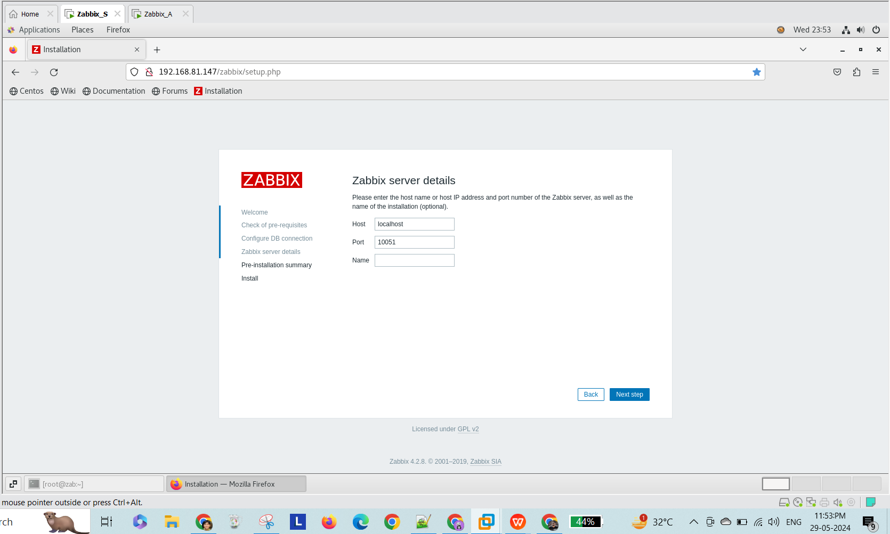

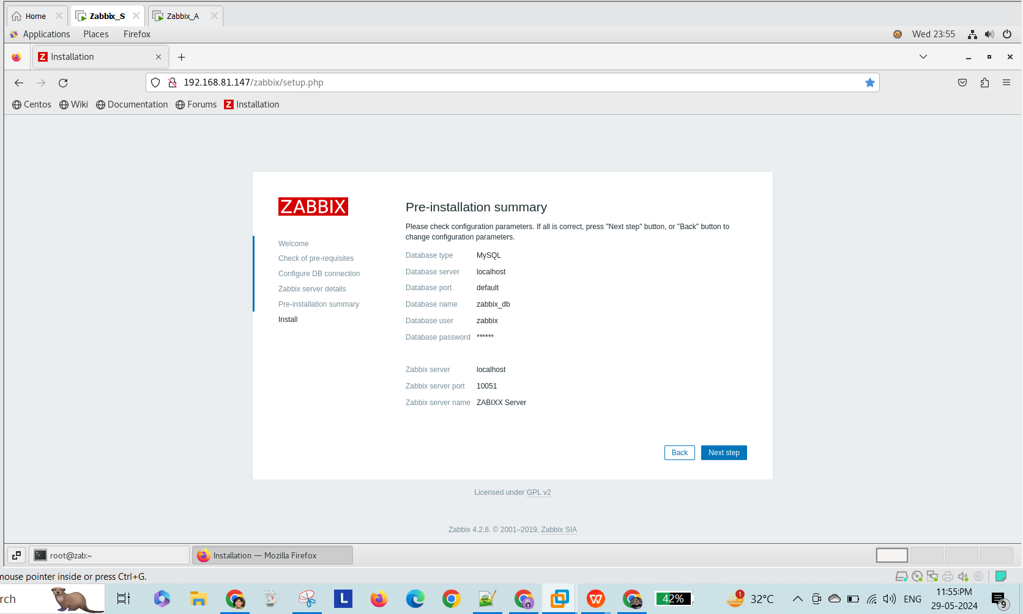

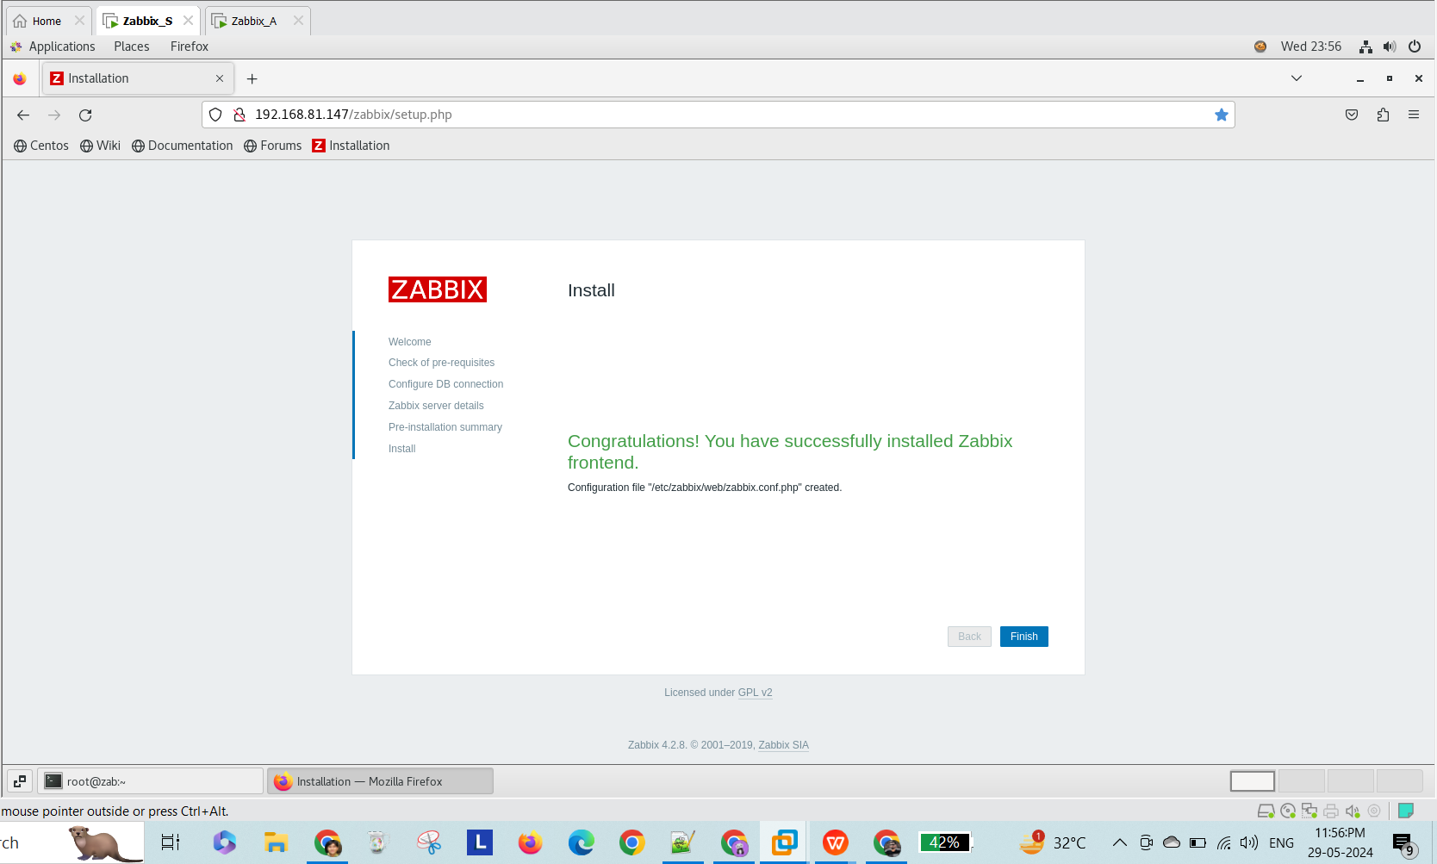

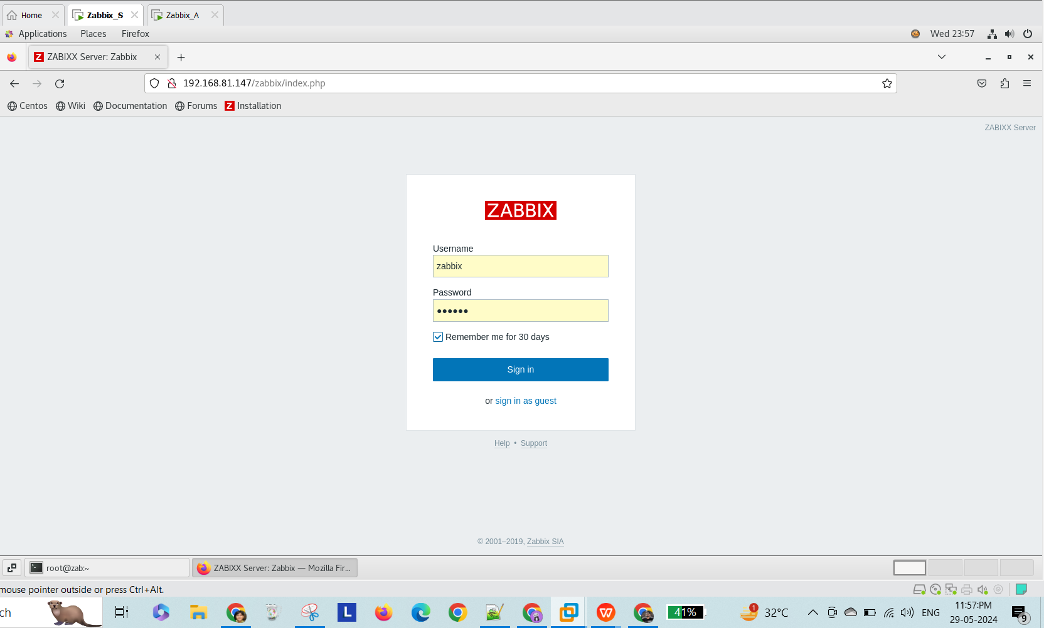

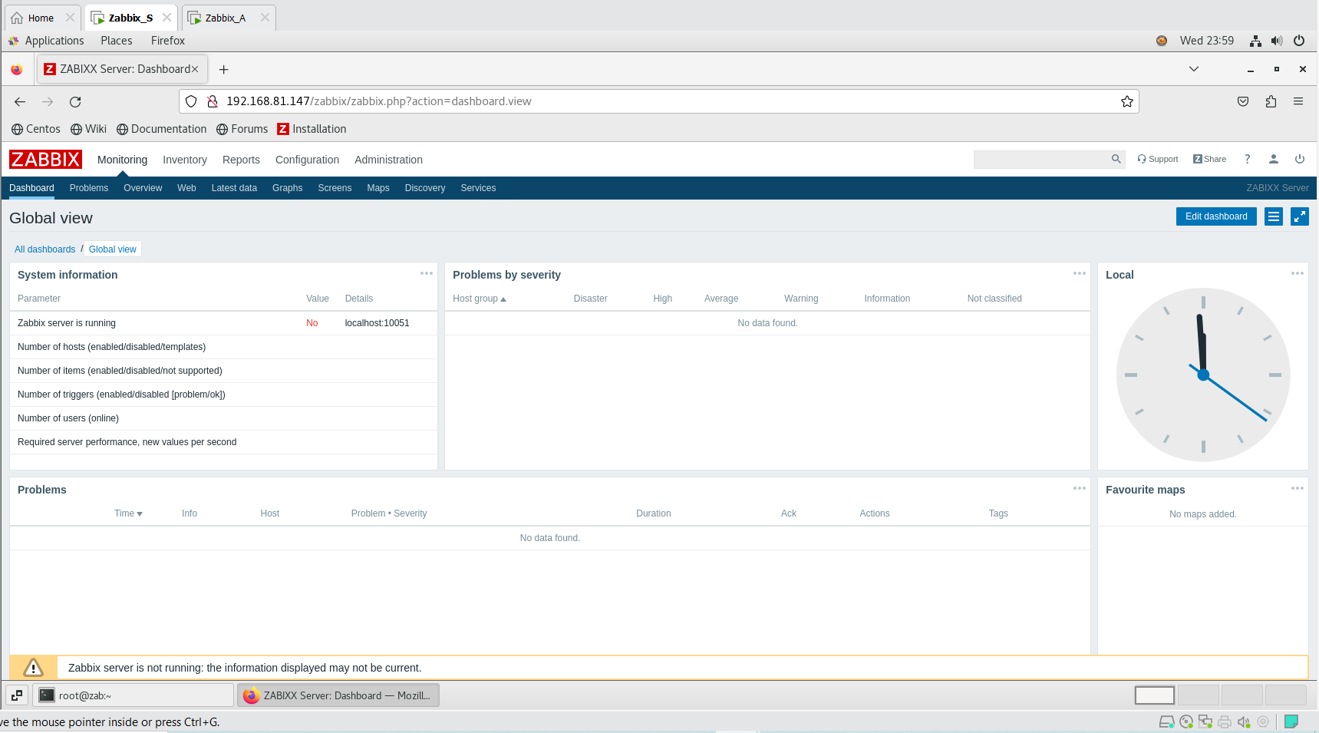

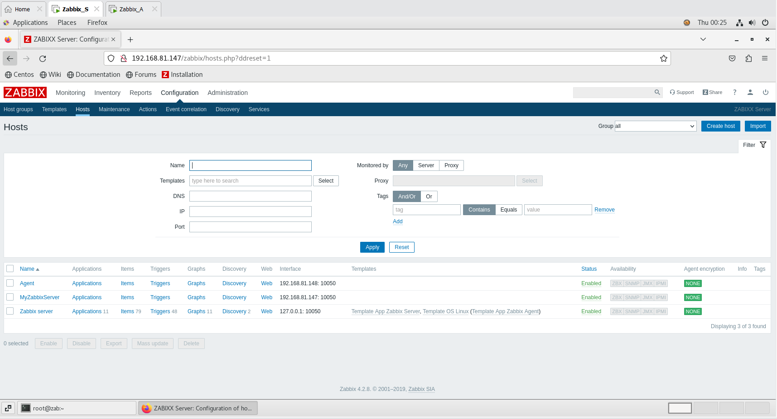

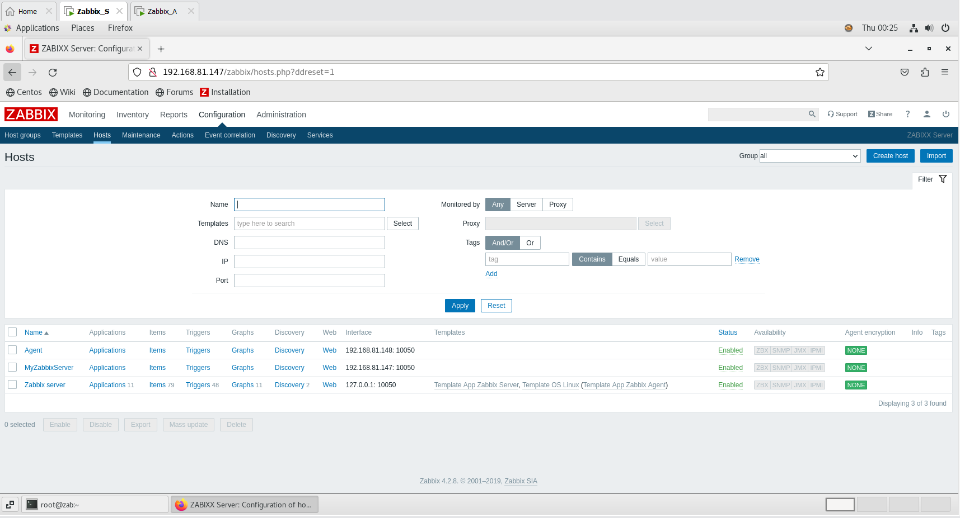

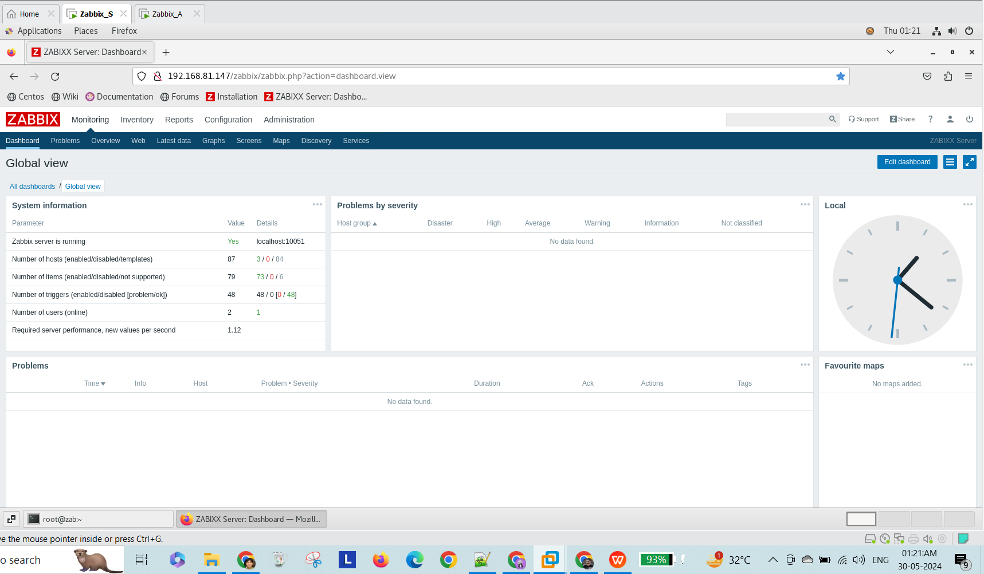

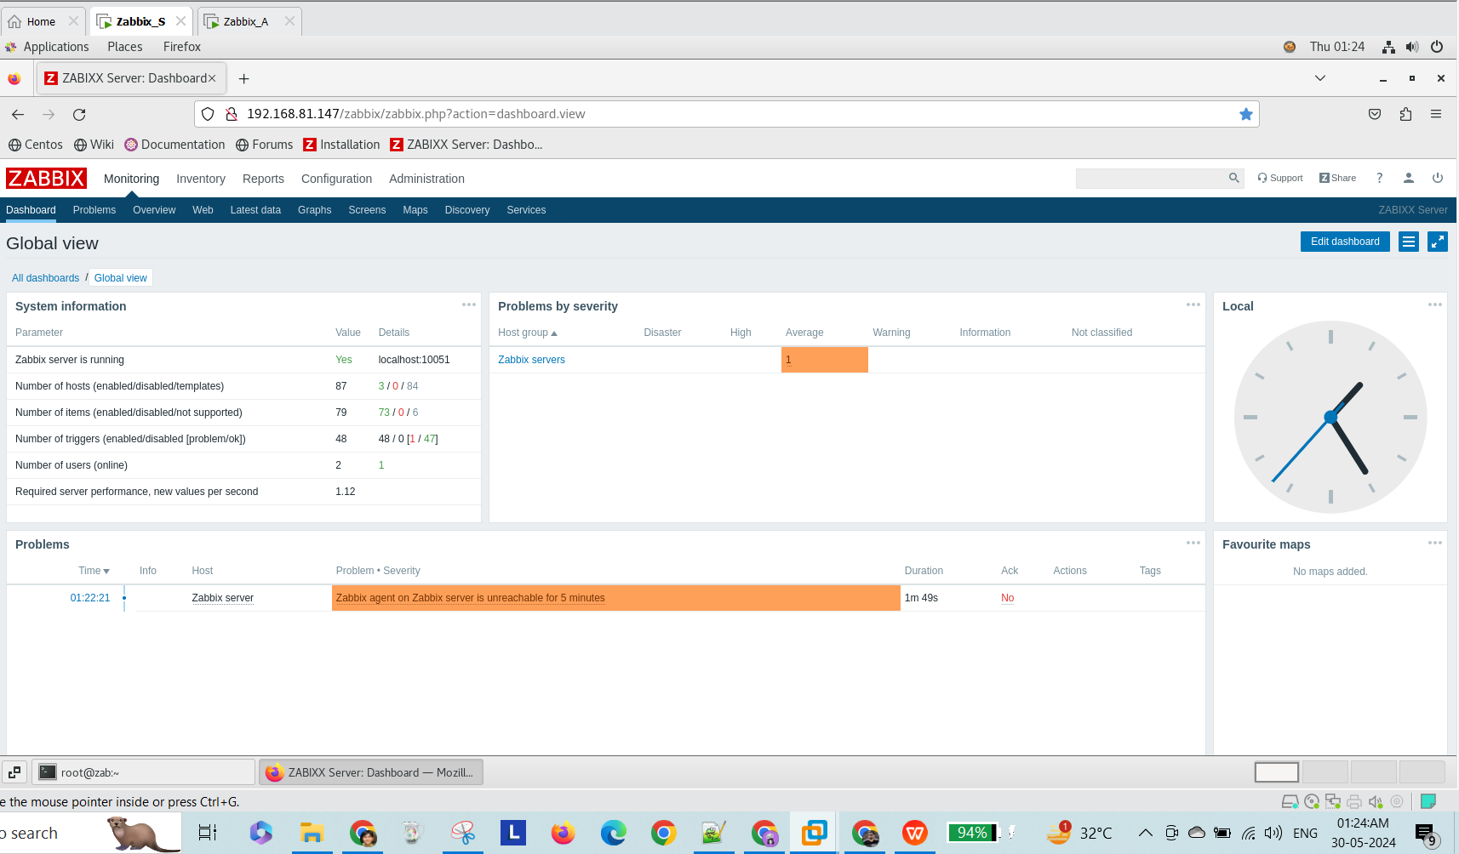

Extra:

Reference: <https://www.digitalocean.com/community/tutorials/how-to-install-and-configure-zabbix-to-securely-monitor-remote-servers-on-centos-7>

<https://www.digitalocean.com/community/tutorials/how-to-install-linux-apache-mysql-php-lamp-stack-on-centos-7>